(10.1.1.) Remove Punctuations from a String

ALGORITHM:
- Start: Get a string st from the user.
- Setup: Create an empty string new_st to store the "cleaned" version.
- Loop: Look at every character ch in the original string.
- Check: Is the character an Alphanumeric (A-Z, 0-9) OR a Space?
- Build: If Yes, add that character to new_st. If No, skip it.
- Result: Print the final cleaned string new_st.
- Stop.

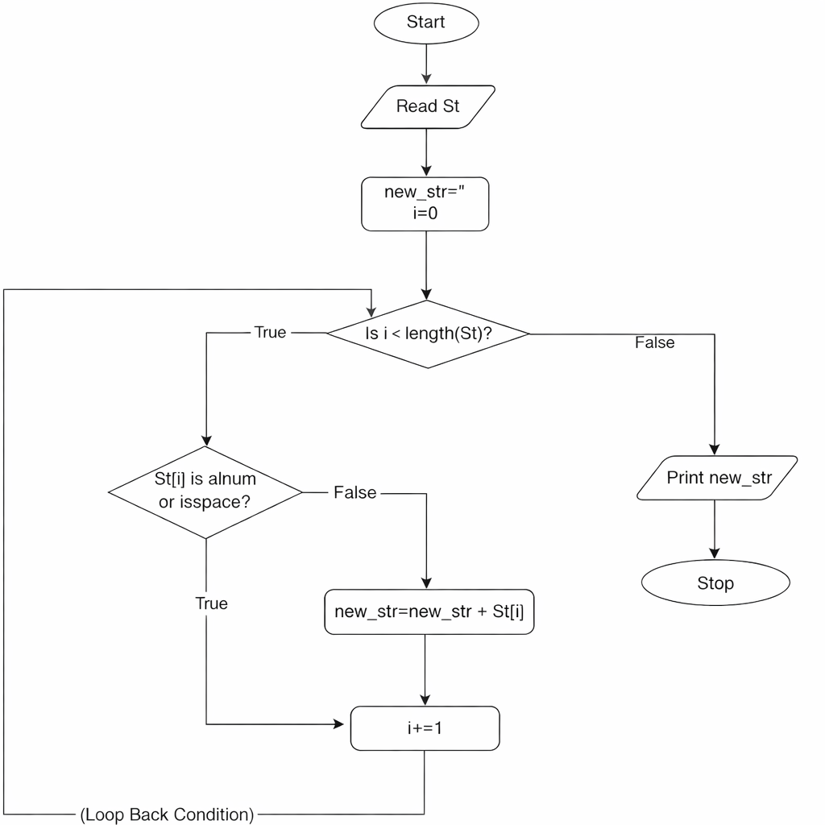
FLOWCHART:

