(8.1.1.) Multiplication of two square matrix
ALGORITHM :
- Start
- Input n (dimension)
- First Matrix input
- Second matrix input
- Resultant Matrix = Matrix1[i][k] * matrix2[k][j]
- Output = Resultant matrix
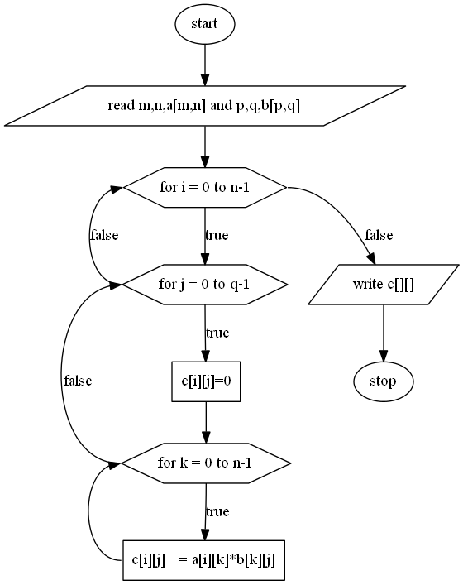
FLOWCHART:

OUTPUT:
