4.1.1. Set operations for union, intersection and difference

ALGORITHM:
- Start.
- Declare two sets A and B
- Read elements of Set A from the user
- Read elements of Set B from the user
- Perform Union operation Union = A ∪ B.
- Perform Intersection operation Intersection = A ∩ B.
- Perform Difference operations
- Difference1 = A − B.
- Display Set A and Set B
- Display Union, Intersection, and Difference results
- Stop.

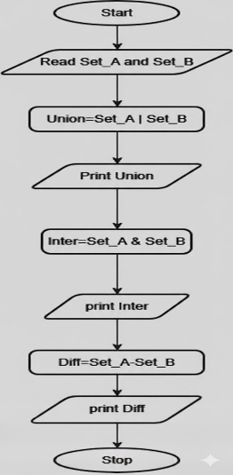
FLOWCHART:

