(10.1.2.) Reverse a String

ALGORITHM:
- Start: Define a function reverse_string and take input from the user.
- Setup: Create an empty string new_st to hold the reversed result.
- Calculate: Find the length of the input string.
- Backward Loop: Start a loop at the last index ($length - 1$) and move toward 0 (the first index).
- Build: In each step, take the character at that position and add it to new_st.
- Return: Send the completed new_st back to the main program.
- Result: Print both the original and the newly reversed string.
- Stop.

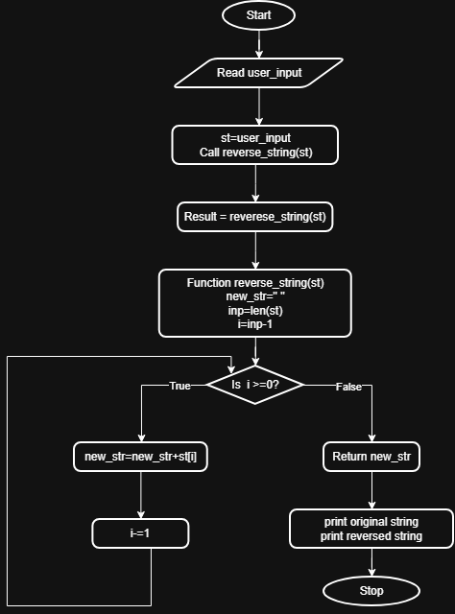
FLOWCHART:

