13.1.1. Fibonacci Sequence using Modules

Algorithm:
- Start
- Input integer n
- If n ≤ 0 Print "Please enter a positive integer" Stop
- Initialize: a ← 0 b ← 1 seq ← empty list
- While a ≤ n do Add a to seq temp ← a + b a ← b b ← temp
- Print all elements of seq
- Stop

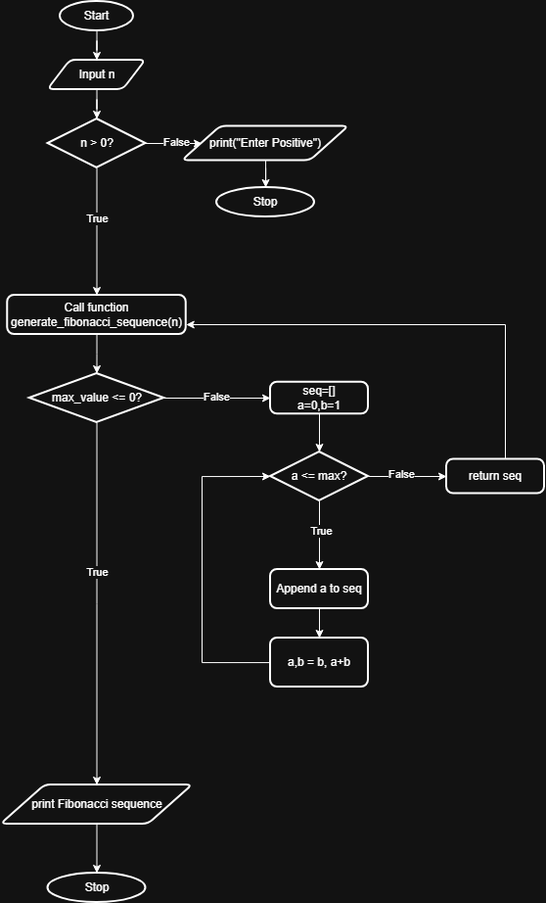
Flowchart:

