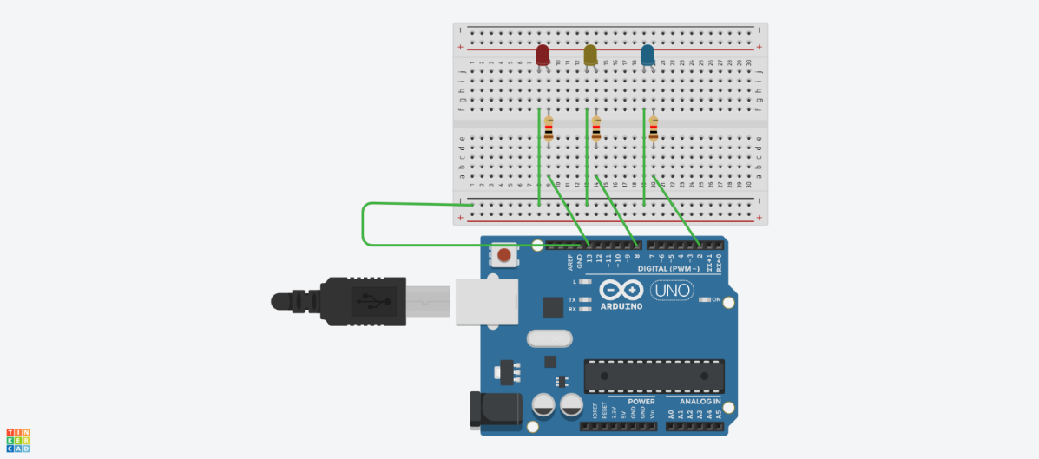

int l1 =13;
int l2 = 8;
int l3 = 2;

void setup() {
pinMode(11, OUTPUT);
pinMode(12, OUTPUT);
pinMode(13, OUTPUT);
}

void loop() {
digitalWrite(l1, HIGH);
delay(1000);
digitalWrite(l1, LOW);
delay(1000);
digitalWrite(l2, HIGH);
delay(1000);
digitalWrite(l2, LOW);
delay(1000);
digitalWrite(l3, HIGH);
delay(1000);
digitalWrite(l3, LOW);
delay(1000);
delay(1000); // Wait for 1000 millisecond(s)
}

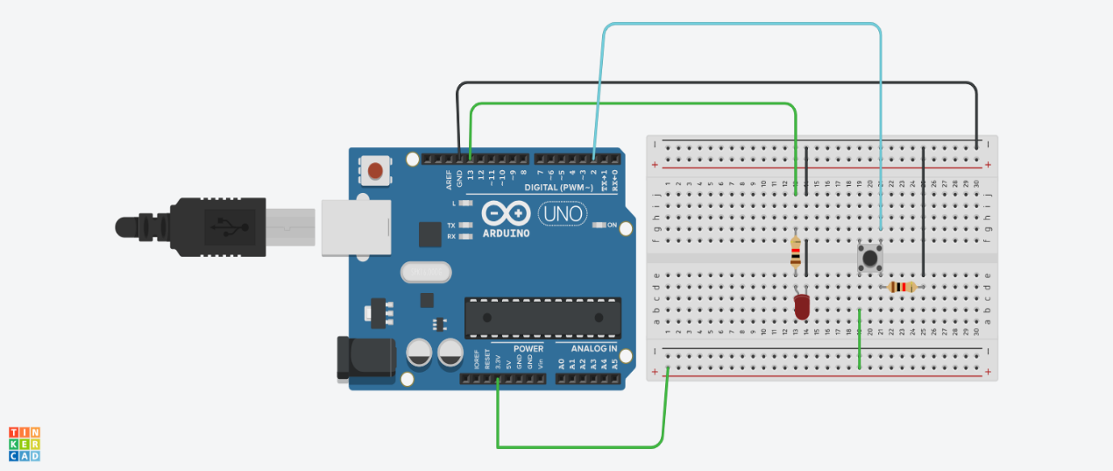

int led = 13;
int pushButton = 2;

void setup() {
Serial.begin(9600);
pinMode(pushButton, INPUT);
pinMode(led, OUTPUT);
}

void loop() {
int buttonState = digitalRead(pushButton);
Serial.println(buttonState);

if (buttonState == HIGH) {
digitalWrite(led, HIGH); // Turn LED ON
delay(500); // Stay ON for half a second
digitalWrite(led, LOW); // Turn LED OFF
delay(500); // Stay OFF for half a second
} else {
digitalWrite(led, LOW); // Keep LED OFF if button not pressed
}
}

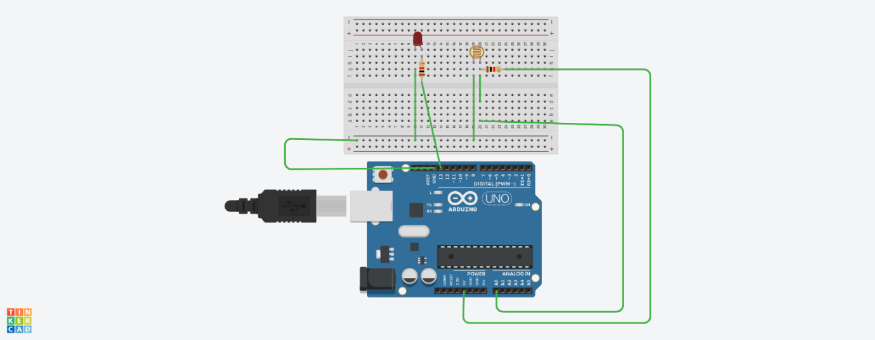

const int ldrpin = A0;
const int ledpin = 13;
int threshold = 500;

void setup() {
pinMode(ledpin, OUTPUT);
Serial.begin(9600);
}

void loop() {
int val = analogRead(ldrpin);
Serial.println(val);

if (val > threshold) {
digitalWrite(ledpin, HIGH);
} else {
digitalWrite(ledpin, LOW);
}

delay(200);
}

