Lab 3 / Project 2
Autonomous Vehicle: Putting it All Together
COMPENG 4DS4 - Winter 2026
McMaster University
Group 19
Ali Raza - 400338538
Zuhaib Quraishi - 400306494
Khushi Akbari - 400320925

Declaration of Contributions
Ali Raza: Experiment 1 (Build and program PX4). Experiment 2 (hello_world application on NuttX). Experiment 3A (uORB messaging, subscribe and publish).
Zuhaib Quraishi: Experiment 3C (motor control via test_motor). Experiment 4 (MAVLink setup and communication). Project 2 Part 1 (RC controller motor and servo control).
Khushi Akbari: Experiment 5 (ultrasonic sensor on Raspberry Pi). Experiment 6 (camera direction detection). Project 2 Part 2 (autonomous control via MAVLink).

Experiment 2B: Hello World Application
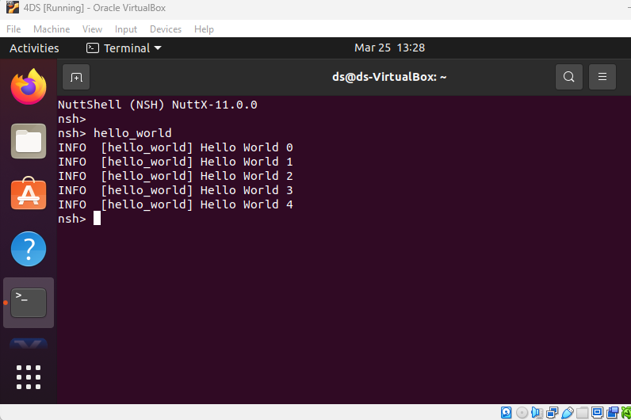

Experiment 3A: uORB Top
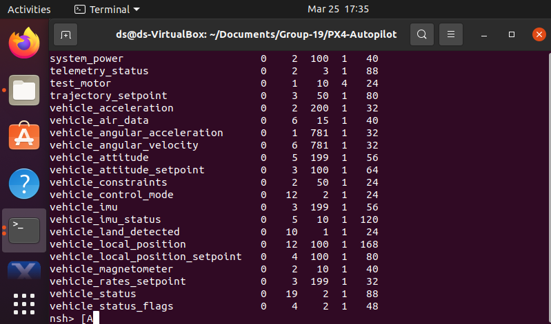

Experiment 3A: Listener sensor_combined
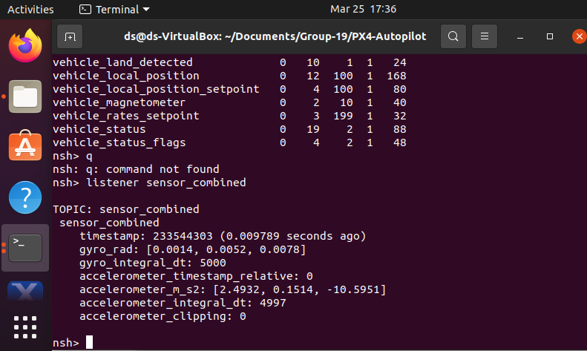

Experiment 3A: Listener input_rc
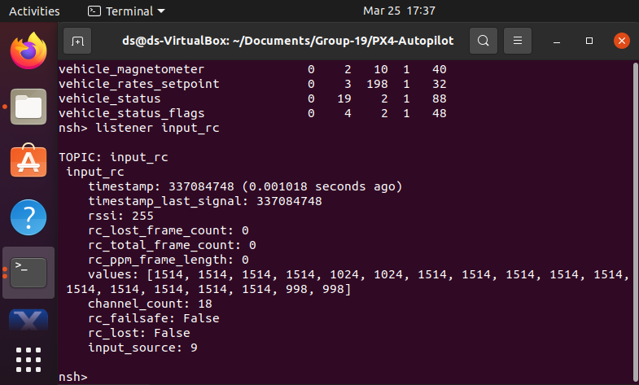

Experiment 3C: Motor Speed Control
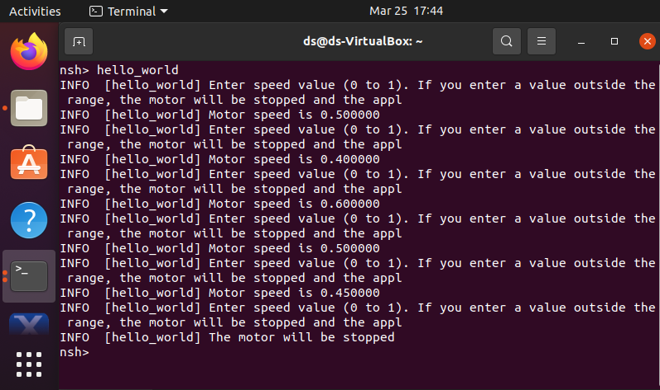

Experiment 4A: MAVLink Message Stream
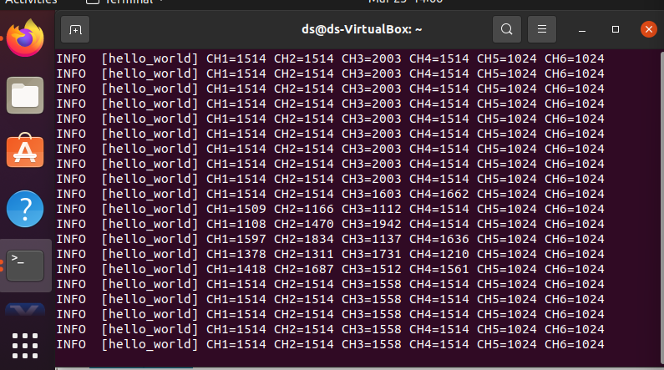

Experiment 4A: ATTITUDE Messages
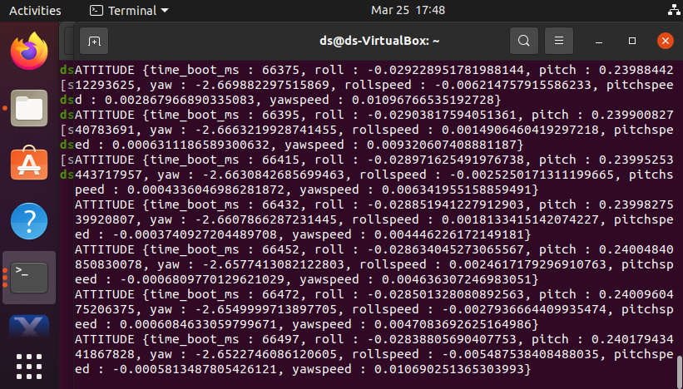

Experiment 5: Ultrasonic Distance Readings
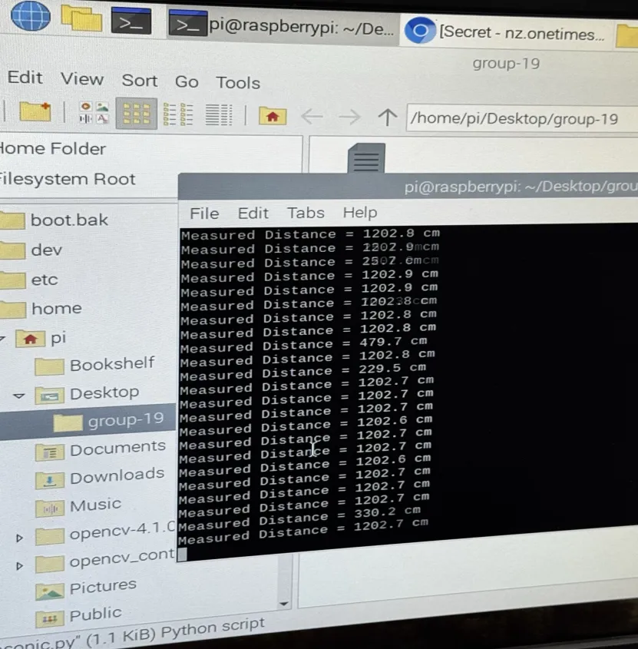

Experiment 6: Camera Direction Detection
