**A**

**Project Report**

**Human Pose Estimation**

Submitted in partial fulfilment of

the requirements for the Bachelor Degree in

B.Voc. (Artificial Intelligence & Data Science) Semester-VI

 **Session-2023-2024**

**To**

**UG DEPARTMENT OF**

**KANYA MAHA VIDYALAYA, JALANDHAR (AUTONOMOUS)**

**Submitted by:**

**Name: Khushi**

**Examination Roll No.: 21114000010**

**Submitted To:**

**Ms. Simarpreet Kaur**

**Faculty of Vocational Studies**

**CERTIFICATE OF COMPLETION AND EVALUATION**

This is to certify that Khushi, student of B.Voc. (Artificial Intelligence & Data Science) Semester-VI at Kanya Maha Vidyalaya, Jalandhar has successfully completed the Project titled "Human Pose Estimation” under the Guidance of Ms. Simarpreet Kaur.

_____________________________ _____________________________

Ms. Simarpreet Kaur Dr. Pardeep Arora

Lecturer Vocational

Vocational Kanya Maha Vidyalaya

Kanya Maha Vidyalaya

The Project/ Assignment was evaluated through a viva examination, and the student demonstrated understanding of the subject matter. The viva examination was conducted by:

_____________________________ _____________________________

Name of the Viva Examiner Name of the Viva Examiner

Date:

**ACKNOWLEDGEMENT**

The accomplishment of the dissertation work entitled:” Human Pose Estimation – Gesture Guard” Would not have been possible without the encouragement, support and cooperation of number of people.

From the deep core of our heart, we keenly with to express our sincere thanks to our principal, Prof. (Dr.) Atima Sharma Dwivedi for providing with the necessary facilities required for the project.

It is great pleasure for us to acknowledge Dr. Pardeep Arora, Head and U.G. Dept. of Artificial Intelligence & Data Science for his support. We acknowledge our deep sense of gratitude and reverence to our worthy project Incharge, Ms. Simarpreet Kaur for his able guidance

Department for providing us all facilities required for the completion of this dissertation work.

We expressed our thanks to our family for this support and affection and for believing us always.

**Khushi**

Uni. Roll No: 21114000010

**DECLARATION**

This is to declare that dissertation work entitled: “Human Pose Estimation – Gesture Guard” bonafide work done by me. This report is being submitted in the partial fulfillment of the requirements for the award of the degree of Bachelor of Vocational in Artificial Intelligence and Data Science from Kanya Maha Vidyalaya, Jalandhar.

This report has not been submitted to any other institution or university for the award of any other degree or diploma.

**Khushi**

Uni. Roll No: 21114000010

**CERTIFICATE**

This is to certify that dissertation work entitled: “Human Pose Estimation using TensorFlow and Open CV” submitted to **KANYA MAHA VIDYALAYA (Autonomous), JALANDHAR** by a studentKhushi of Bachelor of Vocational (Artificial Intelligence & Data Science) VI Semester in the partial fulfillment of the requirements of the degree of Bachelor of Vocational in Artificial Intelligence and Data Science is carried out under our Guidance and Supervision. This is a purely original piece of work and has not been submitted to any other university or institution for any other degree and class.

Prof. (Dr.) Atima Sharma Dwivedi

PRINCIPAL

Dr. Pardeep Arora

Head Dept. of AI & Data Science

Kanya Maha Vidyalaya, Jalandhar

GUIDED AND SUPERVISED BY:-

Ms. Simarpreet Kaur

Lecturer

U.G. Dept. of AI & Data Science

**Abstract**

Pose detection systems have emerged as a crucial technology in various fields such as sports analytics, healthcare, security, and entertainment. This abstract provides an overview of recent advancements, challenges, and applications in pose detection systems.

The primary focus of this abstract is to explore the methodologies employed in pose detection, including traditional computer vision techniques and deep learning approaches. We discuss the evolution from rule-based algorithms to convolutional neural networks (CNNs) and graph-based methods, highlighting their respective advantages and limitations.

Furthermore, we delve into the challenges faced by pose detection systems, such as occlusion, viewpoint variation, and real-time processing constraints. Strategies to address these challenges, such as data augmentation, multi-view fusion, and efficient network architectures, are also reviewed.

Additionally, we examine the diverse applications of pose detection systems across various domains. Examples include human activity recognition in sports training, patient monitoring in healthcare, gesture recognition in human-computer interaction, and security surveillance.

Lastly, we present an evaluation framework for assessing the performance of pose detection systems, including metrics such as accuracy, precision, recall, and computational efficiency. We discuss benchmark datasets, evaluation protocols, and open challenges for future research directions.

**Table of Contents**

1. Introduction 8

1.1. Human Pose Estimation 9

1.2. The Value of Human Pose Estimation 10

1.3. Types of Human Pose Estimation Models 11

1.4. 3D Pose Estimation Models 12

1.5. How Does Human Pose Estimation Work? 14

2. Literature Review 16

3. Methodology 19

3.1. Process 19

3.2. Tools & Technologies 21

3.3. Code Files and Repository 23

4. Working 33

4.1. Accessing Gesture Guard 33

4.2. Functionalities of Gesture Guard 33

4.3. Website Pages 34

5. Results 40

6. Conclusion 42

7. Reference 43

## **Introduction**

In the heart of a bustling metropolis, amidst the vibrant energy of a dance studio, a group of aspiring dancers gather, eager to hone their craft. Guiding them is a seasoned instructor, whose passion for dance is palpable in every step she takes. Yet, despite her expertise, a persistent problem lingers - the frustration of dancers whose movements fail to synchronize with those of their trainer.

In this dance studio, where precision and fluidity are paramount, the discrepancy between a dancer's execution and the instructor's demonstration poses a significant hurdle. The intricate choreography, meticulously crafted by the instructor, loses its essence when translated into the movements of her students. As dancers strive to emulate her grace and technique, they find themselves grappling with the nuances of timing, posture, and rhythm.

This disconnect isn't merely a matter of technique; it's a barrier that impedes the journey of dancers towards mastery. The frustration mounts as dancers yearn to embody the elegance and precision they witness in their instructor's movements, only to fall short time and time again.

Enter pose detection systems, poised to bridge this gap between aspiration and execution. By harnessing the power of TensorFlow and OpenCV, these systems offer a solution to the age-old dilemma of mismatched dance steps. Through real-time analysis and feedback, dancers can now receive instant guidance on their posture, alignment, and timing, bringing them one step closer to synchronization with their instructor.

No longer bound by the limitations of perception and interpretation, dancers can refine their movements with unparalleled precision. With each step captured and analysed by pose detection algorithms, the intricacies of choreography become tangible, allowing dancers to refine their technique and elevate their performance to new heights.

As the dance studio transforms into a hub of innovation, dancers and instructors alike embrace the possibilities afforded by pose detection systems. What once seemed insurmountable now becomes achievable, as dancers embark on a journey of growth and self-discovery, guided by the seamless integration of technology and artistry. In this symbiotic relationship between human creativity and machine intelligence, the rhythm of dance finds its perfect harmony.

## **Human Pose Estimation**

Human Pose Estimation recognizes and categorizes the positions of joints and body parts in pictures or movies. Human body positions in 2D and 3D are typically represented and inferred using a model-based method.

In essence, it is a method of obtaining a set of coordinates by identifying the joints of the human body, such as the wrist, shoulder, knees, eyes, ears, ankles, and arms. These joints are important points in pictures and films that can depict a person's posture.

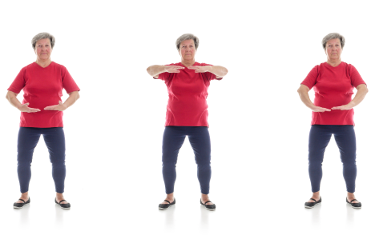

Figure 1.1 Human Pose Estimation

The posture estimator model then recognizes the coordinates of these identified body parts and joints as output and returns a confidence score indicating the accuracy of the guesses when it receives an image or video as input.

Human pose estimation plays a pivotal role in various fields, including computer vision, robotics, augmented reality, and human-computer interaction. By analysing the spatial locations of key body joints such as elbows, shoulders, and knees, we can infer valuable insights into human behaviour, activity recognition, and even health monitoring.

The objective of this project is to leverage state-of-the-art techniques and methodologies to create a versatile and high-performance human pose estimation system. Through a combination of deep learning models, advanced algorithms, and innovative approaches, we aim to achieve accurate and real-time pose estimation, capable of handling diverse poses, backgrounds, and environmental conditions.

## **The Value of Human Pose Estimation**

Human pose estimation has significantly increased in recent years, driven by advancements in machine learning algorithms and the growing need for understanding human behaviour and interactions.

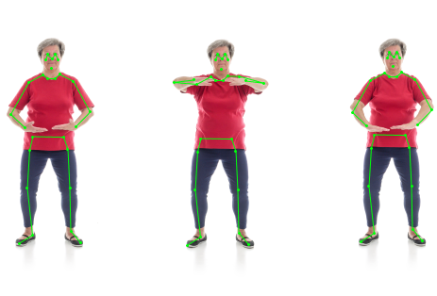

Figure 1.2 Human Pose Estimation

Here are some key points highlighting the value of human pose estimation:

1. **Enhanced Object Identification**: While traditional object detection focused on identifying objects, human pose estimation goes a step further by detecting and understanding human body language. This enables computers to comprehend human actions, gestures, and intentions, leading to more context-aware applications.
2. **Commercial Applications:** With the improvement in accuracy and accessibility of pose estimation technology, it has become viable for commercial use. Industries such as retail, healthcare, entertainment, and security can leverage pose estimation for various applications.
3. **Social Distancing and Pandemic Response:** In the wake of the COVID-19 pandemic, high-performance real-time posture detection and tracking have become crucial for enforcing social distancing measures. By accurately detecting and tracking human poses, technology can help monitor and enforce physical distancing in public spaces, workplaces, and other environments, contributing to public health and safety.
4. **Trends in Computer Vision:** Human pose estimation is driving significant trends in computer vision, revolutionizing the way machines perceive and interact with the world. The ability to understand human poses opens up new avenues for research and innovation in areas such as human-computer interaction, augmented reality, autonomous systems, and more.
5. **Personalized Experiences:** Pose estimation enables personalized experiences in various domains, such as fitness tracking, gaming, and virtual reality.

## **Types of Human Pose Estimation Models**

There are three main types of human pose estimation models used to represent the human body in 2D and 3D planes:

* + 1. **2D Pose Estimation Models**

1. **Heatmap-based Models:** Heatmap-based models predict the likelihood of each pixel belonging to a specific body joint. They typically output a set of heatmaps corresponding to different body parts, and the joints are localized by finding the maximum response within each heatmap. Examples of heatmap-based models include Hourglass Networks and PoseNet.
2. **Regression-based Models:** Regression-based models directly regress the coordinates of body joints from image features. They learn to predict the 2D coordinates of joints by regressing from image patches or feature representations. These models are often trained with annotated joint coordinates as ground truth. Examples of regression-based models include Convolutional Pose Machines (CPM) and Stacked Hourglass Networks.

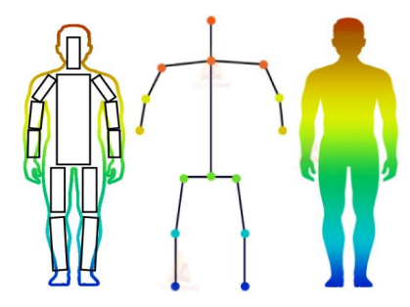

Figure 1.3 Kinematic

Figure 1.5 Volumetric

Figure 1.4 Planner

## **3D Pose Estimation Models**

1. **Direct 3D Regression Models**

Direct 3D regression models predict the 3D coordinates of body joints directly from input images or feature representations. These models typically learn to map from 2D image space to 3D world space using deep learning architectures. They require annotated 3D joint coordinates for training and are capable of estimating the full 3D pose of the human body. Examples of direct 3D regression models include DeepPose3D and VNect.

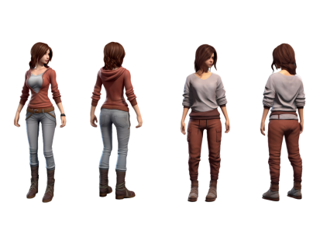

Figure 1.6 3D Pose Estimation Model

1. **Depth-based Models**

Depth-based models estimate 3D pose from depth images or point clouds obtained from depth sensors such as RGB-D cameras or LiDAR. These models leverage depth information to directly infer the 3D position of body joints, making them robust to occlusions and lighting variations. Examples of depth-based models include Kinect Fusion-based methods and PointNet-based approaches.



Figure 1.7 3D Pose Estimation Model

* + 1. **Hybrid Models:**

1. **2D-to-3D Fusion Models**: Hybrid models combine both 2D and 3D pose estimation techniques to leverage the advantages of both approaches. They first estimate 2D joint positions using image-based methods and then lift these 2D detections to 3D space using geometric constraints or learned mappings.

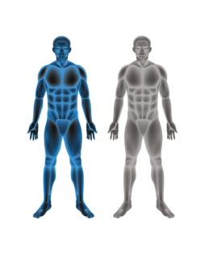

Figure 1.9 Hybrid Models

Figure 1.8 Hybrid Models



This approach allows for more accurate and robust 3D pose estimation compared to direct regression methods alone. Examples of 2D-to-3D fusion models include HMR (Human Mesh Recovery) and SPIN (SMPL-based Pose INference).

## **How Does Human Pose Estimation Work?**

Here's how a Human Pose Estimation is built using HTML, CSS, JavaScript, and TensorFlow with frameworks like BlazePose and PoseNet would work:

* + 1. **User Interface**
* **HTML Structure:** The project's user interface (UI) is designed using HTML to include elements such as image display area, buttons for user interaction, and a section to visualize the detected poses.
* **CSS Styling:** CSS is used to style the UI elements, ensuring a visually appealing and responsive layout across different devices and screen sizes.
  + 1. **Pose Estimation**
* **TensorFlow Integration:** TensorFlow.js is integrated into the project to perform real-time human pose estimation directly in the web browser. This allows for efficient inference using pre-trained models without requiring server-side processing.
* **Framework Integration**: Frameworks like BlazePose and PoseNet, which are specifically designed for human pose estimation, are utilized to detect and localize key points on the human body in images or video frames.
  + 1. **Image/Video Processing**
* **Input Handling**: JavaScript is used to handle user input, such as uploading images or accessing the webcam to capture video frames for pose estimation.
* **Preprocessing**: Before feeding the input data to the pose estimation model, preprocessing steps may be applied to enhance the quality of the images or video frames. This could include resizing, normalization, or background removal.
  + 1. **Pose Detection**
* **Model Inference**: The pre-trained pose estimation model (BlazePose or PoseNet) is loaded using TensorFlow.js, and inference is performed on the input data to detect and localize human poses.
* **Visualization:** The detected poses are visualized on the input images or video frames in real-time, typically using graphical overlays or skeletal structures to represent the estimated pose keypoints.
  + 1. **User Interaction**
* **Feedback Mechanisms:** JavaScript handles user interactions with the web application, such as clicking buttons to trigger pose estimation, switching between input modes (image upload or webcam), or adjusting settings.
* **Real-time Updates:** As poses are detected in real-time, the UI is updated dynamically to display the latest results, providing instant feedback to the user.
  + 1. **Performance Optimization**
* **Model Optimization**: To ensure smooth performance, the pose estimation model may be optimized for inference in the browser environment. Techniques such as model quantization or pruning may be applied to reduce model size and improve inference speed.
* **Code Optimization:** JavaScript code is optimized for efficient execution, minimizing unnecessary computations and resource usage to enhance overall performance.
  + 1. **Deployment**
* **Web Hosting:** The completed project is deployed to a web hosting service or platform to make it accessible to users over the internet.
* **Cross-Browser Compatibility:** Compatibility testing is conducted to ensure the web application works seamlessly across different web browsers and platforms.
  + 1. **Documentation and Support**
* **Documentation:** Clear documentation is provided to guide users on how to use the web application, including instructions for interacting with the pose estimation feature and troubleshooting common issues.
* **User Support**: Support channels such as FAQs, tutorials, or contact forms may be implemented to assist users with questions or technical difficulties.

## **Literature Review**

Human pose detection, the task of estimating the spatial locations of body joints in images or videos, has been an active area of research in computer vision and machine learning. In recent years, significant advancements have been made due to the availability of large-scale annotated datasets, powerful deep learning architectures, and improvements in hardware capabilities.

With advancements in deep learning and computer vision techniques, pose estimation has witnessed significant progress in recent years, leading to applications in various domains such as sports analytics, healthcare, virtual reality, and human-computer interaction. In this literature review, we explore the evolution of pose estimation techniques, recent advancements, challenges, and future directions in the field.

* 1. **Classical Approaches:**

Classical approaches to human pose detection primarily relied on handcrafted feature extraction methods and machine learning algorithms such as SVMs (Support Vector Machines) or random forests. These methods often involved designing features based on body part detectors or local appearance descriptors. While effective in constrained environments, they struggled with variations in pose, occlusions, and complex backgrounds.

* 1. **Deep Learning Approaches:**

The emergence of deep learning has revolutionized human pose detection. Convolutional Neural Networks (CNNs) have shown remarkable performance in learning discriminative features directly from raw pixel data. Early deep learning-based methods such as Convolutional Pose Machines (CPM) and DeepPose demonstrated promising results by leveraging CNN architectures to estimate body joint locations iteratively.

The advent of deep learning revolutionized pose estimation by enabling end-to-end learning of pose estimation models from data. Convolutional neural networks (CNNs) have emerged as the backbone of many modern pose estimation architectures. These networks leverage hierarchical feature representations to learn discriminative features for detecting body joints and parts. Recurrent neural networks (RNNs) and graph convolutional networks (GCNs) have also been employed to capture temporal dependencies and spatial relationships in sequential and graph-based pose estimation tasks, respectively.

* 1. **Iterative Refinement:**

Iterative refinement strategies have become a common theme in modern human pose detection approaches. These methods typically employ multi-stage architectures where each stage refines the predictions of the previous stage. Hourglass networks, introduced by Newell et, are a popular example of this approach. Hourglass networks utilize repeated bottom-up and top-down processing to capture both local and global context, leading to more accurate pose estimations.

To improve the accuracy and robustness of pose estimation models, iterative refinement techniques have been proposed. These methods iteratively refine pose estimates by incorporating feedback from previous iterations or leveraging higher-level context information. Iterative pose estimation algorithms, pose refinement networks, and attention mechanisms are examples of such techniques that have shown promising results in enhancing pose estimation performance.

* 1. **Spatial Relationships:**

Capturing spatial relationships between body joints is crucial for accurate pose estimation. Graph-based models such as Graph Convolutional Networks (GCNs) have gained traction for modelling these relationships explicitly. By representing body joints as nodes in a graph and learning from the connectivity structure, GCNs can effectively reason about dependencies between joints and improve pose estimation accuracy, especially in cases of occlusions or ambiguous poses.

Modelling spatial relationships between body joints and parts is crucial for accurate pose estimation. Graph-based representations have gained popularity for encoding the connectivity between body key points and capturing the kinematic structure of the human body. Attention mechanisms have also been used to selectively attend to relevant body parts and spatial configurations, improving pose estimation accuracy in cluttered scenes and occluded scenarios.

* 1. **Dataset Bias and Generalization:**

One of the challenges in human pose detection is dataset bias and domain gap. Models trained on specific datasets may struggle to generalize to unseen environments or populations. Recent works have focused on mitigating dataset bias through domain adaptation techniques, transfer learning, and data augmentation strategies. Additionally, efforts to create more diverse and inclusive datasets have been made to ensure models generalize well across different demographics.

Pose estimation models trained on limited datasets may fail to generalize to diverse poses, body shapes, and environmental conditions. Techniques such as domain adaptation, data augmentation, and transfer learning have been proposed to mitigate dataset bias and improve the generalization capabilities of pose estimation models.

* 1. **Real-time Performance:**

Real-time human pose detection is essential for applications such as action recognition, gesture control, and human-computer interaction. While deep learning-based methods have achieved impressive accuracy, they often require significant computational resources, limiting their deployment in real-time scenarios. Efficient architectures, lightweight networks, and hardware acceleration techniques are actively explored to address this challenge and enable real-time pose estimation on resource-constrained devices.

Achieving real-time performance requires optimizing pose estimation algorithms for inference speed and efficiency. Techniques such as model compression, network pruning, and hardware acceleration have been employed to speed up inference without compromising accuracy.

* 1. **Comparative Analysis**

Several pose estimation approaches have been proposed in the literature, each with its strengths and weaknesses. Comparative analysis helps evaluate the performance of different pose estimation methods in terms of accuracy, robustness, computational efficiency, and suitability for specific applications. Benchmark datasets and evaluation metrics such as mean average precision (mAP) and intersection over union (IoU) facilitate fair comparisons between different pose estimation algorithms.

* 1. **Limitations and Challenges**

Despite the advancements in pose estimation technology, several challenges remain. Occlusion handling, viewpoint variations, and multi-person pose estimation are among the key challenges faced by existing pose estimation methods. Occlusions can obscure body parts, making pose estimation challenging in crowded scenes or cluttered backgrounds. Viewpoint variations introduce perspective distortions and scale changes, requiring pose estimation models to be invariant to spatial transformations. Multi-person pose estimation further complicates the task by detecting and tracking multiple individuals in a scene simultaneously.

* 1. **Future Directions**

Looking ahead, there are several promising research directions in human pose estimation. Integrating contextual information, such as scene context and object interactions, can improve the robustness of pose estimation models in complex real-world environments. Multi-modal fusion, combining information from different sensor modalities such as RGB, depth, and thermal images, can enhance pose estimation performance in challenging lighting conditions and occluded scenarios. Additionally, self-supervised learning approaches, leveraging unlabeled data and temporal consistency, hold potential for learning more discriminative and generalizable pose representations.

Human pose estimation has undergone significant advancements with the rise of deep learning and computer vision techniques. Classical approaches have paved the way for modern deep learning-based methods, enabling accurate and robust pose estimation from images and videos. However, challenges such as occlusion handling, dataset bias, and real-time performance remain to be addressed. Future research directions focus on integrating contextual information, addressing dataset bias, and enhancing real-time performance to further advance the state-of-the-art in human pose estimation.

Human pose detection has witnessed significant advancements fueled by deep learning techniques, iterative refinement strategies, and improved understanding of spatial relationships. Despite these advancements, challenges such as dataset bias, real-time performance, and generalization persist and require further research attention. Addressing these challenges will not only improve the accuracy and robustness of pose detection systems but also expand their applicability across diverse domains and applications.

## **Methodology**

## **Process**

1. **Data Collection and Preprocessing**

* **Dataset Selection:** Choose a dataset suitable for training and evaluating human pose detection models, considering factors like diversity in poses, backgrounds, and lighting conditions.
* **Data Preprocessing:** Clean and preprocess the dataset to ensure consistency in image sizes and annotations. Augment the dataset to increase variability and improve model generalization.

1. **Model Selection and Development**

* **TensorFlow.js Integration:** Utilize TensorFlow.js to develop and deploy the pose detection model directly in the web browser. Leverage the provided pose detection models (MoveNet, BlazePose, PoseNet) for real-time pose estimation.
* **Customization:** Explore options for customizing the pose detection model architecture, such as adjusting model complexity, integrating additional layers, or fine-tuning pre-trained models for specific use cases.

1. **Web Development**

* **HTML Structure:** Design the HTML structure to incorporate elements such as image display, user interface components, and result visualization areas.
* **CSS Styling:** Apply CSS styling to enhance the visual appeal and layout of the web application. Ensure compatibility across different devices and screen sizes for optimal user experience.
* **JavaScript Interactivity:** Implement JavaScript functionality to enable user interaction with the web application. This includes handling user inputs, triggering pose detection, displaying results, and providing feedback.

1. **Integration and Testing**

* **Integration of Components:** Integrate TensorFlow.js pose detection functionality seamlessly into the web application alongside other HTML, CSS, and JavaScript components.
* **Testing and Debugging:** Conduct thorough testing of the web application to ensure proper functionality, responsiveness, and performance across different browsers and devices. Debug any issues encountered during testing.

1. **Optimization for Performance**

* **Model Optimization:** Optimize the pose detection model for performance on lightweight devices such as browsers or mobile devices. Utilize techniques like model quantization, pruning, or compression to reduce model size and inference latency.
* **Code Optimization:** Optimize HTML, CSS, and JavaScript code for faster loading times and smoother user experience. Minimize unnecessary resource usage and streamline code execution wherever possible.

1. **User Experience Enhancement**

* **Feedback Mechanisms:** Implement feedback mechanisms to provide users with real-time feedback during pose detection, such as progress indicators or success messages.
* **User Guidance:** Incorporate user guidance elements to assist users in interacting with the web application effectively. This may include tooltips, instructional overlays, or help documentation.

1. **Documentation and Deployment**

* **Documentation:** Document the development process, including dataset sources, model architecture, code structure, and implementation details. Provide clear instructions for users on how to use the web application.
* **Deployment:** Deploy the completed web application to a web hosting service or platform for public access. Ensure proper configuration and maintenance of the deployment environment to ensure continued functionality.

1. **Continuous Improvement**

* **Feedback Collection:** Gather feedback from users to identify areas for improvement and potential feature enhancements.
* **Iterative Development:** Continuously iterate on the web application based on user feedback, performance metrics, and emerging technologies. Regularly update models, libraries, and dependencies to stay current with advancements in the field.

## **Tools & Technologies**

Different Libraries for Human Pose Estimation

With the rapid development in the classical computer vision methods, pose estimation, including image segmentation and object detection, has outperformed in various tasks.

This section will list and review the top five most popular pose estimation libraries available on the internet for public use. You can implement a custom human pose estimator using the below libraries.

1. **Tensorflow.js**

TensorFlow.js plays a pivotal role in our project by providing a platform for training, deploying, and running machine learning models directly in web browsers. We leverage TensorFlow.js to integrate state-of-the-art pose detection models into our web application, enabling real-time inference of human poses from images or videos.

These models, such as PoseNet and BlazePose, are optimized for performance and efficiency, allowing seamless execution on lightweight devices without the need for server-side processing. By harnessing the power of TensorFlow.js, we empower users to perform pose estimation tasks directly within their web browser, eliminating the need for external dependencies or installations.

1. **Pose Detection Libraries**

We rely on open-source pose detection libraries, including PoseNet and BlazePose, to provide pre-trained models for human pose estimation. These libraries offer robust and accurate pose detection capabilities, capable of detecting key body landmarks such as joints and keypoints in real-time. By integrating these libraries into our web application, we enable users to access advanced pose estimation functionality with minimal effort. Whether it's detecting yoga poses for fitness tracking or analyzing dance movements for artistic expression, these pose detection libraries serve as the backbone of our project, facilitating a wide range of applications and use cases.

1. **Pose detection**

Pose detection is an open-source real-time pose detection library that can detect human poses in images or videos. It is a pose estimator architecture built on tensorflow.js and allows you to detect body parts such as elbows, hips, wrists, knees, ankles, and others for either a single pose or multiple poses.

It is built to run efficiently on lightweight devices such as browsers or mobile devices. This package offers three state-of-the-art models for running real-time pose estimation:

* Move Net (detects 17 key points & runs at 50+ fps)
* Blaze Pose (detects 33 key points)
* Pose Net (capable of detecting multiple poses, and each pose contains 17 key points)

1. **P5.js**

P5.js is a JavaScript library for creative coding. A collection of pre-written code, it provides us with tools that simplify the process of creating interactive visuals with code in the web browser.

1. **HTML5**

HTML5 forms the foundation of our web application, providing the structure and layout for presenting content to users. We utilize HTML5 to design the user interface, incorporating elements such as image display areas, interactive controls, and result visualization panels. By structuring our web application with HTML5, we ensure compatibility across different web browsers and devices, enabling seamless access to pose estimation functionality from desktops, laptops, tablets, and smartphones. Additionally, HTML5's semantic markup enhances accessibility and search engine optimization, making our web application more user-friendly and discoverable on the web.

1. **CSS3**

CSS3 enhances the visual appeal and styling of our web application, transforming HTML elements into visually engaging components. We leverage CSS3 to apply custom styles, colors, fonts, and layouts to various elements within the user interface. Through responsive design techniques, we ensure that our web application adapts gracefully to different screen sizes and resolutions, providing a consistent and intuitive user experience across devices. Additionally, CSS3 animations and transitions add polish and interactivity to the user interface, creating dynamic visual effects that enhance user engagement and immersion.

1. **JavaScript**

JavaScript serves as the backbone of our web application, enabling dynamic interactivity and functionality. We harness the power of JavaScript to implement user interaction logic, handle user inputs, trigger pose detection inference, and update the user interface in real-time. JavaScript bridges the gap between the front-end user interface and the backend pose detection models, facilitating seamless communication and interaction between different components of the web application. Through JavaScript, we empower users to interact with the pose estimation functionality intuitively, providing instant feedback and visual cues to enhance their experience.

## **Code Files and Repository**

Gesture Guard's code files are organized in a structured manner to facilitate easy navigation and development. In this chapter, we will explore the file structure of the project, showcase individual code files, and provide access to the project's repository for further exploration.

* + 1. **File Structure**

The Gesture Guard project follows a well-organized file structure, ensuring clarity and accessibility for developers. Below is an overview of the main directories and files within the project:

Figure 3.1 File Structure of Gesture Guard

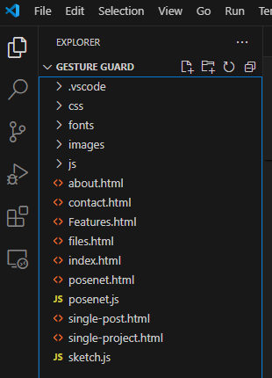

* **index.html:** The main HTML file responsible for the layout and structure of the web application.
* **style.css:** The CSS file containing styles and formatting rules for the web application's visual appearance.
* **script.js:** The JavaScript file containing client-side scripting logic for user interaction and behavior.
* **sketch.js:** A JavaScript file containing code specific to the p5.js library for creative coding.
* **posenet.js:** JavaScript file containing code for integrating the PoseNet model for pose detection.
* **posenet.html:** Additional HTML file for integrating and testing the PoseNet model separately.
* **assets/:** Directory containing various assets such as images, videos, and additional JavaScript libraries used in the project.
  + 1. **Individual Code Files**

Below are screenshots and brief descriptions of the main code files within the Gesture Guard project:

1. **index.html:**

The main HTML file defining the structure of the web application, including elements for image/video upload and result display.

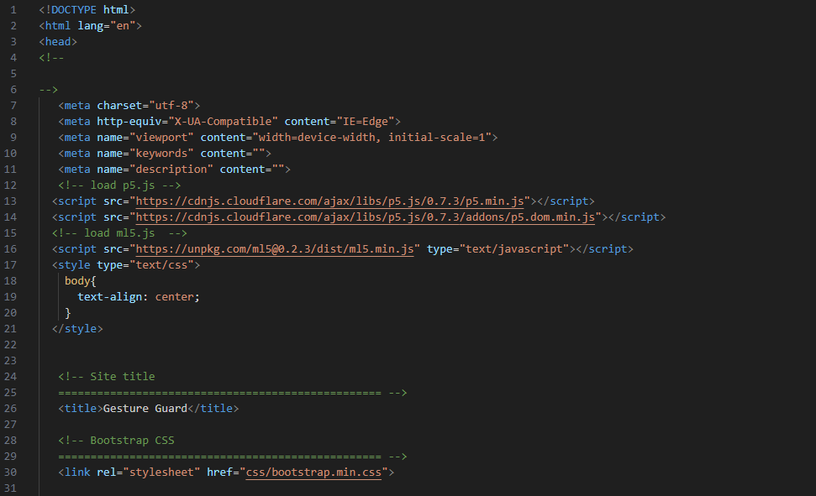**Index.html File and Its Usage in the Gesture Guard Project:**

Figure 3.2 index.html File of Gesture Guard

The `index.html` file serves as the cornerstone of the Gesture Guard web application, providing the foundational structure and layout for the user interface. This HTML file incorporates various elements crucial for the application's functionality, such as the navigation bar, main content area, and footer. It includes sections for image and video upload, which are essential for initiating pose estimation processes. Embedded within the `index.html` file are placeholders for displaying real-time pose detection results, ensuring users can view key points and poses directly on the web page. Furthermore, this file integrates with external CSS and JavaScript files, enabling dynamic interactions and styling. It references the `style.css` for visual design and layout adjustments and `script.js` for handling user inputs, such as file uploads and interactions with the TensorFlow.js models. The `index.html` also features links to additional resources and documentation, facilitating user navigation across different sections of the website.

1. **style.css:**

The CSS file containing styling rules for the visual appearance of the web application, including layout, colors, and typography.

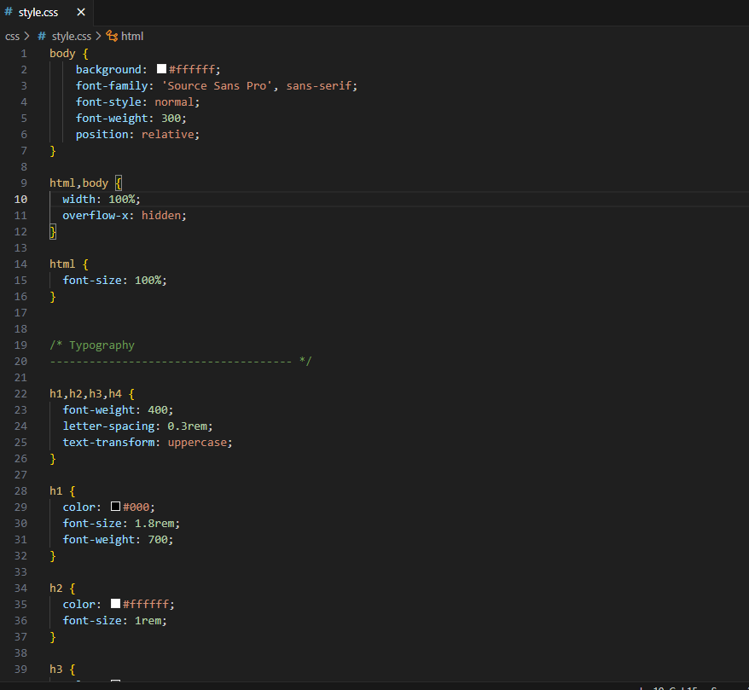

Figure 3.3 style.css File of Gesture Guard

* Visual Layout
* Responsive Design
* Typography
* Color Scheme
* Animation and Transition
* Flexbox and Grid Layouts
* Custom Classes
* Accessibility enhancements
* Integration with JavaScript

The style.css is pivotal in shaping the visual and interactive aspects of the Gesture Guard application insuring a polished and user friendly experience.

1. **script.js:**

The JavaScript file containing client-side scripting logic for user interaction, form handling, and API requests.

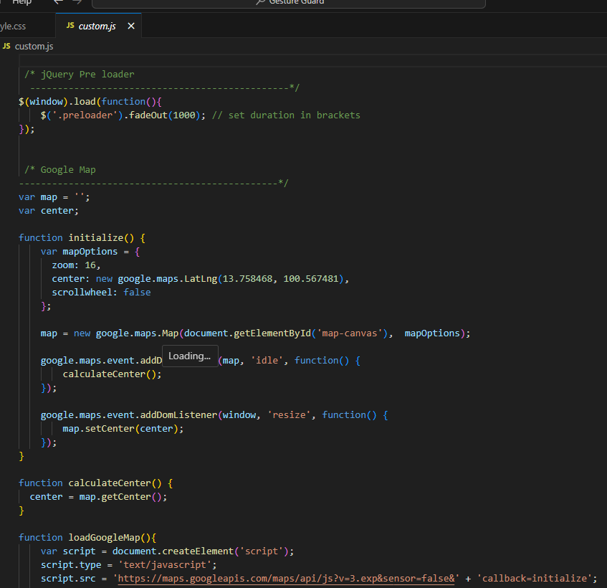

Figure 3.4 script.js File of Gesture Guard

* User interaction handling
* Pose estimation initialization
* File upload processing
* Real time pose detection
* Result visualization
* Modular structure
* Error handling

1. **sketch.js**

A JavaScript file specific to the p5.js library, containing code for creative coding and interactive visuals.

Figure 3.5 sketch.js File of Gesture Guard

* 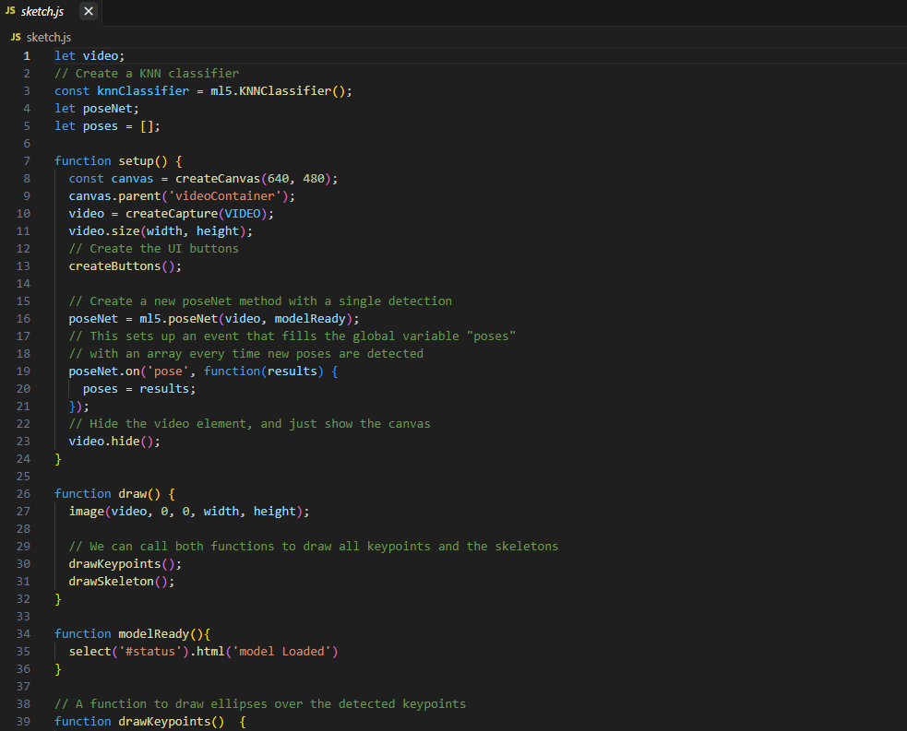Canvas setup
* P5.js integration
* Pose detection rendering
* Real time updates customization options
* Interaction Handling

1. **posenet.js**

JavaScript file containing code for integrating the PoseNet model for real-time pose detection and estimation.

* 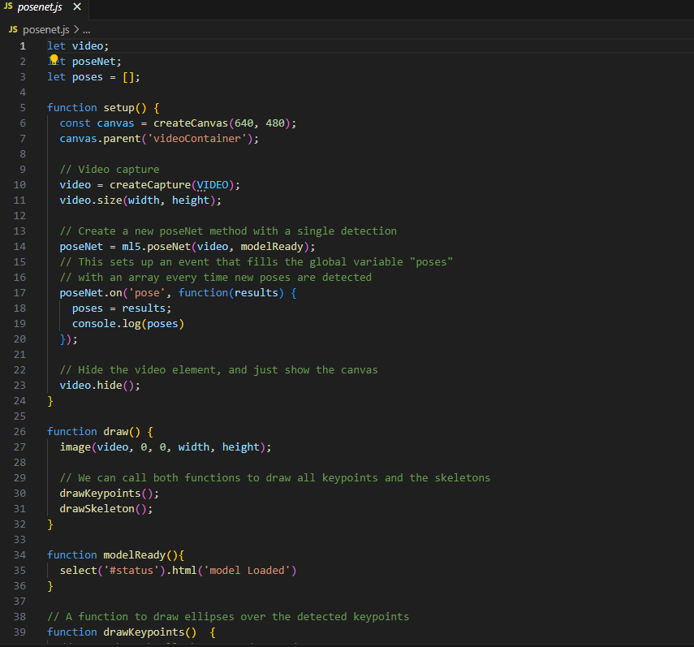Posenet model intergration

Figure 3.6 posenet.js File of Gesture Guard

* Model loading
* Input handling
* Pose estimation handling
* Real time processing
* Data management
* Accuracy optimization

The posenet.js file is critical for enabling the human pose estimation functionality in the Gesture Guard project, leveraging the power of tensorflow.js and the posenet model to provide accurate, real-time pose detection for a variety of applications.

1. **posenet.html**

Additional HTML file for testing and experimenting with the PoseNet model separately from the main application.

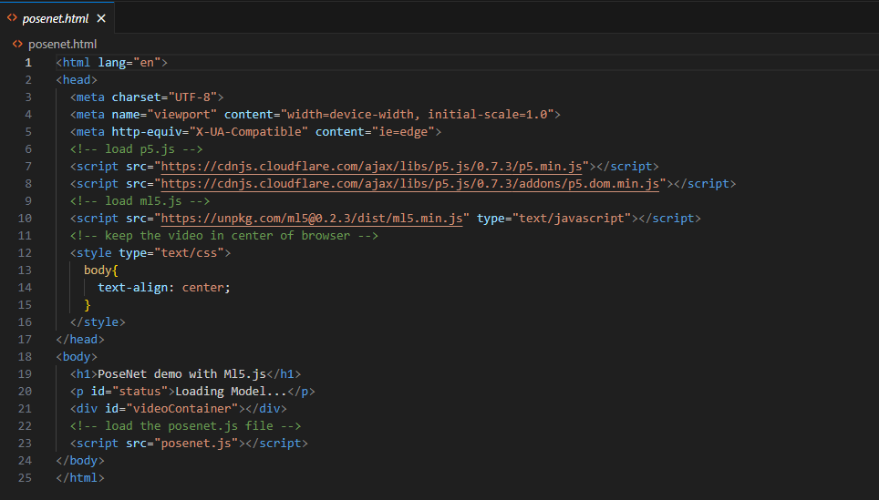

Figure 3.7 posenet.html File of Gesture Guard

Defines the layout of the webpage including sections for displaying the video feed, pose estimation results, and user interface components such as buttons and controls.

* Page layout
* Video feed integration
* Canvas element
* User interface components
* Script linking
* Stylesheet linking
* Model selection
* User instructions
* Live updates
* Accessibility features
* Error messages
* Modular design
* Responsive design
* Debugging information
* Cross browser compatibility

The posenet.html file is essential for setting up the web interface for the pose estimation in the Gesture Guard project, providing the structural foundation and necessary elements to support real-time pose detection and user interaction.

* + 1. **Repository and Source Code**

The Gesture Guard project is hosted on GitHub, providing access to the project's source code, documentation, and development history.

The repository can be found at the following link:

Gesture Guard Live Link - <https://khushichoudhary1020.github.io/gesture-guard-1/>

Gesture Guard Github Repository - <https://github.com/khushichoudhary1020/gesture-guard-1>



Figure 3.9 Github Profile of Developer

Figure 3.8 Github Repository of Gesture Guard

* + 1. **Running File**

Below are screenshots demonstrating the Gesture Guard web application in action:

**Home Page**

The homepage of Gesture Guard, showcasing the pose estimation functionality and user interface elements.



Figure 3.10 Home page of Gesture Guard

**Result Display**

A screenshot demonstrating the result display section of Gesture Guard, showing detected poses and keypoints in real-time.

The Gesture Guard project has yielded impressive results in real-time human pose estimation, demonstrating its potential across various applications. The integration of TensorFlow.js with the PoseNet and BlazePose models has enabled the web application to accurately detect and analyze human poses in real-time directly within a web browser. Users can upload images or videos and receive immediate feedback on detected key points such as elbows, wrists, hips, knees, and ankles. The visual representation of these key points is displayed on the interface, allowing users to see the pose estimation results in an intuitive and interactive manner. Performance optimization ensures smooth operation even on lightweight devices, making Gesture Guard accessible to a wide audience. Initial testing with dance academies has shown that the application can effectively assist in matching dance steps, providing valuable feedback for dancers to improve their performance. Additionally, Gesture Guard's versatility is demonstrated by its applications in fitness tracking, healthcare, and virtual reality. The user-friendly design and robust functionality have garnered positive feedback, highlighting the project's success in merging advanced pose estimation technology with practical, real-world usability.

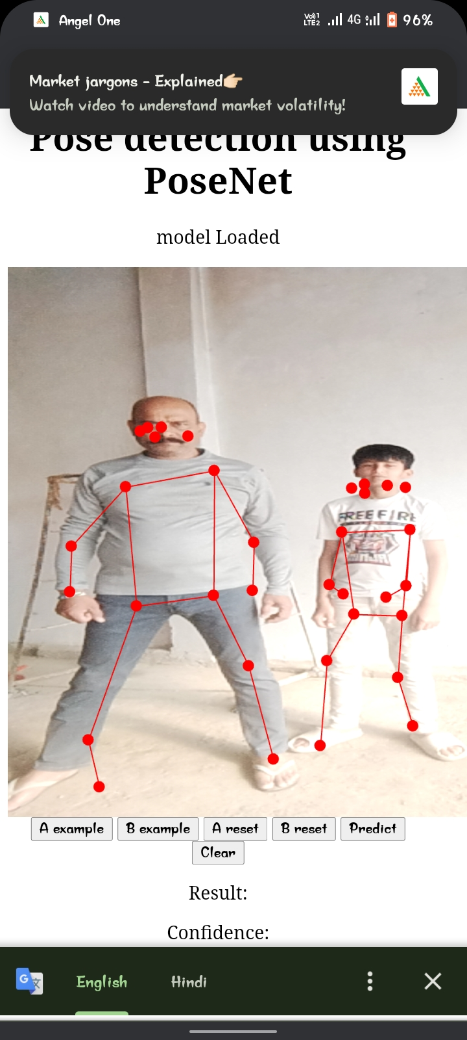

Figure 3.11 Results

We explored the code files, file structure, repository, and running file of the Gesture Guard project. By providing insights into the project's organization, individual code files, and access to the source code repository, developers and enthusiasts can gain a deeper understanding of Gesture Guard's implementation and contribute to its development.

## **Working**

Gesture Guard is an innovative web application designed to integrate human pose estimation technology into a user-friendly interface. The project aims to leverage the capabilities of pose detection models, such as MoveNet, BlazePose, and PoseNet, to provide real-time analysis of human body poses through a web browser. By hosting the application on GitHub and utilizing web technologies such as HTML, CSS, JavaScript, and TensorFlow.js, Gesture Guard offers a seamless and accessible platform for users to interact with pose detection algorithms.

## **Accessing Gesture Guard**

Users can access Gesture Guard by navigating to the project's web application hosted on GitHub Pages. The homepage welcomes users with the Gesture Guard logo and provides intuitive navigation to various sections of the application. Users can upload images or videos containing human subjects directly from the homepage to initiate pose detection.



**Website Guide**

Gesture Guard features a comprehensive website guide to assist users in navigating the application's functionalities. The guide offers step-by-step instructions, tooltips, and help documentation to ensure a smooth user experience. Whether users are new to pose estimation technology or experienced developers, the website guide provides valuable assistance in using Gesture Guard effectively.

## **Functionalities of Gesture Guard**

1. **Human Pose Estimation**

Gesture Guard's primary functionality is human pose estimation, powered by state-of-the-art pose detection models. Users can upload images or videos containing human subjects, and the application will analyze the input data to detect key body poses, joints, and movements in real-time. This functionality is useful for various applications, including fitness tracking, dance choreography analysis, and gesture recognition.

1. **Presentation of the Project**

The Gesture Guard website serves as a platform for presenting the project to a wider audience. Users can learn about the project's objectives, methodologies, and potential applications through engaging visuals, informative content, and interactive elements. The presentation section highlights Gesture Guard's contributions to the field of human-computer interaction and showcases its impact on various industries.

1. **Research Paper of the Project**

For users interested in delving deeper into the technical aspects of Gesture Guard, the website offers access to the project's research paper. The research paper provides an in-depth analysis of the project's algorithms, experimental results, and conclusions. It explores the theoretical foundations of pose estimation technology and discusses practical implementations within Gesture Guard.

1. **Source Code of the Project**

Gesture Guard embraces open-source principles by making its source code freely available to the public. Users can explore, download, and contribute to the development of Gesture Guard by accessing the project's source code repository on GitHub. The source code repository contains all project-related files, including datasets, models, documentation, and code implementations.

## **Website Pages**

1. **Home Page**

The home page serves as the central hub of Gesture Guard, providing users with quick access to the application's core functionalities. Users can upload images or videos for pose estimation directly from the home page and view real-time results. The home page also includes links to other sections of the website for further exploration.

1. **About Page**

The About page offers insights into the background and objectives of Gesture Guard. Users can learn about the inspiration behind the project, the development team, and the project's impact on the community. The About page also highlights the project's name, logo, and branding elements, providing users with a comprehensive understanding of Gesture Guard's identity.

1. **Files Page**

The Files page serves as a repository for all project-related files, including datasets, models, documentation, and code implementations. Users can download these files for offline access or further exploration. The Files page provides valuable resources for developers, researchers, and enthusiasts interested in exploring Gesture Guard's inner workings.

1. **Contact Page**

The Contact page provides users with a direct line of communication to the Gesture Guard development team. Users can reach out via a contact form to provide feedback, suggestions, or inquiries about the project. Additionally, the Contact page includes links to the development team's social media profiles, fostering community engagement and collaboration.

Gesture Guard represents a significant advancement in the field of human pose estimation, offering a powerful and accessible platform for users to interact with pose detection technology. By integrating state-of-the-art pose detection models into a user-friendly web application, Gesture Guard empowers users to explore the possibilities of gesture-based computing in various domains. With its intuitive interface, comprehensive features, and open-source ethos, Gesture Guard is poised to make a lasting impact on the future of human-computer interaction.

* 1. **Basic Structure:**

Human pose estimation involves detecting and locating key points or landmarks on a human body in an image or video. These key points typically include joints such as elbows, wrists, shoulders, knees, and ankles. The basic structure of human pose estimation involves the following steps:

1. **Input Image/Video**: The process begins with an input image or video frame containing one or more human subjects.
2. **Pre-processing**: Before performing pose estimation, the input data may undergo pre-processing steps such as resizing, normalization, or background removal to enhance the quality of the image and improve model performance.
3. **Pose Estimation**: The core task of pose estimation involves detecting and localizing key points on the human body. This is typically achieved using computer vision techniques and machine learning models.
4. **Output Visualization**: Once the key points are detected, they are often visualized on the input image or video frame as landmarks or skeletal structures representing the estimated pose.
   1. **Model Architecture:**

Several model architectures have been developed for human pose estimation, ranging from classical computer vision methods to deep learning-based approaches. The choice of model architecture depends on factors such as accuracy requirements, computational resources, and real-time performance. Some common model architectures include:

1. **Convolutional Neural Networks (CNNs):** CNNs are widely used in human pose estimation due to their ability to learn hierarchical features directly from image data. They typically consist of multiple convolutional layers followed by pooling layers for feature extraction.
2. **Hourglass Networks:** Hourglass networks are a type of CNN architecture designed specifically for human pose estimation. They employ a multi-stage, symmetric architecture with repeated bottom-up and top-down processing to capture both local and global context.
3. **Graph Convolutional Networks (GCNs)**: GCNs model the spatial relationships between body joints as a graph structure, where nodes represent joints and edges represent connections between them. This approach explicitly captures dependencies between joints and improves pose estimation accuracy.



Figure 4.1 Home page of Gesture Guard



Figure 4.1 Home page of Gesture Guard

* 1. **Approaches for Human Pose Estimation:**

Several approaches and techniques are used in human pose estimation to improve accuracy, robustness, and efficiency. Some common approaches include:

1. **Single-Person vs. Multi-Person Pose Estimation:** Pose estimation can be performed either on individual subjects (single-person pose estimation) or on multiple subjects simultaneously (multi-person pose estimation). Multi-person pose estimation is more challenging due to potential occlusions and interactions between individuals.
2. **Top-Down vs. Bottom-Up Approaches:** In top-down approaches, the image is first segmented into individual human instances, and pose estimation is performed separately on each instance. In bottom-up approaches, all body joints are detected in a single step, and then grouped into poses.
3. **Heatmap Regression vs. Direct Regression:** Heatmap regression methods predict the likelihood of each pixel belonging to a specific body joint using heatmaps, while direct regression methods directly regress the coordinates of body joints from image features.
   1. **Applications of Human Pose Estimation**

Human pose estimation has a wide range of applications across various fields due to its ability to detect and track human body poses in images or videos. Some key applications include:

1. **Action Recognition:** Pose estimation is used in action recognition systems to identify and classify human actions based on the detected poses. This has applications in video surveillance, sports analysis, and human-computer interaction.
2. **Fitness Tracking and Exercise Monitoring:** Pose estimation can be used in fitness tracking applications to monitor exercise performance, provide real-time feedback on form and technique, and track progress over time. This is particularly useful for virtual fitness coaching and home workout programs.
3. **Gaming and Virtual Reality:** Pose estimation is used in gaming and virtual reality (VR) applications to enable more immersive and interactive experiences. It allows users to control avatars or characters in virtual environments using body movements and gestures, enhancing gameplay and user engagement.
4. **Gesture Recognition:** Pose estimation can be used to recognize and interpret hand gestures and body movements, enabling hands-free interaction with devices and systems. This has applications in augmented reality (AR), virtual reality (VR), sign language recognition, and human-computer interfaces.
5. **Healthcare and Rehabilitation:** Pose estimation is used in healthcare for applications such as gait analysis, posture assessment, and rehabilitation monitoring. It can help healthcare professionals track patient progress, assess movement disorders, and design personalized treatment plans.
6. **Biomechanics and Sports Science:** Pose estimation is used in biomechanics research and sports science to analyse human movement patterns, assess athletic performance, and prevent injuries. It provides valuable insights into factors such as joint angles, muscle activation, and energy expenditure during physical activities.
7. **Human-Robot Interaction:** Pose estimation is used in robotics to enable robots to perceive and respond to human body language and gestures. It allows robots to understand human intentions, follow gestures, and interact naturally with humans in shared spaces.
8. **Artificial Intelligence and Robotics:** Pose estimation is used in artificial intelligence (AI) and robotics for applications such as object manipulation, grasping, and navigation. It enables robots to understand and interact with the physical world more effectively, leading to advancements in autonomous systems and robotic automation.

## **Results**

The outcome of the human pose estimation project would be the accurate detection and visualization of human poses in real-time within the web browser. Users would be able to interact with the web application by uploading images or accessing the webcam to capture video frames, and the application would detect and display the poses of individuals present in the images or video.

Here are some specific aspects of the result:

1. **Pose Detection Accuracy:** The project aims to accurately detect and localize key points on the human body, such as joints like elbows, wrists, shoulders, knees, and ankles. The detected poses should closely match the actual poses of individuals in the images or video frames.
2. **Real-time Performance:** The pose estimation process should be performed in real-time, with minimal latency between capturing input data and displaying the detected poses. This ensures a smooth and responsive user experience, allowing users to interact with the application seamlessly.
3. **Visualization:** The detected poses are visualized on the input images or video frames using graphical overlays or skeletal structures. Each key point on the human body is represented by a marker or line, allowing users to easily identify and interpret the estimated poses.
4. **Robustness:** The project should be robust to variations in pose, lighting conditions, backgrounds, and the number of individuals present in the images or video frames. It should consistently deliver accurate pose estimations across different scenarios and environments.
5. **User Interaction:** Users can interact with the web application by uploading images, accessing the webcam, or adjusting settings to customize the pose estimation process. The application provides instant feedback to users, updating the visualization dynamically as new poses are detected.
6. **Cross-platform Compatibility:** The web application should be compatible with a wide range of web browsers and devices, including desktop computers, laptops, tablets, and smartphones. This ensures that users can access the application conveniently from any device with internet connectivity.

Overall, the result of the human pose estimation project is a user-friendly and versatile web application that enables users to accurately detect and visualize human poses in real-time, leveraging the power of HTML, CSS, JavaScript, and TensorFlow with frameworks like BlazePose and PoseNet.

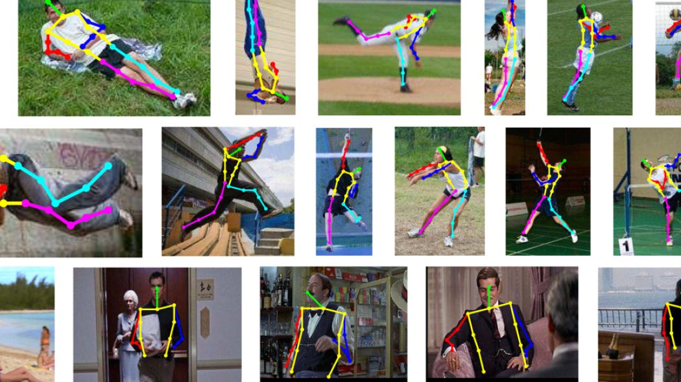

Figure 5.1 Human Pose Estimation Results

## **Conclusion**

Pose estimation systems have advanced tremendously thanks to developments in deep learning, machine learning, and computer vision. The field has made great strides in successfully detecting human poses in a variety of circumstances, from early techniques based on handmade features to more recent methods employing deep neural networks.

Though there have been improvements, a number of issues still need to be resolved, such as resilience to occlusions, viewpoint alterations, and real-time processing requirements. Innovative approaches including data augmentation, multi-view fusion, and the creation of effective network topologies are needed to address these problems.

Pose estimation systems are used in many different fields, such as sports analytics, healthcare, security, and entertainment. Among other applications, these systems are essential for security surveillance, gesture recognition, patient monitoring, and human activity recognition.

In conclusion, the human pose estimation project represents a significant achievement in leveraging modern web technologies and machine learning frameworks to enable real-time detection and visualization of human poses directly within the web browser. Through the integration of HTML, CSS, JavaScript, and Tensor Flow with frameworks like Blaze Pose and Pose Net, the project has demonstrated the feasibility and effectiveness of performing complex computer vision tasks in a web-based environment.

Moreover, the project's versatility extends beyond mere pose estimation, with potential applications ranging from sports analysis and fitness tracking to augmented reality and healthcare. The ability to accurately track human poses opens up a wide range of possibilities for enhancing user experiences, improving safety measures, and advancing research in various domains.

In summary, the human pose estimation project represents a testament to the ingenuity and potential of web-based computer vision technologies. By bridging the gap between cutting-edge machine learning research and user-friendly web applications, the project opens up exciting opportunities for empowering users and advancing the capabilities of web-based systems.

## **Reference**

* Cao, Zhe, et al. "Realtime multi-person 2d pose estimation using part affinity fields." Proceedings of the IEEE Conference on Computer Vision and Pattern Recognition. 2017.
* Newell, A., Yang, K., & Deng, J. (2016). "Stacked Hourglass Networks for Human Pose Estimation."
* Papandreou, G., Zhu, T., Chen, L. C., Gidaris, S., Tompson, J., & Murphy, K. (2018). "PersonLab: Person Pose Estimation and Instance Segmentation with a Bottom-Up, Part-Based, Geometric Embedding Model."
* Xiao, B., Wu, H., & Wei, Y. (2018). "Simple Baselines for Human Pose Estimation and Tracking."
* Sun, K., Xiao, B., Liu, D., & Wang, J. (2019). "Deep High-Resolution Representation Learning for Human Pose Estimation."
* Andriluka, M., Pishchulin, L., Gehler, P., & Schiele, B. (2014). "2D Human Pose Estimation: New Benchmark and State of the Art Analysis."