MINOR PROJECT FILE

**DATA ANALYSIS WITH EXCEL**

**TOPIC- DATA ANALYSIS OF NATIONAL HISTORY OF COVID-19**



**KANYA MAHA VIDYALAYA**

**SUBMITTED BY: - SUBMITTED TO:-**

**KHUSHI MS. AMANDEEP KAUR**

**B.VOC.ARTIFICIAL INTELLIGENCE**

**AND DATA SCIENCE**

**ABSTRACT**

The outbreak of corona virus disease 2019(covid-19), caused by severe acute respiratory syndrome (SARS) corona virus 2 (SARS-CoV-2), has thus far killed over 3,000 people and infected over 80000 in china and elsewhere in the world, resulting in catastrophe for humans. Similar to its homologous virus, SARS-CoV, which caused SARS in thousands of people in 2003, SARS-CoV-2 might also be transmitted from the bats and causes similar symptoms through similar mechanism. However,COVID-19 has lower severity and mortality than SARS but is much more contagious and affects more elderly individuals than youth and more men than women. In response to the rapidly increasing number of researches on the emerging disease, this project attempts to provide a timely comprehensive review of the rapidly developing research subject. I will cover the basics about the epidemiology, virology, diagnosis, treatment, prognosis and prevention of the disease. Although many questions still require answers, I hope that this project helps in the understanding and eradication of the threatening disease.

**TABLE OF CONTENTS**

1. **INTRODUCTION**
   1. **DATA ANALYSIS – MS EXCEL**
   2. Conditional formatting
   3. Text to columns
   4. Remove duplicates
   5. Consolidate
   6. Data validation
   7. **PIVOT TABLE**
2. Insert a pivot table
3. Drag fields
4. Sort
5. Filter
6. Change summary calculations
7. Two-dimensional Pivot Table
   1. **PIVOT CHART**
8. Insert pivot chart
9. Filter pivot chart
10. Change pivot chart
    1. **WHATIF ANALYSIS**
11. Scenario Manager
12. Goal and Seek
13. Data Table
14. **DATA ANALYSIS OF NATIONAL HISTORY OF COVID-19**
    1. Govt’s total expense on covid-19 testing
    2. Maximum and minimum covid-19 cases graphical representation
    3. Holi and dussera analysis(which impacted more)
    4. First day of lockdown24march v/s last day of lockdown14 april
    5. Day with maximum and minimum death reports
15. **WHAT IF ANALYSIS**

3.1. Scenario manager

3.2. Goal seek

3.3 Data table

# INTRODUCTION

* 1. **DATA ANALYSIS IN MS EXCEL**
  2. **CONDITIONAL FORMATTING**

### Highlight Cells Rules

To highlight cells that are greater than a value, execute the following steps.

1. Select the range A1:A10.

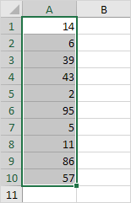

2. On the Home tab, in the Styles group, click Conditional Formatting.

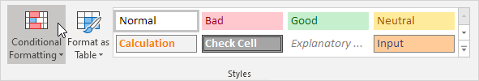

3. Click Highlight Cells Rules, Greater Than.

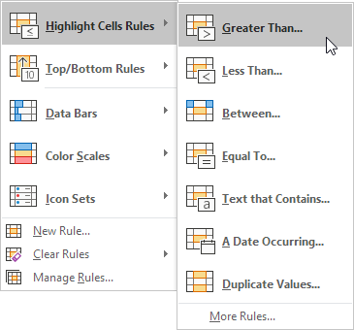

4. Enter the value 80 and select a formatting style.

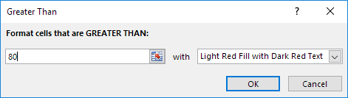

5. Click OK.

Result. Excel highlights the cells that are greater than 80.

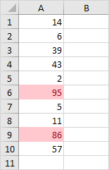

6. Change the value of cell A1 to 81.

Result. Excel changes the format of cell A1 automatically.

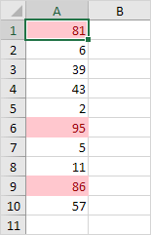

### Clear Rules

To clear a conditional formatting rule, execute the following steps.

1. Select the range A1:A10.

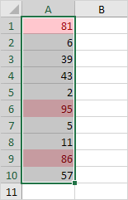

2. On the Home tab, in the Styles group, click Conditional Formatting.



3. Click Clear Rules, Clear Rules from Selected Cells.

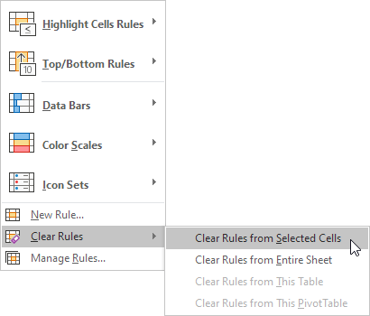

3. Click Clear Rules, Clear Rules from Selected Cells.

### Top/Bottom Rules

To highlight cells that are above average, execute the following steps.

1. Select the range A1:A10.

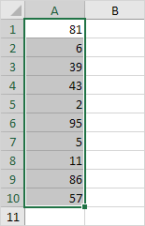

2. On the Home tab, in the Styles group, click Conditional Formatting.



3. Click Top/Bottom Rules, Above Average.

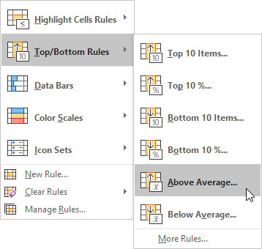

4. Select a formatting style.

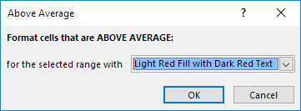

5. Click OK.

Result. Excel calculates the average (42.5) and formats the cells that are above this average.

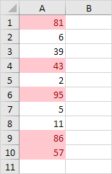

* 1. **TEXT TO COLUMNS**

Text to Columns is a feature in Excel that parses the text in one cell/column into many columns using a delimiter than can be adjusted. You can find the Text to Columns button on the Data tab of the ribbon, in the Data Tools group.

To separate the contents of one Excel cell into separate columns, you can use the 'Convert Text to Columns Wizard'. For example, when you want to separate a list of full names into last and first names.

1. Select the range with full names.

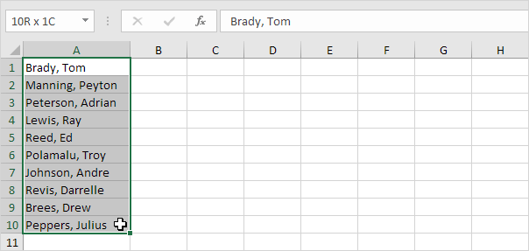

2. On the Data tab, in the Data Tools group, click Text to Columns.



The following dialog box appears.

3. Choose Delimited and click Next.

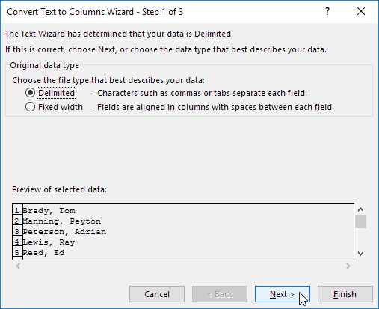

4. Clear all the check boxes under Delimiters except for the Comma and Space check box.

5. Click Finish.

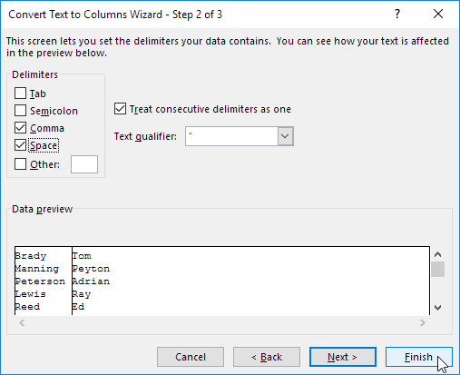

Result:

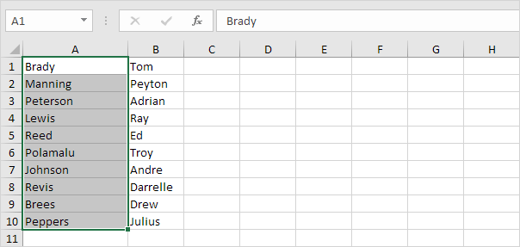

* 1. **REMOVE DUPLICATES**

When you remove duplicate values, the only effect is on the values in the range of cells or table. Other values outside the range of cells or table will not change or move. When duplicates are removed, the first occurrence of the value in the list is kept, but other identical values are deleted.

Sometimes duplicate data is useful, sometimes it just makes it harder to understand your data. Use conditional formatting to find and highlight duplicate data. That way you can review the duplicates and decide if you want to remove them.

1. Select the cells you want to check for duplicates.

Note: Excel can’t highlight duplicates in the Values area of a PivotTable report.

1. Click Home > Conditional Formatting > Highlight Cells Rules > Duplicate Values.

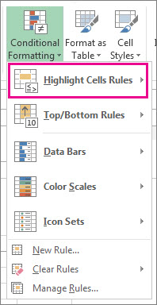

1. In the box next to values with, pick the formatting you want to apply to the duplicate values, and then click OK.

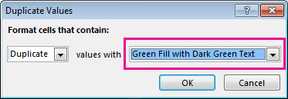

Remove duplicate values

When you use the Remove Duplicates feature, the duplicate data will be permanently deleted. Before you delete the duplicates, it’s a good idea to [copy the original data](https://support.microsoft.com/en-us/office/move-or-copy-cells-and-cell-contents-803d65eb-6a3e-4534-8c6f-ff12d1c4139e) to another worksheet so you don’t accidentally lose any information.

1. Select the range of cells that has duplicate values you want to remove.
2. Click Data > Remove Duplicates, and then Under Columns, check or uncheck the columns where you want to remove the duplicates.

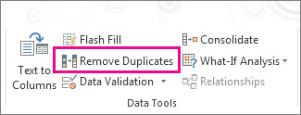

For example, in this worksheet, the January column has price information I want to keep.

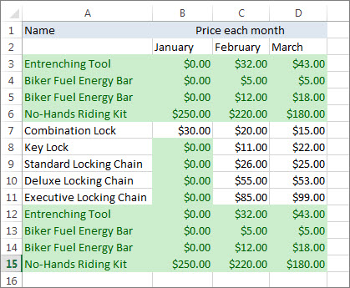

So, I unchecked January in the Remove Duplicates box.

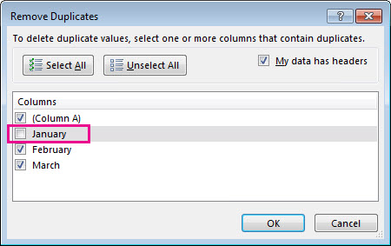

1. Click OK .
   1. **CONSOLIDATE**

To summarize and report results from separate worksheets, you can consolidate data from each sheet into a master worksheet. The sheets can be in the same workbook as the master worksheet, or in other workbooks. When you consolidate data, you assemble data so that you can more easily update and aggregate as necessary.

As you can see, the worksheets are not identical. However, the beauty of the Consolidate feature is that it can easily sum, count, average, etc this data by looking at the labels. This is a lot easier than creating formulas.

1. Open all three workbooks.

2. Open a blank workbook. On the Data tab, in the Data Tools group, click Consolidate.



3. Choose the Sum function to sum the data.

4. Click in the Reference box, select the range A1:E4 in the district1 workbook, and click Add.

5. Repeat step 4 for the district2 and district3 workbook.

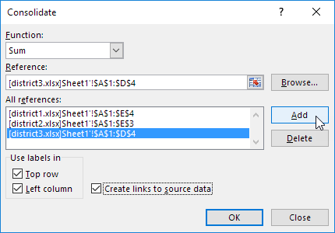

6. Check Top row, Left column and Create links to source data.

7. Click OK.

Result.

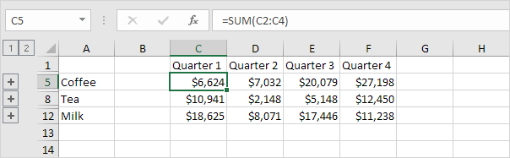

* 1. **DATA VALIDATION**

Excel data validation is a feature that allows you to control the type of data entered into your worksheet. For example, Excel data validation allows you **to** limit data entries to a selection from a dropdown list and to restrict certain data entries, such as dates or numbers outside of a predetermined range**.**

* 1. **PIVOT TABLE**

Pivot tables are one of Excel's most powerful features. A pivot table allows you to extract the significance from a large, detailed data set.

Our data set consists of 213 records and 6 fields. Order ID, Product, Category, Amount, Date and Country.

### Insert a Pivot Table

To insert a pivot table, execute the following steps.

1. Click any single cell inside the data set.

2. On the Insert tab, in the Tables group, click PivotTable.

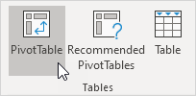

The following dialog box appears. Excel automatically selects the data for you. The default location for a new pivot table is New Worksheet.

3. Click OK.

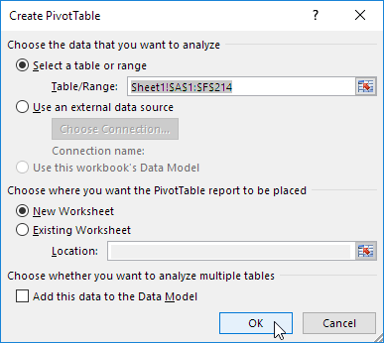

### Drag fields

The PivotTable Fields pane appears. To get the total amount exported of each product, drag the following fields to the different areas.

1. Product field to the Rows area.

2. Amount field to the Values area.

3. Country field to the Filters area.

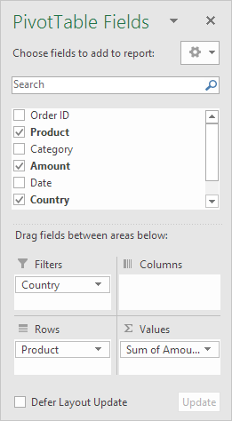

Below you can find the pivot table. Bananas are our main export product. That's how easy pivot tables can be!

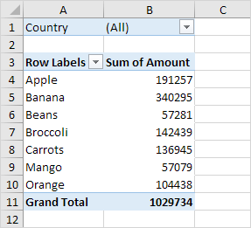

### Sort

To get Banana at the top of the list, sort the pivot table.

1. Click any cell inside the Sum of Amount column.

2. Right click and click on Sort, Sort Largest to Smallest.

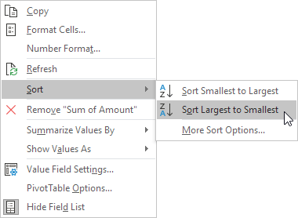

**Result**

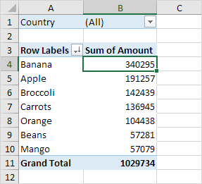.

### Filter

Because we added the Country field to the Filters area, we can filter this pivot table by Country. For example, which products do we export the most to France?

1. Click the filter drop-down and select France.

Result. Apples are our main export product to France.

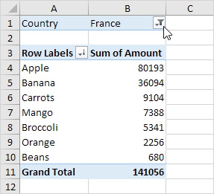

Note: you can use the standard filter (triangle next to Row Labels) to only show the amounts of specific products.

### Change Summary Calculation

By default, Excel summarizes your data by either summing or counting the items. To change the type of calculation that you want to use, execute the following steps.

1. Click any cell inside the Sum of Amount column.

2. Right click and click on Value Field Settings.

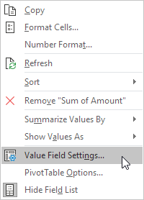

3.Choose the type of calculation you want to use. For example, click Count.

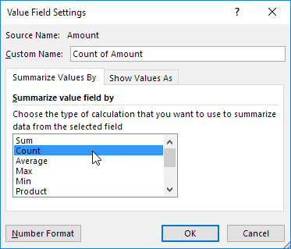

4. Click OK.

Result. 16 out of the 28 orders to France were 'Apple' orders.

### Two-dimensional Pivot Table

If you drag a field to the Rows area and Columns area, you can create a two-dimensional pivot table. First, [insert a pivot table](https://www.excel-easy.com/data-analysis/pivot-tables.html#insert-pivot-table). Next, to get the total amount exported to each country, of each product, drag the following fields to the different areas.

1. Country field to the Rows area.

2. Product field to the Columns area.

3. Amount field to the Values area.

4. Category field to the Filters area.

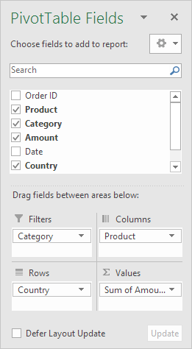

Below you can find the two-dimensional pivot table.

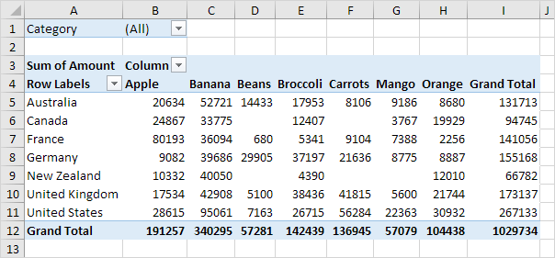

* 1. **PIVOT CHART**

A pivot chart is the visual representation of a pivot table in Excel. Pivot charts and pivot tables are connected with each other.

Below you can find a two-dimensional pivot table. Go back to [Pivot Tables](https://www.excel-easy.com/data-analysis/pivot-tables.html#two-dimensional-pivot-table) to learn how to create this pivot table.



### Insert Pivot Chart

To insert a pivot chart, execute the following steps.

1. Click any cell inside the pivot table.

2. On the Analyze tab, in the Tools group, click PivotChart.

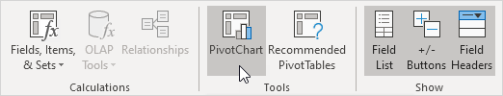

The Insert Chart dialog box appears.

3. Click OK.

To easily compare these numbers, create a [pivot chart](https://www.excel-easy.com/examples/pivot-chart.html) and apply a filter. Maybe this is one step too far for you at this stage, but it shows you one of the many other powerful pivot table features Excel has to offer.

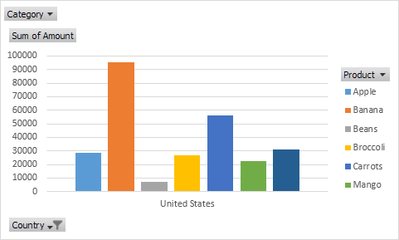

### Filter Pivot Chart

To filter this pivot chart, execute the following steps.

1. Use the standard filters (triangles next to Product and Country). For example, use the Country filter to only show the total amount of each product exported to the United States.

2. Remove the Country filter.

3. Because we added the Category field to the Filters area, we can filter this pivot chart (and pivot table) by Category. For example, use the Category filter to only show the vegetables exported to each country

1. **Change Pivot Chart Type**

You can change to a different type of pivot chart at any time.

Note: pie charts always use one data series (in this case, Beans). To get a pivot chart of a country, swap the data over the axis. First, select the chart. Next, on the Design tab, in the Data group, click Switch Row/Column.

* 1. **WHATIF ANALYSIS**

In Excel, What-if analysis is a process of changing cells' values to see how those changes will affect the worksheet's outcome. You can use several different sets of values to explore all the different results in one or more formulas. What-if Excel is used by almost every data analyst and especially middle to higher management professionals to make better, faster and more accurate decisions based on data. What-if analysis is useful in many situations, such as:

* You can propose different budgets based on revenue.
* You can predict the future values based on the given historical values.
* If you expect a certain value due to a formula, you can find different sets of input values that produce the desired result.

To enable the what-if analysis tool go to the Data menu tab and click on the What-If Analysis option under the Forecast section.

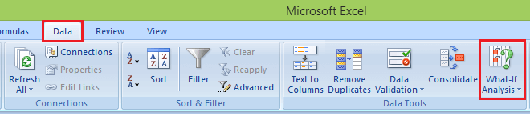

Now click on the What-If Analysis. [Excel](https://www.javatpoint.com/excel-tutorial) has the following What-if analysis tools that can be used based on the data analysis needs:

1. Scenario Manager
2. Goal and Seek
3. Data Table
   * + 1. **Scenario Manager**

Scenario Manager is one of the What-if Analysis tools in Excel. Scenario Manager is useful in a case where you have more than two variables in the sensitivity analysis. Scenario Manager creates scenarios for each set of the input values for the variables under consideration. A scenario is a set of values that Excel saves and can substitute automatically in cells on a worksheet. Below are the following key features, such as:

* You can create and save different groups of values on a worksheet and then switch to any of these new scenarios to view different results.
* A scenario can have multiple variables, but it can accommodate only up to 32 values.
* You can also create a scenario summary report, which combines all the scenarios on one worksheet. For example, you can create several different budget scenarios that compare various possible income levels and expenses, and then create a report that lets you compare the scenarios side-by-side.
* Scenario Manager is a dialog box that allows you to save the values as a scenario and name the scenario.
* Goal and Seek
  + - 1. **Goal and Seek**

Goal Seek is a What-If Analysis tool that helps you to find the input value that results in a target value that you want. Goal Seek requires a formula that uses the input value to give the result in the target value. Then, by varying the formula's input value, Goal Seek tries to solve the input value. Goal Seek is useful if you want to know the formula's result but unsure what input value the formula needs to get that result. For example, if you want to borrow a loan and know the loan amount, tenure of loan and the EMI that you can pay, you can use Goal Seek to find the interest rate at which you can avail of the loan. Goal Seek can be used only with one variable input value. If you have more than one variable for input values, you can use the Solver add-in.

* + - 1. **Data Table**

With a Data Table in Excel, you can easily vary one or two inputs and perform a What-if analysis. A Data Table is a range of cells where you can change values in some of the cells and answer different answers to a problem. A Data Table is a range of cells where you can change values in some of the cells and answer different answers to a problem. For example, you might want to know how much loan you can afford for a home by analyzing different loan amounts and interest rates. You can put these different values and the PMT function in a Data Table and get the desired result.

# ANALYSIS OF COVID-19 DATA USING PIVOT TABLES AND CHARTS

The novel coronavirus (COVID-19) was widely reported to have first been detected in Wuhan (Hebei province, China) in December 2019. After the initial outbreak, COVID-19 continued to spread to all provinces in China and very quickly spread to other countries within and outside of Asia. At present, over 45 million cases of infected individuals have been confirmed in over 180 countries with in excess of 1 million deaths. Although the foundations of this disease are very similar to the severe acute respiratory syndrome (SARS) virus that took hold of Asia in 2003.

As the number of cases of infected individuals has risen rapidly, there has been an increase in pressure on medical services as healthcare providers seek to test and diagnose infected individuals, in addition to the normal load of medical services that are offered in general. In many cases, trying to control COVID-19 has led to a backlog for and deprivation of other medical procedures, with healthcare providers needing to find a balance between the two. note that this conflict may change the nature of healthcare with public and private health sectors working together more often. The implementation of restrictions on the movement of individuals has also led to many suggesting that anxiety and distress may lead to increased psychiatric disorders. These may be related to suicidal behaviour and morbidity and may have a long-term negative impact on the mental health of individuals .

As as a result of this on going pandemic, new results and reports are being produced and published daily. Thus, our motivation stems from wanting to contribute to the statistical analysis of the incidence of COVID-19 in Italy and Spain, where the literature is limited. The main contributions of this paper are:

i) To model the incidence of COVID-19 in Italy and Spain using simple data analysis with excel.

Here’s the real data of covid-19 from 2020-01-13 to 2021-03-07 in INDIA.

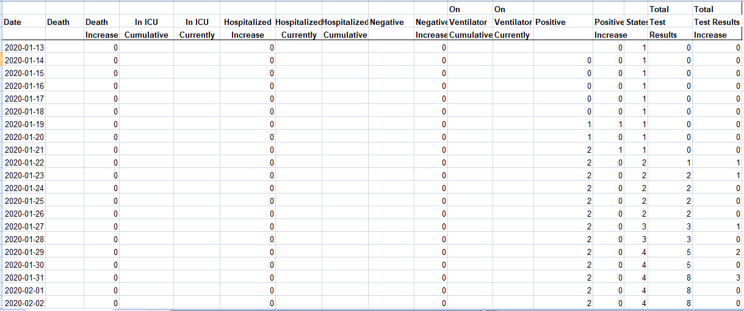

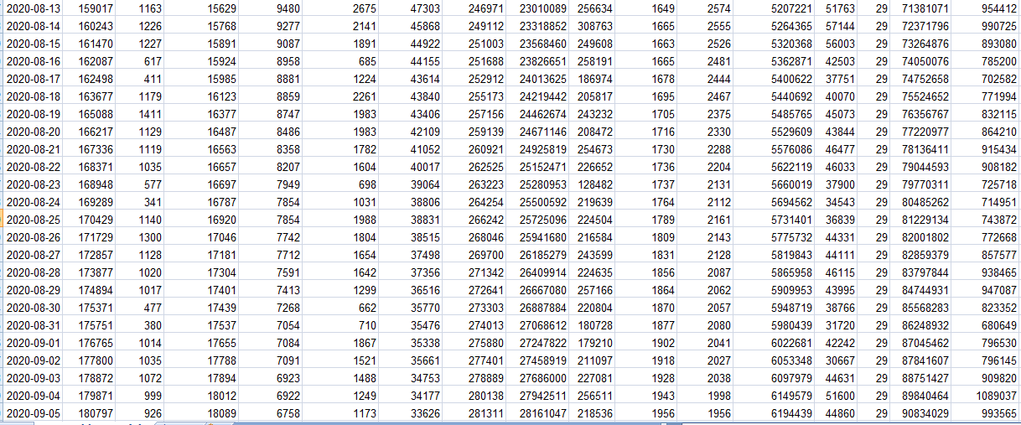

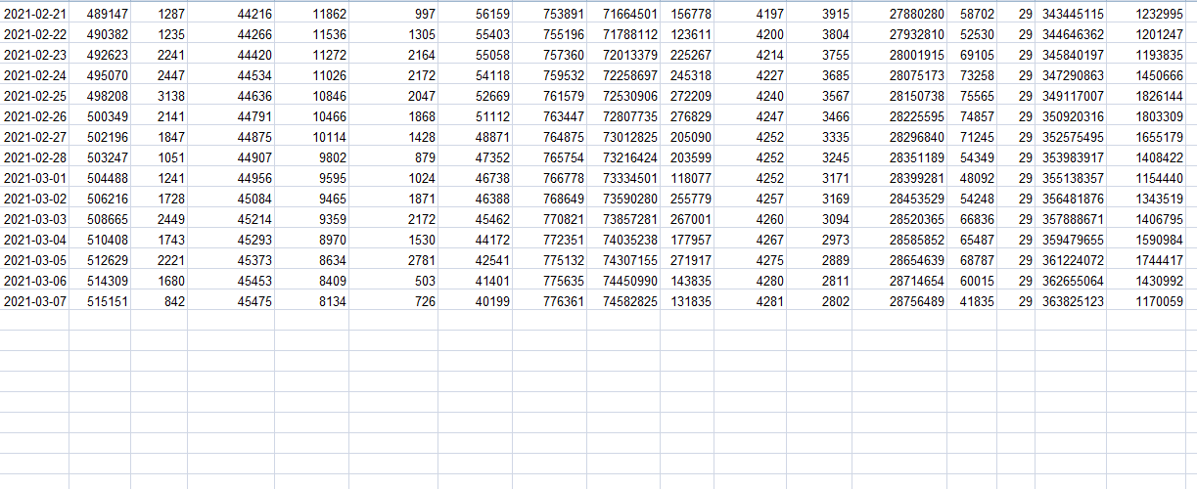

* 1. **GOVT.’s TOTAL EXPENSE IN COVID-19 TESTING**

Confirmation of an active SARS-CoV-2 infection (the virus that causes COVID-19) is done via [tests](https://www.fda.gov/consumers/consumer-updates/coronavirus-testing-basics) that use molecular “PCR” amplification and antigen-based lab technology. Data from 93 hospitals with listed prices yielded 203 distinct prices for diagnostic tests. The price of diagnostic tests can vary based on the type of test performed, where it is processed, the manufacturer, and CDC affiliation.

Now we will analyse the national history of COVID-19 and will ensure how much does govt had spent in this pandemic situation. We all know that this is not only the expense which should be counted, but there is further some more new and unknown expenses.

Here we are just calculating that approximately how much was the expenditure.

So the cost of one testing kit is ₹ 250.00

On the very first day 2020-01-13 there was not even a single case in INDIA. But now till end of March there were 36lakhs testing and 11lakh COVID-19 cases. Daily there were free testing of COVID-19 from govt.’s side.

1. **TOTAL TESTING KITS ON DAILY BASIS**

For calculating total number of testing kits used, we need to check how many testing kits are increasing day by day. By calculating the cumulative testing we can get the exact data.

So we have used **SUM** function for analysing how many testing kits are used till now.

Nation history of COVID-19(testing) data is from cell Q4 to Q423.

By applying **=SUM(Q4:Q423)** function, we have got **363825123 testing kits used till**

**7-march.**

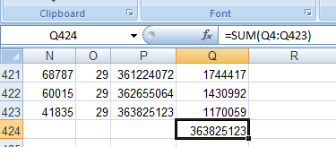

Figure total number of testing kits used

* 1. **MAXIMUM AND MINIMUM COVID-19 CASES GRAPHICAL REPRESENTATION**

1. **THE DAY WITH MAXIMUM NUMBER OF CASES EVER**

Reuters is collecting daily COVID-19 infections and deaths data for 240 countries and territories around the world, updated regularly throughout each day.

Every country reports those figures a little differently and, inevitably, misses undiagnosed infections and deaths. With this project we are focusing on the trends within countries as they try to contain the virus’ spread, whether they are approaching or past peak infection rates, or if they are seeing a resurgence of infections or deaths.

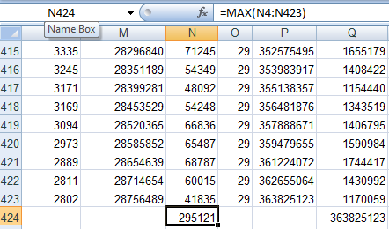

As we know covid-19 was increasing day by day on a very massive scale. And here we are going to analyse the data of increasing cases day by day.

COVID-19 infections are increasing India, with 193677 new infections reported on average each day. That’s 49% of the peak the highest daily average reported in may 9. There have been 34582129 infections and 485350 coronavirus-related deaths reported in the country since the pandemic began.

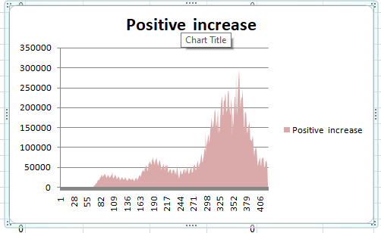

According to the World Health Organization’s report Closing the Gap in a Generation: Health Equity through Action on the Social Determinants of Health, “poor and unequal living conditions are the consequences of deeper structural conditions that together fashion the way societies are organized—poor social policies and programs, unfair economic arrangements, and bad politics.” This toxic combination of factors as they play out during this time of crisis, and as early news on the effect of the COVID-19 pandemic pointed out, is disproportionately affecting African American communities in the United States. I recognize that the pandemic has had and is having devastating effects on other minorities as well, but space does not permit this essay to explore the impact on other minority groups.

As COVID-19 infections began to be reported around the world, many countries responded by shutting down places like schools, workplaces and international borders in order to contain the spread of the virus.

1. **THE DAY WITH MINIMUM NUMBER OF CASES EVER**

We found that for regions with extensive testing it is possible to get early accurate symptomatic CFR coefficients. These values, in combination with an estimate of the age dependence of infection, allows symptomatic CFR values and percentage of the population that is infected to be determined in similar regions with limited testing.

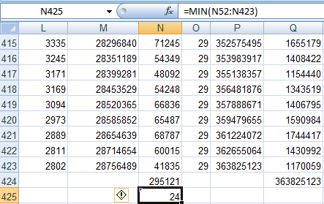

The age dependent symptomatic CFR values accurately predicted the percentage of the population infected as reported by two random testing studies in NYC. They also were in good agreement with later studies that estimated age specific IFR and CFR values from serological studies and more extensive data sets available later in the pandemic.

 Early determination during a surge in cases is made more difficult due to the need to correct for the time delay between infection and death.

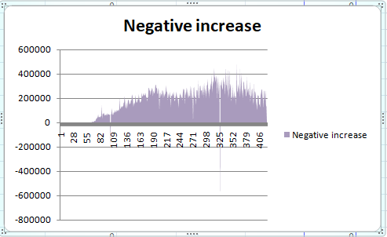

* 1. **HOLI FESTIVAL V/S DUSSERA FESTIVAL**

The nation is celebrating the festival of colors with great zeal and enthusiasm, marking the triumph of good over evil, the arrival of the spring season and the spirit of unity.

During the festival, participants sing and dance and shower each other with flower petals and brightly colored powders of pink, yellow, blue and green.

Earlier, Holi celebrations began a week in advance for children, where small kids used to hide on terraces or balconies and splash oncoming people with water and water balloons. It irritated them but then "Bura Na Mano Holi Hai" was the defense.

Dussera celebrations were highly subdued across India as the festival’s main highlight, the customary burning of the effigies of Ravana in the presence of large revelrous crowds, was disrupted this year.

Many Ramleela committees shelved plans to hold torching of effigies of the demon king Ravana along with Kumbhkarn and Meghnad.

Holi is a festival of colors water and relatives…….covid-19 also spread itself in water and expands itself in crowd.

Dussera is also a festival of crowd and watching ramleela and burning of ravana.

Overall both the festivals showed their impact in covid-19 by sudden rise in the cases of covid-19 cases.

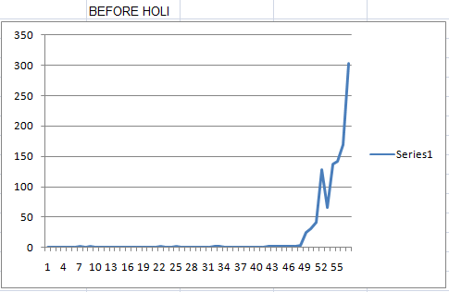

In this line graph you can easily see there is a rise in the covid-19 cases in the very starting of the pandemic.

X axis represents the number of days and Y axis represents the number of cases.

Here we can see that there was a sudden fall in the cases between 52nd-55th day.

This graph is with a gap of 3 days and the rise in the cases in not that much we are going to see in the next graphs.

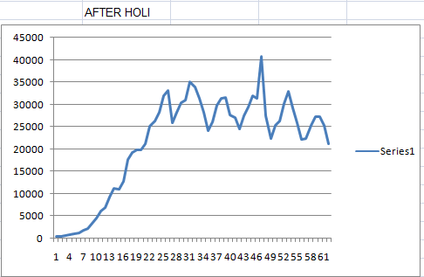

This is line graph after holi here we have the data of 30 days or a month.

X axis represents the number of days and Y axis represents the number of cases.

Here we can see a pattern which looks like mountain, a sudden rise and a sudden fall which shows that the people are getting covid positive just after the next day of holi.

Holi is a festival of water and crowd of people which can spread covid at a very large scale.

Ad we can see the pattern which means that covid cases were increased after holi.

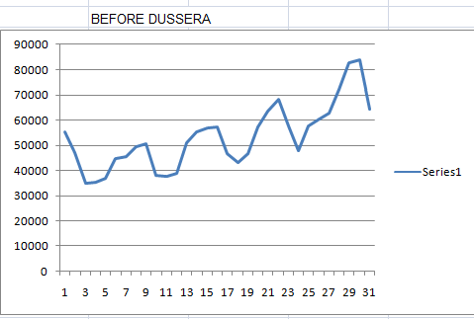

This is line graph before dussera.

X axis represents the number of days and Y axis represents the number of cases.

Here some stability appears. After holi we saw a sudden rise in the cases but after some months just before the dussera we can see the stability in the cases through this line graph.

The stability shows that there is neither rise nor fall in the covid cases.

The data here in the graph is having a gap of just 3 days and in a single day WHO has admitted that there are 2 lakh cases observerd.

Now we have a line graph after dussera…

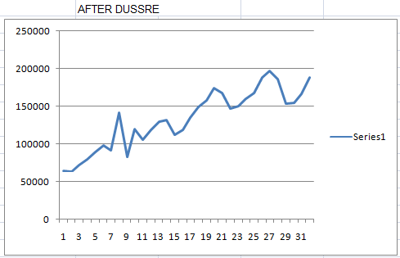

This is the line graph after dussera.

X axis represents number of days and Y axis represents number of cases.

Here we can see there is a rise in covid cases. From day 1 to day 9 there is a sudden increase and after 9th day onwards till 15th day we can see the cases went down but from next day the cases are going to increase after every 3rd day.

Here we are going to analyze the number of cases before holi and dussera and number of cases after holi and dussera. The holi fest in 2020 was on 10 march , the dussera fest 2020 was on 25 October.

Now we will analyse that what was the condition before both the festivals.

We have found that before holi there were on **1054** cases in India and before dussera there were **7597495** cases in India.

Now we will analyze that what was the condition after both the festivals.

We have found that after holi till 1 month the cases were increasing and reached to the peak, the number of cases were 499453 covid-19 positive.

After dussera 20249828+ cases.

* 1. **FIRST DAY OF LOCKDOWN AND THE LAST DAY OF LOCKDOWN**

On the evening of 24 March 2020, the [Government of India](https://en.wikipedia.org/wiki/Government_of_India) ordered a nationwide [lockdown](https://en.wikipedia.org/wiki/Lockdown) for 21 days, limiting movement of the entire 1.38 billion population of [India](https://en.wikipedia.org/wiki/India) as a preventive measure against the [COVID-19 pandemic in India](https://en.wikipedia.org/wiki/COVID-19_pandemic_in_India).

It was ordered after a 14-hour voluntary public curfew on 22 March, followed by enforcement of a series of regulations in the countries' COVID-19 affected regions.

The lockdown was placed when the number of confirmed positive coronavirus cases in India was approximately 500.

Observers stated that the lockdown had slowed the growth rate of the pandemic by 6 April to a rate of doubling every six days, and by 18 April, to a rate of doubling every eight days.As the end of the first lockdown period approached, state governments and other advisory committees recommended extending the lockdown.

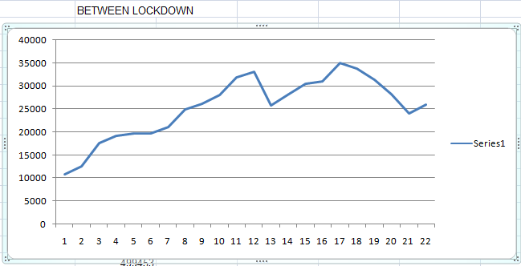

This is line graph of covid-19 between the lockdown period.

X axis represents teh number of days and teh 1st day of lockdown is day 1 and the very last day of lockdown is 21st day. Y axis represents the number of cases.

Here we can see on teh first day of lockdown there were only 10000 cases and on the last day there were 25000 cases.

This lockdown of 21 days made this graph look like this otherwise without lockdown the cases would be definitely more than 1 lakh regularly.

So from this analysis we can see that lockdown helped alot to save us.

* 1. **THE DAY WITH MAXIMUM AND MINIMUM DEATH REPORTS**

Here I have researched about the covid-19 cases and found that till now India has lost her 3.76 crore population.

This is the screenshot provided:

Source: Google

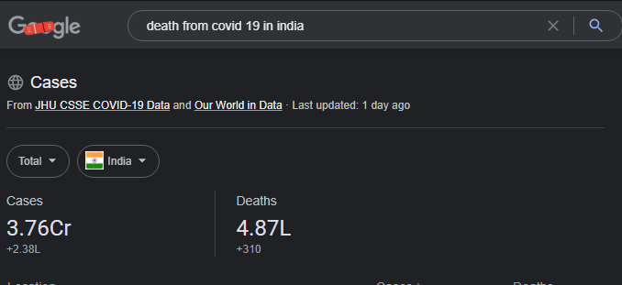

According to my data from the starting of SARS covid-19 till the last year I have found that total deaths were 515151. And now currently at this time from the latest reports there were 3.76crore deaths.

The statistical data from Google is here which shows a sudden rise in death cases

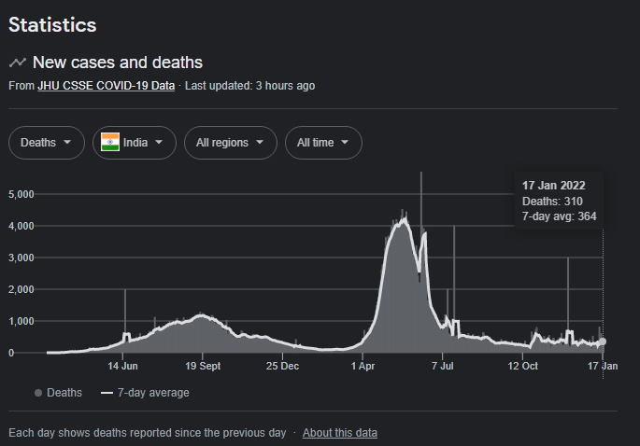

An average of 248,926 cases per day were reported in India in the last week. Cases have increased by 985 percent from the average two weeks ago. Deaths have increased by 48 percent.

Since the beginning of the pandemic, at least 1 in 36 residents have been infected, a total of 37,618,271 reported cases. At least 1 in 2,807 residents have died from the coronavirus, a total of 486,761 deaths.

May 2021 was the month with the highest average cases and deaths in India.

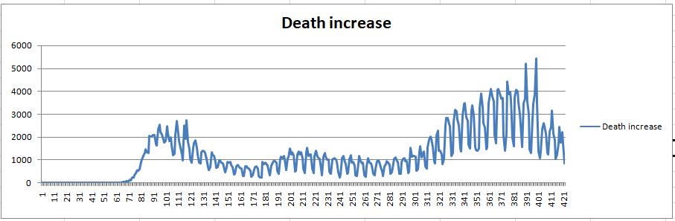

X axis represents the number of days and Y axis represents the number of death cases .

Here we can observe a “W” pattern which means a rise, fall, rise, fall and rise in the death cases.

Confirmed cases and deaths, which are widely considered to be an undercount of the true toll, are counts of individuals whose corona virus infections were confirmed by a molecular laboratory test**.**Probable cases anddeaths count individuals who meet criteria for other types of testing, symptoms and exposure, as developed by national and local governments.

# WHAT IF ANALYSIS



## SCENARIO MANAGER

Scenario Manager is useful in a case where you have more than two variables in the sensitivity analysis. Scenario Manager creates scenarios for each set of the input values for the variables under consideration. A scenario is a set of values that Excel saves and can substitute automatically in cells on a worksheet.

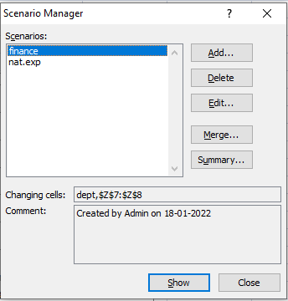

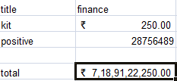

We have one scenario with finance and the price of 1 testing kit is 250 Rs/-

Total expense is 7189122250 Rs/-

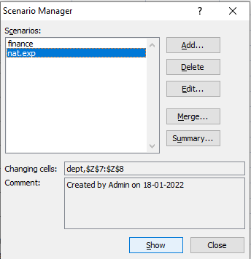

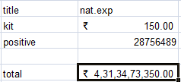

We have scenario with nat.exp and the price of 1 testing kit is 150 Rs/-

Total expense is 4313473350 Rs/-

Here we have got two scenarios of expenses. First heading is ‘finance ’and the second heading is ‘nat.exp ’with the different data.

`

## GOAL AND SEEK

Goal Seek is useful if you want to know the formula's result but unsure what input value the formula needs to get that result. For example, if you want to borrow a loan and know the loan amount, tenure of loan and the EMI that you can pay, you can use Goal Seek to find the interest rate at which you can avail of the loan. Goal Seek can be used only with one variable input value.

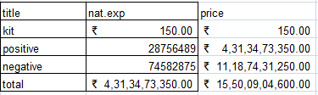

The price of 1 testing kit is 150 Rs/- and according to 28756489 positive cases, the total cost came out was 4313473350 Rs/-.

Goal seek helped here to find what is only 3000000000 Rs/- was spent then how many positive cases would be there?

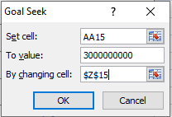

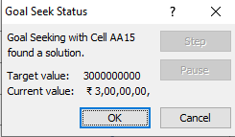

We have found that if there was the expense of only 3000000000 Rs/- then only 20000000 cases positive.

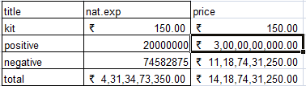

## DATA TABLE

A Data Table is a range of cells where you can change values in some of the cells and answer different answers to a problem. A Data Table is a range of cells where you can change values in some of the cells and answer different answers to a problem.

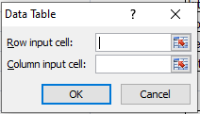

Cost of 1 testing kit is 150 Rs/- and 101 is the number of person who are there for having covid test.

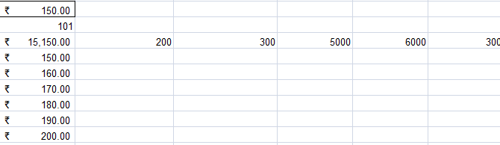

Data table helped us to know the same order data in a massive amount and made the work easier for us.

Data table contains the following two options which are row input and column input. First of all the formula cell un the table is the most important cell because it is the one on which the whole table is based.

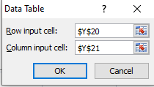

The first cell is Rs 150 and second cell is 101 and the third cell is the product of 1st and 2nd cells.

The 3rd cell is the 1st cell in table now the main point comes is that what should be filled in row input cell and column input cell. We have filled $Y$20 and $Y$21 respectively.

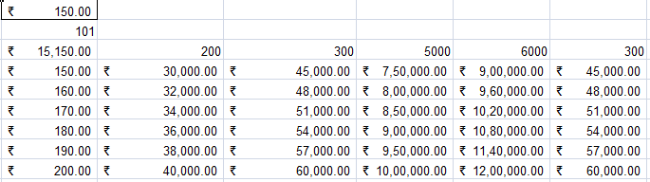

The row heading is the number of people and the column heading is the price according to the testing kits quality. And the price of all the testing kits used by the nation (India) is here.

**CONCLUSION**

The corona virus disease continues to spread across the world following a trajectory that is difficult to predict. The health, humanitarian and socio-economic policies adopted by countries will determine the speed and strength of the recovery.

Countries must work together this will result in a much faster recovery than if each country acts alone. The multilateral system and institutions provide a framework for this to happen, as they were designed to respond to complex, multifaceted, global emergencies such as the one brought on by the COVID-19 pandemic.

The WTO has a series of broad and diverse efforts to support trade development in Africa including agreements, decisions and technical assistance programmes.

Lastly, the WTO Secretariat’s technical activities in Africa have been consistently high over the last half-decade, with 16 per cent of activities focused on African countries – the highest of any region (WTO, 2020). The African continent is grappling with an uncertain future. International cooperation, a multilaterally coordinated response to the crisis, and a reinvigorated multilateral trading system have the potential to lessen the effects of the COVID-19 crisis for the continent.

A range of agreements has been signed over the course of the WTO’s 25 years, all with important implications for industrial policy and economic development on the continent. It is hoped that this review of WTO interventions in the continent can be a tool to further deepen cooperation and to deploy resources through strategic and effective mechanisms.

The conclusion on this project is that the COVID-19 pandemic has reinvigorated WTO debates on e-commerce and the concerns that developing countries have regarding the digital divide and uneven distribution of or access to information and communication technologies. The social distancing measures necessitated by COVID-19 have led to an increased need for internet and mobile data services and sharp increases in business-to-consumer and business-to-business e-commerce sales.