*A passionate Machine Learning professional and data-driven analyst with the ability to apply Machine Learning techniques and algorithms to solve real-world business problems.*

*Established ability in deploying effective predictive models across different industries to accurately forecast consumer behaviour and deliver proven results.*

***SUMMARY***

C:\Users\SAMSUNG\AppData\Local\Microsoft\Windows\INetCache\IE\JC6UXBUV\LTKjo5xTa[1].pngC:\Users\SAMSUNG\AppData\Local\Microsoft\Windows\INetCache\IE\VX9W5VVW\mail-307284_640[1].pngC:\Users\SAMSUNG\AppData\Local\Microsoft\Windows\INetCache\IE\MSQSYRNU\phone-1439841_960_720[1].png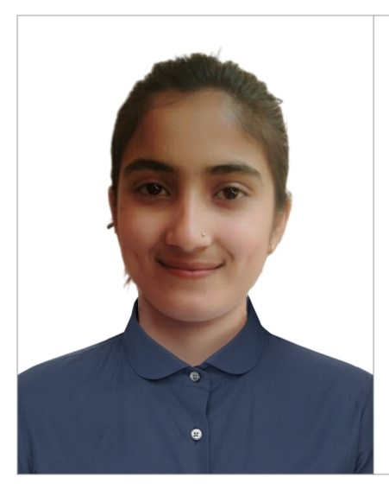

**Covid-19 Data Analysis**

* Tableau
* MS-Excel
* Analyzed the trend of covid-19 patients data
* Analyzed graphs and searched for the reasons and worldwide consequences of covid-19

***HTML5, CSS, JS, PhP, Python, Python GUI, Python advanced libraries including PyTorch, TensorFlow, Natural Language Tookit, Pandas, Numpy, Scikit learn, Seaborn, Matplotlib, Scipy,WordCloud.***

***TECHNOLOGIES***

* ***Tableau***
* ***PowerBI***
* ***Oracle***
* ***MongoDB***
* ***MySQL***
* ***JIRA***
* ***MS Office – MS Excel, MS Powerpoint***
* ***Outlook, MPP***
* ***Experience of MS Teams, Skype for business***

***PROJECTS UNDERTAKEN ARE AS FOLLOWS:***

***EXPERIENCE***

**ANAYA CONSULTANCY**  (2 years) Machine Learning Developer Jalandhar City, IN March 2021-PRESENT

**Data Visualization**

* Assisted in model development
* Testing, and validation of **50+ products** and services
* Created charts in **Jupyter Notebook** to perform analysis
* Visualized data using **Sci-py,** **Matplotlib, Seaborn, WordCloud scikit-learn and Natural Language Toolkit.**
* Used various libraries including Pandas, Numpy,
* Visualized various datasets of covid-19, data science salary hike with **R language** and **tableau**.

**Predictive Modelling**

* Predicted stock price with **95% accuracy** to enable the company to make informed investments.
* Developed an **algorithm** to understand **customer's spam/junk email** leading to 95% success in targeted project.
* Junk/Spam Email detection Jupyter Notebook- Machine learning algorithms: SVM, Naive Bayes. Classification, Random forest, Decision tree, Clustering: K-Means Clustering, K Nearest Neighbour, Adaboost
* Analysed share market for TATA steels data(specifically)
* Studied various trends within previous 20 years
* And predicted the trend for upcoming 5 year
* ***Database Management***
* ***Statistical Computing***
* ***Machine Learning***
* ***Artificial Intelligence***
* ***ML Algorithms***
* ***Predictive Analysis***
* ***Data Visualization***
* ***Statistical Modelling***
* ***Data Analytics***
* ***Data Mining***
* ***Quantitative Analysis***
* ***Model Development***

***SKILLS***

**+91 7717457974**

**Email** [**Khushichodhary1020@gmail.com**](mailto:Khushichodhary1020@gmail.com)

**Jalandhar City - INDIA**

***Khushi Khushi***

***Bagged first position in an idea to solve real world problem using Artificial Intelligence – LKC***

***Bagged third position-North Zonal Badminton Tournament.***

**I hereby declare that all above information is correct with fact or truth up to my knowledge and I bear the responsibilities for the correctness of the above mentioned particulars.**

***ACHIEVEMENTS***

***Reading general questions raised by people on Quora***

***Learning and searching about mysterious things***

***HOBBIES***

***DECLARATION***

***Bachelor of Vocation in Artificial Intelligence and Data Science - GNDU***

***Higher Secondary Certificate – Physics, Chemistry, Mathematics – St. Soldiers Group of Institutions NIT, REC - CBSE***

***Secondary School Certificate – CBSE***

***EDUCATIONAL CREDENTIALS***

* Got certificate of Artificial Intelligence from **Simplilearn** – 2019
* Bagged first position in an idea to solve real world problem using Artificial Intelligence – LKC - 2021

***English***

***Hindi***

***Punjabi***

**Email Spam Detection Model**

* Jupyter notebook – Machine Learning
* Machine Learning algorithms
* Comparison of all suitable algorithms and finding out amazingly suitable algorithm for dataset of emails.

**Data Scientist’s Salary Analysis.**

* R programming language
* Power BI for graphical representations

**Bank Account Management System**

* Integration of Python and SQL
* Database Management System

***PROFESSIONAL CERTIFICATES***

***LANGUAGES***