
—------------- OBJECTIVE ----------------

To study and implement fundamental data structures, namely Singly Linked List and Binary Search Tree, using C programming. The task focuses on performing insertion, deletion, searching, and traversal operations while understanding their working principles, memory management, and time complexities.

PROBLEM STATEMENT :-
Develop menu-driven C programs to implement the Singly Linked List and Binary Search Tree (BST) data structures. The programs should support fundamental operations such as insertion, deletion, searching, and traversal/display of elements. The implementation should use appropriate functions and dynamic memory allocation where required. The objective is to understand the working, applications, and time complexity of these data structures through practical implementation.

—--------------- THEORY –-----------------

- A Singly Linked List is a dynamic linear data structure consisting of nodes, where each node contains two parts: data and a pointer to the next node. Unlike arrays, linked lists do not require contiguous memory locations, making them flexible for dynamic memory allocation.
The first node of the list is called the head node, and the last node points to NULL, indicating the end of the list. Common operations performed on a linked list include insertion, deletion, searching, and traversal. Insertion and deletion can be performed efficiently without shifting elements, making linked lists suitable for applications where frequent modifications are required.
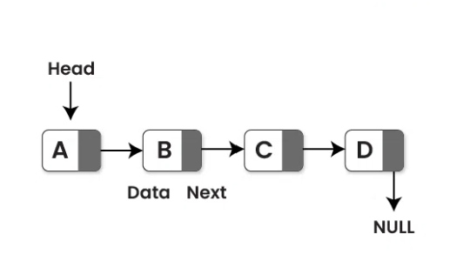
—--------------- THEORY –-----------------

- A Binary Search Tree (BST) is a hierarchical data structure in which each node contains a data element and two child pointers: left child and right child. The BST follows a specific property: all elements in the left subtree are smaller than the root node, and all elements in the right subtree are greater than the root node.
This property enables efficient searching, insertion, and deletion operations. Tree traversal techniques such as Inorder, Preorder, and Postorder are used to visit all nodes in a specific order. In a balanced BST, searching, insertion, and deletion operations can be performed in O(log n) time on average.
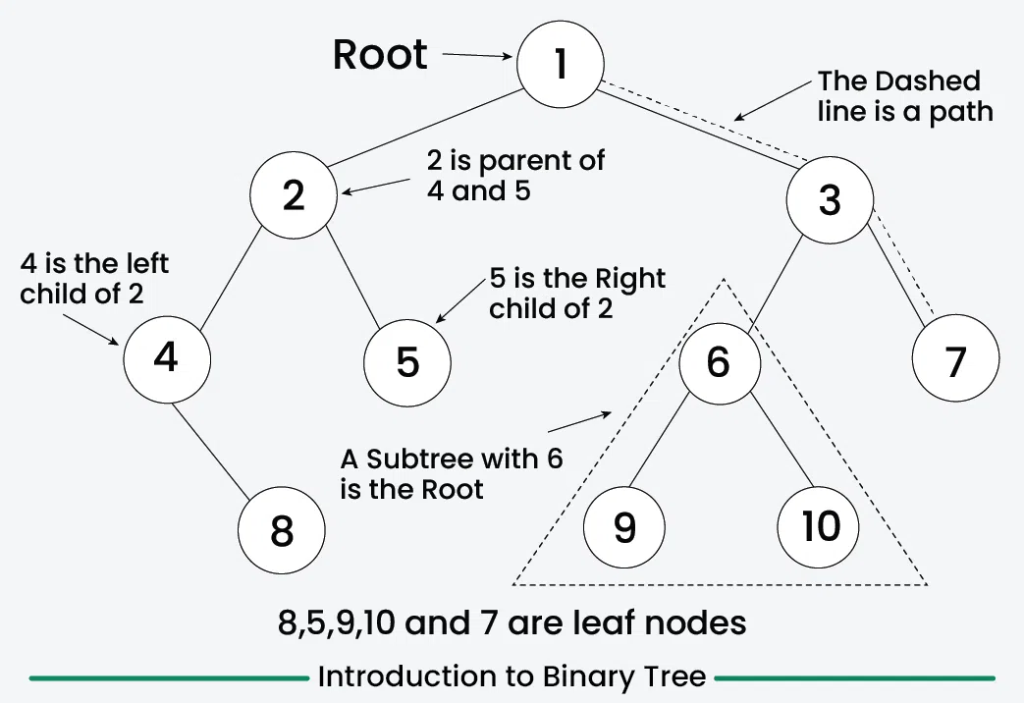
—------------- ALGORITHM----------------


Algorithm: Singly Linked List Operations
- Start the program.
- Initialize the head pointer as NULL.
- Display the menu containing the following operations:
  - Insert at Beginning
  - Insert at End
  - Insert at Position
  - Delete from Beginning
  - Delete from End
  - Delete from Position
  - Search Element
  - Display List
  - Exit
- Accept the user's choice.
- Perform the selected operation:
  - For insertion, create a new node and insert it at the specified location.
  - For deletion, locate the required node, adjust links, and free the node's memory.
  - For searching, traverse the list and compare each node's data with the target element.
  - For display, traverse the list and print all node values.
- Display the result of the operation.
- Return to the menu for the next operation.
- Repeat Steps 4–7 until the user selects Exit.
- Terminate the program.
—------------- ALGORITHM----------------


Algorithm: Binary Search Tree Operations
- Start the program.
- Initialize the root node as NULL.
- Display the menu containing the following operations:
  - Insert Node
  - Delete Node
  - Search Node
  - Inorder Traversal
  - Preorder Traversal
  - Postorder Traversal
  - Exit
- Accept the user's choice.
- Perform the selected operation:
  - For insertion, create a new node and place it in the appropriate position according to BST rules.
  - For deletion, locate the node and remove it while maintaining the BST property.
  - For searching, compare the target value with the current node and move to the left or right subtree accordingly.
  - For traversal, visit nodes using the selected traversal method (Inorder, Preorder, or Postorder).
- Display the result of the operation.
- Return to the menu for the next operation.
- Repeat Steps 4–7 until the user selects Exit.
- Terminate the program.

PROGRAM of LINKED LIST:-
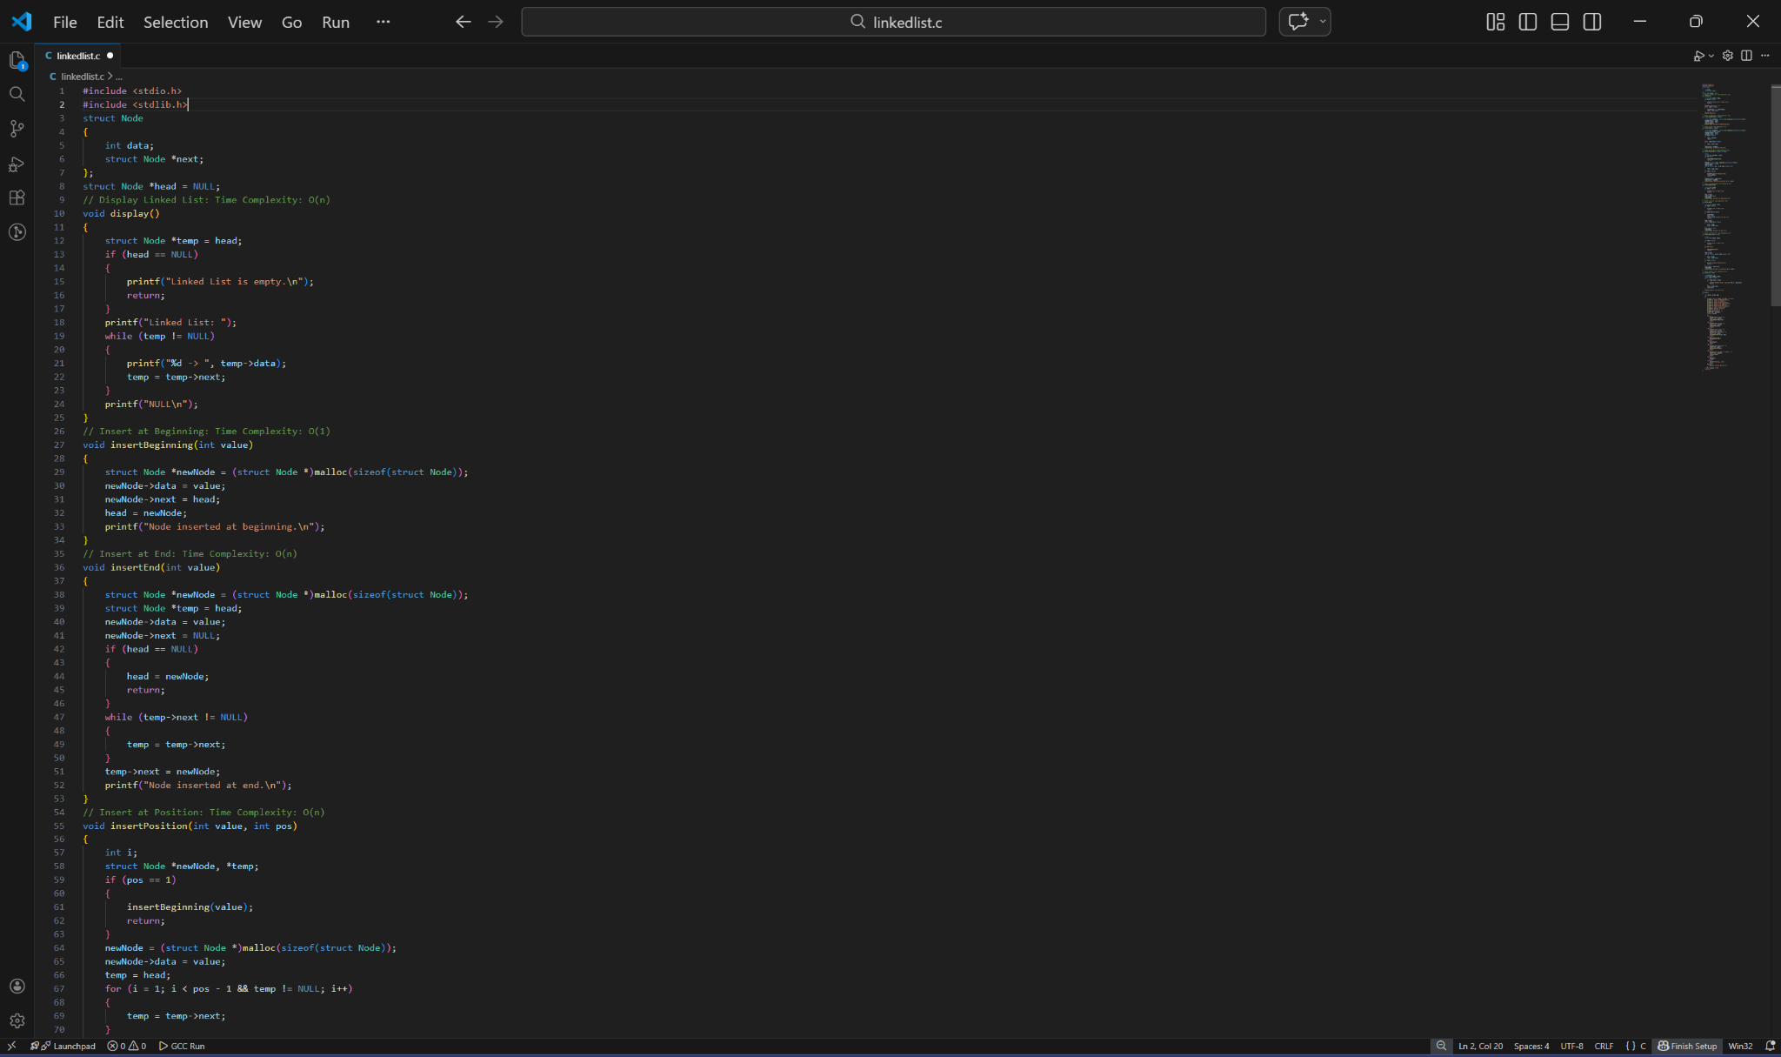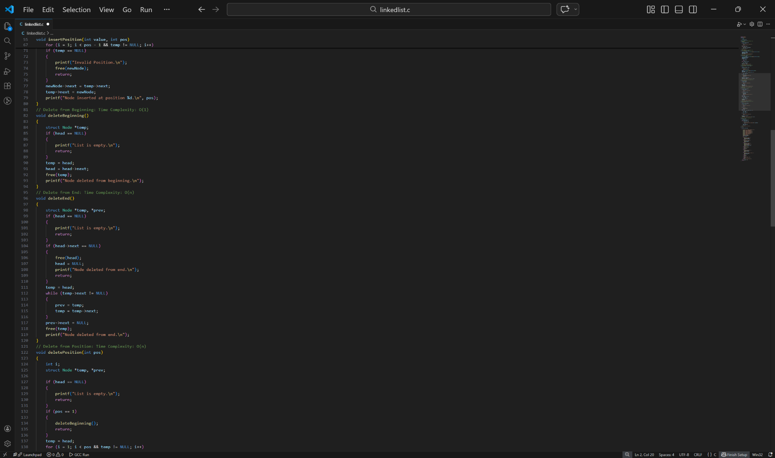

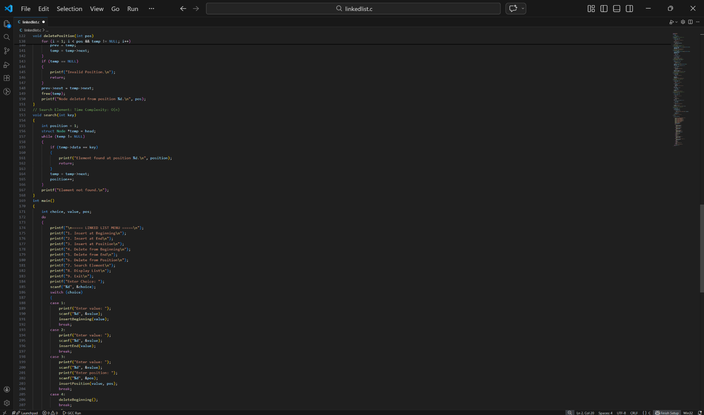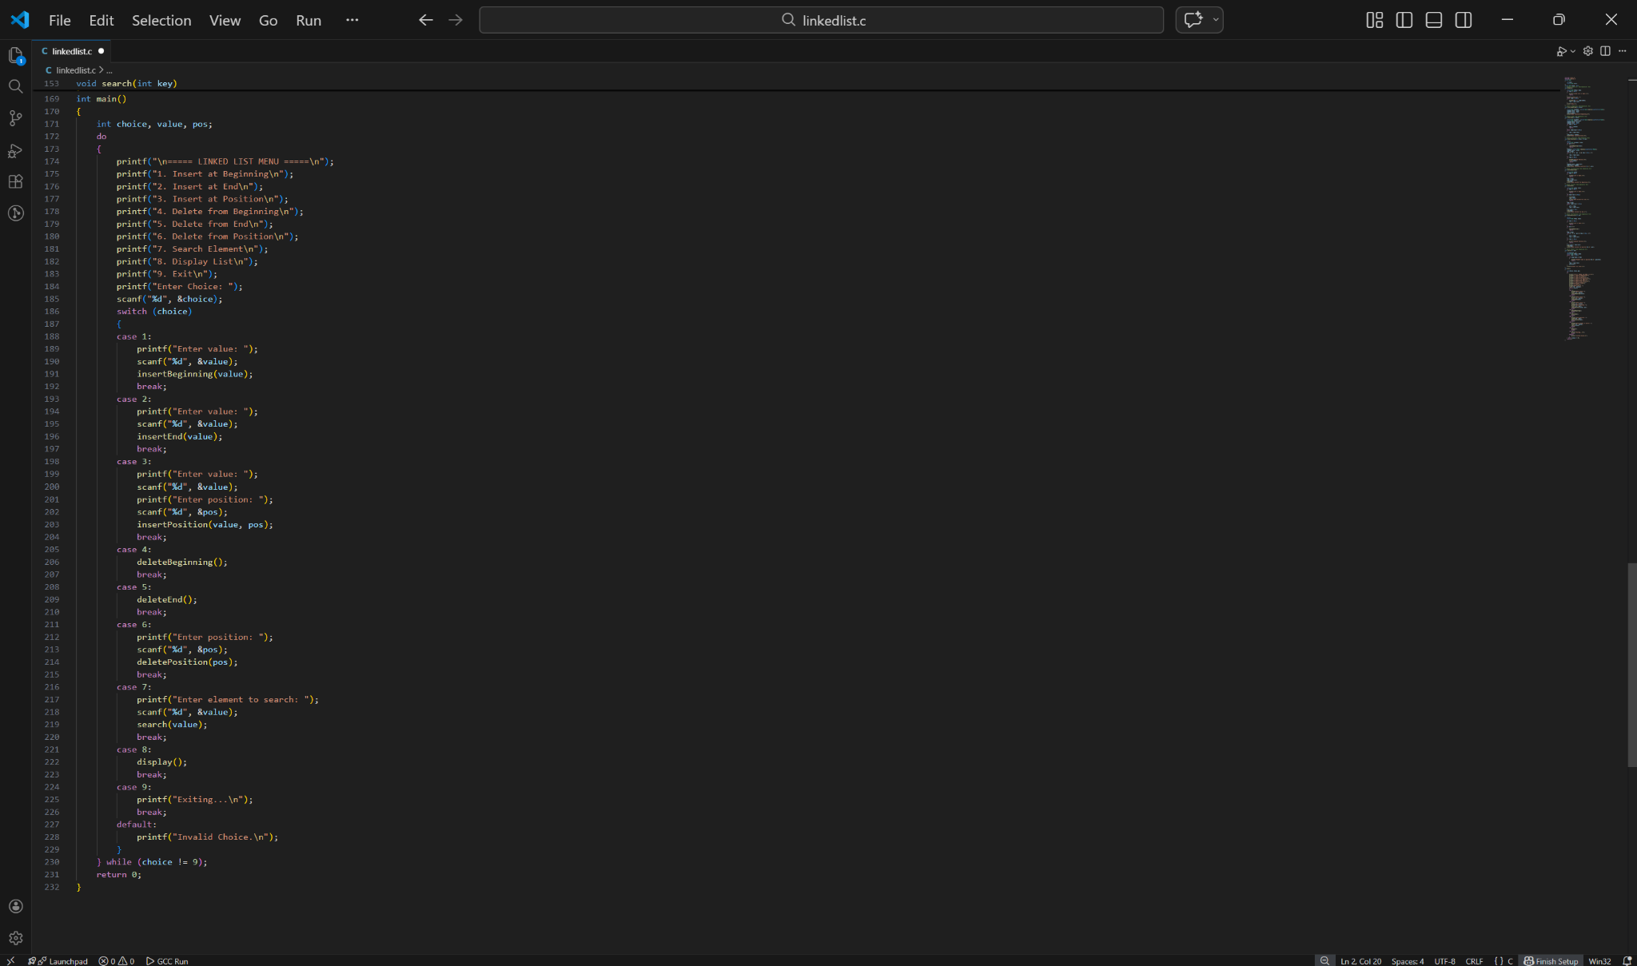




OUTPUT of LINKED LIST:-
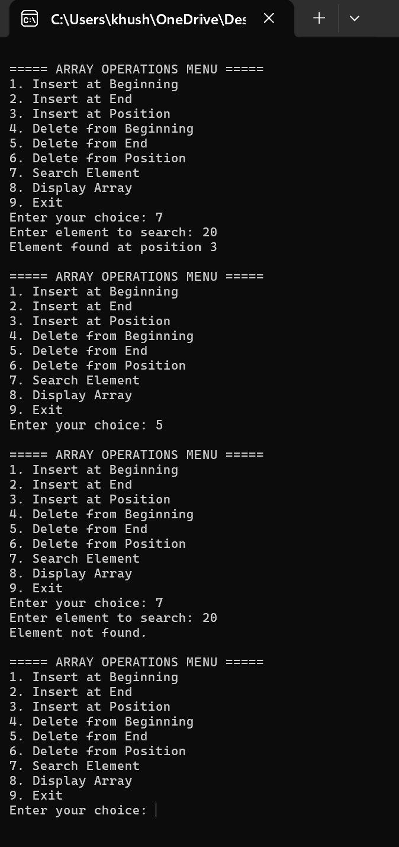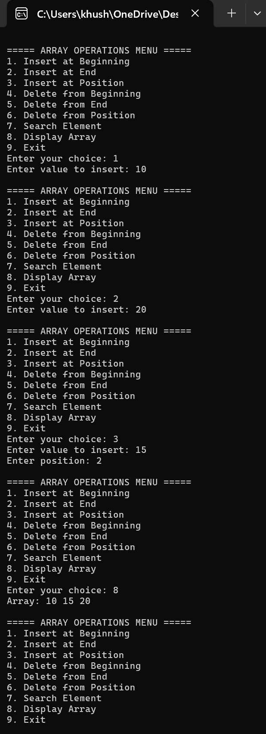

PROGRAM of BINARY SEARCH TREE:-
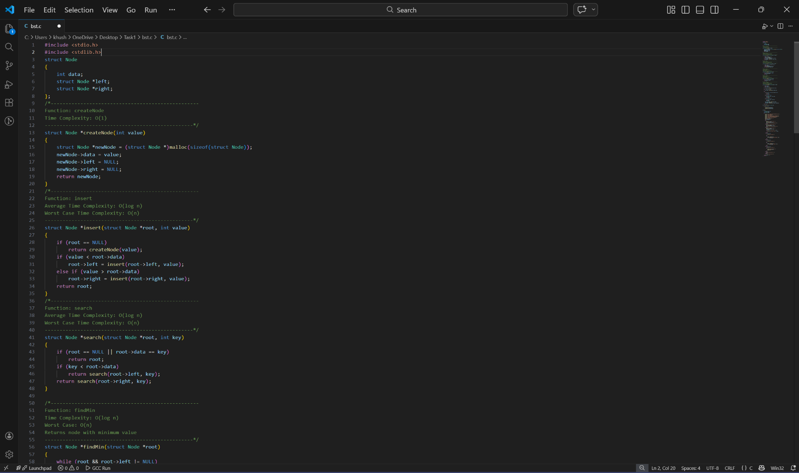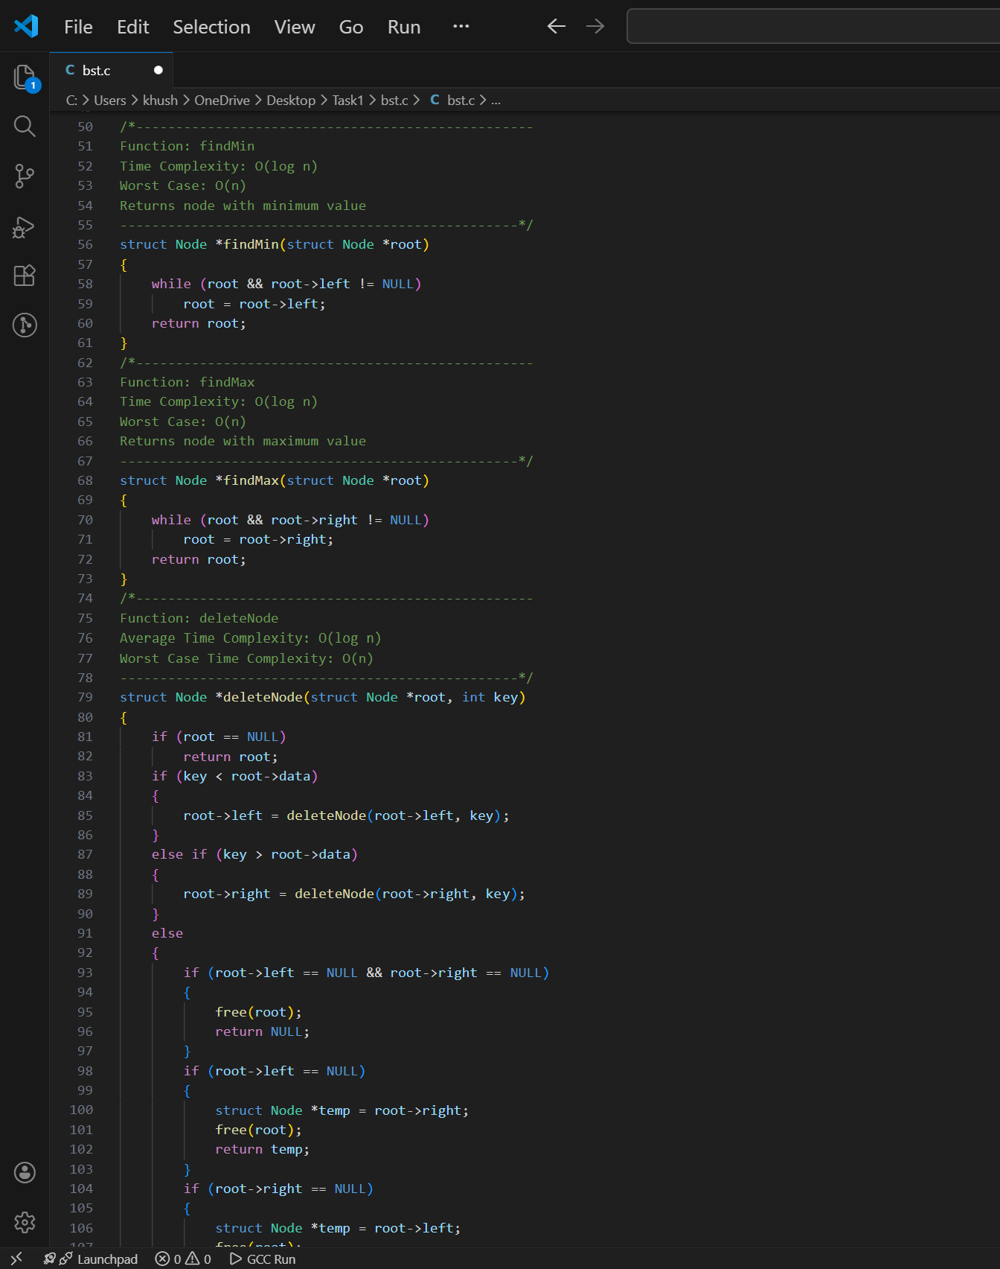

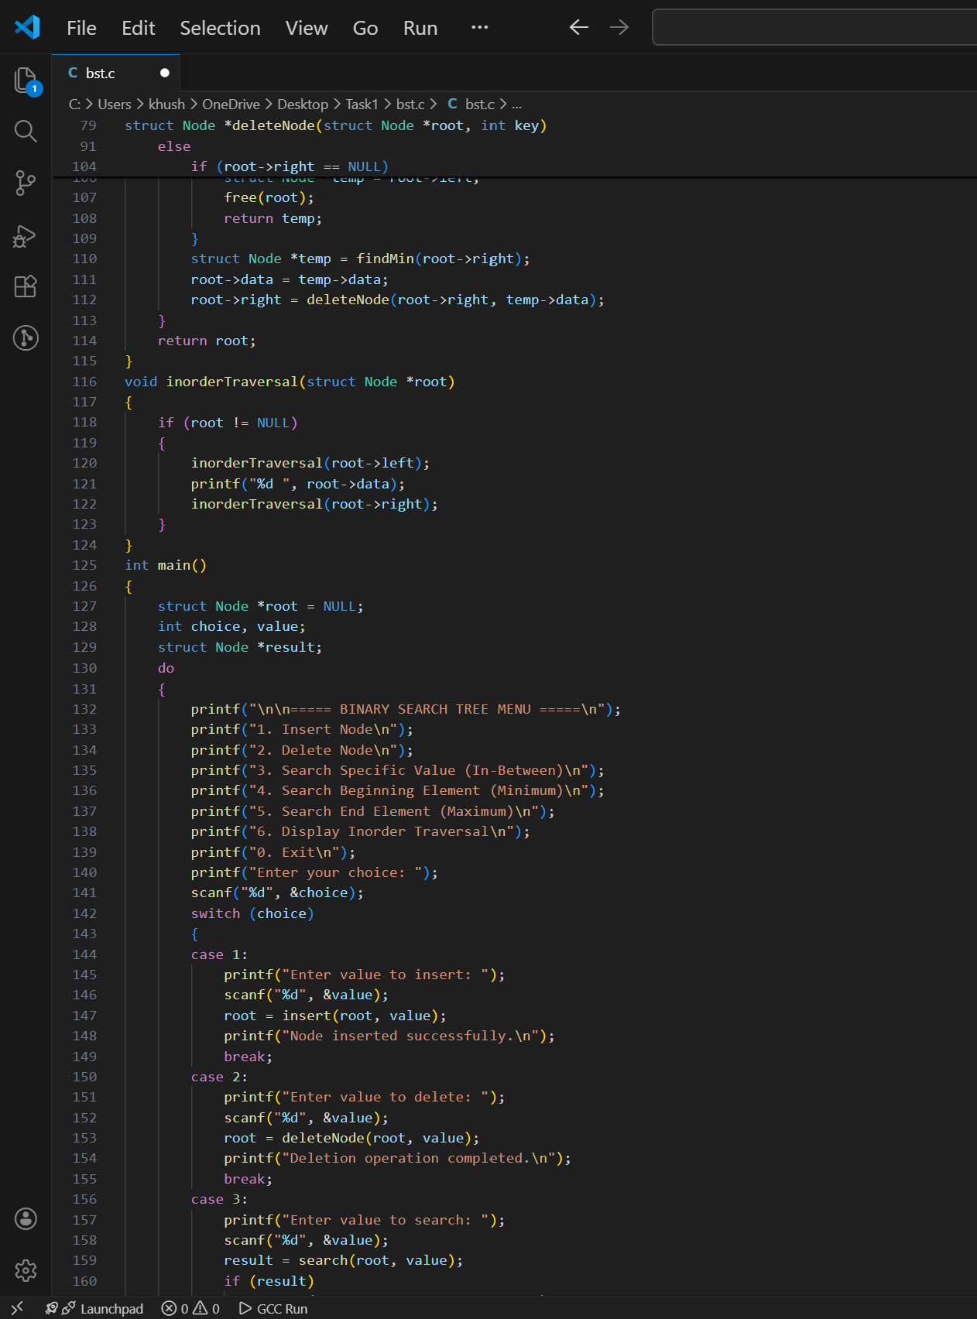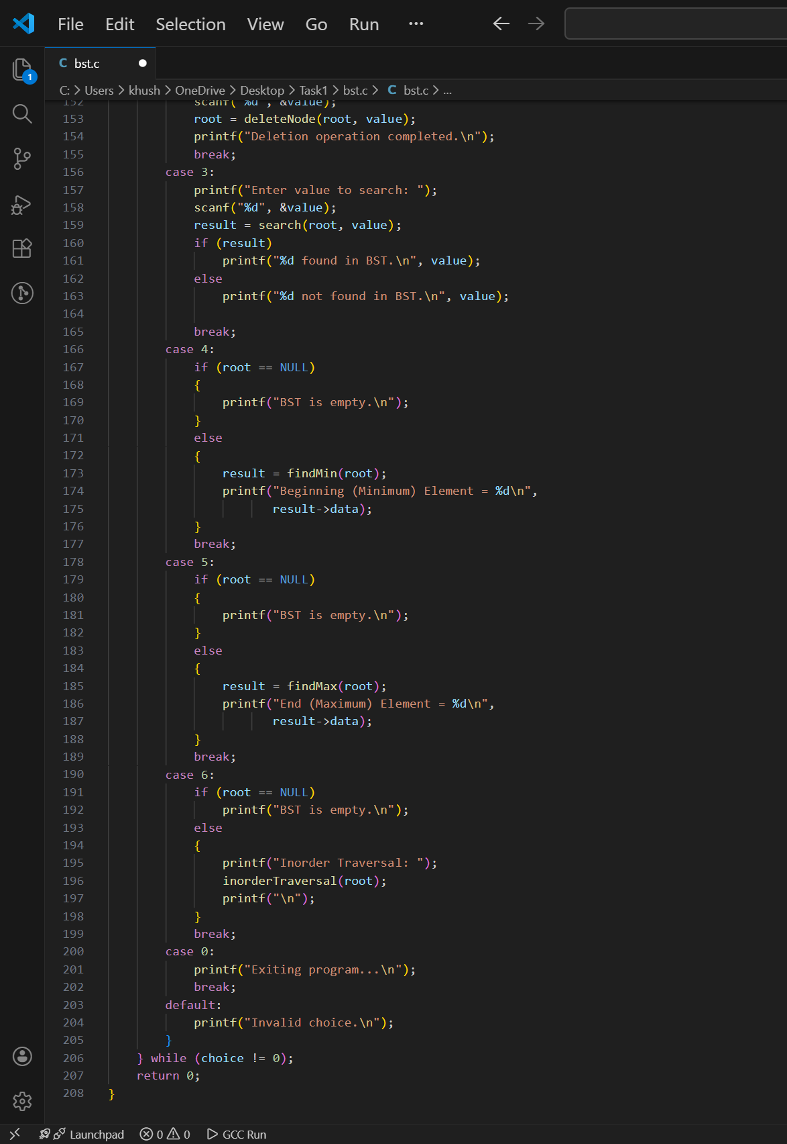




OUTPUT of BINARY SEARCH TREE:-
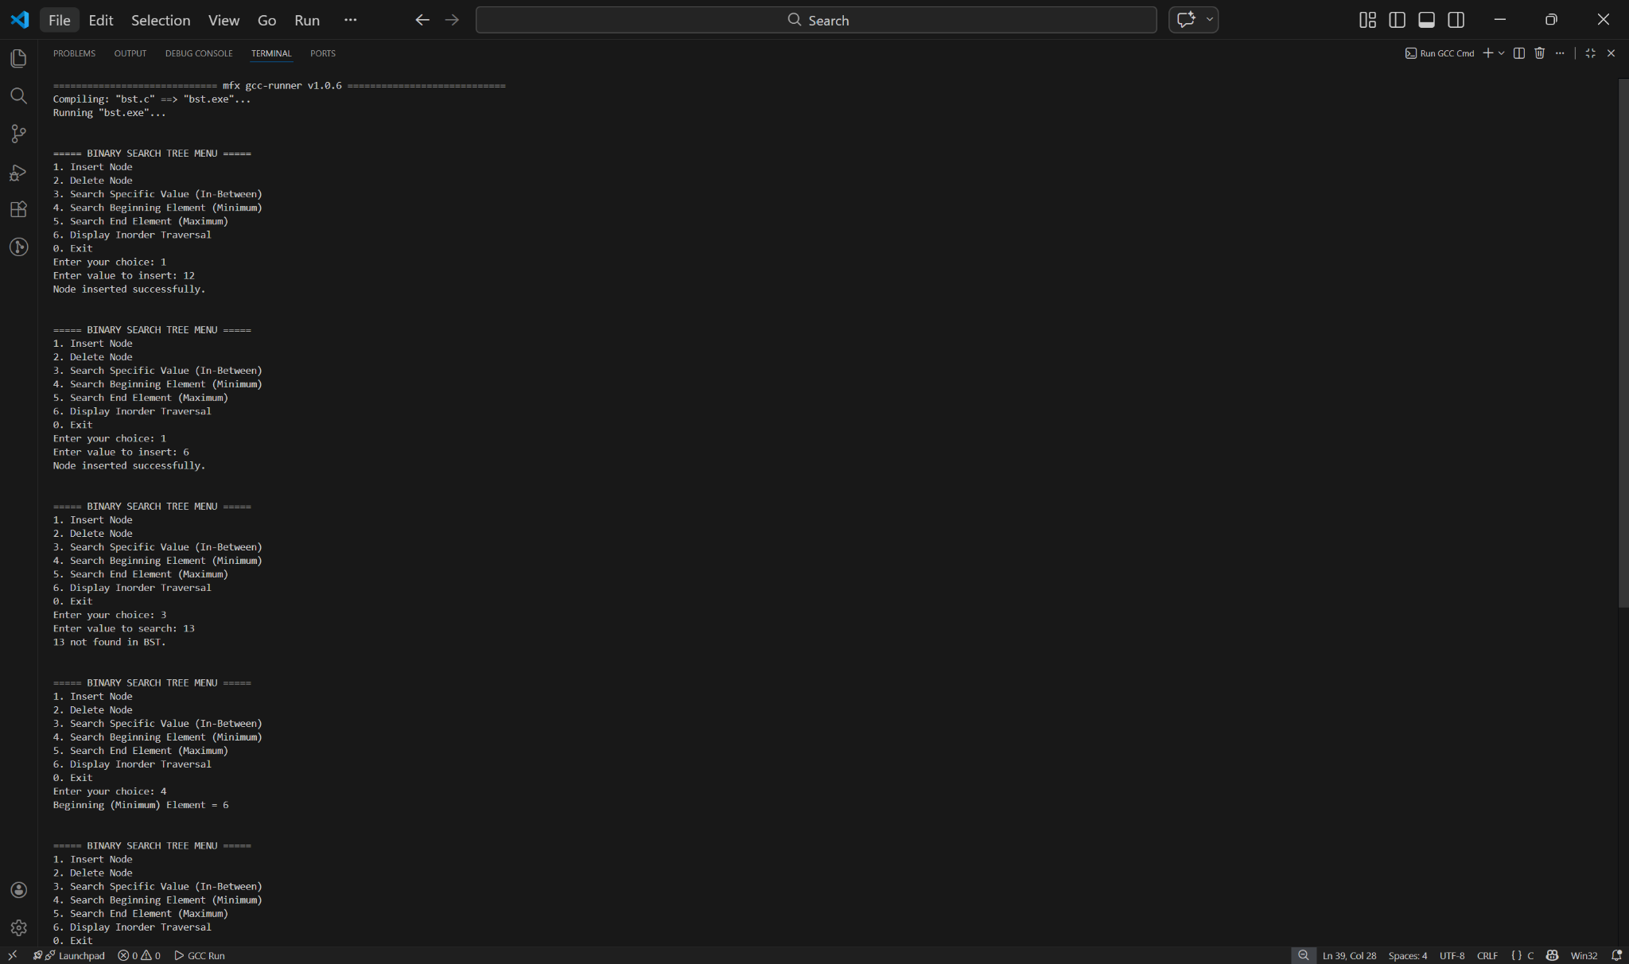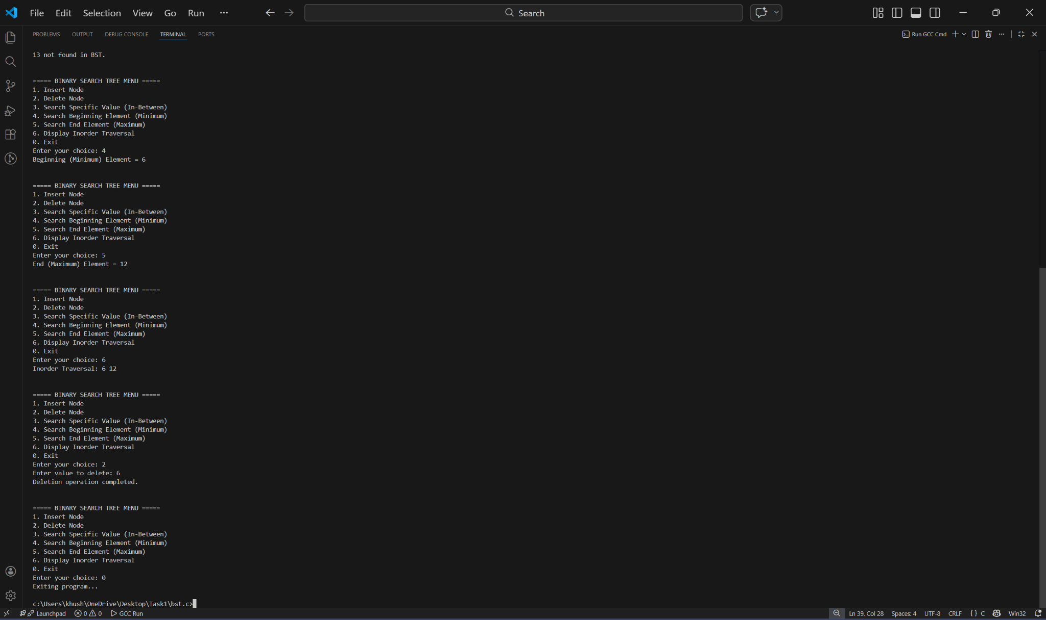
Complexity Analysis – Singly Linked List :-
Operation | Time Complexity
Insert at Beginning | O(1)
Insert at End | O(n)
Insert at Position | O(n)
Delete from Beginning | O(1)
Delete from End | O(n)
Delete from Position | O(n)
Search Element | O(n)
Display List | O(n)

Complexity Analysis – Binary Search Tree (BST) :-
Operation | Average Case | Worst Case
Insert Node | O(log n) | O(n)
Delete Node | O(log n) | O(n)
Search Node | O(log n) | O(n)
Inorder Traversal | O(n) | O(n)
Preorder Traversal | O(n) | O(n)
Postorder Traversal | O(n) | O(n)

—-------------- RESULT------------------


The Singly Linked List and Binary Search Tree programs were successfully implemented and executed using the C programming language. All the required operations were tested with different input values, and the programs produced the expected results.
In the Singly Linked List program, operations such as insertion, deletion, searching, and displaying the list were performed successfully. The program correctly updated the links between nodes and handled different positions within the list as intended.
Similarly, in the Binary Search Tree program, operations including insertion, deletion, searching, and tree traversals were carried out successfully. The Binary Search Tree property was maintained throughout the execution, and the traversal operations displayed the nodes in the correct order.
The implementation of these data structures provided a clear understanding of how data can be organized, stored, and manipulated efficiently. The outputs obtained during testing matched the expected outcomes, confirming the correctness of the algorithms and program logic. Thus, the objectives of the experiment were achieved successfully.

