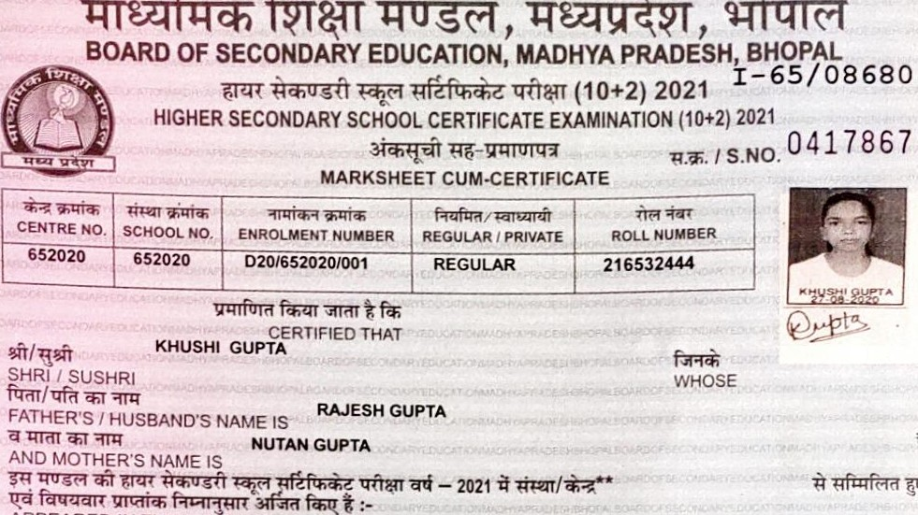BOARD OF SECONDARY EDUCATION, MADHYA PRADESH,

# APPEARED IN THE HIGHER SECONDARY SCHOOL CERTIFICATE EXAMINATION OF THIS BOARD IN THE YEAR 2021 FROM (SCHOOL CENTRE)" AND SUBJECT WISE MARKS OBTAINED ARE AS UNDER .DEEP VIDYA NIKETAN H S SCHOOL, MANDIDEEP, RAISEN



|  |  |  |  |  |  |  |  |  |  |
| --- | --- | --- | --- | --- | --- | --- | --- | --- | --- |
|  | MAXWuM MARKS | | | MINIMUM MARKS | | LARKS OBTAINED | | | REMARKS |
|  |  |  |  |  | cvs |  | tow |
|  | 100  100  070  070  100 | 030  030 | 100  100  100  100  100 | 033  033  023  023  033 | 010  010 | 080  079  044  044 | 019  019 | 080  079  063  063  070 | DISTN  DISTN |
|  | | / GRAND TOTAL | | | | | |  |  |
| THREE HUNDRED FIFTY FIVE••• GRAND TOTAL IN WORDS : | | | | | | | | | |
| /RESULT PASS IN FIRST DIVISION | | | | | | | | | |
|  |  |  |  |  |  |  |  |  |  |

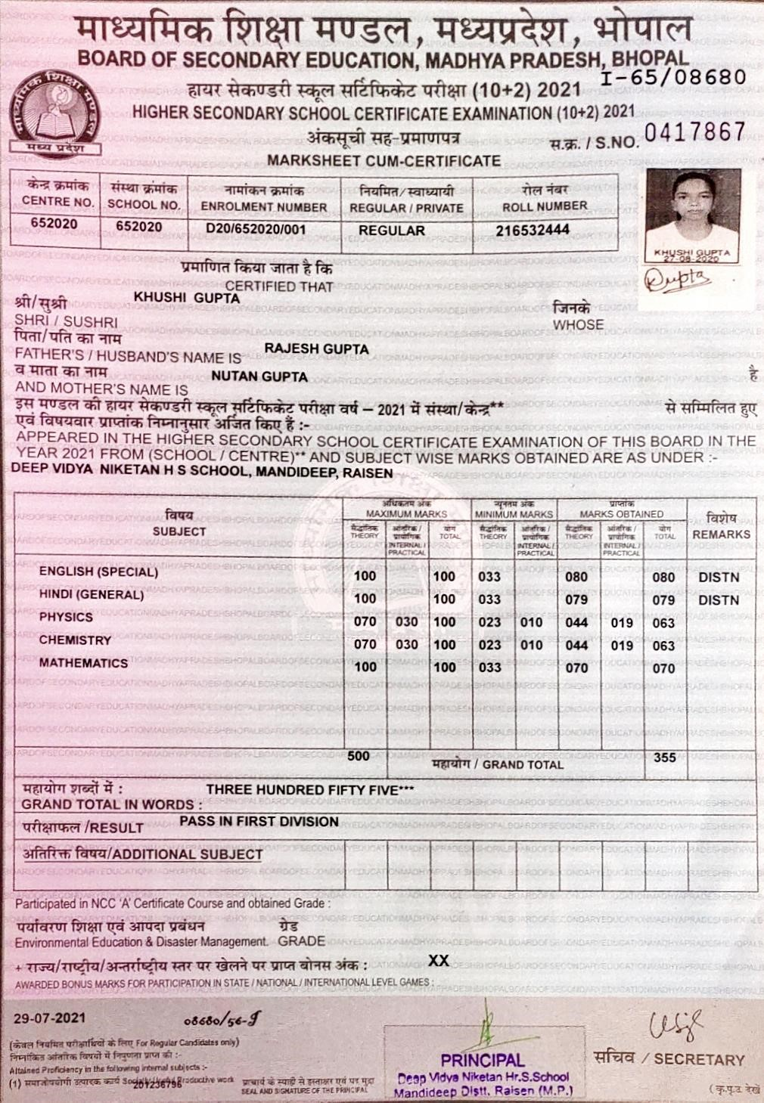"andideep O/Stf. Raisen