

# School of Computer Science & Engineering

**Department of Computer Science and Applications**

**SYBScCS Div –B Year - 2024-25**

**Project Based Learning - Project Report**

**On**

**“ADAPTIVE MENTOR”**

## Submitted By

**Khushi Ghanashyam Hinge - 1132230937**

**Under Guidance of**

## Prof. Punam Chaudhari



**Index**

|  |  |  |
| --- | --- | --- |
| **Sr. No.** | **Contents** | **PAGE NO.** |
| **1** | **Introduction** |  |
| 1.1 | Existing System and Need for System |  |
| 1.2 | Scope of System |  |
| 1.3 | Operating Environment - Hardware and Software |  |
| 1.4 | Brief Description of Technology Used |  |
| **2** | **Proposed System** |  |
| 2.1 | Feasibility Study |  |
| 2.2 | Objectives of Proposed System |  |
| 2.3 | Users of System |  |
| **3** | **Analysis and Design** |  |
| 3.1 | System Requirements (Functional and Non-Functional requirements |  |
| 3.2 | Module Hierarchy Diagram |  |
| 3.3 | Sample Input and Output Screens |  |
| **4** | **Coding** |  |
| 4.1 | Code snippets |  |
| **5** | **Limitations of Proposed System** |  |
| **6** | **Proposed Enhancements** |  |
| **7** | **Conclusion** |  |
| **8** | **Bibliography** |  |

**1. Introduction**

* 1. **Existing System and Need for System**

In the current educational landscape, most learning systems utilize a standardized, one-size-fits-all approach. This method, while efficient, often overlooks the unique needs of individual students, especially those who might benefit from varied instructional methods tailored to their specific learning styles. This discrepancy can lead to decreased engagement, lower comprehension rates, and, ultimately, hindered academic performance for students whose needs differ from traditional teaching methods. Although some educational platforms incorporate personalized features, they frequently rely on extensive backend support and data processing, making these systems resource-intensive and sometimes less accessible.

In light of the above, Adaptive Mentor hopes to provide a solution by designing an easy to use, purely frontend based adaptive learning system with no backend or complex architecture. Such an approach not only widens the pool of users for the tool in question as most systems demand such infrastructure but it also concentrates on short-term, based on the interactive behavior, changes. As the learning of new concepts is presented through different layers of relative complexity in a simple front end, Adaptive Mentor allows for various styles of learning, which means learners can adapt the learning process to what is most comfortable for them and do it at their own pace. This design philosophy promotes effectiveness and modifies teaching approach to the students, assuring learning to each student as per the requirement without incurring the high costs which most of the adaptive systems tend to do.

* 1. **Scope of System**

The scope of the *Adaptive Mentor* system encompasses the development of an interactive, responsive educational tool designed to adapt to various learning styles (visual, auditory, and hands-on learners) purely on the front end. Without relying on backend processing or databases, this system can still simulate adaptive responses to engage users through a selection of content formats tailored to their chosen learning preferences. By focusing on an all-front-end structure, the system is both scalable and user-friendly, making it adaptable to different educational contexts—from individual self-study to supplemental classroom use. Its lightweight design ensures compatibility with a wide range of devices, promoting accessibility for students across diverse educational and economic backgrounds.

**1.3 Operating environment – Hardware and Software**

The Adaptive Mentor system can also run on various devices in the most effective way possible thereby enhancing its reach to a wider audience.

Hardware Requirements: The system will work with any device that has access to the internet and can support a modern web browser; this includes laptops, desktops, tablets and even mobile phones. This wide range of supported devices enables the viewer to access the tool from virtually any device they own. This is very beneficial given the varied device and access levels of the users in the environments.

Software Requirements:

Frontend Technologies: The interface is designed to be fully functional and flexible using HTML, CSS, and JavaScript. Each technology has its purpose: HTML provides the structure, CSS the responsive design, while JavaScript takes care of the interactive part.

Browser Compatibility: The developed system is intended to work on most of the modern web browsers such as Chrome, Firefox, Safari, and Edge. This aspect allows most of the users to access the system without experiencing any compatibility problems. Reassurance of this level is achieved through the testing of the system within all those browsers and such content delivery is consistent irrespective of a users platform preference.

**1.4 Brief Description of Technology Used**

Adaptive Mentor has the following frontend:

HTML: Serves as the core building block for presenting the elearning material in an orderly fashion at every learning section of the system.

CSS: Encompassing system design and styling as well as the responsive nature of the application, CSS aids in the construction of an appealing yet flexible interface. It makes sure the application is still usable on devices that have drastically different screen sizes from that of a desktop computer to the small screen of a smartphone.

JavaScript: The particular functionality incorporated in the system is made possible with the use of the JavaScript resources and this is made in real time as the user responds to the systems prompts. This grants a pseudo personalization capability to the system where the content types will change depending on the user such that images will be shown to visual learners, audios will be played to hearing learners and interactive type of content presented to the user who loves touch.

**2. Proposed System**  
  
**2.1 Feasibility Study**

The adaptive mentor project proposes a front-end-only system making it comparatively less complicated in scope and implementation. The system aims at a cleaner and more responsive design which runs on the client side only. This avoids needless complications of the connection with backend services like the servers and storage of data. In this respect, frontend development eases the process of speed and ease of adoption and with a compromise of design therefore the system can be available on any device with a browser without being heavy. Also, zap and reduction of the backend and database components further increase the project’s feasibility by lowering the skills needed, shortening the developing period, and reducing the effort required to keep the system functioning.  
  
**2.2 Objectives of Proposed System**

The objectives adaptive mentor system are stated below:  
  
Adaptive Front-End Interface: To build an interface, which would change the content, based on the learning style chosen by the user. The system promotes such types of information that help to understand the content better in regard to types of learners by letting them choose the types of information they want to see.

Pseudo-Personalization: Deliver a fully interactive experience that aspires for personalized education but does not process any data in the backend. Due to the front-end-only solutions, the system can change some parameters, like the form of content or the way it is shown, at any time as per the user’s activity and selection, hence the learning process turns to be very interactive and dynamic.

Responsive and User-Friendly Design: Make an easy to use the design in the interface that works on numerous devices of different screen sizes. The aim of the project is to create a system that considers all types of users and provides the same high quality engaging content, which enables students to work with the content smoothly on any device.

**2.3 System’s Users**

The Adaptive Mentor system is designed to address the needs of two main groups of users:

Students: The tool is intended to accommodate the learning requirements of individual students, so as to allow them to use the materials in a manner that takes advantage of their cognitive abilities. The content is further broken down according to visual, auditory, kinesthetic etc, so that the students are able to receive the information in a manner that is most suitable for them, improving their interest in the learning process and the learning experience as a whole.

Educators: Although the tool is designed mostly for the individual student, it can also be used effectively by the teacher as a supplementary device. When a tool is presented to students that fits their individual learning styles, the teacher can better address the various learning needs of students. This tool plays an additional role apart from the traditional teaching strategies, where an educator is able to implement differentiated instruction in class or facilitate learning at the learners’ homes.

**3. Analysis and Design**

**3.1 System Requirements**

Functional Requirements

Learning Style Selection Interface: The system provides an interface where users can specify their preferred learning style. This selection process is important as it determines the type of content the user will be engaged with and the style of interaction they will have throughout the lesson. The preferences in this case are visual, auditory and kinesthetic, since individual learners may vary.

Real-time modification of content presentation and structure: The last aim can be achieved through content personalization and aiming at the particular learning style of the user. For instance, in the event that a user chooses visual content mode, then appropriate images and infographics will be the content displayed. Such a dissociative response is done solely through front end coding with no backend interaction creating an illusion of an experience that does not require an actual user.

Interactive Feedback Mechanism: The system will store data regarding the ways users interact with it, which will enable it to employ adaptive responses. This aspect will enable adaptive feedback emulation by e.g reducing or increasing the lesson complexity or changing the content after the user performed certain actions like staring at one point for too long or skipping parts of materials. Though this is on the front end, it still gives the façade of a learning assistant that is intelligent and can make adjustments to when one is learning.

Non-Functional Requirements

Device Compatibility: The system should be available and usable on numerous devices such as a desktop computer, laptop computer, tablet, or mobile phone. In order to achieve such a goal, responsive design techniques are applied to ensure that system layout, content and user experience do not vary with different screen sizes and resolutions.

User-Friendly and Visually Appealing Interface: The platform should be designed in such a way that it attracts the users. They should be easy to use and navigate which will promote interaction among the users. The users should ideally be able to perform actions with minimal effort; for example, clear and strategically placed buttons, easy to follow paths, and appealing graphics that make learning fun and easy. The design also needs to emphasize ease of use and accessibility so that the most limited users can use it.

**3.2 Diagram Of Module Hierarchy**

The Adaptive Mentor system consists of a number of core modules that collaborate with each other in order to provide a user with an adaptive learning environment. Every module aims to cater to one part of the user journey ranging from the learning style selection to interaction with the specific content.

User Selection Module:

This module forms the first point of contact where users are expected to choose their preferred way of learning, that is, visual, auditory or kinetic. The selections made at this point will determine how the contents will be delivered throughout the session. The User Selection Module is very important because it helps in defining the tailored aspects of the learning process and it is the entry point to adaptive content.

Content Display Module:

The Content Display Module displays the content that is appropriate according to the user’s learning style that was chosen in the User Selection Module. For example, visual learners would be presented with text heavy material with lots of images and diagrams, auditory learners would be provided with explanations in audio form and kinesthetic learners would do lots of role play and physical exercises. This module utilizes back end programming in order to change the presented materials depending on the cognitive ability of a learner so that learning materials are presented in the best way possible.

Interactive Feedback Module:

Designed to mimic adaptivity, this module tracks the user’s interaction with the system and makes appropriate adjustments. It facilitates adaptive learning that helps to modify instructions based on the student’s behavior for instance when a pattern of activity is clearly observed that progresses the learner through the material quickly then the instruction method increases in difficulty. Although this feedback is provided in the front-end as an experience, it helps the user not to become bored as well as providing an atmosphere where the user feels as if the learning assistance is responsive.

**3.3 Input and Output Screens: Illustrations**

Input Screen:

The very first input screen provides the user with options to select a preferred learning style. The screen displays the three main modes which are Visual, Audio, and Kinesthetic (doing it oneself). Each of these has a short description attached to guide the users on what learning style suits them. This screen is kept clean and friendly such that the user is free to select the most comfortable option to him or her since it proposes the beginning of the time a client interacts with the solution.

Output Screens:

When a user chooses a mode of learning, the system then presents him or her with the output screens, depending on the mode chosen. Every learning style has got its own content maximum:

Visual Mode: The content has got a lot of infographics, images, and diagrams for those who learn better with the help of visualizations and space.

Audio Mode: Content is presented via audio based explanations and narrations, as this type of learners prefer listening and consuming information.

Kinesthetic (Do-It-Yourself) Mode: This allows hands on learners to do practical activities or tasks so that they can relate with the content.

**4.** **Coding-**

Some important parts from MAIN CODE-

Login page CSS-

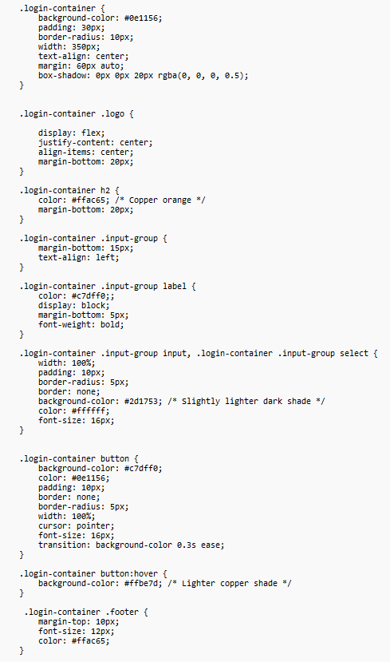

Login page HTML code-

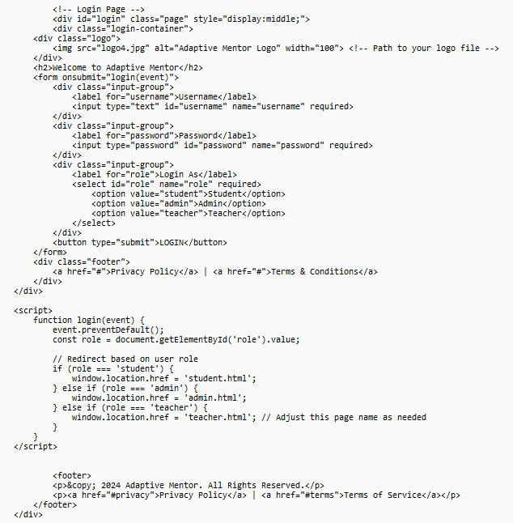

Some important parts from ADMIN CODE-

Dashboard page HTML code-

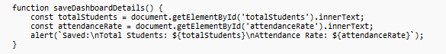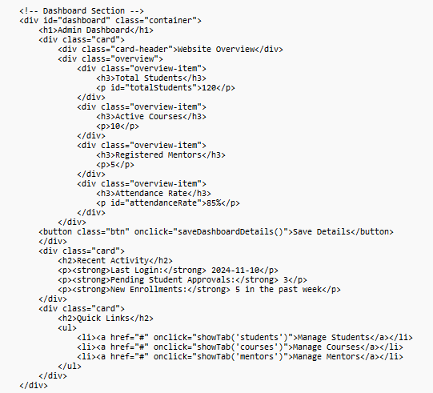

Some important parts from TEACHER CODE-

Settings page CSS-

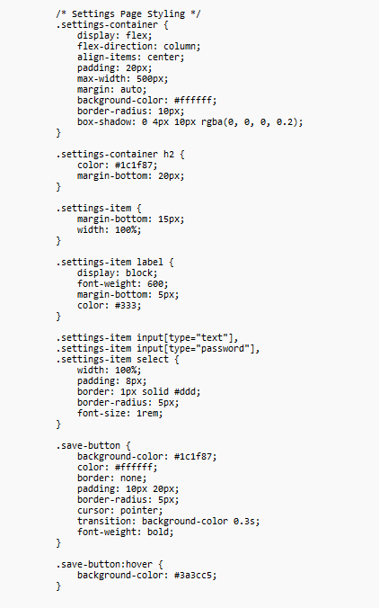

Settings page HTML code-

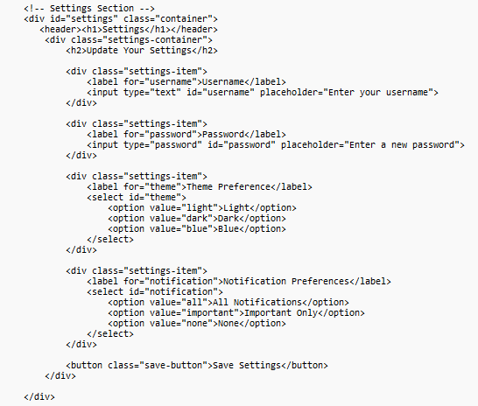

Some important parts from STUDENT CODE-

Home page CSS-

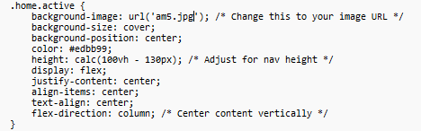

Home page HTML code-

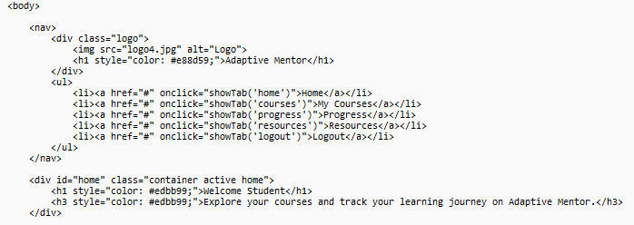

**5. Limitations of the System Proposed**  
  
No Backend Functionality:  
This absence of backend functionality means that the system is not capable of either storing user data or retrieving any user-related information. This incapacitates the system from tracking user progress or saving users preferred settings. So every time a user enters the system, it goes back to square one with the system settings with no recollection of the user learning preference, past activity or progress. This limitation especially dampens the learning process as there is no way an individual can pick up a course where they stopped or get recommendations based on what they did in previous usage of the system.  
  
Simulated Adaptivity:  
Whereas adaptive behavior should be backed by processing data that is being captured in real time or at least made available to the application through the internet, this kind of a system limits its’ adaptive abilities to merely predetermined reactions that correspond to selected learning styles of users. For instance, I could an adaptive system determine the content through monitoring my eyes and body movements, this solution frontend only system implements balance adaptation by using average stereotypes. As a result, the system is able to create a facsimile of a personalized experience for the user, instead of implementing true personalization achievable through usage of user data analytics which may lessen the extent and precision of adaptivity.

Inadequate Integration of User Feedback: In a working adaptive learning system, parameters of user activity, for example, the duration of tasks, percentage of task completion, the accuracy of responses, etc. would be monitored and used to improve the execution of the lessons. Nonetheless as there is no support for backend and database systems the Adaptive Mentor system cannot include requests for these parameters hence its adaptation to user feedback is limited. This absence also limits the capability of the system to offer useful information to the teachers as well as to modify the content based on the performance of the users which in turn restricts its utility as an educational tool.

**6. Proposed Enhancements**

There are promising indications for substantial improvements within the Adaptive Mentor system in several aspects, especially:

Integration of Backend:

The integration of backend capabilities would allow the system to maintain the information of the user, thus providing an option to track progress of particular individuals. The system could be able to create a more E-learning friendly environment by simply saving available information about a user’s learning style, performance history and interaction. Users could also benefit for the feature that allows them to save their progress, which would allow them to continue from where they stopped and be provided with the content that is relevant to their learning at that particular time.

Database Support:

All these would be possible with the introduction of a database that would help the system to store users’ behavioral patterns and interaction histories for better delivery of the contents. The introduction of the new system would give the ability to look back at the data history for purposes of lesson adaptivity enhancement. The data saved can also be helpful for the teachers as they would be able to monitor the progression of their pupils and also understand where the pupils may struggle and need help.

Advanced Adaptivity Using Real Sensors:

The use of real sensors such as eye tracking or motion tracking devices could enhance the system’s capability in that it would be able to detect the user’s level of engagement at any moment. This improvement would allow the system to make real-time changes to the content depending on the user’s eyes, posture, or other physical attributes indicative of engagement. For example, when the user appears to be disinterested based on where their eyes are focused, the system may change the type or speed of the lesson to attract the attention of the user again. This addition would enhance the adaptivity, which would become much quicker and tailored for the user, creating an experience close to what one gets from a human tutor.

Enhancing Analytics for Teachers:

One more improvement may be the addition of an analytics dashboard catered towards educators that will allow such individual to track data per user such as interactions, learning style and learning progress. This will assist teachers with facts to enable them grasp and accommodate differences among their students in the process of teaching them.

**7. Conclusion**

The *Adaptive Mentor* project demonstrates how a personalized educational application can be developed using a modular, front-end-focused approach. By utilizing HTML, CSS, and JavaScript, the project creates an intuitive and adaptive interface that adjusts to different learning styles, providing a customized educational experience without relying on complex backend systems. Despite limitations, such as the lack of backend functionality and real-time adaptivity, the system succeeds in simulating a simplified form of personalized learning.

This project serves as a valuable prototype for a more comprehensive adaptive learning platform, illustrating how lightweight, front-end technologies can emulate aspects of adaptivity. The *Adaptive Mentor* emphasizes user engagement and flexibility, showing potential as a supplement to traditional learning methods. While future enhancements—such as backend integration, database support, and real-time sensor-based adaptivity—would greatly expand its capabilities, the current system highlights the possibilities of adaptive learning technology in a way that is accessible, engaging, and user-friendly.

**8. Bibliography**

DevCommunity: Provided guidance on using JavaScript for interactivity and improving user engagement in the front end. Resources on event handling and adaptive scripting helped make the Adaptive Mentor system responsive to user actions.

GeeksForGeeks: Offered foundational tutorials on CSS for responsive design and HTML structure, which were essential for creating an adaptable user interface. References on Flexbox and Grid systems were especially useful for achieving a flexible layout.

W3Schools: Provided practical examples for HTML, CSS, and JavaScript basics. Step-by-step tutorials supported the project team in building and testing front-end components effectively.