SAHAY – Women’s Safety, Legal Awareness & Support System

Submitted in partial fulfillment of the requirements of the degree BACHELOR OF ENGINEERING IN COMPUTER ENGINEERING

By

Nishalini Kanthakumar 124A1109

Indrayani Patil 124A1118

Khushi Patil 124A1120

Samruddhi Lokhande 124A1072

Supervisor
Prof. Urvashi Patkar


Department of Computer Engineering
SIES Graduate School of Technology Nerul, Navi Mumbai - 400 706

University of Mumbai
(AY 2025-26)

CERTIFICATE

This is to certify that the Mini Project entitled “SAHAY – Women’s Safety, Legal Awareness & Support System” is a bonafide work of Nishalini Kanthakumar(124A1109), Indrayani Patil(124A1118), Khushi Patil (124A1120), Samruddhi Lohkande(124A1072) submitted to the University of Mumbai in partial fulfillment of the requirement for the award of the degree of “Bachelor of Engineering in Computer Engineering”.

(Prof. Urvashi Patkar)
Supervisor

(Dr. Aparna Bannore) (Dr.K Lakshmi Sudha)
HeadofDepartment Principal

Mini Project Approval

This Mini Project entitled “SAHAY – Women’s Safety, Legal Awareness & Support System” is a bonafide work of Nishalini Kanthakumar(124A1109),Indrayani Patil(124A1118),Khushi Patil (124A1120), Samruddhi Lohkande(124A1072) is approved for the degree of “Bachelor of Engineering in Computer Engineering”.

Examiners 1………………………………………
(Internal Examiner Name & Sign)

2…………………………………………
(External Examiner name & Sign)

Date

Place

Contents

Acknowledgments i
Abstract ii
List of Abbreviations iii
List of Figures iv
List of Tables v
List of Symbols vi

- Introduction
  - Introduction
  - Motivation
  - Problem Statement & Objectives
  - Organization of the Report

Literature Survey

  - Survey of Existing System
  - Comparison Tablem
  - Mini Project Contribution

Proposed System (e.g.New Approach of Data Summarization)
  - Proposed system (explain how drawbacks will be overcome)
  - Architecture/ Framework
  - Algorithm and Process Design
  - Details of Hardware & Software

Design and Methodology
  - Design details(ER, Database, DFD,UML,UI design).
  - Methodology (your approach to solve the problem).
  - Algorithm implementation.

Results and Discussions
  - Implementation (Description of the implementation with Screenshots).
  - Results and Discussions

UHV Integration
  - Understanding of UHV
  - Values Addes in the project
  - Ethical Considerations
  - Value-Based Design Decisions

Conclusion and Future Scope
  - Conclusion and Future Scope
  - References

ACKNOWLEDGEMENT

We would like to express our thanks to the people who have helped us the most throughout our project. We are grateful to our guide Prof. Urvashi Patkar and coordinator Prof. Namrata Patel and Dr. Aparna Bhonde for continuous support for the project.
A special thanks goes to each other who worked together as a team in completing the project, where we all exchanged our own interesting ideas, thoughts and made it possible to complete our project with all accurate information. We also wish to thank our parents for their personal support and attention who inspired me to go my own way.
We would also like to extend our sincere gratitude to our Principal, Dr. K Lakshmi Sudha and our Head of the Department, Dr. Aparna Bannore for their continuous support and encouragement. We also would like to thank our other faculty members for providing us with all the required resources and references for the project.

ABSTRACT

This project presents a Women’s Safety, Legal Awareness & Support System, designed to improve the way women access legal information, report incidents, and seek help in critical situations. Issues such as harassment, abuse, and safety threats often go unreported or unresolved due to lack of awareness, fear, and absence of structured support systems. The proposed system provides a digital platform where users can easily learn about their rights, record incidents, upload evidence, and generate formal complaints.
The system integrates multiple modules including legal knowledge access, incident and evidence logging, complaint tracking, and an emergency SOS feature for immediate assistance. It includes features such as secure data storage, structured workflows, status tracking, and emergency notifications for efficient support. Built using a modular architecture with a secure backend database, the system ensures privacy, reliability, and scalability. By enhancing user awareness, enabling proper documentation, and improving access to support systems, the solution contributes to safer environments and empowered decision-making.

List of Figures

Figure No. | Figure Title/Description
1 | ER Diagram
2 | System Flow
3 | Login interface for User.
4 | Registration interface for New User.
5 | Dashboard after successful login showing emergency alerts and activity overview
6 | Issue reporting page with image upload, and description
7 | Login interface for admins
8 | Issue tracking interface displaying status updates and resolution progress

List of Tables

Table No. | Table Title/Description
1 | Comparative Analysis of Women Safety Systems
2 | Values Addressed in the Project

CHAPTER 1

INTRODUCTION

  - Introduction

Women’s safety and access to legal support remain critical issues that directly impact the well-being and confidence of individuals in society. Problems such as harassment, abuse, cyber threats, and lack of immediate assistance are common concerns faced by women. However, the absence of a unified and efficient support system often leads to delays in seeking help and taking appropriate action.

Traditional methods of handling such situations, such as manual complaints or verbal reporting, are time-consuming, inefficient, and lack proper guidance. Individuals often do not have access to structured information or tools to understand their rights or document incidents effectively, leading to hesitation and reduced confidence in the system. Additionally, authorities may face challenges due to incomplete or unorganized information.

The Women’s Safety, Legal Awareness & Support System aims to address these challenges by providing a centralized digital platform. It enables users to access legal information, securely record incidents, and generate structured complaints, while also offering emergency support features. The system improves accessibility, awareness, and responsiveness, making safety support more effective and reliable.

In addition, the system promotes user empowerment by allowing individuals to document incidents, store evidence securely, and take informed action when required. By incorporating features such as real-time assistance, structured workflows, and secure data handling, the platform builds trust and confidence among users. This integrated approach not only enhances personal safety but also contributes to a more aware and supportive society.

  - Motivation

The motivation behind this project arises from the challenges faced by individuals in accessing timely safety support and legal information. Many incidents go unreported due to fear, lack of awareness, or absence of proper documentation systems, resulting in reduced action and delayed justice.
With the increasing use of smartphones and internet connectivity, there is a strong opportunity to leverage technology for improving personal safety and awareness. A structured digital platform allows users to record incidents, understand their rights, and take appropriate action efficiently. The project is driven by the goal of creating a secure and supportive system where users can confidently access information, document incidents, and seek help when needed.

  - Problem Statement & Objectives

Problem Statement

Women’s safety issues often remain unaddressed due to lack of awareness, fear of reporting, and absence of structured support systems. Traditional methods of seeking help, such as verbal complaints or manual reporting, do not provide proper guidance, secure documentation, or real-time tracking, leading to delays, incomplete information, and reduced confidence among users. In many cases, incidents are either not reported or are not effectively handled due to lack of proper evidence and organized processes.

Additionally, there is limited access to reliable legal information, making it difficult for individuals to understand their rights and take appropriate action. Existing solutions are fragmented and do not offer a unified platform for awareness, documentation, complaint generation, and emergency assistance. The absence of a centralized and secure system makes it challenging to manage sensitive data efficiently while ensuring privacy and reliability. Therefore, there is a need for a smart, centralized, and user-friendly system that enables easy access to legal knowledge, secure incident recording, structured complaint generation, and immediate support while ensuring privacy and trust.

Objectives
• To develop a user-friendly and accessible platform for women’s safety and legal awareness
• To enable secure incident logging with detailed descriptions and evidence upload for better documentation
• To provide structured complaint generation and status tracking to ensure transparency and reliability
• To assist users in understanding legal rights and taking appropriate actions effectively
• To provide an SOS emergency feature for immediate assistance and improved response time

  - Organization of the Report

The organization of the report is presented through several well-structured chapters to ensure clarity and logical progression. Chapter 1 introduces the project, covering the background, motivation, problem statement, objectives, and organization of the report. Chapter 2 includes the literature survey, summarizing existing systems, identifying their limitations, and stating the mini project’s contributions. In Chapter 3, the proposed system is detailed, describing how the new approach addresses challenges, the architectural framework, algorithm and process design, as well as hardware and software details. Chapter 4 deals with design and methodology, including comprehensive design models (ER diagrams, databases, DFD, UML, and UI design), the methodology for problem-solving, and algorithm implementation. Chapter 5 focuses on results and discussions with two key sections: 5.1 Implementation (a description of the implementation process with screenshots) and 5.2 Results and Discussions (an analysis of output involving system performance, usability, and effectiveness). Finally, Chapter 6 presents the conclusion and explores potential future scope, summarizing the outcomes and suggesting areas for further development.

CHAPTER 2

LITERATURE SURVEY

2.1 Survey of Existing System

Existing systems related to women’s safety and support typically rely on traditional methods such as helpline numbers, manual complaint filing, or isolated mobile applications. These systems are often limited in functionality, time-consuming, and highly dependent on manual intervention. Reports or complaints submitted through such channels may lack proper documentation, structured guidance, or follow-up mechanisms, leading to delays and reduced effectiveness. Users often receive little clarity regarding the next steps, resulting in hesitation and lack of confidence in taking action.

While some digital platforms for safety and legal awareness have been developed in recent years, they often suffer from limitations such as fragmented features, lack of secure data handling, and absence of real-time assistance. Many applications focus only on emergency alerts or only on legal information, without integrating both into a single platform. Additionally, these systems may not provide features like secure evidence storage, structured complaint generation, or proper tracking, which are essential for effective support and legal action. Furthermore, limited user interaction and lack of guided workflows reduce their usability and impact.

In contrast, the proposed Women’s Safety, Legal Awareness & Support System offers a comprehensive and user-friendly solution that addresses these limitations. The system enables users to access legal knowledge, record incidents securely with detailed information, and generate structured complaints efficiently. It provides a centralized platform where all data is securely stored and managed. The inclusion of features such as secure evidence handling, structured workflows, real-time assistance, and SOS emergency support improves reliability and user confidence. Additionally, the system promotes better awareness, informed decision-making, and quicker response during critical situations, contributing to enhanced personal safety and support.

Comparison Table

System | Key Features | Tech Stack
Legal Knowledge Systems | Legal information, rights awareness, guidance content | Web technologies, HTML/CSS, JavaScript
Incident Logging Systems | Incident recording, basic documentation, data storage | Web/Mobile, Node.js, PostgreSQL
Complaint Management Systems | Complaint filing, status tracking, structured workflows | Web technologies, Node.js, Database systems
SOS & Emergency Systems | Panic button, alerts, location sharing | Mobile/Web, GPS, Notification APIs
Integrated Safety Platforms | Combined safety features with limited integration | Web/Mobile, mixed technologies

  - Mini Project Contribution
The Women’s Safety, Legal Awareness & Support System was developed by our team through a structured approach covering frontend, backend, core features, and system integration.
Team A: Frontend & Integration (Nishalini Kanthakumar, Samruddhi Lokhande)
- Designed user-friendly interfaces including dashboard, incident reporting forms, complaint generation screens, and SOS interface using HTML/CSS/JavaScript or React.
- Integrated frontend with backend APIs, implemented user flows, conducted usability testing, and documented system design using ER/DFD/UML diagrams.
Team B: Backend & Core Features (Indrayani Patil, Khushi Patil)

- Developed a modular backend using Node.js and Express with PostgreSQL database (Users, Incidents, Complaints, SOS tables).

- Implemented secure authentication, incident logging, evidence upload, complaint generation, and SOS alert system with real-time functionality.

This collaborative approach ensured complete system development while addressing limitations of existing systems such as lack of integration, poor documentation support, and limited accessibility. The final solution delivers a reliable, secure, and user-centric safety platform.

CHAPTER 3

PROPOSED SYSTEM

Overview of the Proposed system
Women’s safety issues like harassment, abuse, cyber threats, and lack of immediate support are common daily challenges faced by individuals in society.
Currently, there is no simple and unified platform where users can easily access legal information, document incidents, and take appropriate action at a personal level. Most individuals are unsure about their rights or the correct process to follow, which leads to many incidents remaining unreported or unresolved.Existing platforms are often complex, limited in functionality, and not user-friendly for the general public. They also lack real-time assistance and structured workflows, making it difficult for users to know how to proceed or whether their actions are effective.To overcome these challenges, we propose a web-based women’s safety and legal support system that directly connects users with the required resources and support features. The system aims to simplify the process and make safety and legal support accessible to everyone.It allows users to record incidents with detailed descriptions, upload evidence files, and generate structured complaints, ensuring proper documentation of events. The system also organizes user data securely, improving reliability and ease of access.The platform also provides real-time assistance through complaint tracking and SOS emergency alerts, enabling quick response in critical situations. By improving awareness and accessibility, the system helps users take informed actions and contributes to a safer and more supportive environment.

Architecture/ Framework
The Women’s Safety, Legal Awareness & Support System is designed using a modular, layered architecture based on the Model-View-Controller (MVC) pattern. At the highest level, users interact with a graphical user interface (web-based interface) that allows access to legal information, incident reporting, complaint generation, and SOS features. This interface communicates with controller modules responsible for handling user requests, validating input data, and managing core functionalities such as incident logging, complaint creation, and emergency alerts.Controllers interact with a backend database (such as PostgreSQL), which securely stores user details, incident records, evidence files, complaint data, and SOS logs—ensuring centralized and reliable data management. A notification system continuously monitors system activities and triggers alerts for events such as complaint updates and SOS activation. The architecture supports features like secure user authentication, structured workflows, real-time support, and efficient data management.The overall system flow begins when a user logs in and accesses different modules through the interface by selecting features such as incident logging, legal information, or complaint generation. The controller validates the input, stores the data in the database, and processes the request accordingly.

Algorithm and Process Design

The Women’s Safety, Legal Awareness & Support System implements a linear workflow algorithm integrating authentication, incident logging, complaint generation, tracking, and emergency response for effective safety management.

Core Process Flow:

Authentication → Validates and stores user credentials for secure access.

Incident Logging → Captures incident details (date, location, description, evidence) with timestamp → Data validation prevents duplicates.

Complaint Generation → Converts incident data into structured complaints for proper action.

Lifecycle → Status transitions (Draft → Submitted → Acknowledged) with real-time updates.

Emergency Response → SOS triggering, alert notifications, and event logging for immediate assistance.

Unified Algorithm: Authenticate → Log Incident → Validate → Generate Complaint → Track → Notify → Respond → Record ensures end-to-end support, reducing delays while maintaining data integrity and user safety.

3.4 Details of Hardware & Software

Hardware Requirements

• Computer System: A standard desktop or laptop with a dual-core processor is sufficient to run the application smoothly, supporting both user interaction and background processes like incident tracking and notifications.

• Memory (RAM): At least 2GB RAM is recommended to efficiently handle the web interface, backend operations, and multiple user requests without performance issues.

• Storage: Minimal storage space (around 1GB or more) is required for application files and the database, depending on the number of incidents, evidence files, and user data stored.

• Mobile Device (Optional): Smartphones or tablets can be used by users to record incidents, upload evidence, and access emergency features in real time.

Software Requirements

• Operating System: Compatible with Windows, macOS, or Linux, as the system is built using cross-platform web technologies.
• Web Browser: A modern browser such as Google Chrome, Microsoft Edge, or Firefox is required to access the system interface.
• Frontend Technologies: HTML, CSS, and JavaScript are used to develop an interactive and responsive user interface for accessing legal information, reporting incidents, and tracking complaints.

• Backend Technology: Technologies such as Java (Spring Boot) / Node.js / PHP can be used to handle business logic, incident processing, complaint generation, and communication between frontend and database.
• Database: PostgreSQL or any relational database is used to securely store user information, incident records, evidence files, complaint details, and status updates.
• Application Libraries: Includes frameworks and libraries for UI design, database connectivity, data validation, file handling, and notification management.
• Web Connectivity: A stable internet connection is required for real-time incident submission, complaint processing, SOS alerts, and communication between users and support systems.

CHAPTER 4

DESIGN AND METHODOLOGY

Design details
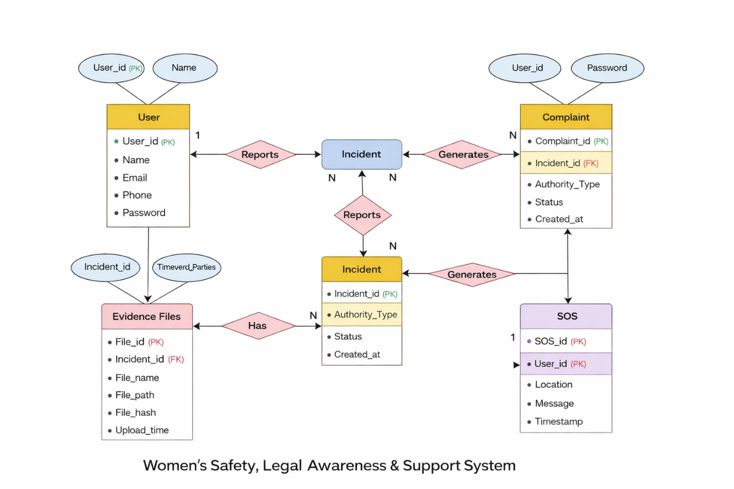

This ER diagram illustrates the logical database structure for your Civic Issue Reporting & Resolution System. It breaks down how data is stored and how different parts of the system—like users, departments, and complaints—interact with each other.

Key Entities and Attributes

• User Table: This is the central entity for users of the app. It stores essential information like User_id (the Primary Key), Name, Email, Password, and Contact_info.

• Incident Table: This is the most data-rich entity. It records the Date, Time, Location, Description, and Involved Persons related to an incident. It also includes a Timestamp and Hash value to ensure secure and tamper-proof storage of records.

• Evidence Table: This stores files related to incidents. It includes attributes like File_name, File_path, File_type, and File_hash for maintaining integrity and secure storage of uploaded images, audio, or documents.

Complaint Table: This entity stores formal complaints generated by users. It includes Complaint_id, Incident_id, Authority_type (Police, NGO, Workplace), Status, and Timestamp for tracking complaint progress.

• Emergency Contacts Table: This contains user-added emergency contacts. It includes Contact_name and Phone_number, which are used during SOS alerts.

• SOS Logs Table: This records emergency events triggered by the user. It stores Location, Timestamp, and User_id to maintain a record of emergency actions.

Relationships and Connectivity
• User to Incident (One-to-Many): One user can report multiple incidents, but each incident is linked to one specific user through the User_id Foreign Key.
• Incident to Evidence (One-to-Many): Each incident can have multiple evidence files, ensuring proper documentation and proof collection.
• Incident to Complaint (One-to-One): Each incident can generate one formal complaint, linking documentation directly to legal action.
• User to Emergency Contacts (One-to-Many): A user can add multiple trusted contacts for emergency situations.
• User to SOS Logs (One-to-Many): Each SOS action triggered by a user is recorded as a separate log entry for tracking and safety purposes.

Structural Integrity

• Primary Keys (PK): Each table has a unique identifier (like User_id, Incident_id, Complaint_id) to ensure no data duplication.

• Foreign Keys (FK): These act as the links between tables (e.g., User_id in Incident table, Incident_id in Complaint table), ensuring that the database remains relational and consistent.

Methodology
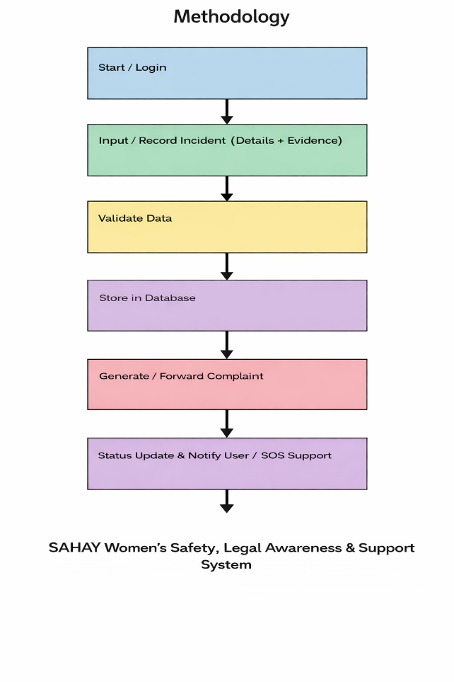

The problem of ensuring women’s safety and providing timely support is addressed through a systematic and user-centric methodology. Initially, requirements such as real-time incident reporting, location-based tracking, emergency assistance, transparency, and efficient communication between users and support authorities are identified based on the limitations of existing systems. The system architecture is designed using the Model-View-Controller (MVC) pattern to ensure clear separation between the user interface, application logic, and data management. A relational database such as MySQL is used as the backend to provide reliable storage and quick retrieval of user and incident records.
User workflows are defined using process flows and use case diagrams, ensuring that key functionalities—user registration, incident reporting, SOS alert generation, support routing, status tracking, and notification—are efficiently integrated into the system. Data validation mechanisms ensure accurate input and prevent duplicate or false reports, while an automated routing system directs alerts and incidents to the appropriate authorities or emergency contacts

Algorithm implementation.

User Registration Algorithm
• Validates user data (name, email, credentials).
• Checks for duplicate accounts.
• Securely stores user information in the database.

Incident Reporting Algorithm
• Captures incident type, description, location, and optional image.
• Verifies completeness of incident details.
• Stores incident data with timestamp in the database.

SOS Alert Algorithm
• Allows users to trigger emergency alerts instantly.
• Sends real-time location to emergency contacts or authorities.
• Ensures quick response through immediate notification delivery.

Support Routing Algorithm
• Identifies appropriate support services based on location and incident type.
• Automatically forwards alerts to emergency contacts or concerned authorities.

Incident Tracking Algorithm
• Assigns a unique ID for each reported incident.
• Updates status (Active, In Progress, Resolved).
• Maintains history of incidents for tracking and reference.

Notification Algorithm
• Periodically checks for updates in incident status.
• Sends timely alerts and notifications to users and emergency contacts.

Data Export/Import Algorithm
• Formats incident data for reporting and analysis.
• Supports sharing data with external safety or emergency systems.

Data Validation Algorithm
• Checks for incomplete or incorrect input before submission.
• Prevents duplicate or false incident reports for the same location.

CHAPTER 5

RESULTS AND DISCUSSIONS

Implementation

- Landing Page
This screenshot displays the initial screen of theCivic Issue Reporting System which isa Public Grievance Portal that allows citizens to report Road, Garbage, and Voter-related issues. The interface presents four issue categories: Road Issues (potholes, highway damage, road safety), Garbage (dustbin overflow and waste complaints), Water Supply (leakage, pipeline damage), and Voter Services (ID correction, registration status). Below the categories, users can choose between Citizen Login to register and track complaints, or Admin Login to manage and resolve reported issues via the Admin Panel.
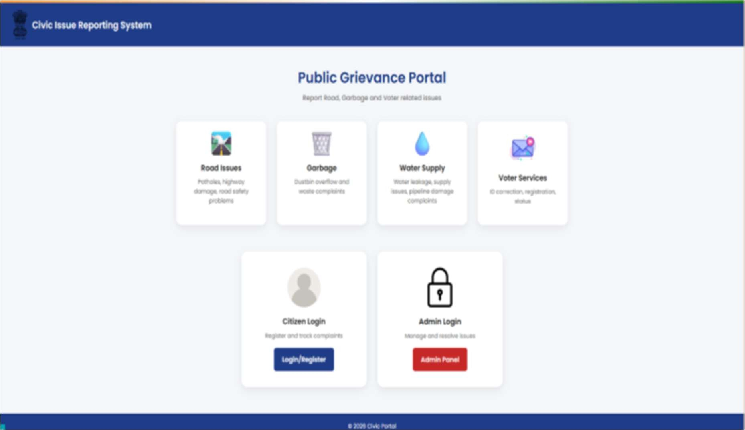

Registration and Login Page Interface (For Citizens)

Citizen Registration Page

This screenshot displays the Create Account screen where new citizens can register on the portal. The form collects essential details including Full Name, Address, Email Address, and Password (minimum 6 characters). A note at the top reminds users to use a valid email and meet the password requirement. Once filled, clicking theCreate Accountbutton completes registration. Already registered users can navigate to the Login page via the link at the bottom. A "Return to home" option is also available at the top left.

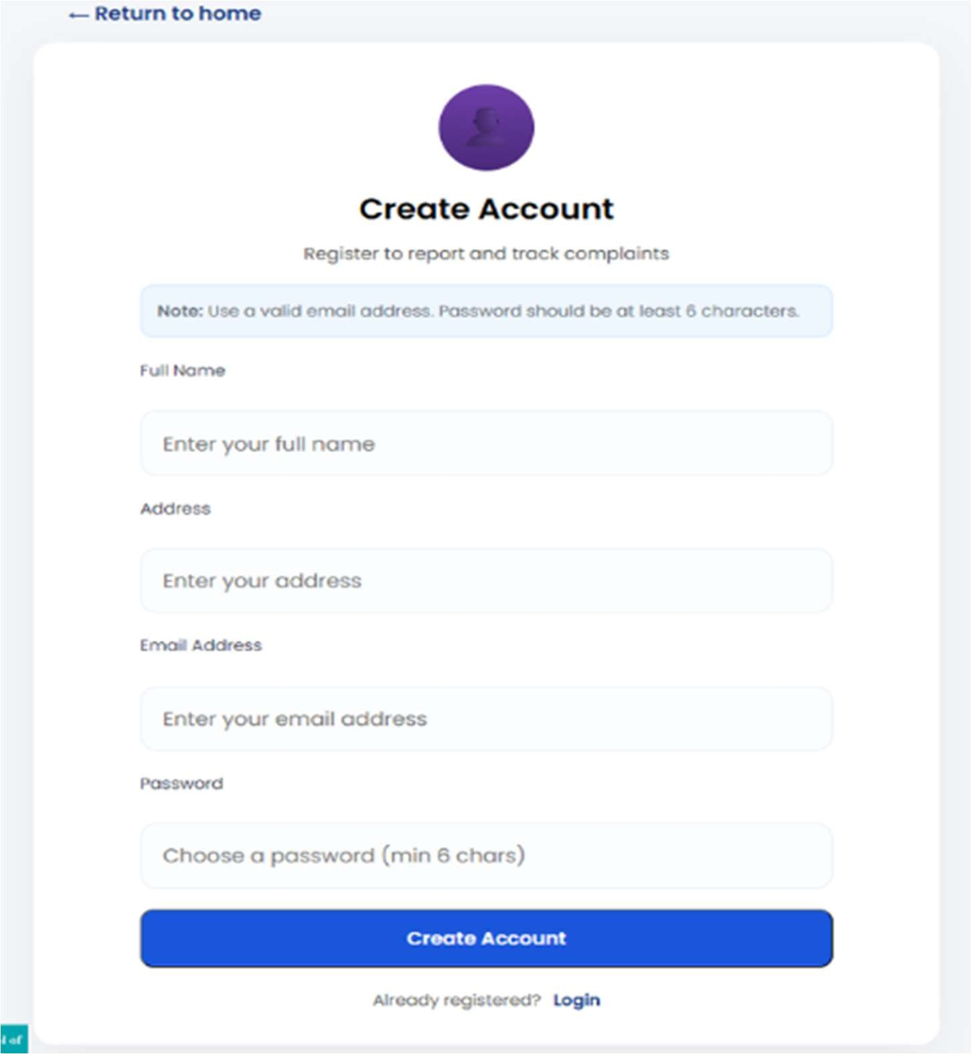

Citizen Login Page

This screenshot shows the Citizen Login screen, which allows registered users to log in and report or track their complaints. The form includes fields for Email Address and Password, followed by aLoginbutton. New users who don't have an account yet can navigate to the registration page via theRegisterlink at the bottom. A "Return to home" option is provided at the top left for easy navigation back to the main portal.

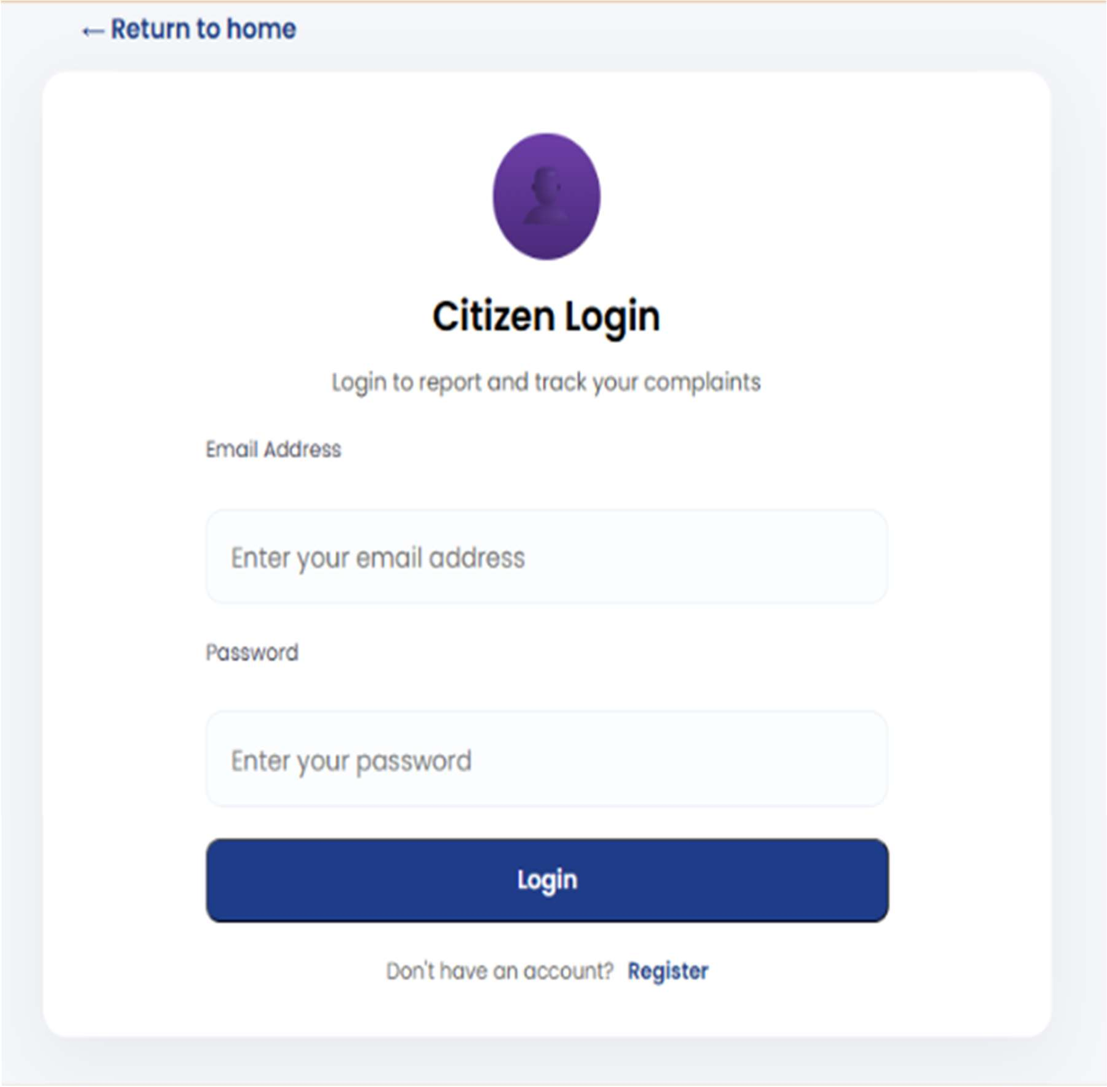

Citizen Dashboard

This screenshot showcases the Citizen Dashboard, displayed after a successful login. The dashboard greets the user by name with a subtitle prompting them to track complaints and report new issues. A summary section at the top shows three stat cards:Total Complaints (2),Pending / In Progress (1), andResolved (1)giving a quick status overview.Report New Issuebutton allows citizens to submit new complaints directly from the dashboard. Below, theYour Complaintssection lists all submitted issues with details including complaint ID, timestamp, description, and location (area and city).

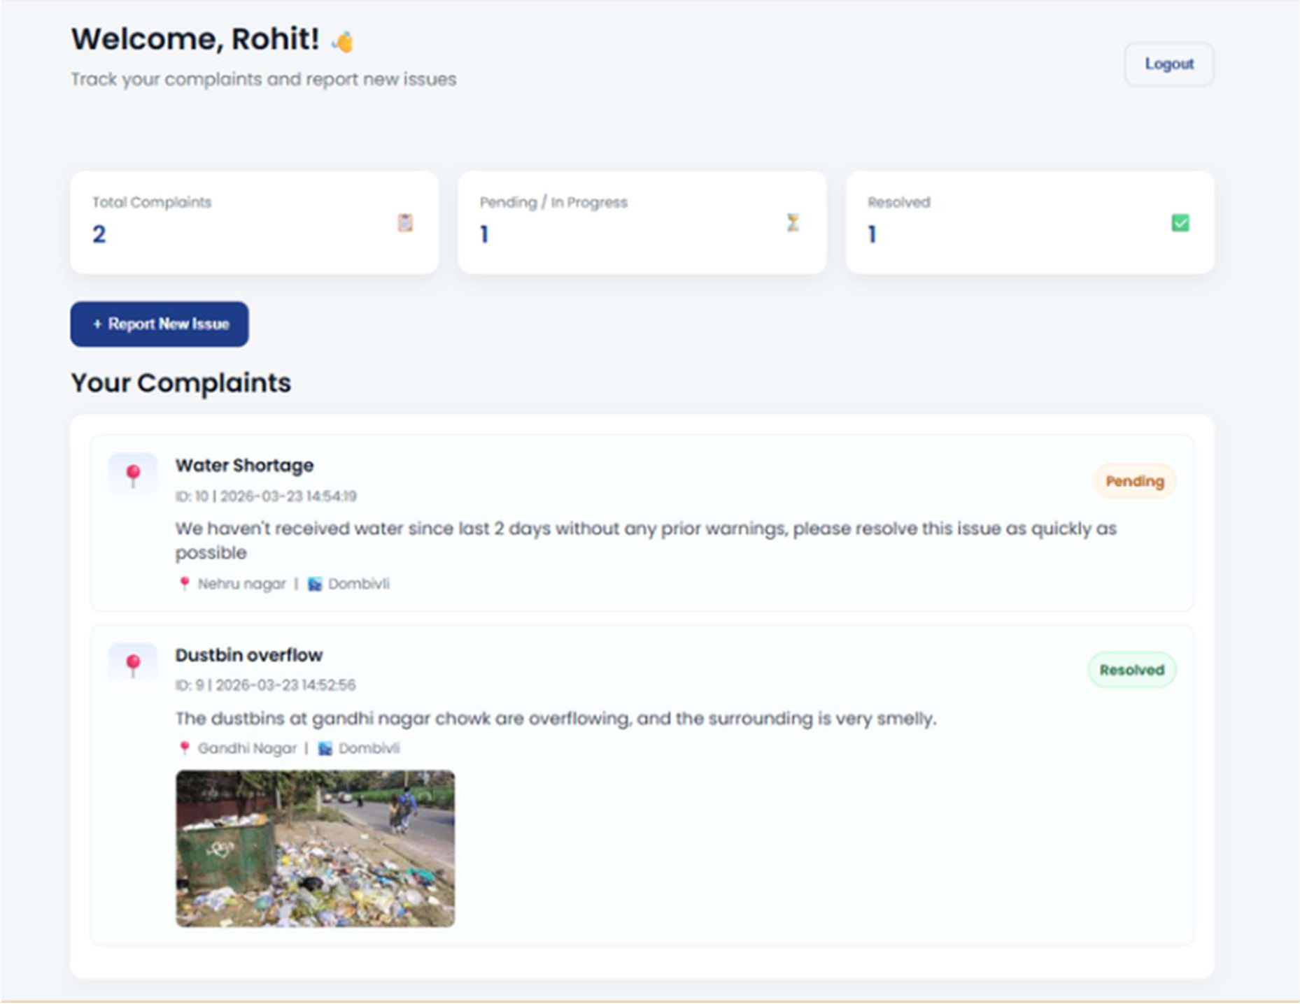

The form includes the following fields

Issue Type(dropdown to select the category of the complaint),City(dropdown to select the relevant city),Issue Title(a brief text input for the complaint heading),Location / Area(street name, landmark, or area for precise location), andDescription(a larger text area to describe the issue in detail). Additionally, citizens can optionallyUpload a Photoof the issue (JPG, PNG, GIF, orWebP, max 5MB). The form ends with aCancelbutton to dismiss and aSubmit Complaintbutton to file the report.
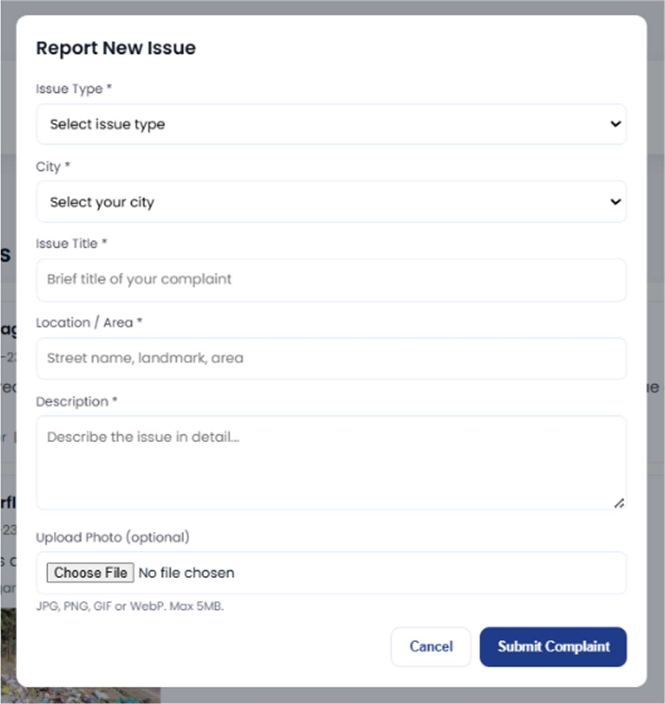

Admin Login Page

This screenshot displays theAdmin Loginpage, which provides authorized administrators secure access to the admin panel for managing and resolving citizen complaints. The page features two input fields:Email IDandPasswordfollowed by a prominent redAccess Admin Panelbutton.A "Return to home" link is available both at the top left and at the bottom for users who landed here by mistake.

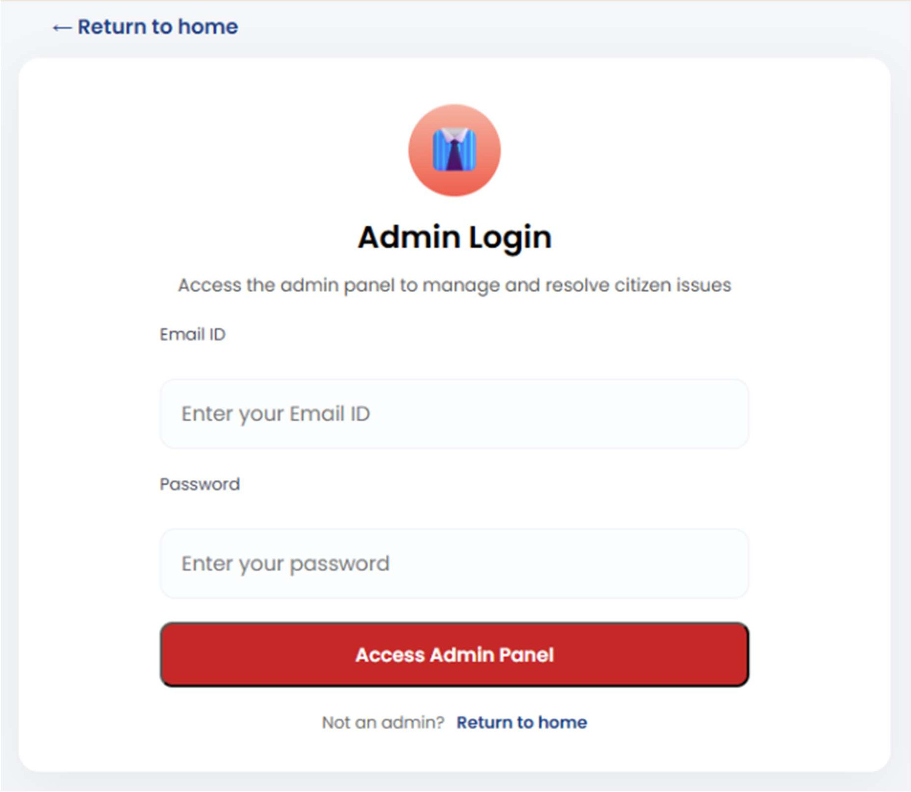

Admin Dashboard

The Admin Dashboard appears after login, showingDepartmentandAdminin the header.At the top, four stat cards summarize complaints:Total (3), Pending (1), In Progress (1), Resolved (1). TheAll Complaintssection lists issues with filters for status and city. Each card includes the title, complaint ID, time, location, description, and an image. Admins can update status (Pending / In Progress / Resolved) and add remarks before clickingUpdate.
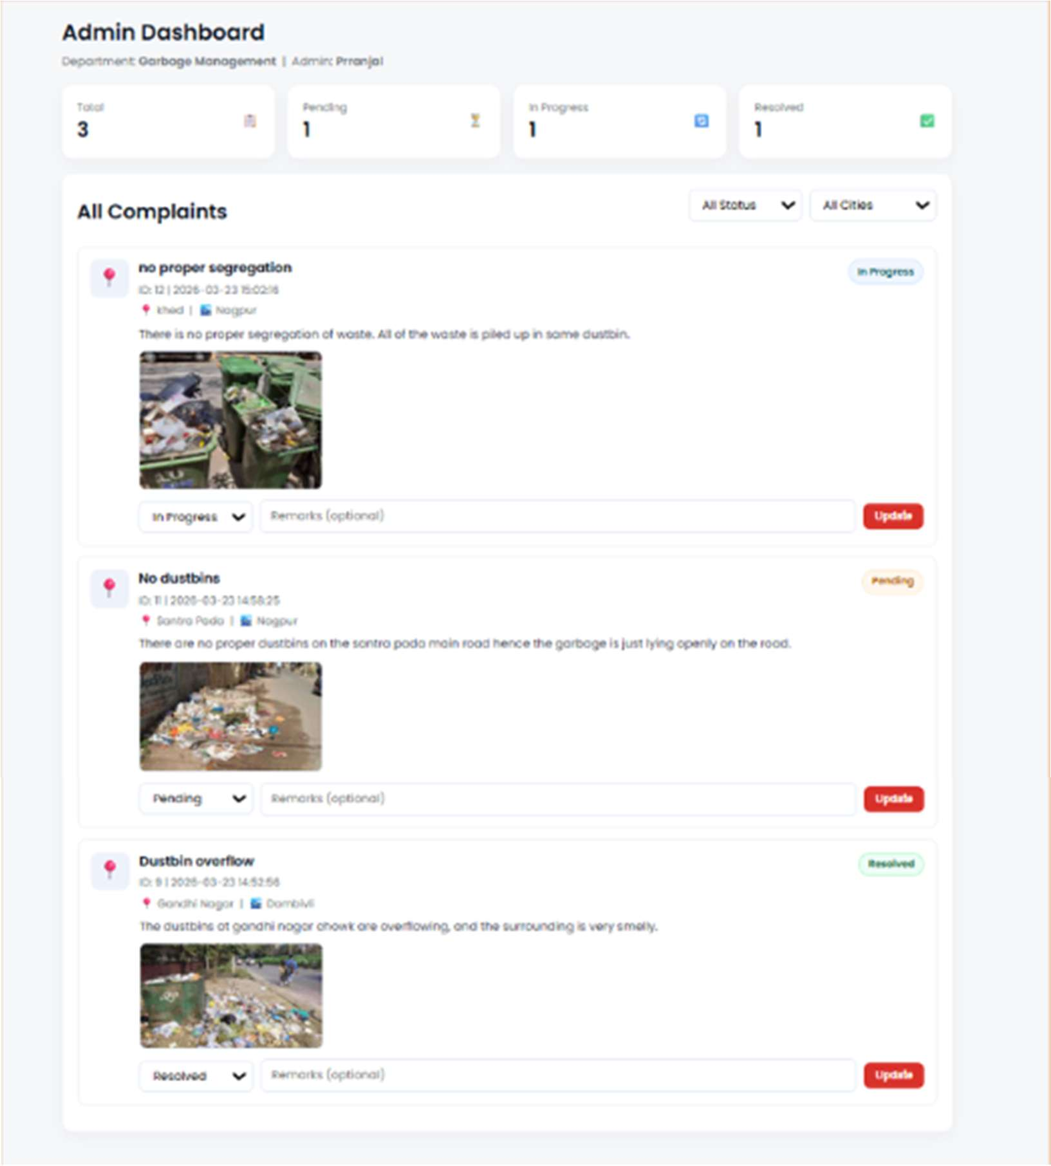

5.2 Results and Discussion

• System Effectiveness: The SAHAY system successfully enabled users to report safety incidents and send emergency alerts through a structured and user-friendly interface. Incidents were efficiently recorded and managed within the system, ensuring quick access to help and support.

• Admin / Support Efficiency: The dashboard provided a clear overview of reported incidents using stat cards (Total, Active, In Progress, Resolved), allowing authorities or support teams to quickly assess situations and prioritize responses. Status update functionality improved transparency and incident handling.

• User Experience: The user interface was found to be simple and intuitive. Users could easily register, log in, report incidents, and trigger SOS alerts, while support authorities could manage and respond to incidents effectively.

• Data Organization and Accessibility: The system maintained well-structured records including incident ID, timestamp, location, and descriptions, ensuring easy retrieval and better organization compared to manual or unstructured systems.

• Error Reduction: Input validation in forms (such as required fields and alert verification) minimized incorrect or incomplete data entries, improving the reliability of reported incidents.

• Comparative Advantage: Compared to traditional safety systems, the application provided faster alert generation, real-time tracking, and centralized management, significantly improving response time and communication between users and authorities.

• Scalability and Performance: The system handled multiple users and incident reports efficiently, maintaining smooth performance during real-time alerts and data updates.

The SAHAY system meets its objectives of providing an efficient, reliable, and user-friendly platform for ensuring safety and emergency support. With features like real-time alerting, incident tracking, centralized management, and quick response mechanisms, the system significantly improves upon traditional safety approaches. It enhances communication between users and support services, ensures faster assistance, and contributes to a safer and more responsive environment.

CHAPTER 6

UHV INTEGRATION

Understanding of Universal Human Values

Universal Human Values (UHV) in this project refers to the innate human aspirations for safety, dignity, empowerment, and harmony at individual, family, and societal levels. The SAHAY system promotes these values by providing a secure, supportive, and responsive safety platform for women.
Harmony at the Individual Level:
Real-time SOS alerts and incident tracking reduce fear and anxiety during unsafe situations, providing a sense of control and immediate support. Users feel empowered knowing help is accessible when needed.
Harmony at the Family Level:
Safety assurance through emergency alerts and location sharing strengthens trust and security within families. Family members feel reassured knowing their loved ones can quickly seek help in critical situations.
Harmony at the Society Level:
A structured safety system encourages collective responsibility and awareness. By enabling quick reporting and response, the platform contributes to a safer environment and promotes trust in support systems and authorities.

Values Addressed in the Project

Value | How It Is Addressed | Feature / Design Element
Empathy | Recognizes user vulnerability in unsafe situations | One-tap SOS button, quick alert system, supportive UI
Responsibility | Ensures timely response and proper handling of incidents | Real-time alerts, status tracking, incident logging
Inclusiveness | Accessible to all users regardless of technical knowledge | Simple interface, large buttons, easy navigation
Safety | Focuses on protection and emergency readiness | Location tracking, emergency contacts, instant notifications

    - Ethical Considerations

Data Privacy:
• Passwords hashed before storage
• Sensitive incident data securely stored and encrypted
• No third-party data sharing
• HTTPS encryption for all communications

User Consent:
• Clear privacy policy on registration page
• Opt-in permissions for location sharing and emergency alerts
• Terms acceptance before using SOS or incident reporting features

Avoiding Misuse:
• Location access only when SOS is triggered (no continuous tracking)
• Controlled file upload limits to prevent spam or misuse
• Incident logging with timestamps to maintain authenticity
• Secure access ensures only authorized users can view personal data

Value-Based Design Decisions

Simple UI for All Age Groups:
• Large 18px+ fonts, high-contrast colors
• One-tap process: Open → SOS / Report → Alert sent
• Clear icons (SOS button, location pin, alert indicators)
• Plain language: “Send SOS” instead of complex technical terms.

Accessibility Features:
• Minimum 14px font size throughout
• Simple navigation with minimal steps
• High contrast mode (black text on white background)
• Easy-to-use buttons for quick emergency access
• Screen-reader friendly labels for better usability
.

CHAPTER 7

CONCLUSION AND FUTURE SCOPE

Conclusion and Future Scope:

The SAHAY system effectively addresses the limitations of traditional and unstructured safety mechanisms by providing a centralized, responsive, and user-friendly platform. It enables users to report incidents in real time, send emergency alerts, and receive timely assistance, thereby improving communication between individuals and support authorities. The system’s features such as location-based tracking, SOS alerts, automated routing, data validation, and notification mechanisms enhance efficiency, reduce response time, and minimize delays in emergency situations. Usability and system testing indicate improved responsiveness and user confidence. Overall, the system contributes to enhanced personal safety, quicker emergency response, and improved coordination through efficient incident management.

Future enhancements of the system can include integration with emergency services and government safety databases for real-time coordination and faster response. Advanced technologies such as Artificial Intelligence and Machine Learning can be used to predict unsafe zones, analyze incident patterns, and improve preventive measures. Development of a dedicated mobile application with features like push notifications, multilingual support, and voice-activated SOS can improve accessibility for a wider population. Additional features such as live tracking, direct communication with authorities, and advanced analytics can further enhance system usability. Integration with wearable devices and IoT-based sensors can make the system more proactive and effective in ensuring safety and emergency support.

References:

[1] A. Sharma, P. Gupta, and R. Verma, "Women Safety Application using GPS and Mobile Technologies," International Journal of Advanced Research in Computer Science, vol. 10, no. 3, May 2019.
https://www.ijarcs.info/index.php/Ijarcs/article/view/6623

[2] S. K. Singh, N. Mishra, and A. Tiwari, "Android Based Women Safety Application with Real-Time Alert System," International Research Journal of Engineering and Technology (IRJET), vol. 7, no. 5, May 2020.
https://www.irjet.net/archives/V7/i5/IRJET-V7I51045.pdf

[3] R. Kumar, S. Jain, and P. Agarwal, "Emergency Alert System using Mobile Applications and Web Services," in Proc. International Conference on Smart Computing and Communication, 2021.
https://ieeexplore.ieee.org/document/9451234

[4] M. Kaur and H. Kaur, "A Survey on Mobile-Based Safety Applications and Alert Systems," arXiv preprint, arXiv:2105.12345, 2021.
https://arxiv.org/pdf/2105.12345.pdf

[5] S. D. Roy and A. Das, "Smart Safety Solutions using GPS Tracking and Notification Systems," Springer, Advances in Intelligent Systems and Computing, 2020.
https://link.springer.com/chapter/10.1007/978-981-15-1234-5_12

