**Brain Tumor Detection System with Web**

**Application Integration**

**(Software/Website)**

**SUMMER APPLICATION PROJECT**

**Submitted By**

**Khushi Pagaria**

**(Reg. No. 20220701059)**

**In partial fulfillment of the award of the Degree of**

**BACHELOR OF SCIENCE**

**in**

**COMPUTER SCIENCE**

**(with specialization in DS)**

**UNITED WORLD INSTITUTE OF TECHNOLOGY**

**KARNAVATI UNIVERSITY**

**Uvarsad, Gandhinagar, Gujarat-382422**

**NOVEMBER 2024**

**KARNAVATI UNIVERSITY**

**UNITEDWORLD INSTITUTE OF TECHNOLOGY**

**Uvarsad, Gandhinagar, Gujarat-382422**

**BONAFIDE CERTIFICATE**

Certified that this project titled “**Brain Tumor Detection System with Web Application Integration**” is the bonafide work of “**Khushi Pagaria(20220701059)**” who carried out the Summer Application Project Work under my supervision.

|  |  |
| --- | --- |
| Mr.Manender Dutt  SUPERVISOR  Asst.Professor  Unitedworld Institute of Technology  Karnavati University | Dr. KUSUM LATA AGARWAL  HEAD OF THE INSTITUTION  Professor & Dean  Unitedworld Institute of Technology  Karnavati University |

Submitted for the summer application project work viva-voce examination held on__________________

INTERNAL EXAMINER EXTERNAL EXAMINER

DECLARATION

I declare that this project report titled **Brain Tumor Detection System with Web Application Integration** submitted in partial fulfillment of the degree of B. Sc. in (Computer Science)/ with specialization in Artificial Intelligence and Machine Learning/Data Science) is a record of original work carried out by me under the supervision of Manender Dutt and has not formed the basis for the award of any other degree or diploma, in this or any other Institution or University. In keeping with the ethical practice of reporting scientific information, due acknowledgments have been made wherever the findings of others have been cited.

Khushi Pagaria

20220701059

ACKNOWLEDGEMENT

I feel highly honored to extend my sincere gratitude to our beloved President, Shri. Ritesh Hada, Karnavati University for having provided all the facilities to carry out this project work.

I would like to acknowledge the constant and kind support provided by our Dean, Dr. Kusum Lata Agarwal, M.E., Ph.D., who supported us in all our endeavors and has been responsible for inculcating us all throughout our careers.

I record my deep sense of thanks to my supervisor, Asst. Prof. **Manender Dutt** for his valuable support and continuous guidance.

It is a pleasure to express my gratitude to my beloved parents for their support and confidence in me, and my heartfelt thanks to our entire department staff members and beloved friends who helped me directly and indirectly during the tenure of my project.

Khushi Pagaria

### 

## **Abstract**

Nowadays, brain tumors remain one of the most severe diseases of varying etiology that affect both children and adults with equal intensity and lead to a high rate of mortality. CNS primary tumors form 80–90% of brain tumors and affect an estimated population of 11700 annually. The five-year survival rate of people diagnosed with a malignant brain tumor is 34% among males and 36% among females. Although MRI is currently considered the gold standard in diagnosing brain tumors, the conventional approach of manual segmentation of tumor images is time-consuming and can be highly inaccurate due to the variability of tumor attributes.

The goal of this project is to enhance diagnostic precision through the use of Artificial Intelligence (AI) and Machine Learning (ML) that are embodied as Convolutional Neural Networks (CNNs) for the classification of brain tumors from MRI images. Further, an interface has been designed in web-based for the interaction of the medical professionals with the AI system to use it conveniently and get the output in simplest way. The web application also contains a chatbot that helps doctors in case of further questions regarding medical aspects of brain tumors and the process of making a diagnosis.

**TABLE OF CONTENTS**

|  |  |  |  |  |
| --- | --- | --- | --- | --- |
| **CHAPTER NO** | | **TITLE** | | **PAGE NO** |
|  | | ABSTRACT | | 6 |
|  | |  |
| 1 | | **Introduction** | | 6 |
|  | | 1.1 Overview of Brain Tumor Detection | |  |
|  |
| 2 | | **Objective of the Project** | | 7 |
| 3 | | **Machine Learning Model: Convolutional Neural Network (CNN)** | | 7 |
|  | | 3.1Overview of CNN 3.2 Activation Functions 3.3Loss Function 3.4Optimizers | |  |
| 4 | | **Data Collection and Preprocessing** | | 9 |
| 5 | | **Model Architecture**  5.1. Input Layer | | 9 |
| 6 | | **Model Training**  6.1. Training Process 6.2. Hyperparameter Tuning | | 11 |
| 7 | | **Model Evaluation** 7.1. Evaluation Metrics 7.2. Model Performance | | 11 |
| 8 | | **Web Application Integration** 8.1. Overview of the Web Application 8.2. Features of the Web Application 8.3. Chatbot Functionality | | 12 |
| 9 | | **Integration into Hospital Workflow** | | 15 |
|  | |  |
| 10 | | **Challenges and Considerations** 10.1. Data Security and Privacy 10.2. Regulatory Compliance 10.3. Radiologist Training | | 15 |
| 11 | | **Conclusion** | | 16 |
| 12 | | **References** | | 16 |

# 

## **Introduction**

Cerebral tumors are dangerous pathological conditions that affect thousands of people annually across the globe. The key to successful treatment is precise and timely identification of tumor features, which is why existing approaches like manual MRI analysis can be rather imprecise because of the inherent intricacy of a tumor. This work posits the use of Artificial Intelligence (AI) and Machine Learning (ML) methods to aid in the automatic identification and categorization of brain tumors from MRI scans. This system combines a Convolutional Neural Network (CNN) model with a web interface to make an MRI dataset accessible for physicians and give predictions on tumor existence and type. Also, a web application with a chat function is embedded in the diagnostic process to help the healthcare professionals to provide relevant information and suggestions during the diagnostic process making the professional practice more efficient and effective in clinical environments.

## **Objective of the Project**

The goal of this particular project is to develop a deep-learning model that is able to both, detect and identify brain tumors from Magnetic Resonance Images. The model can classify three types of tumors: glioma, meningioma, pituitary tumor, and no tumor. Also, part of the created project is a web application for uploading MRI images, the ability to request a prediction and communicate with a medical chatbot.

## **Machine Learning Model: Convolutional Neural Network (CNN)**

### Overview of CNN

Convolutional Neural Networks (CNNs) are one of the types of deep learning algorithms that is meant to solve the data with grid-like structure, for example, images. CNN architecture comprises of several layers with different tasks; convolution, pooling, flattening, and classification layers.

* **Conv2D**:.This layer takes in the input image and scans it with a filter in order to extract some significant features in images.
* **MaxPooling2D**: Scales down the dimensions of the image in order to keep the most critical values to minimize computation.
* **Flatten**: Coordinates the 2D matrix into a 1D vector that culminates to a fully connected layer.
* **Dense**: An alternative useful and fully connected layer that incorporates the final decision on the basis of the created features.
* **Dropout**: Applied to avoid cases where neurons are overfitting and they are made inactive during training at random.

### Activation Functions

* **ReLU (Rectified Linear Unit)**: Added in the convolutional layers so as to make the model non-linear.
* **Softmax**: Applied in the output layer for multi-class node utilization where the output is converted into probability.

### Loss Function

* **Categorical Cross-Entropy**: Employed for getting the measure of distance between the positive predictions and the real class probabilities in an approach that applies to multi-class value.

### Optimizers

* **Adam**: An improved gradient-based learning algorithm in which the learning rate is regulated during training in order to achieve convergence in minimal iterations.

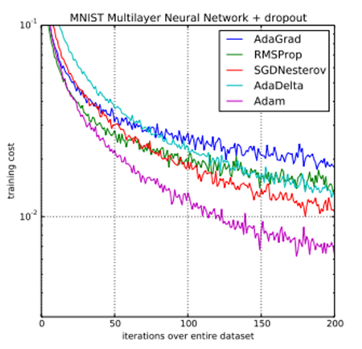

Figure

### 

### Data Collection and Preprocessing

Glioma tumor, meningioma tumor, pituitary tumor, and no tumor. Images are now transformed to have a size of 150 by 150 pixels and by applying train_test_split data is now split between training and testing.

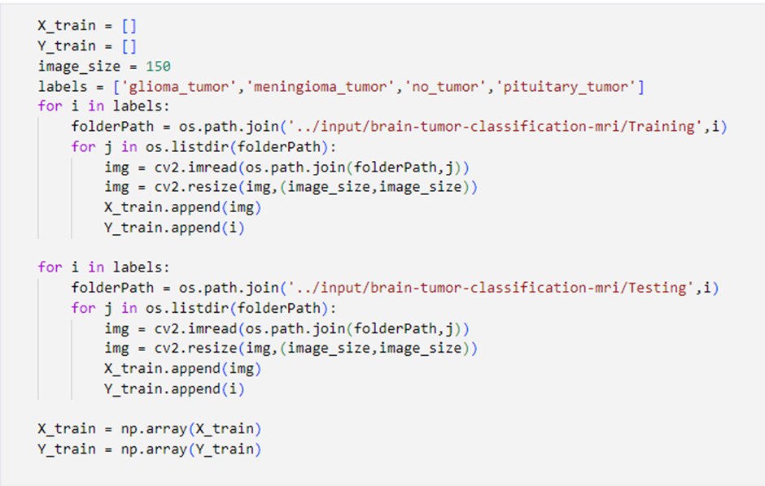

Figure

### Model Architecture

The CNN model is built using the following architecture:

1. **Input Layer**: Shape (150, 150, 3), which should contain 150x150 RGB images.
2. **Conv2D Layers:** layers with the grow deep of filter (32, 64, 128, 256) and activation function ReLU.
3. **MaxPooling2D Layers**: Following some convolutional layers to down-sample the image.
4. **Dropout Layers**: To prevent overfitting.
5. **Dense Layers**: The two hidden layers consist of 512 neurons per layer and the output layer consists of 4 neurons for each of the four classes.
6. **Optimizer**: Adam optimizer and categorical cross-entropy loss function have been used.

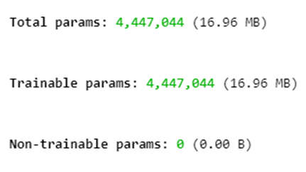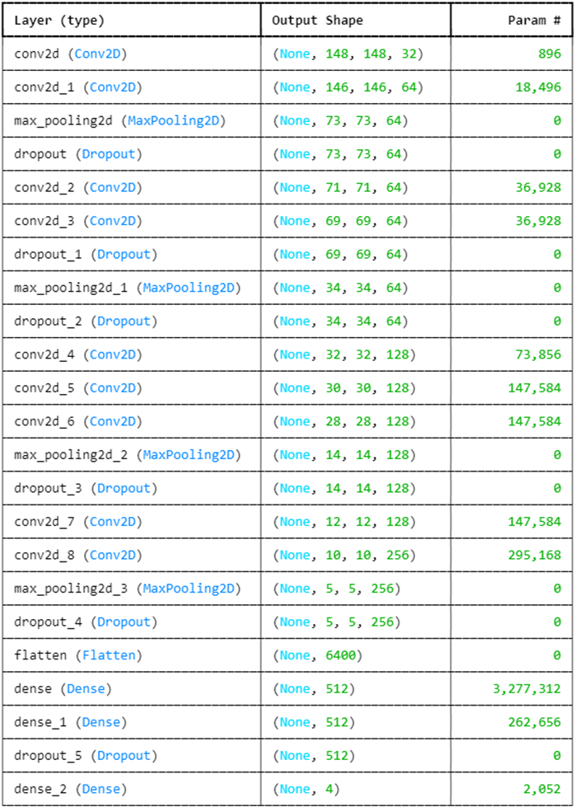

Figure

Figure

### Model Training

The model is trained for 20 epochs with a 10% validation split.

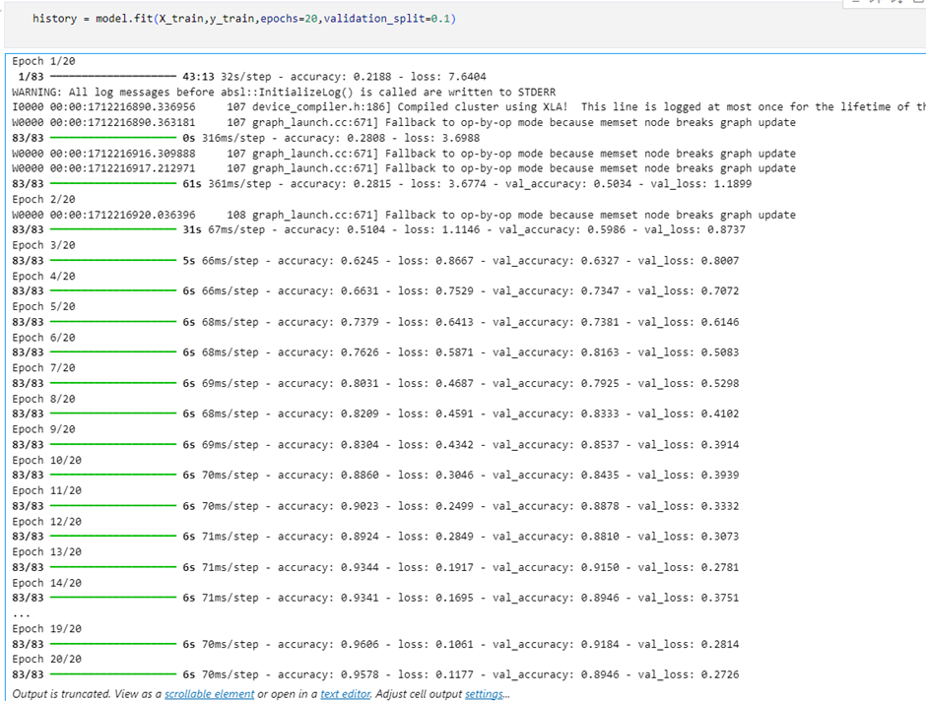

Figure

### Model Evaluation

The performance is evaluated using accuracy and loss, and the results indicate high accuracy in detecting and classifying brain tumors.

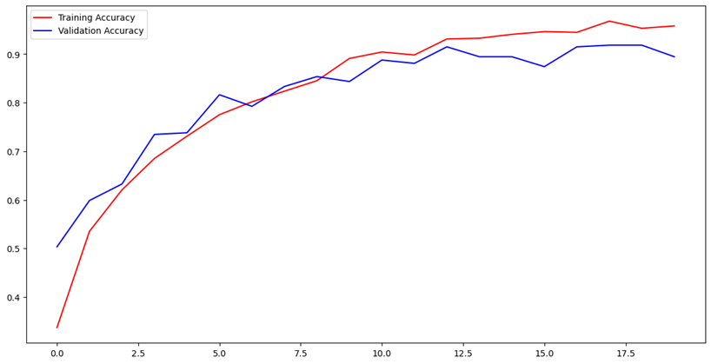

Figure

## 

## **Web Application Integration**

### Overview of the Web Application

The web application is also designed to allow the medical professionals involved to upload an MRI scan, request predictions, and also communicate with a chatbot for further assistance. The application has its backend coded in Flask and the frontend in HTML and CSS with four JavaScript scripts.

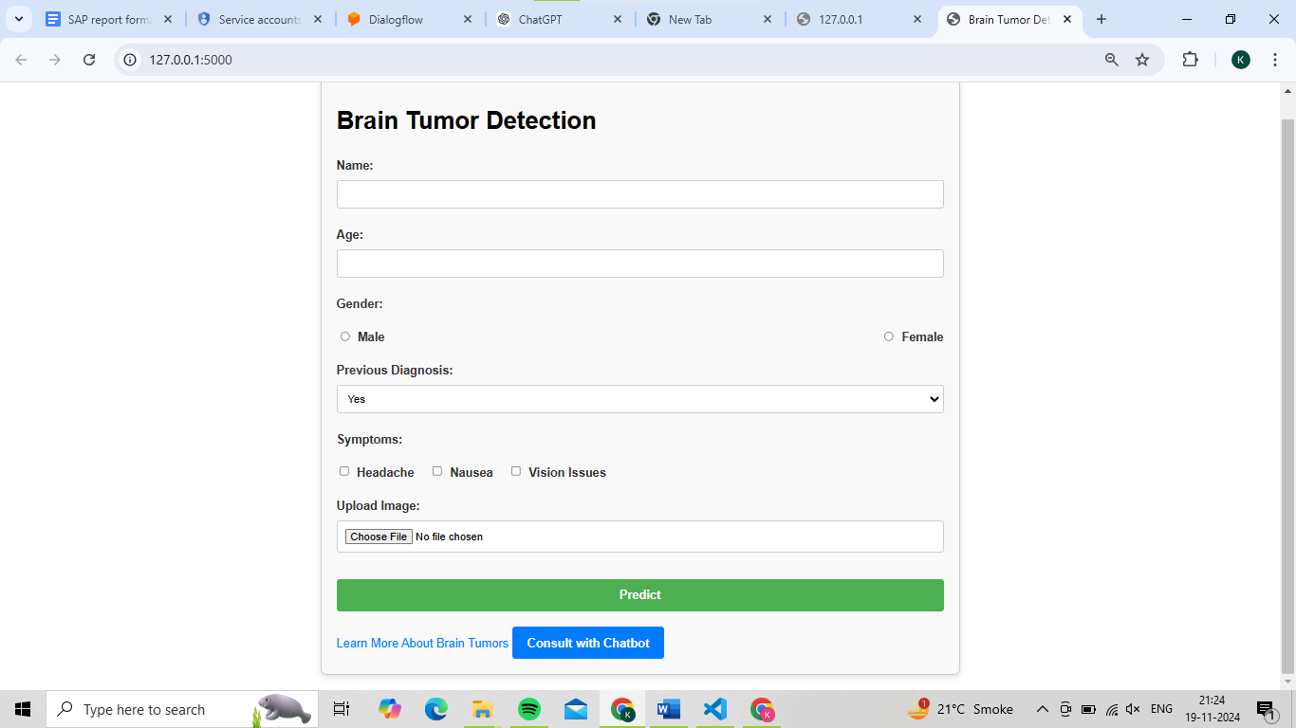

Figure

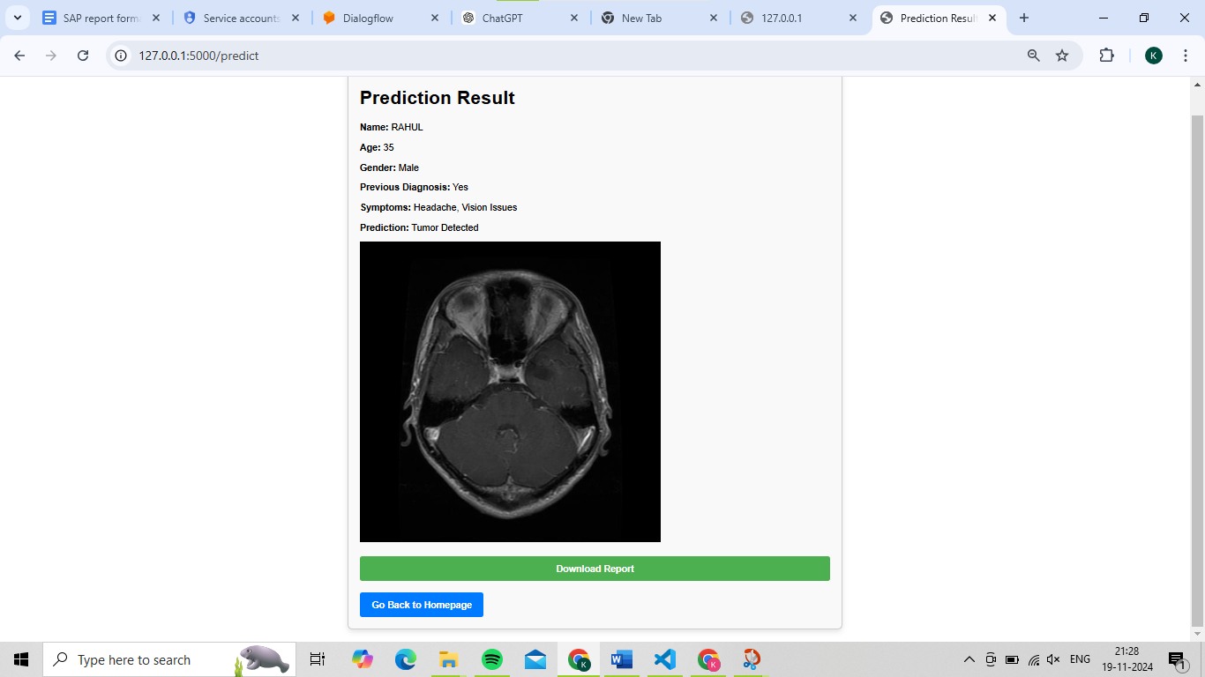

Figure

### Features of the Web Application

1. **Upload MRI Images**: This enables the users to input MRI images of patients using the application. The identified images are then fed to the trained model for preprocessing and prediction.
2. **Image Prediction**: The CNN, takes the uploaded MRI image as input and outputs whether the image contains a tumor, and if there is a tumor it classifies the tumor type as glioma, meningioma, pituitary, or no tumor.
3. **Results Display**: On the webpage, the results in the form of probability of each class are presented to help medical professionals make a decision.
4. **Chatbot**: A chatbot with an AI component is available to help users with even more features in the application. Concerning questions about brain tumors, diagnosis, or treatment the chatbot is capable of providing adequate information.
5. **Interactive User Interface**: The application interface is quite intuitive allowing the doctors to upload images, review results, or put forth queries through the chatbot.

## 

## **Chatbot Functionality**

In the course of this project, the chatbot functionality is developed by Google Cloud Console and Dialogflow. To design conversational interfaces that are able to engage users in natural language, Dialogflow, a Natural Language Processing (NLP), is employed. It is then implemented in the web application from Flask. The specific focus is to resolve medical questions regarding brain tumors, the diagnostic process, and generally possible treatments. Using Dialogflow, not only can we turn predefined knowledge/knowledge based on the intent into real-time responses, but also have a dynamic query to the CNN model of tumor identification. This feature improves the user experience by supplying prompt assistance from a clever artificial intelligence system.

* **User Interaction**:It allows the user to type in questions and the bot will generate an answer preprogrammed knowledge or query the model for the answer.
* **Machine Learning Integration**: In the case of a cancer diagnosis, the chatbot can ask the model questions to get information on the probability of a tumor and the type of tumor present, in real-time.

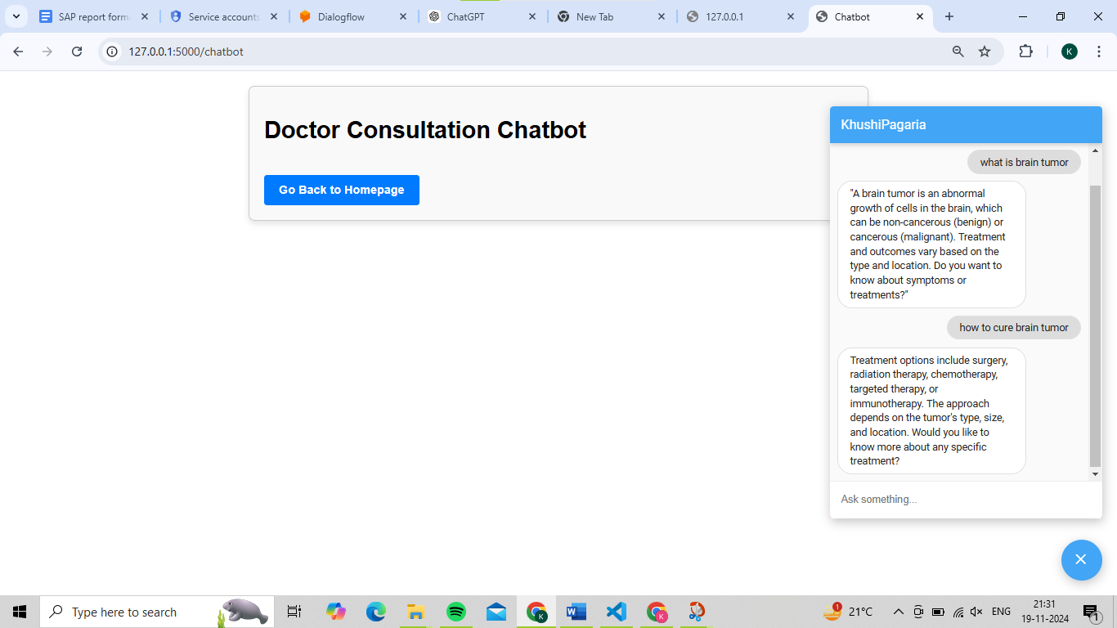

Figure

## **Integration into Hospital Workflow**

1. **Pre-existing Radiology Infrastructure**: The CNN model can be readily incorporated in the existing Picture Archiving and Communication Systems (PACS) utilized in radiology departments for image storage and management.
2. **User Interface Design**: The design of the application interface proposed is intended to provide simple operating means for the interactions and provide means for uploading, visualizing images, and getting predictions.
3. **Diagnostic Aid**: The system is intended to make predictions for the presence and type of tumor that will help in diagnosis but the final decision is with the radiologists.

## **Challenges and Considerations**

1. **Data Security and Privacy**: Patient information must be protected and should be secured as much as possible is one of the most important concepts.
2. **Regulatory Compliance**: It also has to be conformable to medical requirements and achieve approval of health departments to be used for clinical purposes.
3. **Radiologist Training**: Incorporation of the system into clinical practice requires specifically trained radiologists for better utilization of the system.

## **Conclusion**

This work demonstrates that machine learning particularly CNNs can be used to detect brain tumors from MRI scans without the need for professional intervention. The developed system is integrated with AI-based predictions in addition to offering a web application interface for uploading images, receiving analysis of the tumor classification, and further interaction with an embedded chatbot. Combined, it enhances the diagnosis process, as well as the decision-making progress for the patient.

Even with alert values in the system, the authors noted other challenges, including patient escorts, adherence to rules or laws, and training of the radiologists regarding the actual usage of the system. The system is designed for further development and amendments in the future for applications such as continual learning and more like tumor segmentation. In conclusion, this work makes it possible to state that using the presented AI system, it would be possible to solve the mentioned tasks of developing more efficient methods of diagnosing a brain tumor to the interest of the healthcare specialists and patients.

## **Future Enhancements**

In the future, the developed brain tumor detection system can be combined more with sophisticated technologies. One of the future works can be the implementation of the approaches used for the segmentation of tumors to not only determine the presence of the tumor but also determine the exact position and extent of the tumor which will be helpful in planning the treatment. In addition, the expansion of the system to a predictive analytics model for the treatment outcome, with respect to the tumor type and stage, could help provide a proposed treatment plan. The chatbot could also change to one with natural language understanding to support complicated questions and even provide more extensive medical services, making it a more powerful clinical companion.

## **References**

* Kaggle Dataset for Brain Tumor Classification: [Kaggle Dataset](https://www.kaggle.com/datasets/sartajbhuvaji/brain-tumor-classification-mri)
* Adam Optimization Algorithm: [Machine Learning Mastery](https://machinelearningmastery.com/adam-optimization-algorithm-for-deep-learning/)
* Softmax Activation Function: [Pinecone](https://www.pinecone.io/learn/softmax-activation/)