1. Project Overview
This project predicts students' marks based on the number of study hours using Machine Learning techniques. The model learns from previous student data and predicts expected marks.
2. Objective
- To predict student marks based on study hours.
- To understand the relationship between study time and marks.
- To apply Machine Learning for prediction.
3. Dataset Description
The dataset contains student information:
- Study Hours (Input Feature)
- Marks (Target Output)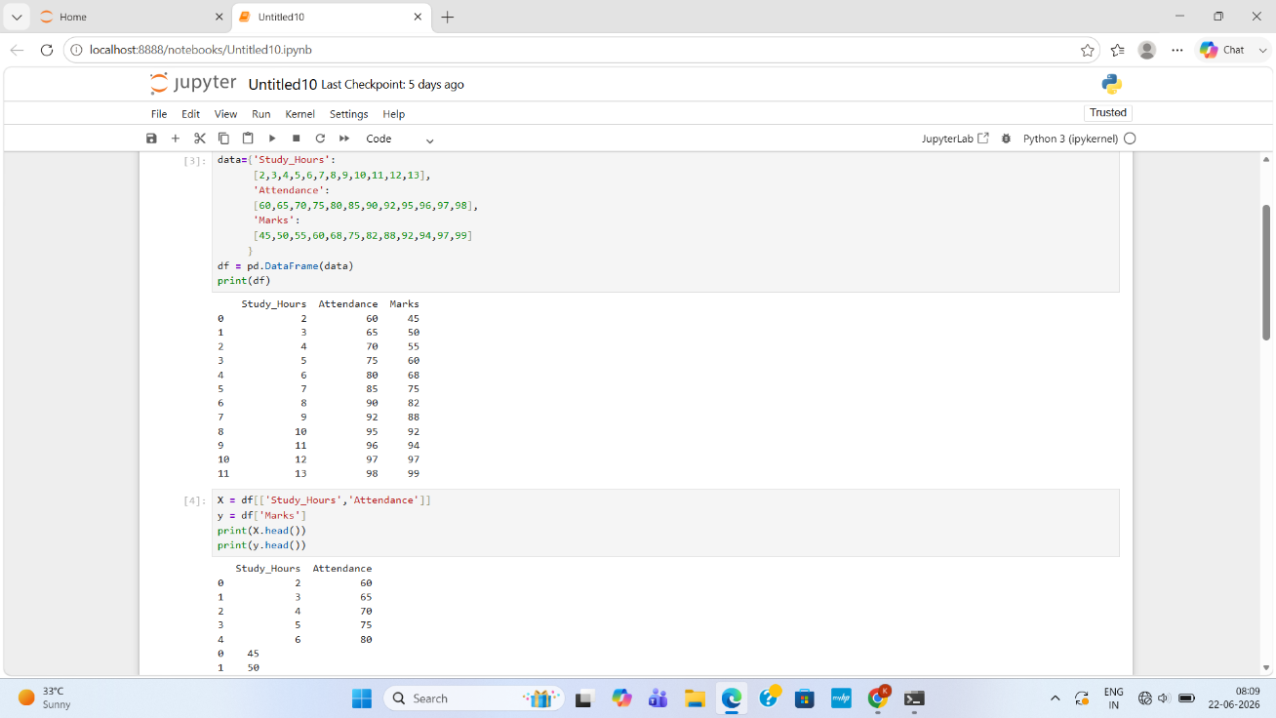
4. Technologies Used
- Python
- Jupyter Notebook
- Pandas
- NumPy
- Matplotlib
- Scikit-learn
5. Methodology
Steps followed:
- Import required libraries
- Load dataset
- Analyze and visualize data
- Split data into training and testing sets
- Train Machine Learning model
- Test model accuracy
- Predict marks for new input data
6. Machine Learning Model
Algorithm Used: Linear Regression
Linear Regression is used to find the relationship between study hours and marks.
7. Result
The model successfully predicts student marks based on study hours. The prediction accuracy is evaluated using the test data.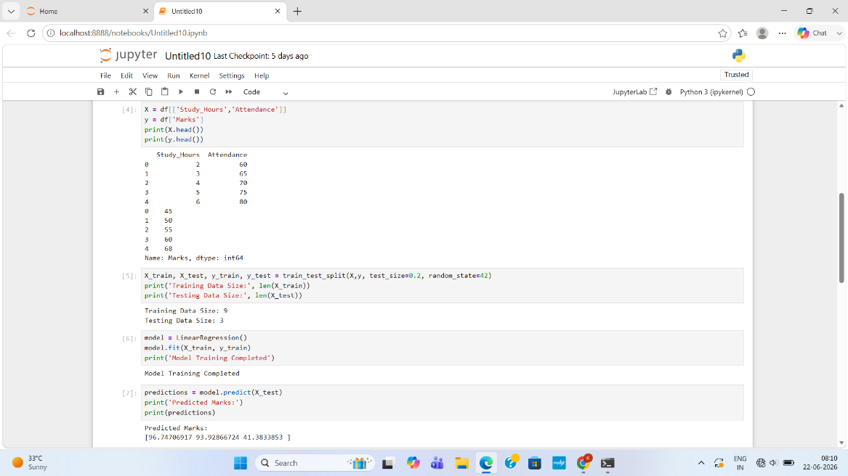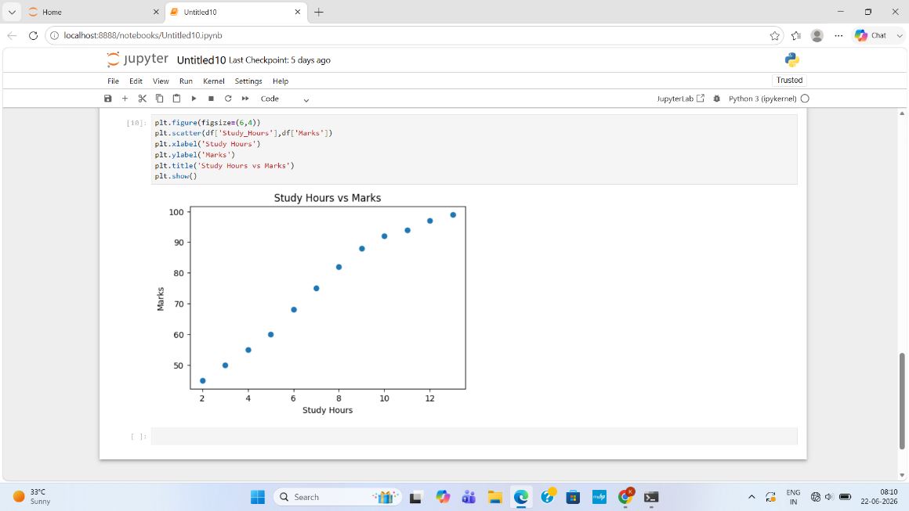
8. Conclusion
This project shows how Machine Learning can be used to predict student performance. It helps understand how study habits affect marks

