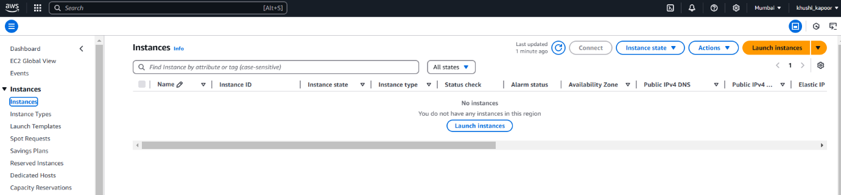

**Elastic Compute Cloud**

Step 1 - Click on **Launch Instance**.

Step 2 - Choose an **AMI** (Amazon Machine Image)

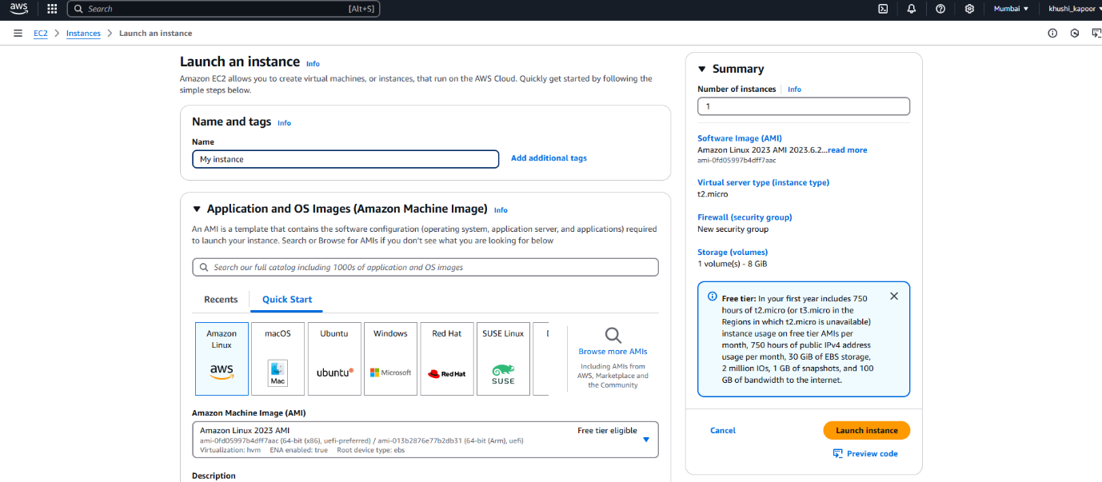

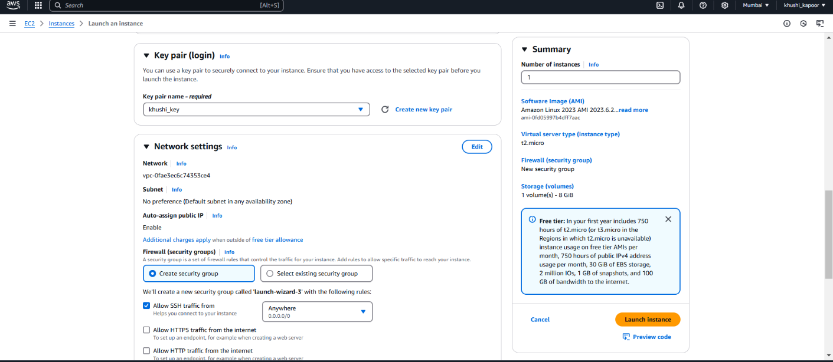

Step3 - Select an **Instance Type**

Step 4 - Click **Launch**.



