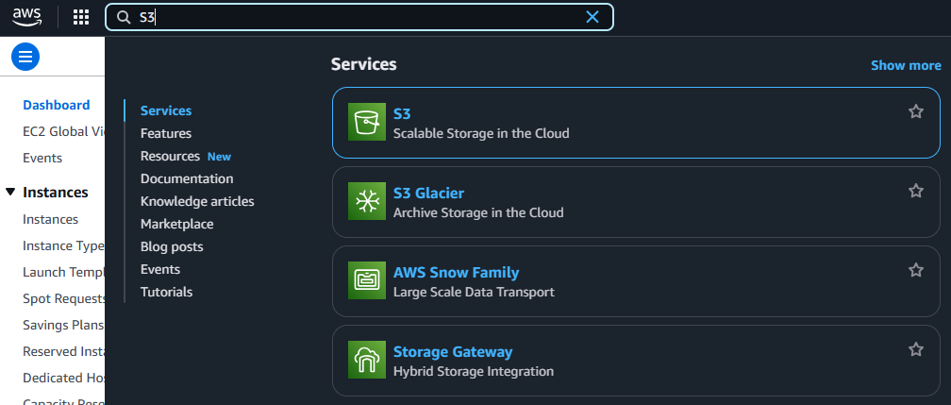

**Simple Storage Service Bucket**

Step2 - Click **Create Bucket**.

Step1 - Search for **S3**.

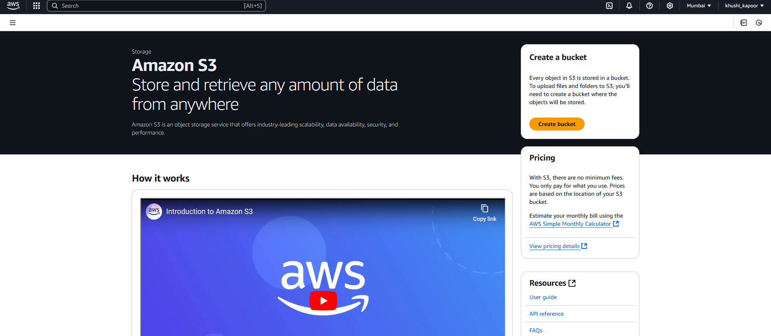

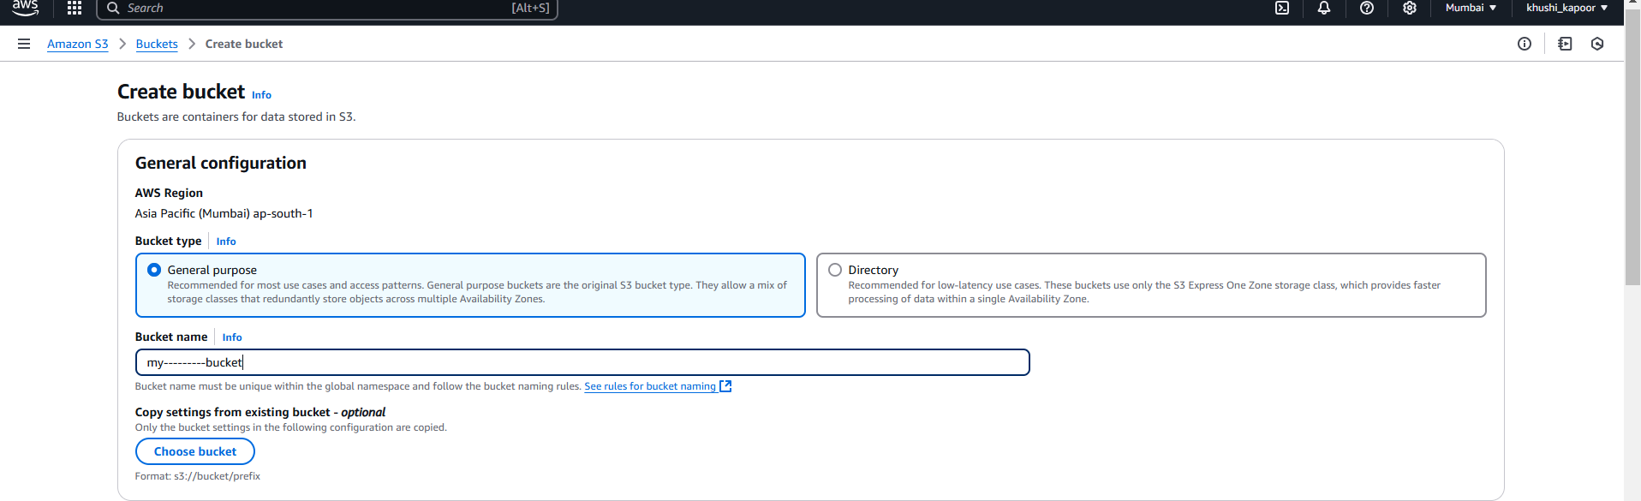

Step3 - Enter a **Bucket Name**

Step4 - Choose a **Region**

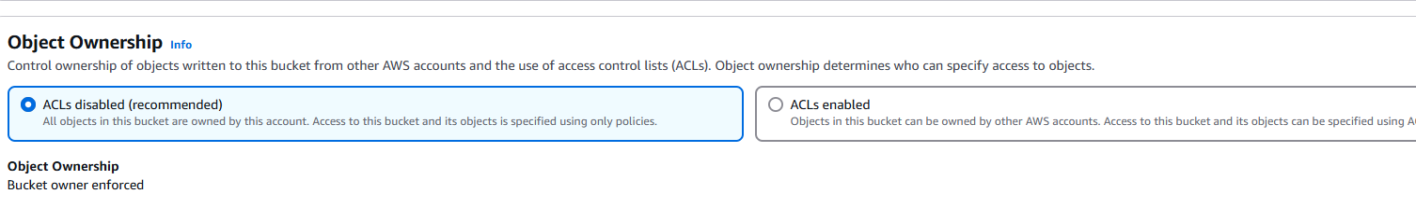

Step5 - Keep default or adjust: **Block Public Access** (recommended for sensitive data) and **Create Bucket**.

