DEFECTS LIST

|  |  |
| --- | --- |
| **Defect ID** | **Description** |
| DEF 01 | After creating new contract, it should display on contact list without user refresh. |
| DEF 02 | Error message does not disappear, after user creates/updates contract |
| DEF 03 | Existing Job role dates are not updated when user update contract dates |
| DEF 04 | When user update Job role dates, error message with incorrect date value displayed on screen, even when user cancel the update action |
| DEF 05 | If job role end date < contract start date and < job role start date, system should show 2 error messages |
| DEF 06 | Inappropriate calendar widget opens up, when user try to edit 2 job roles same time. |
| DEF 07 | Only 1 job role is saved properly, when user try to edit multiple job roles at same time |
| DEF 08 | Incorrect date format on error message, when user update contract |

1. **DEF 01**
   1. **Summary**: After creating new contract, it should display on contact list without user refresh.
   2. **Screen**: Add job contract
   3. **Description**: Try to add new job contract and save it.
      1. Actual result: Newly created contract is not listed on contract page, until user refresh the page.
      2. Expected Result: newly created contract should display on contract page after user saves it and without refresh required.
   4. **Screenshot**: Not Required.
2. **DEF 02**
   1. **Summary**: Error message does not disappear, after user creates/updates contract
   2. **Screen**: Add/update contract
   3. **Description**: Try to add new contract with dates as existing contract or update contract with some dates which falls under effective date of other contract. Error message occurs on the screen.
      1. Actual Result: This error message remains on screen until user clicks on “x” to delete message.
      2. Expected Result: Once user update his error, error message should go away from screen, user should not exclusively click on “x” to remove error.
   4. **Screenshot**: 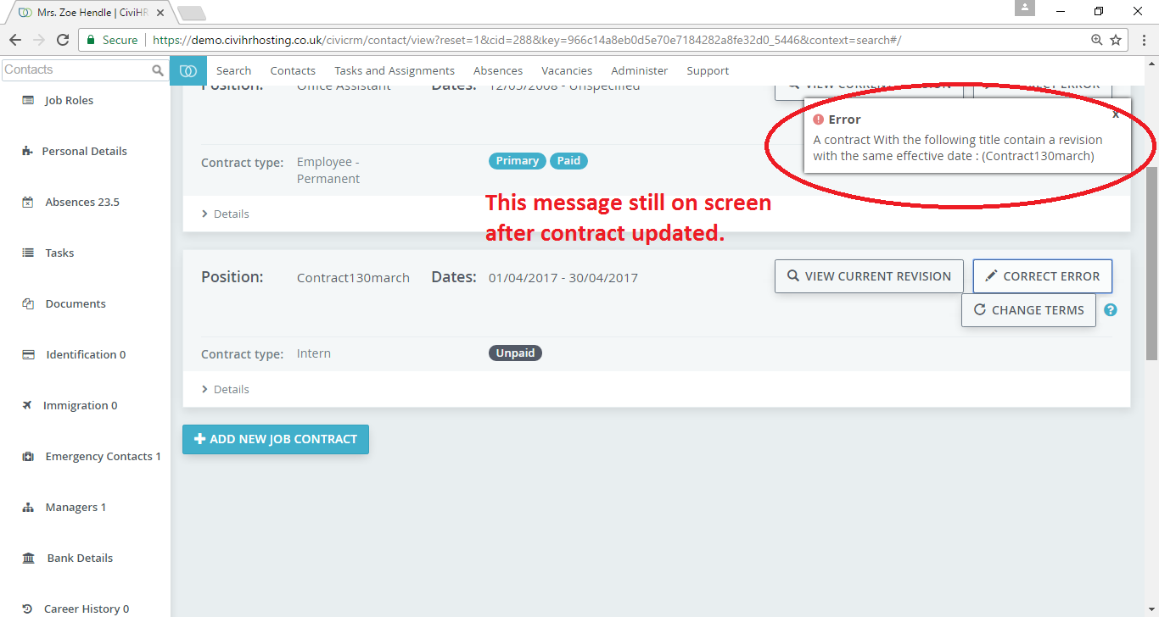

1. **DEF 03**
   1. **Summary**: Existing Job role dates are not updated when user update contract dates
   2. **Screen**: Job Role list
   3. **Description**: Update contract start and end dates. Go to job role, and view role associated with updated contract. Job role dates should get updated as contract start and end date.
      1. Actual result: Job role start and end dates are not getting updated automatically, when contract start and end dates are updated.
      2. Expected result: Job role start and end dates should get updated as contract start and end dates when contract dates are updates.
   4. **Screenshot**: 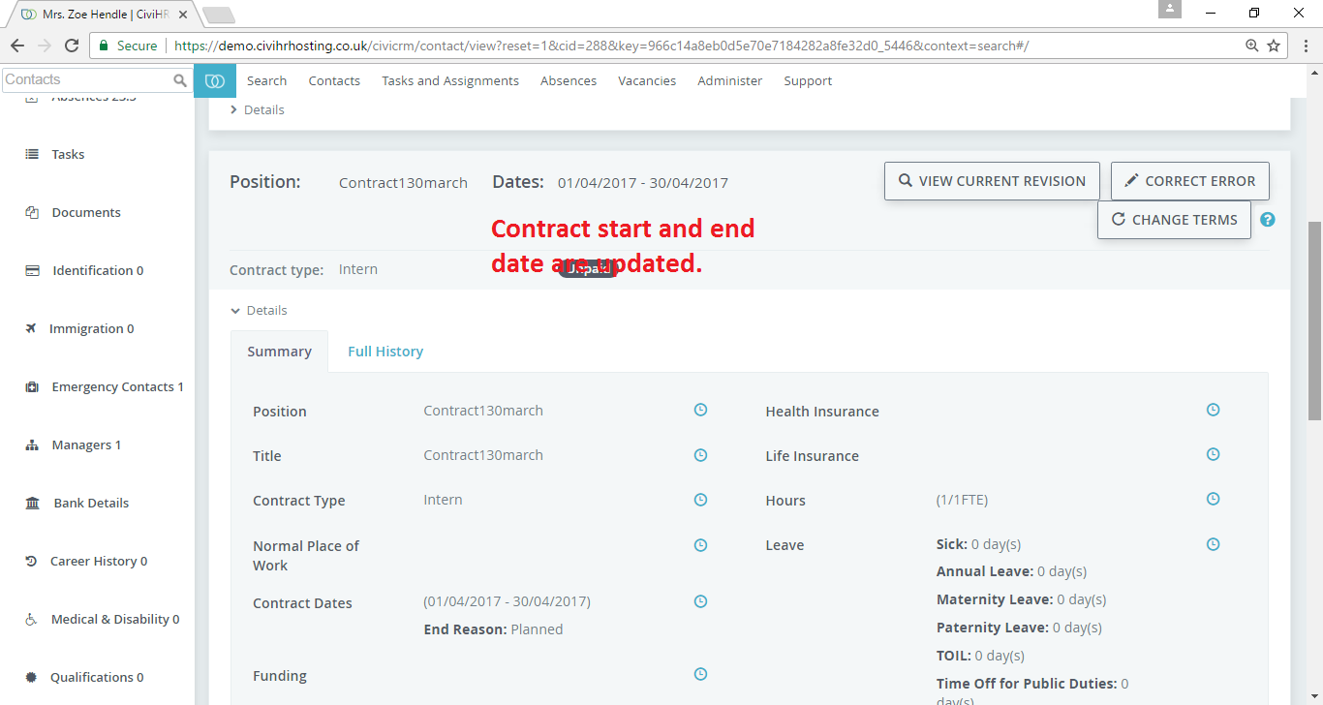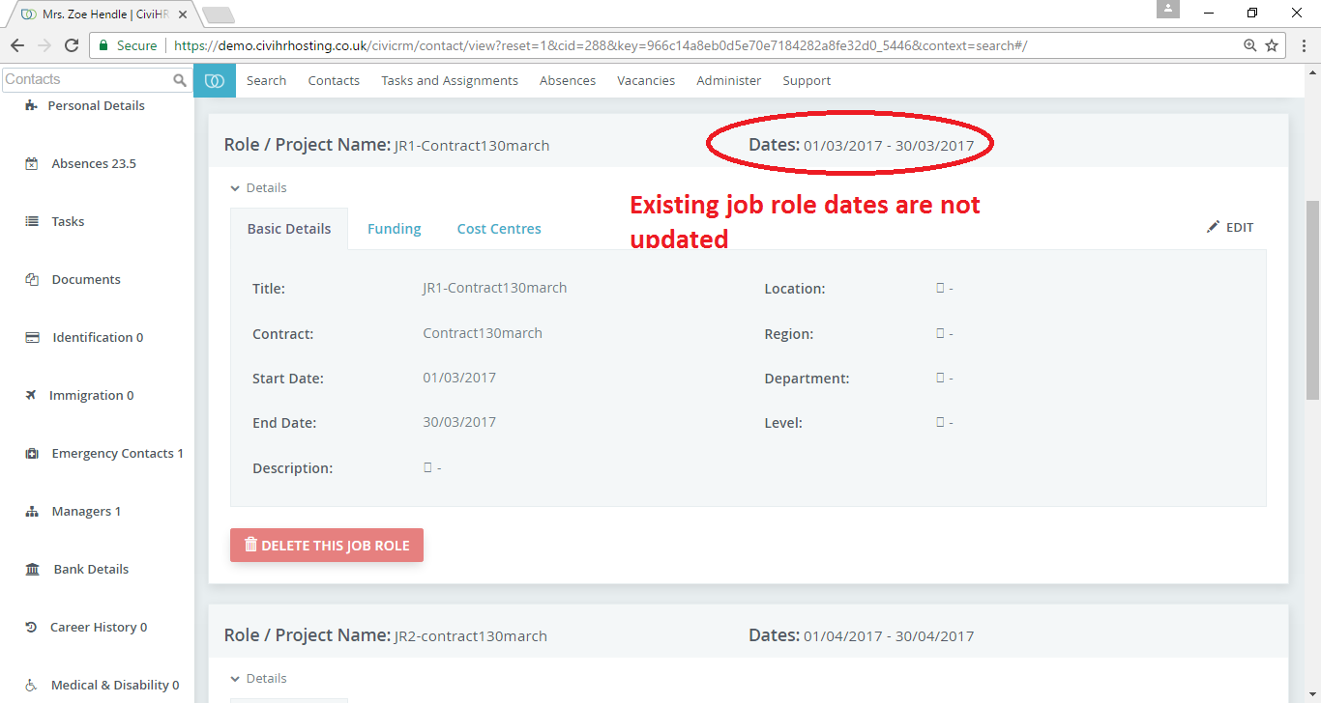

1. **DEF 04**
   1. **Summary**: When user update Job role dates, error message with incorrect date value displayed on screen, even when user cancel the update action
   2. **Screen**: Update/Edit Job role
   3. **Description**: Click on edit job role, change start date or end date in such a way that it gives error message. E.g. change start date < contract start date. And save. User will get message –“start date cannot be lower than contract start date”. Now click on cancel. User will see that message and the actual date which user selected.
      1. Actual result: User can see the error message and incorrect date value, even when user cancel the action.
      2. Expected result: If user clicks on cancel, original date value without error message should be displayed on screen.
   4. **Screenshot**: 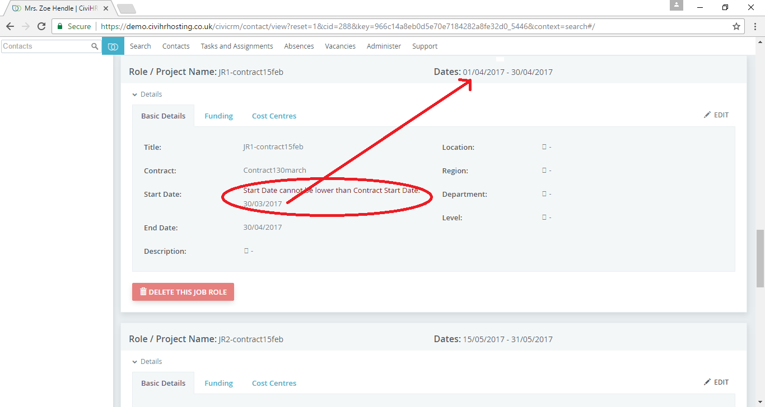
2. **DEF 05**
   1. **Summary**: If job role end date < contract start date and < job role start date, system should show 2 error messages.
   2. **Screen**: Edit job role
   3. **Description**: Click on edit job role, enter end date < contract start date and < job role start date.
      1. Actual result: It shows only 1 message "Start date cannot be same as or after the end date"
      2. Expected result: It should show 2 messages – "End date cannot lower then contract start date" and "Start date cannot be same as or after the end date"
   4. **Screenshot**: 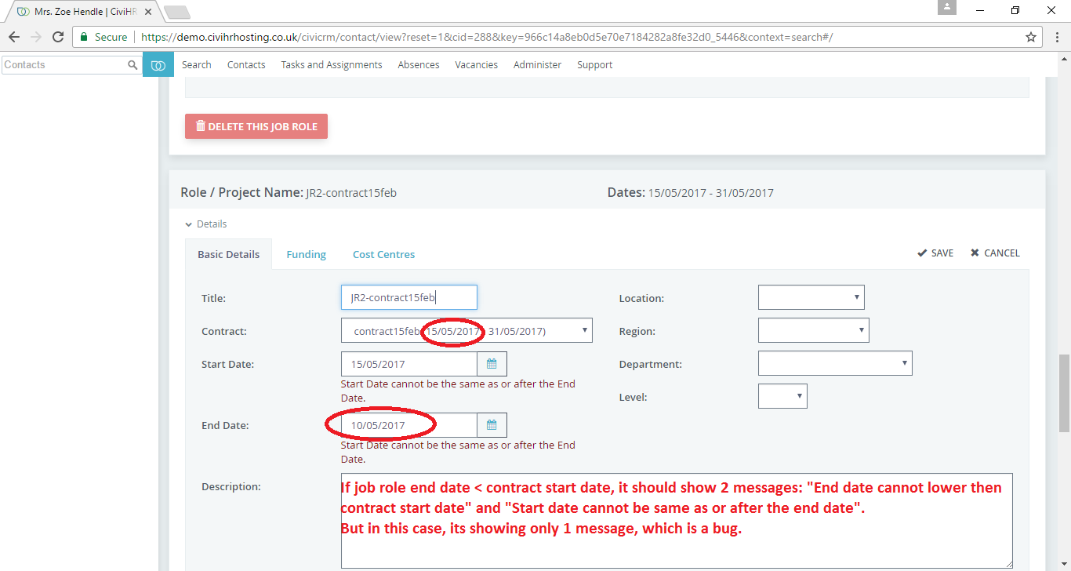
3. **DEF 06**
   1. **Summary**: inappropriate calendar widget opens up, when user try to edit 2 job roles same time.
   2. **Screen**: Edit job role
   3. **Description**: Click on edit job role, keep the edit window as it is and scroll down to edit another job role. Now click on any date to update it, 2 calendar widget will open up
      1. Actual result: inappropriate calendar widget opens up when user try to edit 2 job roles at same time.
      2. Expected result: Either user should be restricted to click on edit if one edit window is open OR those calendar widgets should open accordingly.
   4. **Screenshot**: 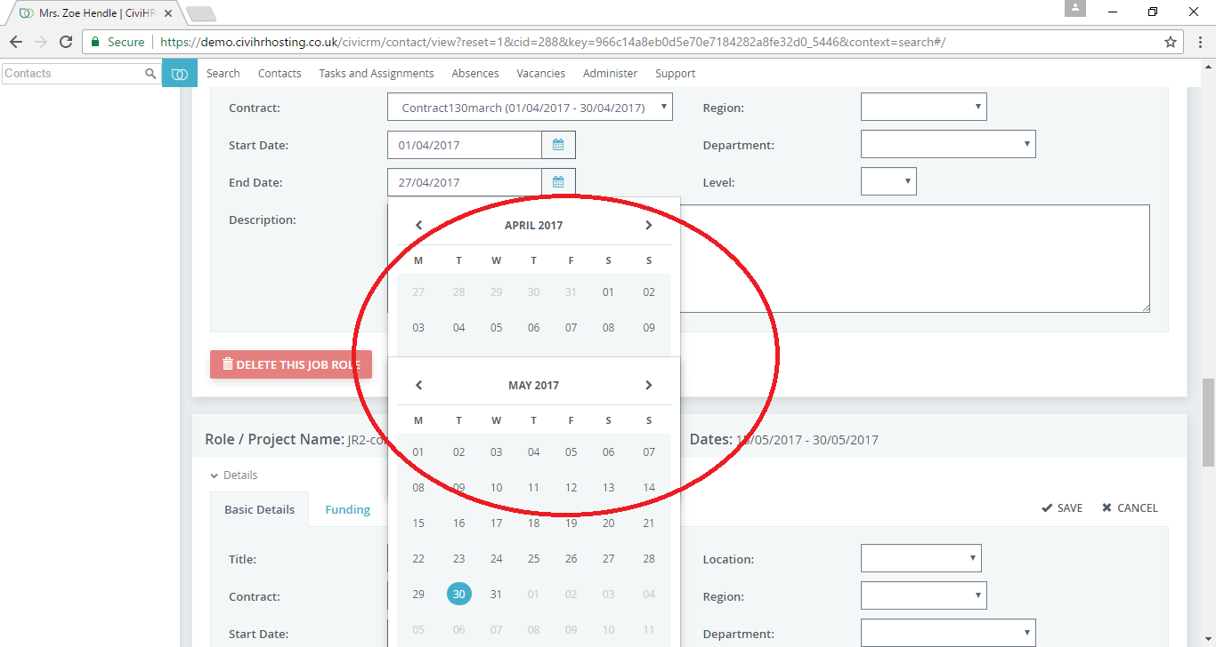

1. **DEF 07**
   1. **Summary**: only 1 job role is saved properly, when user try to edit multiple job roles at same time
   2. **Screen**: Edit job role
   3. **Description**: Try to edit job role, keep that edit window open and click on edit on another job role. Edit either job role start date or contract or anything on both and then click on save on first one.
      1. Actual result: When user click on save on 1 job role, value of that job role is updated but values of other job roles are not updated.
      2. Expected Result: Either edit option should be disabled, when one edit window is open OR when user click on save, only that job role should get updated.
   4. **Screenshot**: Not Required.

1. **DEF 08**
   1. **Summary**: Incorrect date format on error message, when user update contract
   2. **Screen**: Update job contract
   3. **Description**: Update job contract, and enter start date which overlaps another contract start date. Click on save.
      1. Actual result: Date format on error message is incorrect. It says yyyy-mm-dd
      2. Expected Result Date format on error message should be dd-mm-yyyy.
   4. **Screenshot**: 