Case

- Write an SQL query to find the top 5 highest-rated restaurants in Koramangala that serve North Indian cuisine, using the Zomato Bangalore dataset.
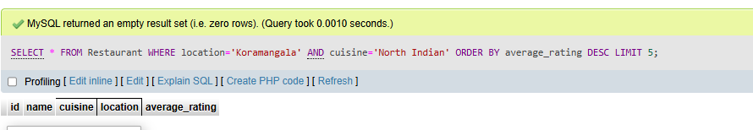

2. Using SQL, calculate the average cost for two people for each cuisine type and list the 3 most expensive cuisines to eat in Bangalore.
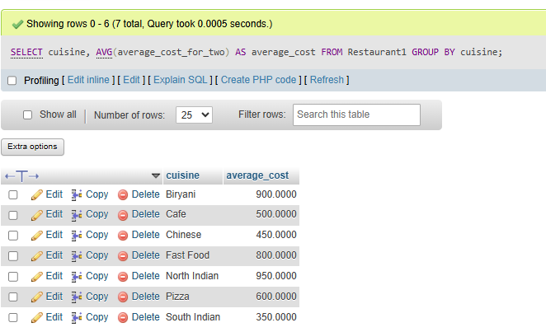
- Find all restaurants that offer online delivery but have a rating below 3.0, and suggest a marketing strategy to improve their ratings based on your findings.<br><br><em><strong>Hint:</strong> Look for patterns in location, cuisine, or price that might explain the low ratings.</em>

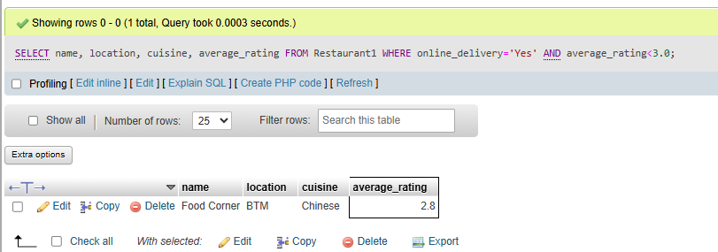

- Write an SQL query to segment restaurants into three market segments based on average cost for two: budget (below 400), mid-range (400-800), and premium (above 800). Count how many restaurants fall into each segment.
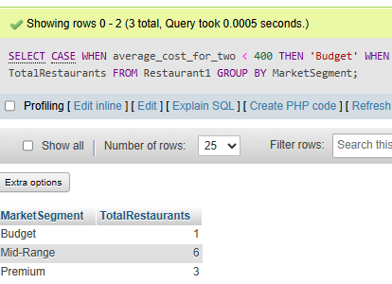

- Use ChatGPT or Copilot to help you write an SQL query that lists the top 10 most popular restaurant chains (by number of outlets) in the dataset, then run and validate the query yourself.<br><br><em><strong>Hint:</strong> Search for 'SQL group by count example' if you get stuck.</em>
