# AWS Cloud

# What is AWS Cloud?

AWS (Amazon Web Services) is a cloud computing platform.

The first product (S3) was released in 2006.

AWS has grown a lot since then in both size and product range.

It is, to date, the largest cloud provider in the world.

## **Why Learn AWS?**

* AWS is the largest of the cloud providers
* AWS competence is popular in the job market
* You can do most things in the AWS Cloud
* Big community/support

**Use of AWS**

* IT professionals
* Marketing professionals
* Sales
* Business analysts
* Students
* Project managers
* Legal

# AWS Cloud Computing

## **The Client-Server Model**

The client-server model is an important concept in cloud computing. It is about many clients using services from a centralized server. The Client-Server model is about a client that interacts and makes requests to a computer server.

A client is the way that the person interact with the server.

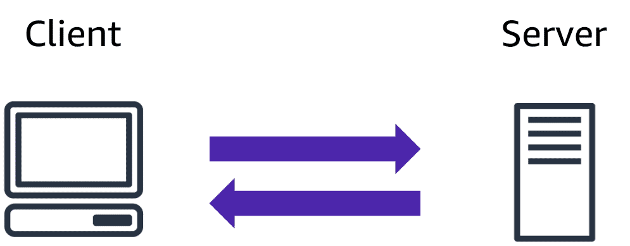

## **What is Cloud Computing?**

Cloud computing is a computing service made available over the internet. Cloud computing is a pay-as-you-go model for delivering IT resources. You pay only for what you use.

## **Why Choose Cloud Computing?**

There are many reasons for going with the cloud.

Cloud computing enables benefits such as:

* Cost savings
* Security
* Scalability
* Flexibility

## **Payment Model**

The cloud payment model is flexible. You do not have to invest in a data centers , servers, and other resources. The cloud services is a variable expense. You can use the services from the start and consume more as you grow.

## **Fewer Operations**

Having your own data centers and servers requires resources and staffing. Cloud computing reduces operation and lets you focus on important things, such as your applications and customers.

## **Flexible Capacity**

Having and managing your own servers can result in unused capacity and limitations. On the other hand, you can grow freely with cloud computing.

## **Economies at Scale**

Cloud computing is about shared resources. Sharing the infrastructure cost with hundreds of thousands of other customers lowers the overall costs.

## **Increased Speed**

The flexibility of cloud computing makes it easier to develop and deploy applications. You can test and utilize resources as you want in minutes. This freedom allows you to experiment and invent more. It allows for instant resource access.

**Global Reach**

AWS has data centers all over the world. The AWS Cloud's global reach allows you to swiftly deploy apps to consumers anywhere. Customers can access your apps quickly. You can pick the ones near your clients to reduce the latency.