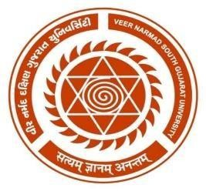
VEER NARMAD SOUTH GUJARAT UNIVERSITY
University Campus, Udhna-Magdalla Road, Surat – 395001, Gujarat, India.

AS PARTIAL REQUIREMENT FOR THE DEGREE
OF
MASTER OF SCIENCE IN INFORMATION AND COMMUNICATION TECHNOLOGY (MSC ICT 2 Year Course)

2025-26
(SEMESTER – I)

Department of Information and Communication Technology M.Sc. (ICT) Programme

Online Book Store
SUBMITTED BY
Khushi M. Patel [1054]
Yesha H. Udhanawala[1068]
GUIDED BY:
Mr. Kamlendu pandey

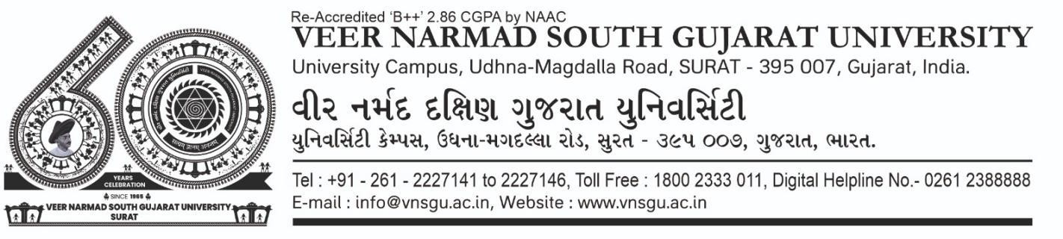
Department of Information and Communication Technology

M.Sc.(Information and Communication Technology) Program
Certificate
This is to certify that Ms. Khushi Manojbhai Patel with exam seat number 1054 and PG Enroll Number R25110018000710048 has worked on his project work entitled as online Book Store at Department of ICT as a partial fulfillment of requirement of M.Sc. (Information and Communication Technology) - 1st Semester, during the academic year 2024-2025.

Date: 15/12/2025

Place: Department of ICT, VNSGU, Surat

Internal Project Guide  MSc(ICT) 1st semester  Department of ICT  VNSGU, Surat |  | Head Of Department  Department Of ICT  VNSGU, Surat

Department of Information and Communication Technology

M.Sc.(Information and Communication Technology) Program
Certificate
This is to certify that Ms. Yesha Hirenkumar Udhnawala with exam seat number 1068 and PG Enroll Number R25110018000710061 has worked on his project work entitled as online Book Store at Department of ICT as a partial fulfillment of requirement of M.Sc. (Information and Communication Technology) - 1st Semester, during the academic year 2024-2025.

Date: 15/12/2025

Place: Department of ICT, VNSGU, Surat

Internal Project Guide  MSc(ICT) 1st semester  Department of ICT  VNSGU, Surat |  | Head Of Department  Department Of ICT  VNSGU, Surat

