Khushi@DESKTOP-IEE8LDD MINGW64 ~ (master)

$ git config --global user.email "khushiprabhudessai7@gmail.com"

Khushi@DESKTOP-IEE8LDD MINGW64 ~ (master)

$ git config --global user.name "khushi"

Khushi@DESKTOP-IEE8LDD MINGW64 ~ (master)

$ git config -l

diff.astextplain.textconv=astextplain

filter.lfs.clean=git-lfs clean -- %f

filter.lfs.smudge=git-lfs smudge -- %f

filter.lfs.process=git-lfs filter-process

filter.lfs.required=true

http.sslbackend=schannel

core.autocrlf=true

core.fscache=true

core.symlinks=false

pull.rebase=false

credential.helper=manager-core

credential.https://dev.azure.com.usehttppath=true

user.name=khushi

user.email=khushiprabhudessai7@gmail.com

user.emil=khushiprabhudessai7@gmail.com

core.editor=notepad

filter.lfs.clean=git-lfs clean -- %f

filter.lfs.smudge=git-lfs smudge -- %f

filter.lfs.process=git-lfs filter-process

filter.lfs.required=true

core.repositoryformatversion=0

core.filemode=false

core.bare=false

core.logallrefupdates=true

core.symlinks=false

core.ignorecase=true

remote.origin.url=https://github.com/khushiprabhudessai/Khushi.git

remote.origin.fetch=+refs/heads/*:refs/remotes/origin/*

Khushi@DESKTOP-IEE8LDD MINGW64 ~ (master)

$ pwd

/c/Users/Khushi

Khushi@DESKTOP-IEE8LDD MINGW64 ~ (master)

$ ls

'[$'/ fibonacci.sh* Pictures/

_.swo first.txt prime__number.sh

_.swp forloop.sh* prime_num.sh*

_viminfo git/ prime_number.sh*

'=0' head_tail.sh* PrintHood@

'=y]'/ inittk.ini PycharmProjects/

0 inst.ini Recent@

'3D Objects'/ IntelGraphicsProfiles/ reverse_num.sh*

addingnumbers.sh* java-2021-09/ 'Saved Games'/

AppData/ khushi/ scientific_calculator.sh*

'Application Data'@ Links/ Searches/

bluej/ 'Local Settings'@ SendTo@

char_lines.sh* Microsoft shellscripting/

check_even_odd.sh* MicrosoftEdgeBackups/ shellscripting.sh/

cloned_repo/ multi.sh si.sh

Contacts/ multiplication.sh source/

Cookies@ multiplication_num.sh 'Start Menu'@

count_vowels.sh* Music/ Temp/

d4ac4633ebd6440fa397b84f1bc94a3c.7z 'My Documents'@ Templates@

Desktop/ NetHood@ test.py

digit.sh* Nox_share/ test.txe

digits.sh NTUSER.DAT test2.text

digits_num.sh* ntuser.dat.LOG1 text.exe*

displayprog.sh* ntuser.dat.LOG2 twonumbers.sh*

Documents/ NTUSER.DAT{78c5f324-8ce0-11ea-8761-70b5e87bdceb}.TM.blf useruid.ini

Downloads/ NTUSER.DAT{78c5f324-8ce0-11ea-8761-70b5e87bdceb}.TMContainer00000000000000000001.regtrans-ms Videos/

eli.sh* NTUSER.DAT{78c5f324-8ce0-11ea-8761-70b5e87bdceb}.TMContainer00000000000000000002.regtrans-ms vimfiles/

elif.sh* ntuser.ini vmlogs/

fac_num.sh nuuid.ini whileloop.sh*

factorial_number.sh* odd_even.sh*

Favorites/ OneDrive/

Khushi@DESKTOP-IEE8LDD MINGW64 ~ (master)

$ cd desktop

Khushi@DESKTOP-IEE8LDD MINGW64 ~ (master)

$ mkdir khushi

mkdir: cannot create directory ‘khushi’: File exists

Khushi@DESKTOP-IEE8LDD MINGW64 ~ (master)

$ cd khushi

Khushi@DESKTOP-IEE8LDD MINGW64 ~/khushi (master)

$ git init

Reinitialized existing Git repository in C:/Users/Khushi/khushi/.git/

Khushi@DESKTOP-IEE8LDD MINGW64 ~/khushi (master)

$ git status

On branch master

No commits yet

Untracked files:

(use "git add <file>..." to include in what will be committed)

home.html

nothing added to commit but untracked files present (use "git add" to track)

Khushi@DESKTOP-IEE8LDD MINGW64 ~/khushi (master)

$ ls -lart

total 52

drwxr-xr-x 1 Khushi 197121 0 May 4 19:47 ./

-rw-r--r-- 1 Khushi 197121 0 May 4 19:47 home.html

drwxr-xr-x 1 Khushi 197121 0 May 22 10:19 ../

drwxr-xr-x 1 Khushi 197121 0 May 22 10:21 .git/

Khushi@DESKTOP-IEE8LDD MINGW64 ~/khushi (master)

$ touch service.html

Khushi@DESKTOP-IEE8LDD MINGW64 ~/khushi (master)

$ touch design.html

Khushi@DESKTOP-IEE8LDD MINGW64 ~/khushi (master)

$ git status

On branch master

No commits yet

Untracked files:

(use "git add <file>..." to include in what will be committed)

design.html

home.html

service.html

nothing added to commit but untracked files present (use "git add" to track)

Khushi@DESKTOP-IEE8LDD MINGW64 ~/khushi (master)

$ git add -A

Khushi@DESKTOP-IEE8LDD MINGW64 ~/khushi (master)

$ git status

On branch master

No commits yet

Changes to be committed:

(use "git rm --cached <file>..." to unstage)

new file: design.html

new file: home.html

new file: service.html

Khushi@DESKTOP-IEE8LDD MINGW64 ~/khushi (master)

$ git commit -m "we are in commit mode"

[master (root-commit) 1fcb135] we are in commit mode

3 files changed, 0 insertions(+), 0 deletions(-)

create mode 100644 design.html

create mode 100644 home.html

create mode 100644 service.html

Khushi@DESKTOP-IEE8LDD MINGW64 ~/khushi (master)

$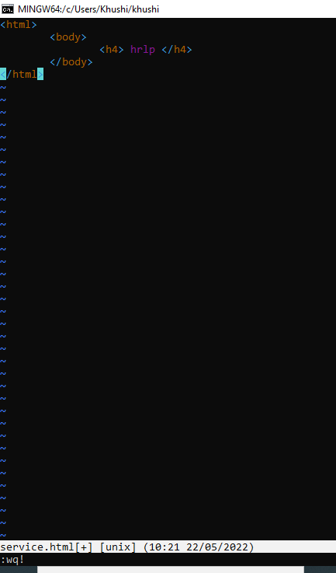 vi service.html

Khushi@DESKTOP-IEE8LDD MINGW64 ~/khushi (master)

$ git status

On branch master

Changes not staged for commit:

(use "git add <file>..." to update what will be committed)

(use "git restore <file>..." to discard changes in working directory)

modified: service.html

no changes added to commit (use "git add" and/or "git commit -a")

Khushi@DESKTOP-IEE8LDD MINGW64 ~/khushi (master)

$ git diff

warning: LF will be replaced by CRLF in service.html.

The file will have its original line endings in your working directory

diff --git a/service.html b/service.html

index e69de29..25732ec 100644

--- a/service.html

+++ b/service.html

@@ -0,0 +1,5 @@

+<html>

+ <body>

+ <h4> hrlp </h4>

+ </body>

+</html>

Khushi@DESKTOP-IEE8LDD MINGW64 ~/khushi (master)

$ git restore --spagde

error: unknown option `spagde'

usage: git restore [<options>] [--source=<branch>] <file>...

-s, --source <tree-ish>

which tree-ish to checkout from

-S, --staged restore the index

-W, --worktree restore the working tree (default)

--ignore-unmerged ignore unmerged entries

--overlay use overlay mode

-q, --quiet suppress progress reporting

--recurse-submodules[=<checkout>]

control recursive updating of submodules

--progress force progress reporting

-m, --merge perform a 3-way merge with the new branch

--conflict <style> conflict style (merge or diff3)

-2, --ours checkout our version for unmerged files

-3, --theirs checkout their version for unmerged files

-p, --patch select hunks interactively

--ignore-skip-worktree-bits

do not limit pathspecs to sparse entries only

--pathspec-from-file <file>

read pathspec from file

--pathspec-file-nul with --pathspec-from-file, pathspec elements are separated with NUL character

Khushi@DESKTOP-IEE8LDD MINGW64 ~/khushi (master)

$ git status

On branch master

Changes not staged for commit:

(use "git add <file>..." to update what will be committed)

(use "git restore <file>..." to discard changes in working directory)

modified: service.html

no changes added to commit (use "git add" and/or "git commit -a")

Khushi@DESKTOP-IEE8LDD MINGW64 ~/khushi (master)

$ git add -A

warning: LF will be replaced by CRLF in service.html.

The file will have its original line endings in your working directory

Khushi@DESKTOP-IEE8LDD MINGW64 ~/khushi (master)

$ git commit -m "we are in commit mode"

[master ac4792f] we are in commit mode

1 file changed, 5 insertions(+)

Khushi@DESKTOP-IEE8LDD MINGW64 ~/khushi (master)

$ git checkout -f

Khushi@DESKTOP-IEE8LDD MINGW64 ~/khushi (master)

$ git status

On branch master

nothing to commit, working tree clean

Khushi@DESKTOP-IEE8LDD MINGW64 ~/khushi (master)

$ git branch

* master

Khushi@DESKTOP-IEE8LDD MINGW64 ~/khushi (master)

$ git status

On branch master

nothing to commit, working tree clean

Khushi@DESKTOP-IEE8LDD MINGW64 ~/khushi (master)

$ git branch bca

Khushi@DESKTOP-IEE8LDD MINGW64 ~/khushi (master)

$ ls

design.html home.html service.html

Khushi@DESKTOP-IEE8LDD MINGW64 ~/khushi (master)

$ git branch

bca

* master

Khushi@DESKTOP-IEE8LDD MINGW64 ~/khushi (master)

$ vi wave.html

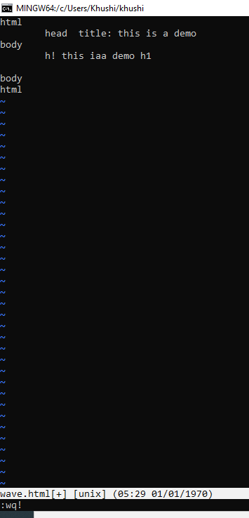

Khushi@DESKTOP-IEE8LDD MINGW64 ~/khushi (master)

$ git checkout master

Already on 'master'

Khushi@DESKTOP-IEE8LDD MINGW64 ~/khushi (master)

$ git status

On branch master

Untracked files:

(use "git add <file>..." to include in what will be committed)

wave.html

nothing added to commit but untracked files present (use "git add" to track)

Khushi@DESKTOP-IEE8LDD MINGW64 ~/khushi (master)

$ git add -A

warning: LF will be replaced by CRLF in wave.html.

The file will have its original line endings in your working directory

Khushi@DESKTOP-IEE8LDD MINGW64 ~/khushi (master)

$ git checkout -f

Khushi@DESKTOP-IEE8LDD MINGW64 ~/khushi (master)

$ git status

On branch master

nothing to commit, working tree clean

Khushi@DESKTOP-IEE8LDD MINGW64 ~/khushi (master)

$ git checkout bca

Switched to branch 'bca'

Khushi@DESKTOP-IEE8LDD MINGW64 ~/khushi (bca)

$ git status

On branch bca

nothing to commit, working tree clean

Khushi@DESKTOP-IEE8LDD MINGW64 ~/khushi (bca)

$ git add -A

Khushi@DESKTOP-IEE8LDD MINGW64 ~/khushi (bca)

$ git status

On branch bca

nothing to commit, working tree clean

Khushi@DESKTOP-IEE8LDD MINGW64 ~/khushi (bca)

$ ls

design.html home.html service.html

Khushi@DESKTOP-IEE8LDD MINGW64 ~/khushi (bca)

$ git merge bca

Already up to date.

Khushi@DESKTOP-IEE8LDD MINGW64 ~/khushi (bca)

$ vi contact.html

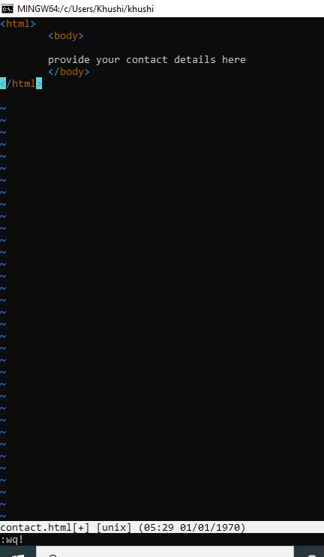

Khushi@DESKTOP-IEE8LDD MINGW64 ~/khushi (bca)

$ git status

On branch bca

Untracked files:

(use "git add <file>..." to include in what will be committed)

contact.html

nothing added to commit but untracked files present (use "git add" to track)

Khushi@DESKTOP-IEE8LDD MINGW64 ~/khushi (bca)

$ git add -A

warning: LF will be replaced by CRLF in contact.html.

The file will have its original line endings in your working directory

Khushi@DESKTOP-IEE8LDD MINGW64 ~/khushi (bca)

$ git status

On branch bca

Changes to be committed:

(use "git restore --staged <file>..." to unstage)

new file: contact.html

Khushi@DESKTOP-IEE8LDD MINGW64 ~/khushi (bca)

$ git diff

Khushi@DESKTOP-IEE8LDD MINGW64 ~/khushi (bca)

$ git checkout -f

Khushi@DESKTOP-IEE8LDD MINGW64 ~/khushi (bca)

$ git status

On branch bca

nothing to commit, working tree clean

Khushi@DESKTOP-IEE8LDD MINGW64 ~/khushi (bca)

$ git restore --spagde

error: unknown option `spagde'

usage: git restore [<options>] [--source=<branch>] <file>...

-s, --source <tree-ish>

which tree-ish to checkout from

-S, --staged restore the index

-W, --worktree restore the working tree (default)

--ignore-unmerged ignore unmerged entries

--overlay use overlay mode

-q, --quiet suppress progress reporting

--recurse-submodules[=<checkout>]

control recursive updating of submodules

--progress force progress reporting

-m, --merge perform a 3-way merge with the new branch

--conflict <style> conflict style (merge or diff3)

-2, --ours checkout our version for unmerged files

-3, --theirs checkout their version for unmerged files

-p, --patch select hunks interactively

--ignore-skip-worktree-bits

do not limit pathspecs to sparse entries only

--pathspec-from-file <file>

read pathspec from file

--pathspec-file-nul with --pathspec-from-file, pathspec elements are separated with NUL character

Khushi@DESKTOP-IEE8LDD MINGW64 ~/khushi (bca)

$ git checkout -f

Khushi@DESKTOP-IEE8LDD MINGW64 ~/khushi (bca)

$

***Screenshorts***

