**OUTPUT**

SAFE STATE

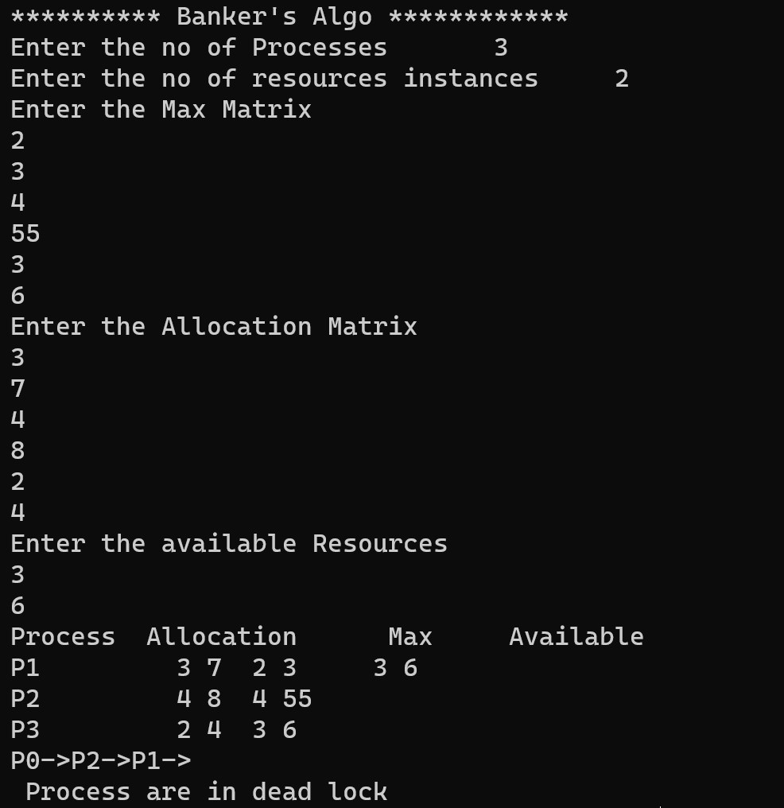

UNSAFE STATE

