Game Design Document

Fill up the following document

1. Write the title of your project.

The Journey.

1. What is the goal of the game?

The goal of the game is for our characters (The person) to go over obstcales to reach the finish line.

1. Write a brief story of your game.

The person is on a journey to reach the finish line. Our job is to help the players to overcome the obstacles and reach 1st to the finish line.

1. Which are the playing characters of this game?

* Playing characters are the ones who respond to the user based on the input from the user.
* Cars, monkeys, dinos, wizards, etc., are the playing characters in the game.

|  |  |  |
| --- | --- | --- |
| Number | Character Name | What can this character do? |
| 1 | The boy | They can move forward, left and right. |
| 2 | The Girl | They can move forward, left and right. |
| 3 |  |  |
| 4 |  |  |
| 5 |  |  |
| 6 |  |  |
| 7 |  |  |
| 8 |  |  |

1. Which are the Non-Playing Characters of this game?

* Non-Playing characters are the ones that don't have an action or behavior when the user interacts with the game.
* Hurdles, stones, bananas, coins, etc., are non-playing characters in the game.

|  |  |  |
| --- | --- | --- |
| Number | Character Name | What can this character do? |
| 1 | The static car obstacles | Move up and down |
| 2 | The water bottles | They spawn randomly |
| 3 | Coins | They spawn randomly |
| 4 |  |  |
| 5 |  |  |
| 6 |  |  |
| 7 |  |  |
| 8 |  |  |

Draw your imagination of this game. What does this game look like?

* Draw the game either on your computer or on paper.
* Add images of the game scenes to show each of the playing and non-playing characters at least once.

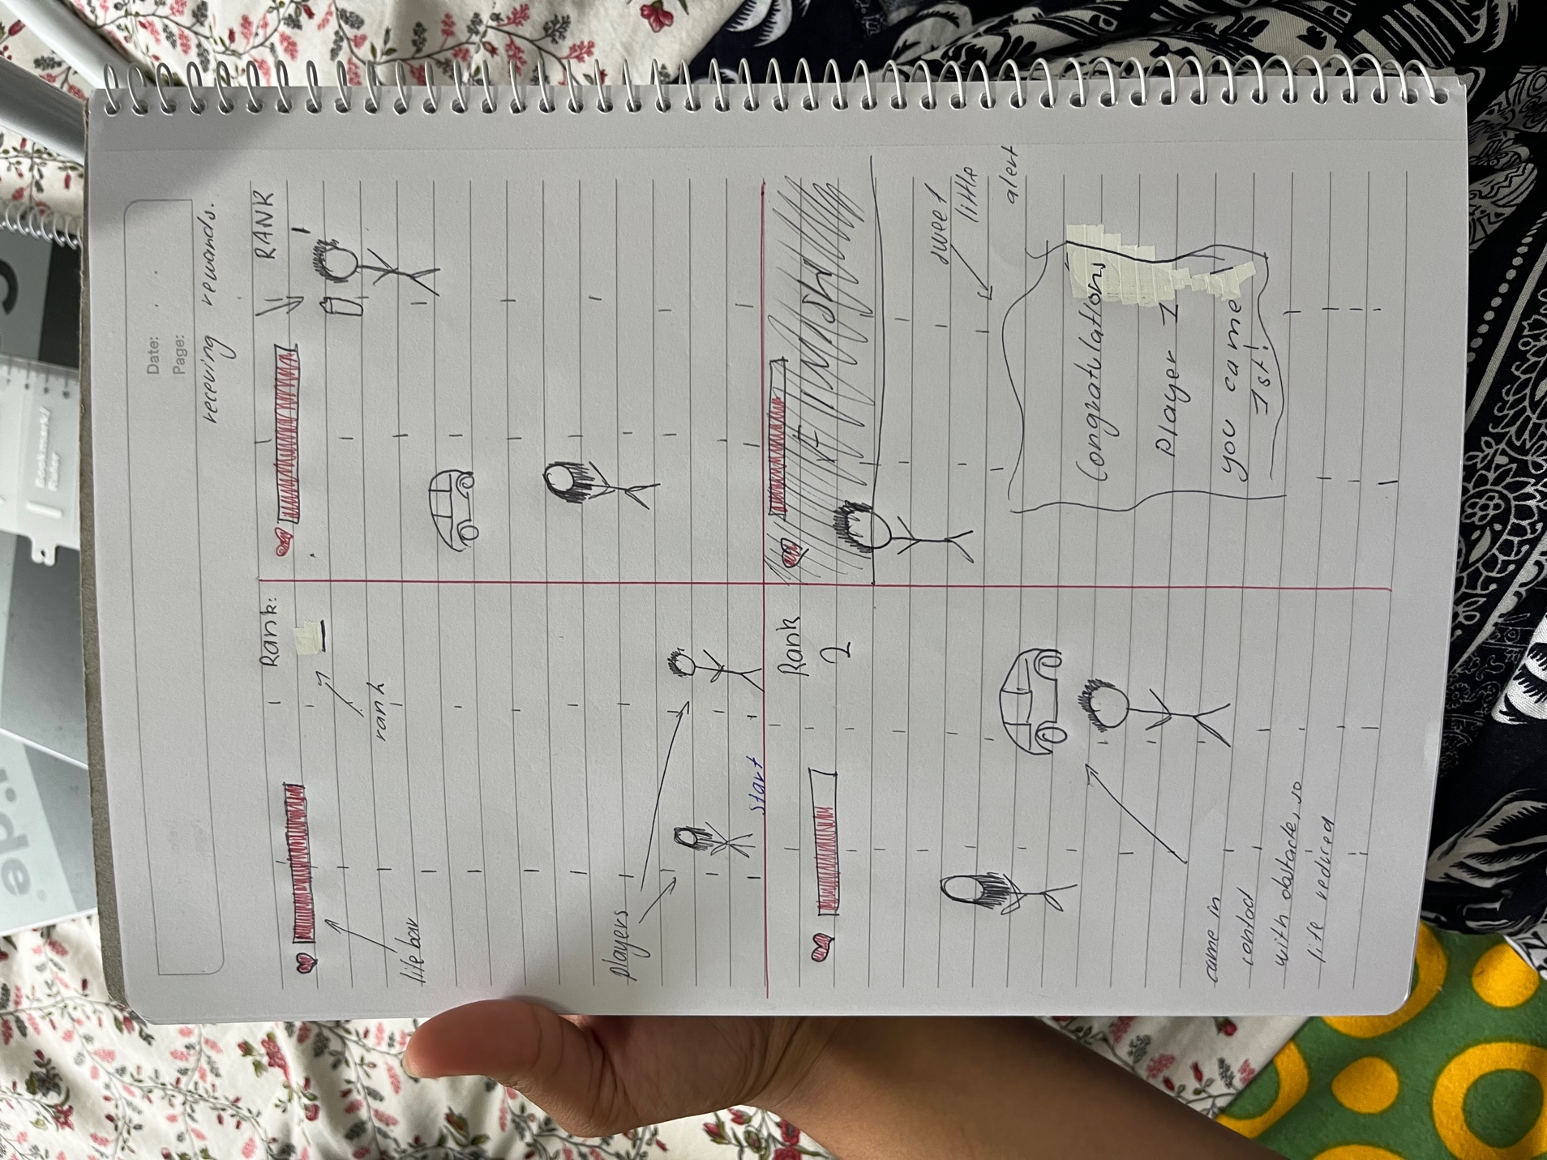

How do you plan to make your game engaging?

* Making the game multiplayer
* Random spawn of obstacles
* Life bar
* Rewards