NAVIOTECH SOLUTION PVT. LTD.
INTERNSHIP PROJECT REPORT
DIABETES PREDICTION USING MACHINE LEARNING
A Machine Learning Based Healthcare Prediction System
Submitted By
Khushi Rawat
B.Tech Computer Science Engineering (AI & ML)
Submitted To
Naviotech Solution Pvt. Ltd.
Academic Year: 2026
ACKNOWLEDGEMENT

I would like to express my sincere gratitude to Naviotech Solution Pvt. Ltd. for providing me with the opportunity to undertake this internship project titled 'Diabetes Prediction Using Machine Learning'.
This internship helped me understand the practical implementation of machine learning concepts in healthcare. I sincerely thank my mentor, faculty members, family, and friends for their continuous guidance and support.

ABSTRACT

This project aims to predict diabetes using machine learning. The Kaggle diabetes dataset was explored, cleaned, visualized, and standardized before training a Logistic Regression model. The model was evaluated using accuracy score, confusion matrix, classification report, and probability prediction. The project provided practical experience in data preprocessing, exploratory data analysis, feature scaling, model training, and evaluation.

Contents
- Introduction
- Problem Statement
- Objectives of the Project
- Scope of the Project
- Literature Survey
- Dataset Description
- Software and Hardware Requirements
- Methodology
- System Architecture
- Flowchart of the Project
- Data Preprocessing
- Exploratory Data Analysis
- Feature Scaling
- Logistic Regression Algorithm
- Model Training and Testing
- Model Evaluation
- Prediction on New Patient Data
- Results and Discussion
- Conclusion
- Future Scope
- References
INTRODUCTION
1.1 Introduction
Artificial Intelligence (AI) and Machine Learning (ML) have become some of the most influential technologies in recent years. They are being used in various fields such as healthcare, finance, education, agriculture, transportation, and business to solve real-world problems. Among these fields, healthcare has gained significant benefits from machine learning because it helps in analyzing large amounts of medical data and identifying patterns that may not be easily visible through traditional methods.
Diabetes is one of the most common chronic diseases affecting millions of people across the world. It occurs when the body is unable to regulate blood glucose levels effectively due to insufficient insulin production or improper utilization of insulin. If diabetes is not detected at an early stage, it can lead to serious health complications such as heart disease, kidney failure, nerve damage, and vision problems.
Traditionally, diabetes diagnosis depends on laboratory tests and clinical examination. Although these methods are accurate, they require medical resources and time. Machine learning offers an additional approach by analyzing patient medical information and predicting whether a patient is likely to have diabetes. Such prediction models can support healthcare professionals in making informed decisions and identifying high-risk patients at an earlier stage.
In this internship project, a Logistic Regression model has been developed to predict diabetes using patient medical information. The project uses the Pima Indians Diabetes Dataset, which contains several medical attributes such as glucose level, blood pressure, insulin level, body mass index (BMI), age, pregnancies, skin thickness, and diabetes pedigree function. These features are used to determine whether a patient is diabetic or non-diabetic.
Before building the machine learning model, the dataset was carefully explored and analyzed using various data analysis techniques. The preprocessing stage included checking for missing values, understanding the structure of the dataset, generating statistical summaries, and visualizing the relationships among different features using histograms, box plots, scatter plots, and a correlation heatmap. Feature scaling was then performed using the StandardScaler technique to improve model performance.
After preprocessing, the dataset was divided into training and testing sets. A Logistic Regression algorithm was trained using the training data and evaluated using the testing data. The model's performance was assessed using the Accuracy Score, Confusion Matrix, and Classification Report. Finally, the trained model was used to predict the diabetes status of a new patient based on their medical information.
This project provided practical exposure to the complete machine learning workflow, including data preprocessing, visualization, model development, evaluation, and prediction. It also strengthened my understanding of how machine learning techniques can be applied to solve real-life healthcare problems.

1.2 Importance of the Project
The importance of this project can be summarized as follows:
- It demonstrates the practical application of machine learning in the healthcare domain.
- It helps in understanding the complete machine learning workflow from data collection to prediction.
- It supports early diabetes prediction using patient medical information.
- It improves knowledge of data preprocessing and visualization techniques.
- It provides hands-on experience with the Logistic Regression algorithm.
- It enhances programming skills using Python and Jupyter Notebook.
- It builds practical experience in using machine learning libraries such as Pandas, NumPy, Matplotlib, and Scikit-learn.

1.3 Need for Diabetes Prediction
Early detection of diabetes plays a significant role in reducing health risks and improving the quality of life of patients. Machine learning models can analyze medical data quickly and provide predictions that may assist healthcare professionals during the diagnosis process. Although machine learning models do not replace doctors, they can serve as a useful decision-support system by identifying patients who may require further medical examination.
Developing such prediction systems also helps students understand how data science and artificial intelligence can be applied to solve practical healthcare challenges.

PROBLEM STATEMENT
Diabetes has become one of the fastest-growing health concerns worldwide. Many individuals remain unaware of their condition until serious complications develop. Early prediction of diabetes can help patients receive timely medical advice and treatment, thereby reducing the risk of severe complications.
The main objective of this project is to develop a machine learning model that predicts whether a patient is diabetic or non-diabetic using various medical attributes available in the dataset. The project focuses on building an accurate and efficient Logistic Regression model that can classify patients based on their health information.
The proposed system aims to assist healthcare professionals by providing quick predictions using patient data. The project also demonstrates the practical implementation of machine learning concepts learned during the internship.

OBJECTIVES OF THE PROJECT
The primary objectives of this project are:
- To study the application of machine learning in the healthcare sector.
- To analyze the Diabetes Dataset obtained from Kaggle.
- To perform data preprocessing and exploratory data analysis.
- To visualize important features using graphs and charts.
- To standardize numerical features using StandardScaler.
- To divide the dataset into training and testing datasets.
- To develop a Logistic Regression model for diabetes prediction.
- To evaluate the model using Accuracy Score, Confusion Matrix, and Classification Report.
- To predict the diabetes status of a patient using the trained machine learning model.
- To understand the complete machine learning development process using Python and Jupyter Notebook.

SCOPE OF THE PROJECT
This project focuses on predicting diabetes using machine learning techniques based on patient medical information. The developed system can be used as an educational project to understand the practical implementation of classification algorithms.
The project demonstrates how healthcare data can be processed, analyzed, and used to build predictive models. It also provides valuable learning experience in data preprocessing, visualization, feature scaling, model training, and evaluation.
In the future, similar systems can be improved by using larger datasets, advanced machine learning algorithms, web-based deployment, and real-time patient data integration.

LITERATURE SURVEY
5.1 Introduction
Before developing any machine learning project, it is important to understand the existing research and methods related to the problem. A literature survey helps in identifying the techniques, algorithms, and approaches that have already been used by researchers. It also provides an understanding of the strengths and limitations of different methods.
Diabetes prediction has become an active research area because diabetes is one of the fastest-growing chronic diseases worldwide. Researchers have developed several machine learning models to predict diabetes at an early stage using patient medical records. These models assist healthcare professionals in making quicker and more accurate decisions.
During this internship project, I studied different machine learning techniques used in healthcare applications. After comparing different classification algorithms, Logistic Regression was selected because of its simplicity, efficiency, and suitability for binary classification problems.

5.2 Machine Learning in Healthcare
Machine Learning has transformed the healthcare industry by providing intelligent solutions for disease diagnosis, patient monitoring, medical image analysis, and predictive healthcare systems.
Hospitals and healthcare organizations generate a large amount of patient data every day. Analyzing such data manually is difficult and time-consuming. Machine learning algorithms help in identifying hidden patterns within the data and making predictions based on previous medical records.
Some common healthcare applications include:
- Disease prediction
- Medical diagnosis
- Drug recommendation
- Patient risk analysis
- Health monitoring systems
- Personalized treatment planning
The healthcare sector is increasingly adopting machine learning because it improves decision-making, reduces manual effort, and supports doctors with data-driven insights.
5.3 Diabetes Prediction Using Machine Learning
Diabetes is a chronic disease that affects the body's ability to regulate blood sugar levels. Early detection of diabetes helps patients receive timely treatment and avoid severe complications.
Traditional diagnosis relies on laboratory tests and clinical examination. Machine learning provides an alternative approach by analyzing historical patient data and identifying patterns associated with diabetes.
Several machine learning algorithms have been applied for diabetes prediction, including:
- Logistic Regression
- Decision Tree
- Random Forest
- Support Vector Machine (SVM)
- K-Nearest Neighbors (KNN)

Each algorithm has its own advantages depending on the characteristics of the dataset.
For this project, Logistic Regression was selected because the dataset contains two classes (Diabetic and Non-Diabetic), making it an ideal binary classification problem.

5.4 Logistic Regression
Logistic Regression is one of the most widely used supervised machine learning algorithms for classification problems.
Unlike Linear Regression, which predicts continuous values, Logistic Regression predicts categorical outcomes.
In this project, the model predicts whether a patient belongs to one of two categories:
- Diabetic
- Non-Diabetic
The algorithm estimates the probability that a patient belongs to the diabetic class using patient medical attributes.
Some advantages of Logistic Regression include:
- Easy to understand and implement.
- Fast training process.
- Suitable for binary classification.
- Works well with standardized numerical data.
- Provides probability values for predictions.
Because of these advantages, Logistic Regression is widely used in healthcare prediction systems.

5.5 Existing Systems
Several diabetes prediction systems have already been developed using machine learning techniques.
Most existing systems follow these steps:
- Collection of patient medical records.
- Data preprocessing.
- Feature selection.
- Machine learning model training.
- Performance evaluation.
- Prediction of diabetes status.
Although different algorithms are available, Logistic Regression remains one of the simplest and most interpretable models for healthcare applications.

5.6 Limitations of Existing Systems
Some limitations observed in existing diabetes prediction systems include:
- Small datasets may reduce prediction accuracy.
- Missing or incorrect medical data can affect model performance.
- Different patient populations may produce different results.
- Many systems require continuous updates with new medical data.
- Prediction models assist doctors but cannot replace professional medical diagnosis.

5.7 Motivation Behind the Project
The primary motivation behind this project was to gain practical knowledge of Machine Learning and understand how predictive models are developed using real-world healthcare datasets.
This project provided an opportunity to implement the complete machine learning workflow, including:
- Data loading
- Data preprocessing
- Data visualization
- Feature scaling
- Model training
- Model evaluation
- Prediction
Working on this project also improved my programming skills in Python and enhanced my understanding of machine learning libraries such as Pandas, NumPy, Matplotlib, and Scikit-learn.

DATASET DESCRIPTION
6.1 Dataset Overview
The dataset used in this project is the Pima Indians Diabetes Dataset, obtained from Kaggle.
The dataset contains medical information collected from female patients belonging to the Pima Indian community. Each record contains several medical measurements that are used to determine whether a patient is diabetic.
The target variable in the dataset is Outcome, where:
- 0 → Non-Diabetic
- 1 → Diabetic
This dataset is widely used for educational purposes and machine learning classification problems because it is clean, well-structured, and suitable for binary classification.

6.2 Dataset Characteristics
Property | Description
Dataset Name | Diabetes Dataset
Source | Kaggle
Number of Records | 768
Number of Features | 8
Target Variable | Outcome
Problem Type | Binary Classification

6.3 Features Used in the Dataset
Feature | Description
Pregnancies | Number of pregnancies experienced by the patient
Glucose | Plasma glucose concentration
BloodPressure | Diastolic blood pressure (mm Hg)
SkinThickness | Triceps skin fold thickness (mm)
Insulin | 2-Hour serum insulin level
BMI | Body Mass Index
DiabetesPedigreeFunction | Genetic likelihood of diabetes
Age | Age of the patient
Outcome | Diabetes status (0 = Non-Diabetic, 1 = Diabetic)

6.4 Target Variable
The target variable is Outcome, which indicates whether the patient has diabetes.
Outcome | Meaning
0 | Non-Diabetic
1 | Diabetic
This makes the dataset a binary classification dataset.

SOFTWARE AND HARDWARE REQUIREMENTS
7.1 Software Requirements
The following software was used during the development of this project:
Software | Purpose
Python 3.x | Programming Language
Jupyter Notebook | Development Environment
Pandas | Data Manipulation
NumPy | Numerical Computations
Matplotlib | Data Visualization
Scikit-learn | Machine Learning
OpenPyXL | Reading Excel Files

7.2 Hardware Requirements
The project does not require high-end hardware. The following configuration is sufficient:
Hardware | Specification
Processor | Intel Core i3/i5/i7 or equivalent
RAM | Minimum 4 GB
Storage | 500 MB Free Space
Operating System | Windows 10 / Windows 11
Internet | Required only for downloading the dataset

7.3 Python Libraries Used
During the project, the following Python libraries were used:
Pandas
Used for loading, cleaning, and manipulating the dataset.
NumPy
Used for numerical calculations and array operations.
Matplotlib
Used to generate visualizations such as histograms, scatter plots, box plots, and the correlation heatmap.
Scikit-learn
Used for:
- Train-Test Split
- StandardScaler
- Logistic Regression
- Accuracy Score
- Confusion Matrix
- Classification Report

METHODOLOGY
The methodology describes the sequence of steps followed to develop the Diabetes Prediction System. The project uses a supervised machine learning approach to analyze patient medical data and predict whether a patient is diabetic or non-diabetic using the Logistic Regression algorithm.
The workflow begins with collecting the dataset from Kaggle, followed by data preprocessing to check the quality of the dataset. Exploratory Data Analysis (EDA) is then performed to understand the distribution and relationship between different features. After preprocessing, feature scaling is applied using StandardScaler to standardize the numerical values.
The processed dataset is divided into training and testing sets using the train-test split technique. The Logistic Regression model is trained using the training dataset and evaluated on the testing dataset using performance metrics such as Accuracy Score, Confusion Matrix, and Classification Report. Finally, the trained model is used to predict the diabetes status of a patient based on the given medical attributes.

8.2 Methodology Steps
The complete workflow of the project consists of the following steps:
- Dataset Collection
- Data Loading
- Data Preprocessing
- Exploratory Data Analysis (EDA)
- Feature Scaling
- Train-Test Split
- Model Training
- Model Evaluation 9. Patient Prediction

System Architecture
Diabetes Dataset
│
▼
Data Preprocessing
│
▼
Exploratory Data Analysis
│
▼
Feature Scaling
│
▼
Train-Test Split
│
▼
Logistic Regression Model
│
▼
Model Evaluation
│
▼
Diabetes Prediction

PROJECT FLOWCHART
The following flowchart represents the complete workflow of the project.
Start
│
▼
Load Diabetes Dataset
│
▼
Data Preprocessing
│
▼
Exploratory Data Analysis
│
▼
Feature Scaling
│
▼
Train-Test Split
│
▼
Train Logistic Regression
│
▼
Evaluate Performance
│
▼
Predict Diabetes Status
│
▼
End

DATA PREPROCESSING
11.1 Introduction
Data preprocessing is an important step in any machine learning project because the quality of the input data directly affects the performance of the model. Before training the Logistic Regression model, the dataset was carefully examined and prepared.

11.2 Dataset Loading
The dataset was loaded into Jupyter Notebook using the pd.read_excel() function from the Pandas library.

11.3 Dataset Information
The following function was used:
df.info()
This provided information about:
- Number of rows
- Number of columns
- Data types
- Missing values
Figure 11.1: Dataset Information (df.info())
Name: count, dtype: int64

11.4 Statistical Summary
The statistical properties of the dataset were examined using:
df.describe()
This function displayed:
- Mean
- Standard Deviation
- Minimum Value
- Maximum Value
- Quartiles

11.5 Missing Value Analysis
The dataset was checked for missing values using:
df.isnull().sum()
No missing values were found in the dataset, indicating that it was complete and suitable for analysis.

11.6 Duplicate Record Check
Duplicate records were checked using:
df.duplicated().sum()
The dataset did not contain significant duplicate entries, so no duplicate removal was required.

11.7 Summary
After preprocessing, the dataset was found to be clean and ready for visualization, feature scaling, and model training.

EXPLORATORY DATA ANALYSIS (EDA)
12.1 Introduction
Exploratory Data Analysis (EDA) was performed to understand the dataset before training the machine learning model. Different graphs were used to study the distribution of features and the relationship between variables.
Visualizations Used
- Histogram
- Bar chart
- Scatter Plot
- Box Plot
- Correlation Heatmap
Fig 12.1: Histogram of Dataset Features fig 12.2 Bar chart of outcome
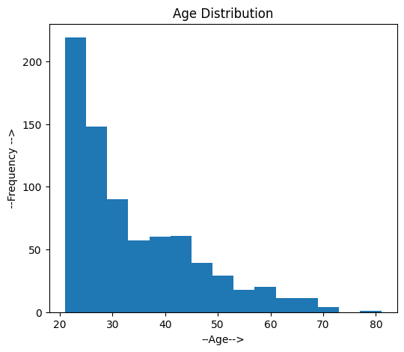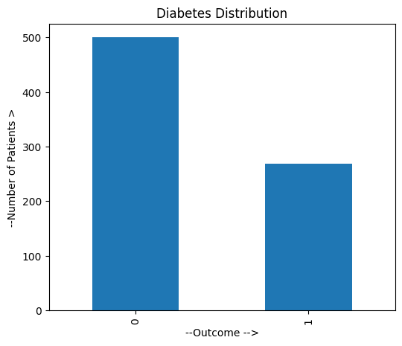

Figure 12.3: Scatter Plot Figure 12.4: Box Plot
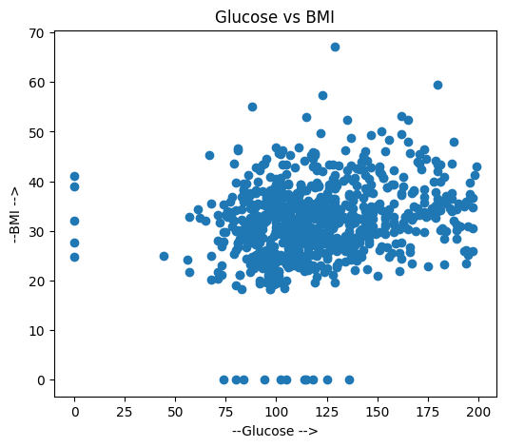
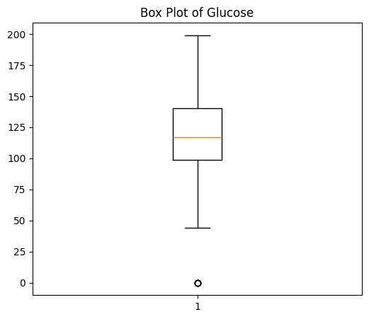
Figure 12.5: Correlation Heatmap

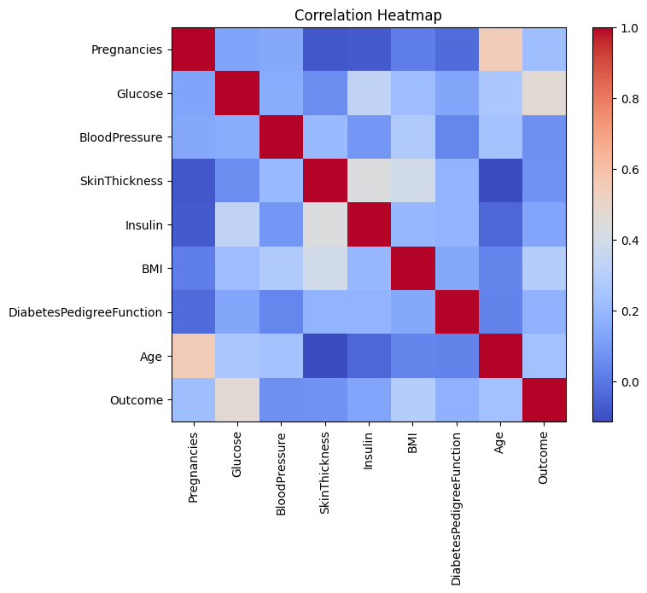
Summary
The visualizations helped in understanding the data distribution, identifying outliers, and observing relationships among different medical attributes.

FEATURE SCALING
Feature Scaling was performed using StandardScaler to standardize the numerical features before training the Logistic Regression model.
Since different features have different ranges, scaling ensures that all features contribute equally during model training.

LOGISTIC REGRESSION MODEL
Logistic Regression is a supervised machine learning algorithm used for binary classification problems. Since the target variable (Outcome) has only two classes (0 and 1), Logistic Regression was selected for this project.
The dataset was divided into training and testing sets using an 80:20 ratio. The model was trained using the training dataset and then tested on unseen data.

MODEL EVALUATION
The trained model was evaluated using three performance metrics.
Accuracy Score
The Accuracy Score represents the percentage of correctly classified instances.
Model Accuracy: 74.68 %
Confusion MatrixThe Confusion Matrix compares the predicted values with the actual values and shows the number of correct and incorrect predictions.
Figure 15.1: Confusion Matrix
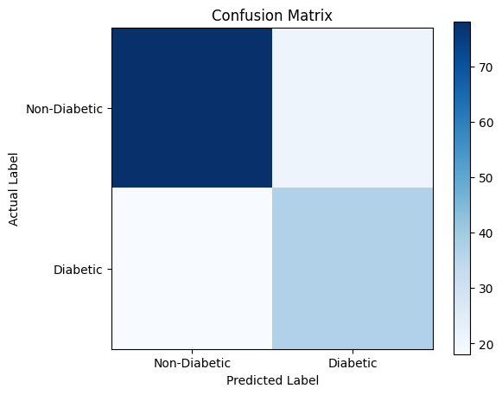
Classification Report
The Classification Report provides Precision, Recall, F1-Score, and Support for each class.
Figure 15.2: Classification Report
precision recall f1-score support

0 0.81 0.79 0.80 99
1 0.64 0.67 0.65 55

PREDICTION ON NEW PATIENT DATA
After training the model, a new patient's medical information was provided to the trained Logistic Regression model.
The model successfully predicted whether the patient was diabetic or non-diabetic based on the input values.
Figure 16.1: Prediction Output
The patient is likely to be Non-Diabetic.
Prediction Probability:
[[9.99895567e-01 1.04433075e-04]]

RESULTS AND DISCUSSION
The Logistic Regression model was successfully trained using the Diabetes Dataset.
The dataset was preprocessed, visualized, and standardized before training. The trained model produced satisfactory classification performance and correctly predicted diabetes for most test samples.
The project demonstrates that Logistic Regression can effectively classify patients based on their medical information and can be used as a simple decision-support tool for diabetes prediction.

CONCLUSION
This internship project successfully developed a Diabetes Prediction System using the Logistic Regression algorithm.
The project involved data preprocessing, visualization, feature scaling, model training, and evaluation using Python and Jupyter Notebook.
The results show that machine learning can assist in predicting diabetes using patient medical attributes. This project also enhanced my understanding of supervised machine learning, data preprocessing, and model evaluation.

FUTURE SCOPE
The project can be enhanced in the future by:
- Using larger and more diverse datasets.
- Comparing Logistic Regression with other classification algorithms.
- Developing a web application for real-time prediction.
- Improving prediction accuracy through feature engineering.
- Integrating the system into healthcare applications.

REFERENCES
- Kaggle – Diabetes Dataset.
- Scikit-learn Documentation.
- Pandas Documentation.
- NumPy Documentation.
- Matplotlib Documentation.
- Python Official Documentation.

