Netflix & Spotify Viewing and Listening Habits
A Personal Data Analysis Project

Problem Statement
Nowadays we spend a lot of our free time watching shows and movies on Netflix and listening to music on Spotify, but we rarely stop to look at our own habits. This project was made to understand exactly that — how much time is actually spent on these two platforms, what kind of content is preferred, and whether there are any patterns in when and what we watch or listen to.
A dashboard was built to bring all this information together in one place. Instead of scrolling through hundreds of rows of raw viewing and listening history, the dashboard turns that data into simple charts and numbers that are easy to understand at a glance. It helps answer questions like: Do we watch more shows or movies? Which days do we watch the most? Do we skip a lot of songs? Which artists do we listen to the most?

Key Objective
The main objective of this project is to study personal Netflix viewing history and Spotify listening history, and find out:
- How much content has been watched on Netflix and how much time has been spent listening on Spotify.
- Whether movies or shows are watched more, and which specific titles are the most watched.
- Which days of the week and which months have the highest activity.
- Who the most-listened artists are and how listening has changed over the years.
- How often songs are skipped, which shows whether the music being played is actually liked or not.

Who Will Use the Dashboard
This dashboard is mainly made for personal use, so that the account holder can track and understand their own Netflix and Spotify habits. It can also be useful for:
- Anyone who wants to review their own screen time and listening time habits.
- Students or beginners who want to see a simple example of how raw data can be turned into a dashboard.
- Content platforms (like Netflix or Spotify) in a real-world scenario, since the same kind of dashboard could help them understand what their users enjoy watching or listening to the most.

Data Description
Netflix Data
The Netflix data contains the viewing history of the account, including the name of the show or movie watched and the date and time it was watched. This raw data was cleaned and organised in the "NetflixClean" sheet, and pivot tables were created in the "NetflixPivots" sheet to summarise it. In total, 565 titles were recorded, made up of 106 movies and 459 shows.
Spotify Data
The Spotify data contains the streaming history of the account, including details such as the artist name, the track played, the date and time it was played, how long it was played for, and whether the song was skipped or not. This data was organised and summarised in the "SpotifyPivots" sheet. In total, the account has listened to 5,341.5 hours of music, spread across many years from 2013 to 2024.

Preprocessing and Transformation
Before the data could be used in the dashboard, it had to be cleaned and organised. The main steps followed were:
- Checked the data types of each column (like making sure dates were recognised as dates, and not as plain text) so that charts and calculations would work correctly.
- Removed blank or missing rows so that the totals and charts stay accurate.
- Added new helper columns to make analysis easier, such as extracting the Month Name and Day of Week from the date column, and marking whether a day was a Weekday or a Weekend.
- For Spotify data, an Hour column was created from the timestamp to study what time of day music is played the most.
- Used pivot tables to group and summarise the cleaned data by month, day, artist, and content type, which were then used to build the charts on the dashboard.
- Filtered out unnecessary columns that were not needed for the analysis, keeping the sheets clean and easy to read.

Dashboard and Insights

Netflix: Top Shows and Content Type
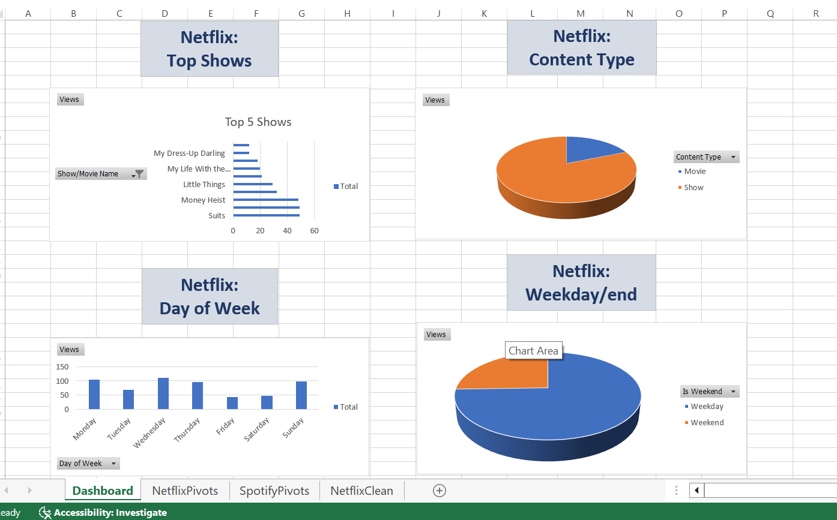
Fig 2: Top 5 shows watched, content type split, day-of-week pattern, and weekday vs weekend split.
Suits and Money Heist are clearly the most re-watched shows on the list. Looking at content type, shows are watched far more often than movies, which matches the earlier numbers. When it comes to days of the week, Wednesday and Sunday see the most viewing, while Friday and Saturday are the quietest days. Interestingly, most of the viewing still happens on weekdays rather than weekends.

Netflix: Monthly Trend
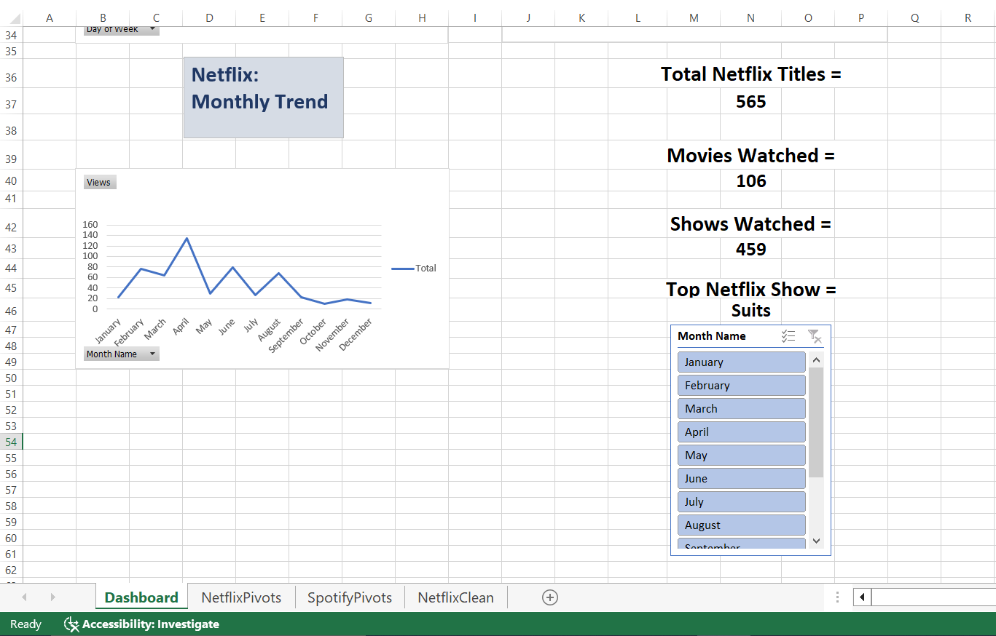

Fig 1: Monthly viewing trend along with total Netflix titles, movies watched, shows watched and top show.
The monthly trend shows that viewing goes up and down through the year, with April standing out as the month with the highest activity. Overall, 565 titles have been watched in total, with shows (459) being watched far more often than movies (106). The most-watched show on the account is Suits.

Spotify: Top Artists and Hourly Trend
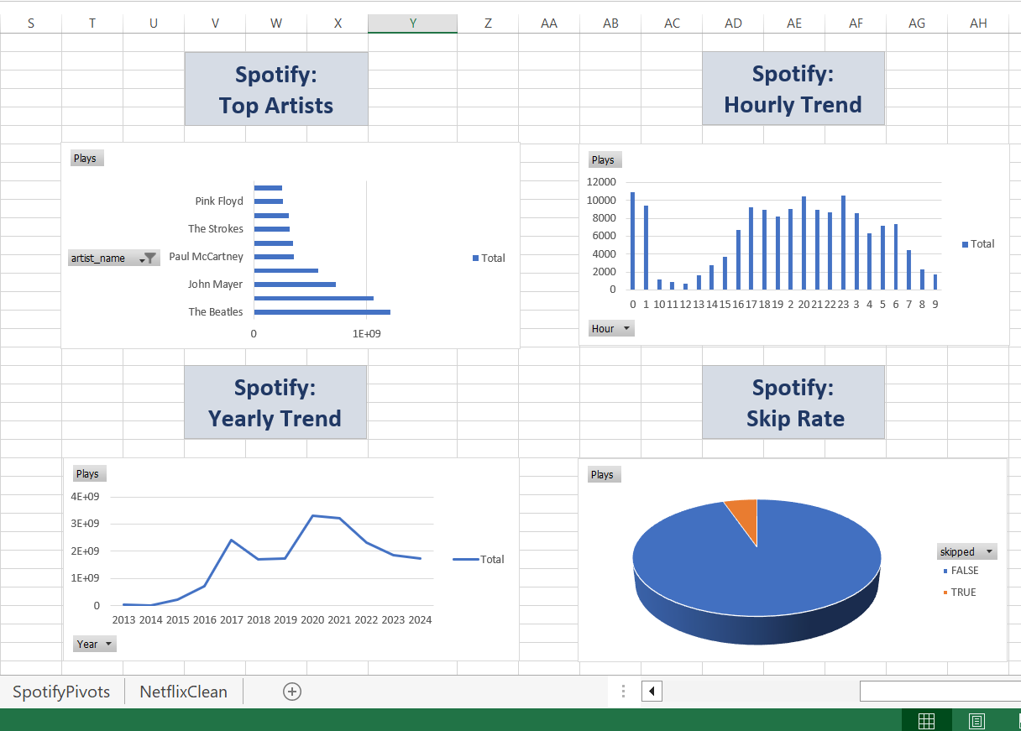
Fig 3: Top 5 most-played artists and the hourly listening trend.
The Beatles come out on top as the most-played artist by a big margin, followed by John Mayer and Paul McCartney. The hourly trend shows that listening is lowest late at night and early morning, and picks up steadily from the afternoon onwards, peaking in the evening hours.

Spotify: Yearly Trend and Skip Rate
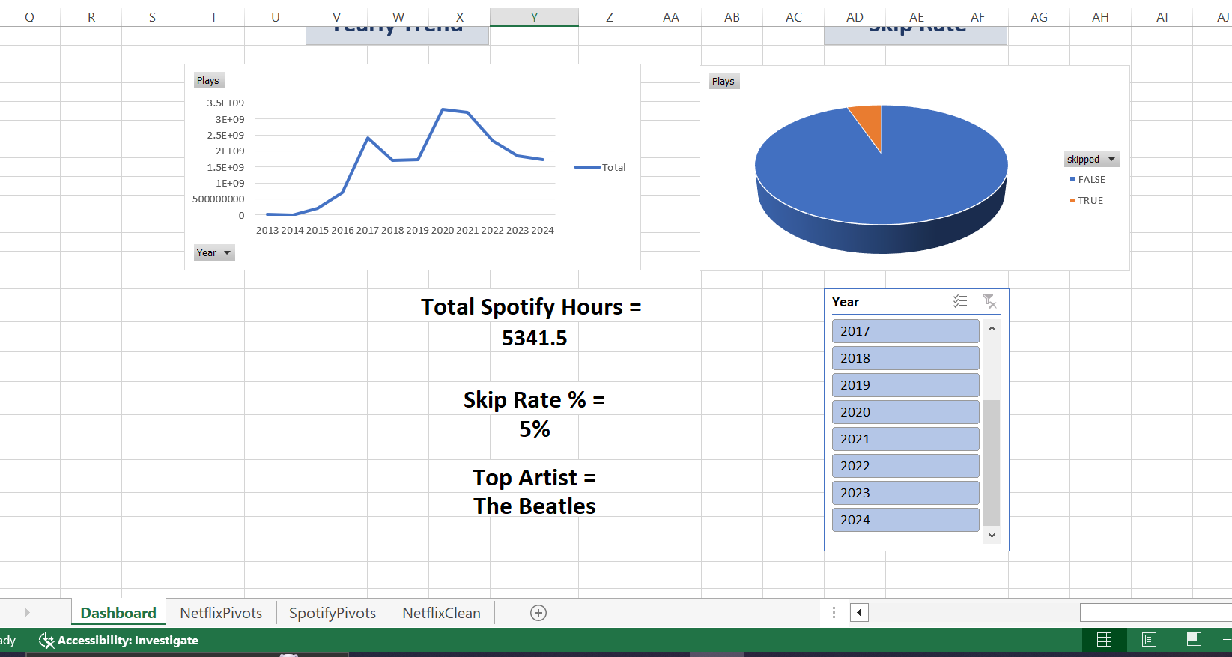
Fig 4: Yearly listening trend, skip rate, and key Spotify numbers.

Listening activity grew steadily from 2013, dipped a little around 2018, and then peaked around 2020-2021 before slightly coming down again. Out of all songs played, only about 5% were skipped, which means most of the music played was actually enjoyed rather than skipped over. In total, 5,341.5 hours have been spent listening on Spotify, and The Beatles remain the top artist overall.

Top 5 Key Insights
- Shows are watched far more than movies on Netflix — 459 shows compared to only 106 movies.
- Suits is the most-watched title overall, and April is the peak month for Netflix viewing.
- Netflix is actually watched more on weekdays than weekends, which is a bit surprising.
- The Beatles are the most-played artist on Spotify, and listening peaked around 2020-2021.
- Only 5% of songs are skipped, meaning most of the music played is genuinely liked.

Conclusion and Future Improvements
This project shows how personal Netflix and Spotify data, which usually just sits unused in an export file, can be turned into a simple and clear dashboard that tells a story about our own habits. It became clear that shows are preferred over movies on Netflix, weekdays are actually watched more than weekends, and on Spotify, classic artists like The Beatles dominate the listening history with a very low skip rate.
Going forward, this dashboard could be improved by:
- Adding more years of data as it becomes available, to see longer-term trends.
- Comparing Netflix and Spotify activity side by side, to see if there is a connection between watching and listening habits (for example, do people listen to more music on days they watch fewer shows?).
- Building the same dashboard in a tool like Power BI or Tableau for more interactive filtering.
- Adding genre-level analysis, if genre data is available, to understand content preferences even better.

