AI STUDYMATE
(AI-Powered Student Performance Predictor & Personalized Learning Recommendation System)
A PROJECT REPORT
SUBMITTED BY
Roll Number | Registration Number | Student Code | Student Name
24103460069 | 24103002850 | BWU/BCA/24/071 | MOHIT KUMAR PANDIT
In partial fulfillment for the award of the degree of
BACHELOR OF COMPUTER APPLICATION
IN
DEPARTMENT OF COMPUTATIONAL SCIENCE

BRAINWARE UNIVERSITY
398, Ramkrishnapur Road, Barasat, North 24 Parganas, Kolkata - 700 125

ABSTRACT
AI StudyMate (AI-Powered Student Performance Predictor & Personalized Learning Recommendation System) is a web-based application built with Python, Flask, scikit-learn and a vanilla HTML5/CSS3/JavaScript front end. A student chooses a course (BCA, BTech CSE or MCA), enters the marks of the six subjects of that course and the number of hours that can be studied each day, and instantly receives a diagnostic dashboard without any page reload. The main objective of the project is to show the practical implementation of a machine-learning-assisted educational analytics tool and of full-stack web engineering.
For every subject the system predicts the mark that a student with a similar profile would be expected to score, using a regression model that takes the other five marks and the daily study hours as inputs. It also calculates the percentile rank of the student against a reference cohort of 1,000 students per course, sets a realistic target mark and labels the subject as Needs Improvement (below the 35th percentile), Average (35th to 70th percentile) or Good (70th percentile and above). The overall mark and its percentile are reported in the same way.
The diagnosis drives three kinds of guidance. The daily study hours are divided between subjects in proportion to priority weights (3, 2 and 1); a personalised 7-day study plan is generated from the three weakest subjects; and 90 curated learning resources for 15 subjects (two for each of three performance tiers) are recommended in order of urgency. The client communicates with a Flask REST API (/api/courses and /api/analyze) through the Fetch API and shows the result with animated SVG progress rings, status badges, insights and next steps.
Because public subject-wise marks for these courses are not available, the reference cohorts are synthetic and are produced by a documented statistical model. For each of the 18 subject models, Linear Regression and Random Forest were compared on a 20% hold-out set; Linear Regression achieved the higher R² in every case (mean R² 0.63, mean absolute error 6.9 marks) and was saved. Overall, the project demonstrates data generation, model training and selection, modular Python architecture, RESTful API design and responsive front-end development, and it gives students an actionable path to improve their academic performance.

INDEX
❖ ABSTRACT 2
❖ LIST OF FIGURE 4
❖ LIST OF TABLE 5
❖ LIST OF SCREENSHOTS 6
1. INTRODUCTION 7
2. LITERATURE SURVEY 9
3. SYSTEM ANALYSIS AND DESIGN 11
4. IMPLEMENTATION 20
5. OUTPUT SCREENSHOT 28
6. TESTING AND DEBUGGING 35
7. CONCLUSION AND FUTURE ENHANCEMENT 38
8. REFERENCES 39

LIST OF FIGURE
Fig. 3.1 :- Layered Theory Architecture of AI StudyMate 14
Fig. 3.2 :- System Flow Chart of AI StudyMate 16
Fig. 3.3 :- DFD Level 0 of AI StudyMate 17
Fig. 3.4 :- DFD Level 1 of AI StudyMate 18
Fig. 4.1 :- Offline Training Pipeline 21
Fig. 4.2 :- Model Comparison (R²) by Course, Generated by the Training Script 23
Fig. 4.3 :- Correlation Heatmap of the BCA Cohort 23

LIST OF TABLE
Table 2.1 :- Comparison of Common Approaches with AI StudyMate 9
Table 3.1 :- Functional Requirements 11
Table 3.2 :- Non-Functional Requirements 12
Table 3.3 :- Technologies Used 13
Table 3.4 :- Layers and Their Responsibilities 14
Table 3.5 :- Core Concepts and Where They Are Used 14
Table 3.6 :- Performance Labels, Weights and Resource Priority 15
Table 3.7 :- Steps of the System Flow 16
Table 3.8 :- Processes and Data Stores in the DFD 18
Table 3.9 :- Courses, Subjects and Cohort Files 19
Table 4.1 :- Files and Folders of the Project 20
Table 4.2 :- Model Evaluation on the Hold-out Set (20%) for All 18 Subject Models 21
Table 4.3 :- Average Model Performance by Course 22
Table 4.4 :- The 7-Day Study Plan Template 24
Table 4.5 :- REST API Endpoints 24
Table 4.6 :- Fields of the JSON Response 25
Table 4.7 :- Main Functions of the Frontend 26
Table 4.8 :- Files Not Used by the Flask Application 26
Table 5.1 :- Sample Input Used for the Screenshots 28
Table 6.1 :- Test Cases and Observed Results 35
Table 6.2 :- Observations and Known Limitations 36

LIST OF SCREENSHOTS
Screenshot 5.1 :- Home Page with the Student Details Form 28
Screenshot 5.2 :- Marks Grid Generated for the BCA Course and Study-Hours Slider 29
Screenshot 5.3 :- Overall Result Banner 30
Screenshot 5.4 :- Subject Rings, Study Plan Summary, Key Insights and Next Steps 31
Screenshot 5.5 :- Expanded 7-Day Study Plan 32
Screenshot 5.6 :- Recommended Learning Resources with Priority Badges and Filters 33
Screenshot 5.7 :- Input Form on a Narrow (Mobile-width) Screen 34

1. INTRODUCTION
Higher-education programmes in computing, such as BCA, B.Tech CSE and MCA, combine many subjects that call for very different skills: programming languages, operating systems, databases, networks, mathematics and web technologies. Every student is stronger in some of these subjects and weaker in others. A raw mark, however, says very little on its own. A score of 62 in Java may be an excellent result in a difficult paper or a disappointing one in an easy paper, and it means something different for a student who scored 90 everywhere else than for one who scored 45 everywhere else.
In the traditional process the student receives a grade card after the examination and is left alone with a list of numbers. The student cannot easily tell how he or she compares with the rest of the class, whether a subject is genuinely weak or just a little below the student's own average, how the limited daily study time should be divided between subjects, or where to find good learning material for the weak ones. These questions are answered late, informally, or not at all.
AI StudyMate (AI-Powered Student Performance Predictor & Personalized Learning Recommendation System) is a web application developed to answer these questions in a few seconds. The student selects a course, types in the marks of the six subjects of that course, chooses how many hours can be studied per day, and presses one button. The dashboard then shows, for every subject, the mark that a student with a similar profile would be expected to score, the percentile rank against a reference cohort of 1,000 students, a performance label (Needs Improvement, Average or Good) and a realistic target mark. It also produces a personalised 7-day study plan, a split of the daily study hours that gives weak subjects more time, a set of key insights and next steps, and curated learning resources (video courses, tutorials, practice platforms) ordered by urgency.
The application is written in Python 3 with the Flask micro-framework. The prediction models are built with scikit-learn (Linear Regression and Random Forest regressors are compared and the better one is kept), data handling is done with pandas and NumPy, and trained models are stored with joblib. The browser side is a single-page interface written in plain HTML5, CSS3 and vanilla JavaScript; it talks to the server with the Fetch API and draws animated SVG progress rings, so results appear without reloading the page.
The code is organised into small, separate parts: core/ holds the pure Python logic (model loading, analysis, planning, resources), routes/ holds the Flask blueprint with the REST endpoints, scripts/ holds the data-generation and training programs, and templates/ and static/ hold the user interface. This separation makes the system easy to test, to explain and to extend with new courses or subjects.

1.1 Objectives of the Project
- To give students instant, subject-wise feedback that compares their marks with a reference cohort and with their own expected level.
- To train and compare machine-learning regression models that predict the expected mark of a subject from the other subjects and the daily study hours.
- To convert the diagnosis into action: a priority-based study-hour split, a 7-day plan and categorised learning resources.
- To build a clean REST API and a responsive single-page front end that work together without page reloads.
- To keep the project modular, so that new courses, subjects and resources can be added with very small changes.

1.2 Scope and Limitations
- The current release supports three courses (BCA, BTech CSE and MCA) with six subjects each, i.e. 18 subject models in total.
- The reference cohorts are synthetic (1,000 generated students per course) because no public subject-wise marks dataset exists for these courses. They can be replaced with real marks by keeping the same CSV format.
- The system is a decision-support tool. Its predictions are statistical estimates and not guarantees of examination results.
- There is no login, database or history of past sessions in this version; every analysis is independent.

2. LITERATURE SURVEY
AI StudyMate is built on ideas from Educational Data Mining (EDM) and Learning Analytics (LA), two research areas that apply statistics and machine learning to data produced in education. Surveys of these fields (for example Romero and Ventura, 2020) identify the prediction of student performance from earlier grades and activity as one of the most studied tasks, and they stress that the results are most valuable when they reach the student early enough to change behaviour.
Regression for performance prediction. Predicting a numeric mark is a regression problem. Linear Regression is the standard baseline because it is fast, needs little data and is easy to explain. Ensemble methods such as the Random Forest (Breiman, 2001) can model non-linear effects but need more data and are harder to interpret. Choosing between them by measuring the coefficient of determination (R²) and the mean absolute error (MAE) on unseen data is a standard practice, and it is the approach used in this project. Marks in related subjects are usually positively correlated, which is exactly what makes cross-subject prediction possible; the correlation heatmaps produced by this project (Chapter 4) show values between about 0.5 and 0.77 for the BCA cohort.
Norm-referenced feedback. A percentile rank tells a student how many peers he or she has outperformed. Combined with an expected mark from a model, it separates two situations that a raw mark hides: "this subject is hard for everyone" and "this subject is weak for me". AI StudyMate reports both the percentile and the gap between the actual and the expected mark.
Feedback with action. Diagnostic feedback is most useful when it is paired with concrete next steps. A bare percentage can discourage a learner, whereas a prioritised list of subjects, a short timetable and direct links to learning material turn the same information into a routine that can be followed. This idea shaped the planner and the resource recommender of the system.
Web architecture. Modern educational tools are usually delivered as web applications. A lightweight server framework such as Flask exposes a small REST API that returns JSON, and a single-page front end updates the page in place using the browser's Fetch API. This avoids full page reloads, keeps the entered values on screen and gives immediate visual feedback.

2.1 Comparison with Common Approaches
Table 2.1 :- Comparison of Common Approaches with AI StudyMate
Aspect | Printed grade card | Static marks spreadsheet | AI StudyMate
Peer comparison | None | Manual formulas only | Percentile against 1,000-student cohort
Expected vs. actual | Not available | Not available | ML-predicted expected mark and gap
Study plan | None | None | 7-day plan with hour split
Learning resources | None | None | Curated links by priority
Speed of feedback | After results are published | Depends on the user | Instant (one request)

2.2 Evolution of this Project
The project folder shows how the idea developed. The first prototype (train.py, studymate_app.py, StudentsPerformance.csv, reference_marks.csv) was a Streamlit dashboard trained on the public Students Performance in Exams dataset, which contains math, reading and writing scores. Because that dataset does not describe computing subjects, it was replaced by course-specific data: scripts/make_dataset.py generates one cohort per course and scripts/train_courses.py trains one model for every subject. The Streamlit dashboard (studymates_v2.py) was then rebuilt as the Flask application documented in this report, with a clean separation between logic, routes and interface.

3. SYSTEM ANALYSIS AND DESIGN
The System Analysis and Design phase defines what the system must do, the constraints it works under, and how its parts are arranged. It covers the functional requirements, the modular architecture, the machine-learning formulation and the flow of data through the application.

3.1 System Analysis
System analysis studies the weaknesses of the current way of reviewing marks and defines the requirements of the new system.
Existing System: In most institutions a student sees marks on a printed or online grade card. Any further analysis, such as finding the weak subjects, estimating how many hours to study or searching for notes and videos, is done by the student alone and without any benchmark.

Problems in the Existing System:
- Raw marks give no information about the student's position relative to the rest of the class.
- There is no way to tell whether a mark is below what the student should be able to achieve, given the student's other marks and study effort.
- Study time is divided by guesswork and not by priority.
- Good learning material has to be searched for manually across many websites.
- Feedback arrives only after examinations, when little can be corrected.
Proposed System: AI StudyMate is a lightweight web application that accepts the course, the subject marks and the daily study hours, runs pre-trained regression models and a reference cohort comparison on the server, and returns a complete diagnosis, study plan and resource list in one JSON response that the browser renders instantly.

Advantages of the Proposed System:
- Instant diagnosis with percentile rank, expected mark, target mark and a three-level performance label for each subject.
- Expected marks come from trained models, so the system highlights subjects where the student is below his or her own expected level.
- Study hours are split by priority, and a 7-day plan is generated automatically.
- Learning resources (video courses, interactive guides, documentation, practice platforms) are suggested for every subject according to its performance tier.
- Modular code and data files make it simple to add courses, subjects and resources.

Functional Requirements
Table 3.1 :- Functional Requirements
ID | Requirement | Description
FR-1 | Course selection | The system loads the list of courses and their subjects from the server and shows one marks field per subject of the selected course.
FR-2 | Input validation | A name is required and every mark must be a number between 0 and 100; invalid fields are highlighted and an alert names the problem.
FR-3 | Expected mark | For every subject the server predicts the expected mark using the pre-trained model of that subject.
FR-4 | Percentile rank | Each mark and the overall average are ranked against the reference cohort of the course.
FR-5 | Labels and targets | Subjects are labelled Needs Improvement, Average or Good and a target mark and required gain are calculated.
FR-6 | Study hours and plan | Daily hours are divided between subjects by priority and a 7-day plan is produced.
FR-7 | Resources | Learning resources are returned for every subject, grouped by priority.
FR-8 | Dashboard | Results (score banner, rings, plan, insights, next steps, resources) are shown without reloading the page.

Non-Functional Requirements
Table 3.2 :- Non-Functional Requirements
Quality | Requirement
Performance | Metadata and models are loaded once and cached in memory; each analysis then only reads the small cohort CSV and performs prediction and arithmetic.
Usability | Single-page interface, progress rings and colour-coded badges, responsive grid that stacks on narrow screens.
Maintainability | Logic (core/), routing (routes/) and presentation (static/, templates/) are separate; data and models are plain files.
Portability | Runs on any system with Python 3.10+ and the packages in requirements.txt; no database server is needed.
Extensibility | A new course needs only a new CSV file and a re-run of the training script; resources are a Python dictionary.

3.2 System Design
System design defines the structure of the application and the way its functional modules interact.

Modules of the System:
- Course & Subject Module (routes/api.py, meta.pkl) – serves the courses and their subjects to the browser.
- Marks Input Module (templates/index.html, static/js/app.js) – builds the form dynamically and validates every field before sending.
- Prediction & Ranking Module (core/analyzer.py, core/model_loader.py) – predicts expected marks, computes percentiles, targets and labels.
- Study Planner Module (core/analyzer.py) – splits daily hours by priority and builds the 7-day plan.
- Resource Recommendation Module (core/resources.py) – selects and orders curated resources by performance tier.
- Training Module (scripts/make_dataset.py, scripts/train_courses.py) – generates the data, trains and compares models, and writes the evaluation graphs.
System Architecture: The system uses a client–server REST architecture. The browser runs the single-page interface. When the student submits the form, JavaScript sends one HTTP POST request with a JSON body to /api/analyze. The Flask server executes the analysis in Python and returns a JSON document; the browser then updates the page in place. The trained models are read from disk once and cached.

Technologies Used:
Table 3.3 :- Technologies Used
Area | Technology | Purpose
Backend | Python 3.10+, Flask 3 (blueprints) | Web server, routing, JSON responses
Machine learning | scikit-learn, joblib | Linear Regression / Random Forest, model saving and loading
Data handling | pandas, NumPy | Reading CSV cohorts, percentile and quantile calculations, data generation
Visualisation (offline) | matplotlib, seaborn | Correlation heatmaps and model-comparison chart during training
Frontend | HTML5, CSS3, vanilla JavaScript (ES6+) | Single-page interface, validation, SVG rings, Fetch API calls
Typography | Inter (Google Fonts) | Interface font
Data storage | CSV files, pickled models (.pkl) | Cohort data, 18 trained models, metadata

3.3 Theory Architecture
AI StudyMate follows a four-layer architecture. Each layer has one job and talks only to the layer next to it. The browser never reads data files directly: every request goes through the Flask API, the API calls the core logic, and the core logic reads the data and the trained models.
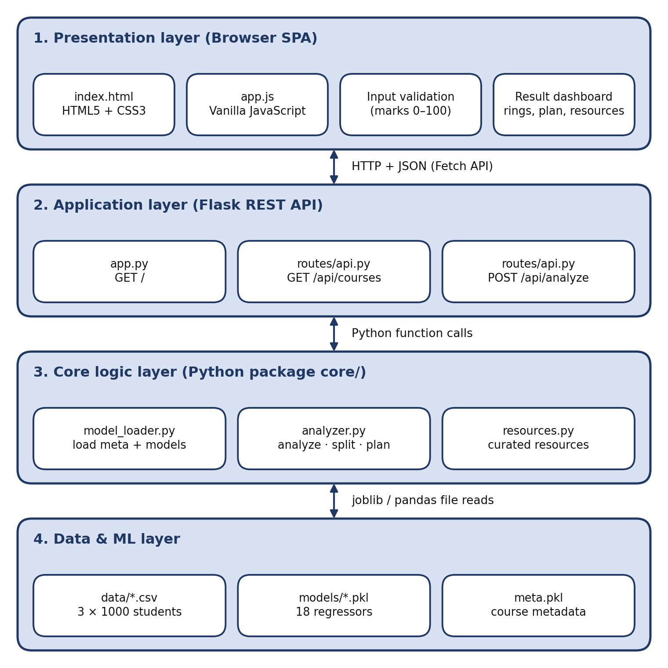
Fig. 3.1 :- Layered Theory Architecture of AI StudyMate
Table 3.4 :- Layers and Their Responsibilities
Layer | Main parts | Responsibility
Presentation | index.html, style.css, app.js | Builds the form, validates input, sends the request and draws the dashboard.
Application (API) | app.py, routes/api.py | Receives requests, converts marks to numbers, calls the core logic and returns JSON.
Core logic | core/model_loader.py, analyzer.py, resources.py | Loads models, predicts, ranks, labels, splits hours, makes the plan and selects resources.
Data & ML | data/*.csv, models/*.pkl, meta.pkl | Stores the reference cohorts, the 18 trained regressors and the course metadata.

Core Concepts Used
Table 3.5 :- Core Concepts and Where They Are Used
Concept | Simple meaning | Where it is used
Client–server model | The browser asks, the server answers. | Browser and Flask app
REST API | Fixed URLs that accept and return JSON. | /api/courses, /api/analyze
Single-page application | One page that updates itself without reloading. | fetch() calls in app.js
Regression | Predicting a number from other numbers. | Expected mark of each subject
R² and MAE | How well a model fits unseen data; the average size of its error in marks. | Choosing between Linear Regression and Random Forest
Percentile rank | Share of the cohort that scored lower. | Labels, hour split and plan order
Rule-based decisions | If/else limits written by the developer. | Labels, weights and targets

Machine-Learning Formulation
For every subject S of a course, one regression model is trained. Its inputs are the marks of the other five subjects and the daily study hours; its output is the expected mark in S.
features(S) = [marks of the other 5 subjects] + [study_hours]
expected(S) = model_S( features(S) )
gap(S) = actual(S) - expected(S)

Because a model never sees the subject it predicts, the expected mark answers the question: "given how this student performs in the other subjects and how long he or she studies, what is a typical mark in S?" A subject is reported as below expected when actual < expected - 5.

Decision Rules
All labels and the study-hour weights come from the percentile rank of the mark within the reference cohort of the course:
percentile(S) = (number of cohort students with mark < your mark) / 1000 x 100
target(S) = min( 100, max( mark + 5, 70th percentile of cohort ) )
need(S) = max( 0, target(S) - mark )
overall = mean of the six marks
overall_pct = share of cohort students whose six-subject mean < overall

Table 3.6 :- Performance Labels, Weights and Resource Priority
Percentile | Label | Weight | Resource priority badge
Below 35 | Needs Improvement | 3 | High Priority (foundation material)
35 to below 70 | Average | 2 | Medium Priority (practice and review)
70 and above | Good | 1 | Mastery (advanced material)

Study-hour split. Each subject receives a share of the daily hours proportional to its weight:
hours(S) = round( total_hours x weight(S) / sum of all weights , 1 )

Here total_hours is the chosen daily study time, but never less than 1.0. For example, a student who studies 4 hours a day and has three Needs Improvement subjects (weight 3 each), two Average subjects (weight 2 each) and one Good subject (weight 1) has a weight sum of 14, so each weak subject gets 4 × 3 / 14 ≈ 0.9 h, each average subject 0.6 h and the good subject 0.3 h.

3.4 System Flow
The flow chart shows what happens from the moment a student opens the page until the dashboard is displayed. The left side runs in the browser and the right side runs on the Flask server. The validation check in the browser stops the request until the input is correct.
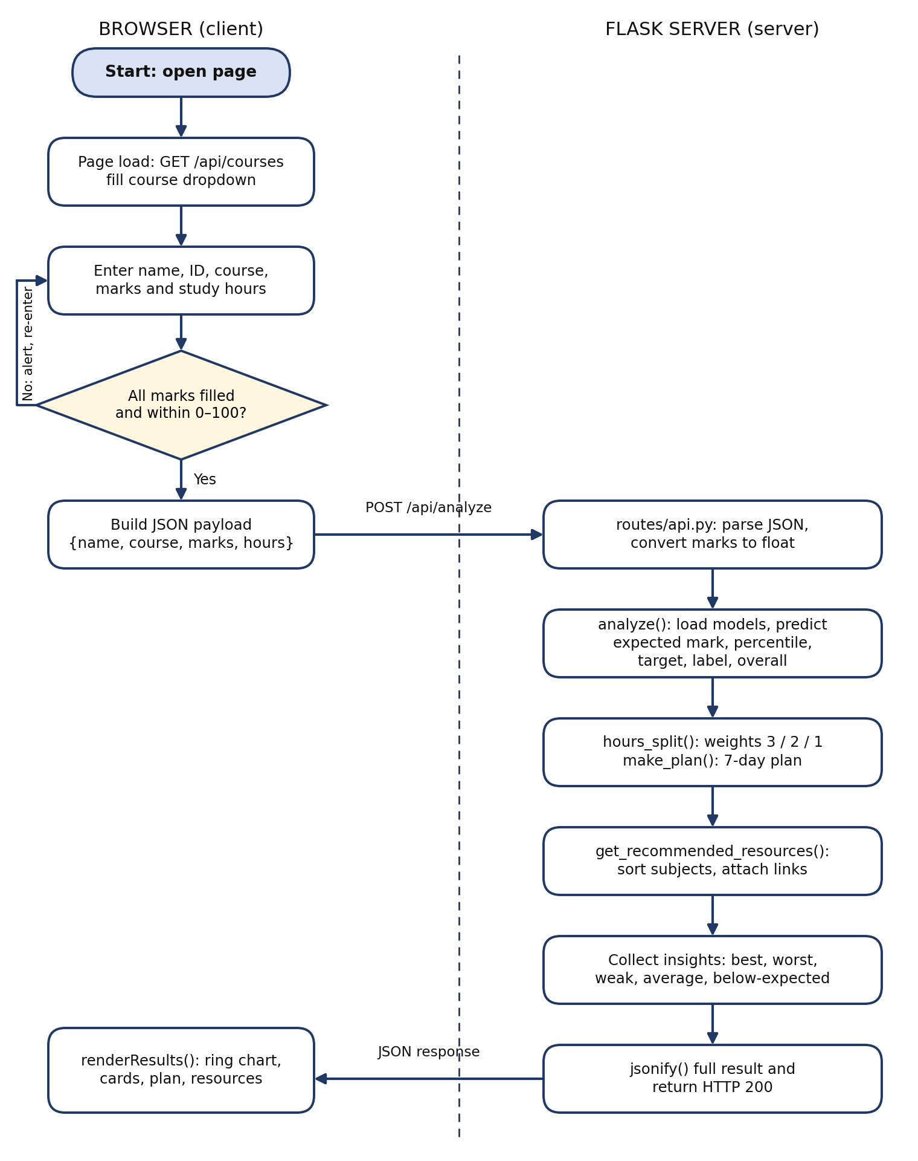
Fig. 3.2 :- System Flow Chart of AI StudyMate
Table 3.7 :- Steps of the System Flow
Step | Action | Where it runs
1 | Page loads and requests the list of courses; the dropdown is filled. | Browser, GET /api/courses
2 | Student enters name, ID, course, marks and daily study hours (slider 0.5–8 h). | Browser
3 | Name must be present; every mark must be 0–100. Otherwise the field is outlined in red and an alert is shown. | Browser (JavaScript)
4 | Name, course, marks and hours are sent as JSON. | POST /api/analyze
5 | Marks are converted to numbers; metadata and models are loaded (cached) and the cohort CSV of the course is read. | Flask, core/model_loader.py
6 | For each subject: expected mark, percentile, label, target and need are calculated; overall mark and percentile are calculated. | core/analyzer.py: analyze()
7 | Daily hours are split by weight and the 7-day plan is built from the three lowest-percentile subjects. | hours_split(), make_plan()
8 | Resources are chosen for each subject by its label and sorted from weakest to strongest. | core/resources.py
9 | Best, weakest, low, average and below-expected subjects are collected and the full result is returned as JSON. | routes/api.py
10 | The dashboard is drawn: banner, rings, plan, insights, next steps and resources. | Browser: renderResults()

3.5 Data Flow Diagrams
A Data Flow Diagram (DFD) shows how data moves between the user, the processes and the stored data. In the diagrams below, a rectangle is an external entity or a data store, a circle is a process and an arrow is a data flow.

DFD Level 0 (Context Diagram)
Level 0 shows the whole system as one process. The Student supplies the name, course, marks and study hours and receives scores, percentiles, a plan and resources. The system reads the reference data (D1) and the trained models (D2).
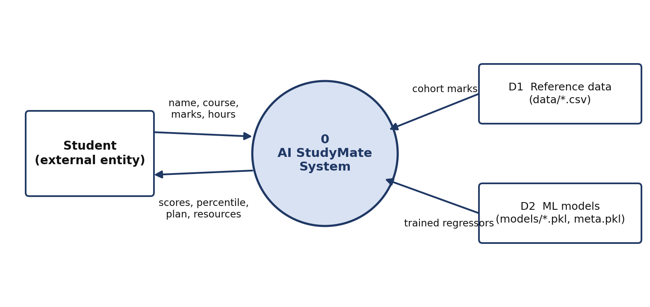
Fig. 3.3 :- DFD Level 0 of AI StudyMate

DFD Level 1
Level 1 splits the system into four processes. Process 2.0 reads both data stores; the other processes work on the data passed along the arrows.
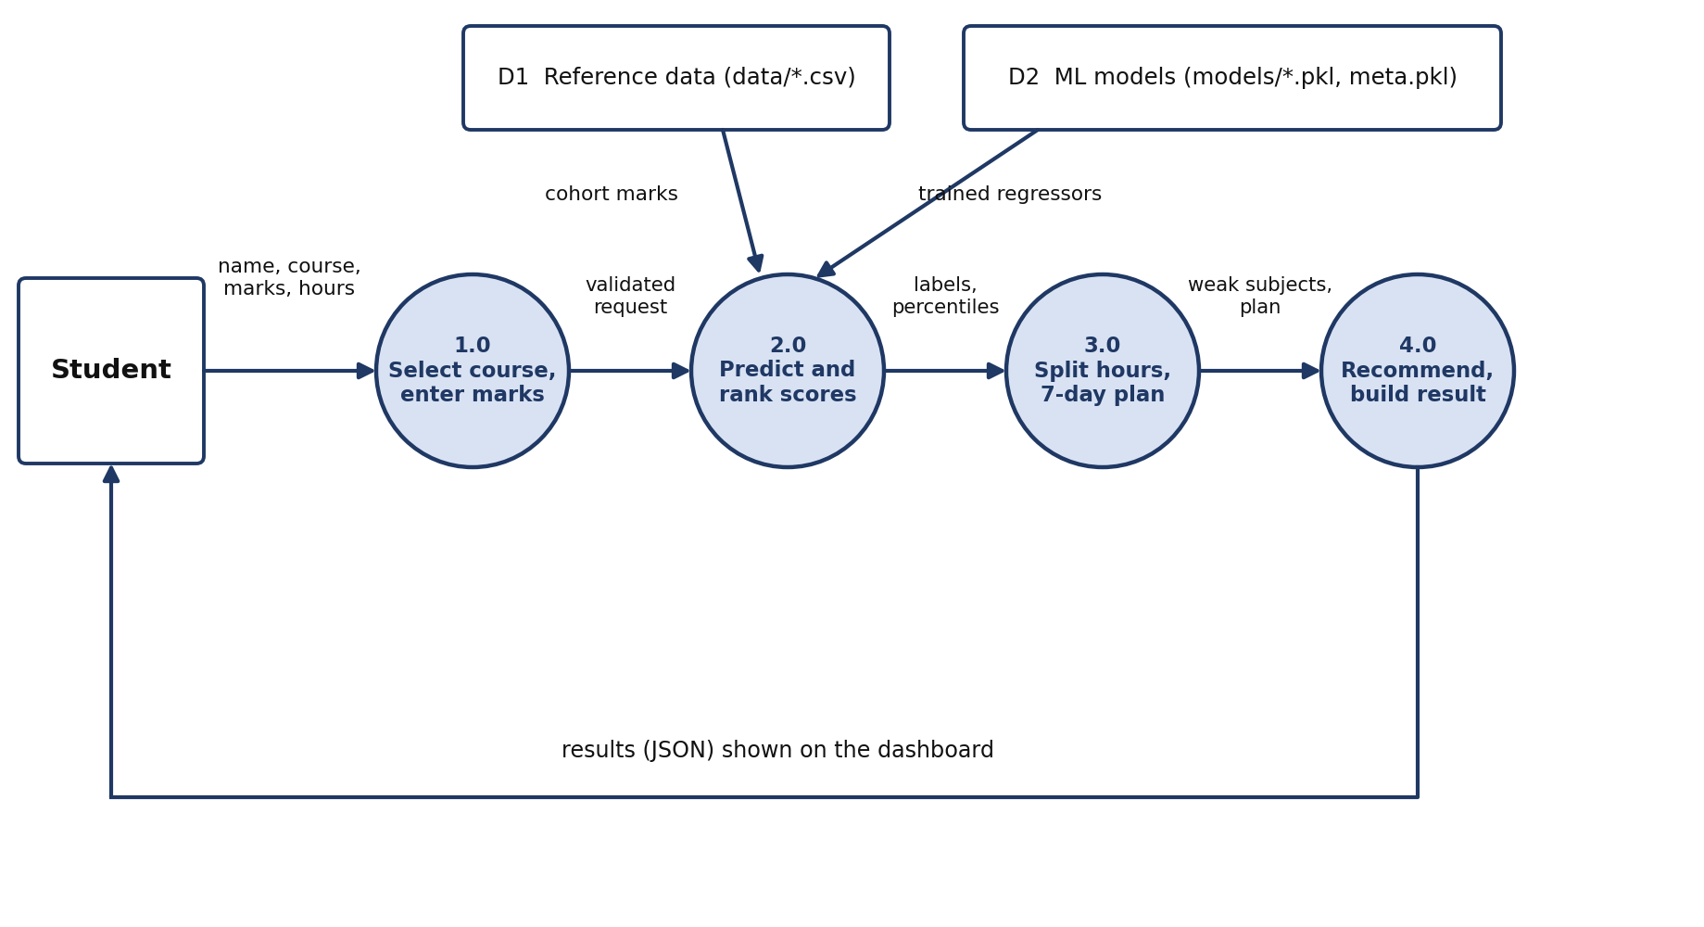
Fig. 3.4 :- DFD Level 1 of AI StudyMate
Table 3.8 :- Processes and Data Stores in the DFD
Item | Name | What it does
1.0 | Select course, enter marks | Takes the course, marks and hours from the Student and checks them in the browser (the course list comes from meta.pkl).
2.0 | Predict and rank scores | Predicts expected marks (D2), ranks marks against the cohort (D1), and assigns labels, targets and needs.
3.0 | Split hours, 7-day plan | Splits the daily hours by weight and builds the 7-day plan.
4.0 | Recommend, build result | Selects resources, collects insights and returns the JSON result that the dashboard displays.
D1 | Reference data | data/BCA.csv, data/BTech_CSE.csv, data/MCA.csv (1,000 students each).
D2 | ML models and metadata | models/*.pkl (18 regressors) and meta.pkl (subjects, features and file paths).

3.6 Data Design
Each course has its own cohort file with one row per student: a student id, six subject marks and the daily study hours. The courses and subjects are:
Table 3.9 :- Courses, Subjects and Cohort Files
Course | Subjects | Cohort file
BCA | Java, Operating System, Machine Learning, Computer Networks, HTML & CSS, DBMS | data/BCA.csv
BTech CSE | DSA, Operating System, DBMS, Computer Networks, Python, Engineering Maths | data/BTech_CSE.csv
MCA | Advanced Java, Cloud Computing, Data Science, Software Engineering, Web Technologies, Algorithms | data/MCA.csv

Every file holds 1,000 rows and has no missing values. The student ids follow the pattern BCA0001–BCA1000, BTE0001–BTE1000 and MCA0001–MCA1000. Marks are whole numbers between 20 and 100 and study hours are between 0.5 and 8. The course average of the subject marks lies between about 59 and 71, and the average study time is about 3 hours per day.

4. IMPLEMENTATION
The implementation phase turns the design into working software. The project is delivered as the folder ai_studymates/. Its main parts are an offline training pipeline (scripts/), the Flask application (app.py, routes/, core/) and the browser interface (templates/, static/).

4.1 Project Directory Structure
Table 4.1 :- Files and Folders of the Project
File / folder | Purpose
app.py | Flask entry point; creates the app, registers the API blueprint and serves the page at / (debug mode, port 5000).
requirements.txt | Python packages: flask, joblib, pandas, scikit-learn, numpy, matplotlib, seaborn.
core/model_loader.py | Loads and caches meta.pkl and the per-course models; reads the cohort CSV of a course.
core/analyzer.py | label_from_percentile(), analyze(), hours_split() and make_plan().
core/resources.py | Curated resource catalogue and get_recommended_resources().
routes/api.py | Blueprint with GET /api/courses and POST /api/analyze.
templates/index.html | Single HTML page (navbar, input form, result sections).
static/css/style.css | Dark-navy theme, cards, badges, rings, responsive grid (about 1,000 lines).
static/js/app.js | Loads courses, builds the form, validates, calls the API and renders the results (about 500 lines).
scripts/make_dataset.py | Generates the three synthetic cohort CSV files in data/.
scripts/train_courses.py | Trains and compares models, saves models/*.pkl, meta.pkl and the graphs.
data/ | BCA.csv, BTech_CSE.csv, MCA.csv (1,000 students each).
models/ | 18 trained models, named <Course>_<index>.pkl (for example BCA_0.pkl).
meta.pkl | Dictionary: for each course the subjects, the feature list of each subject and the model file path.
graphs/ | Correlation heatmaps, model_comparison.png and model_evaluation.csv.

4.2 Dataset Generation
scripts/make_dataset.py creates 1,000 students for each course with a fixed random seed (42), so the result can be reproduced. Every student has a hidden general ability drawn from a normal distribution. Study hours depend partly on ability, and every subject mark is built from the ability, the study hours and some subject-specific noise:
ability ~ Normal(0, 1)
study_hours = clip( round( 3 + 0.8*ability + Normal(0, 1.2), 1 ), 0.5, 8 )
mark(subject)= base + loading*ability + 1.5*(study_hours - 3) + Normal(0, noise)
mark = clip( round(mark), 20, 100 )
# per subject: base ~ U(58,72), loading ~ U(8,13), noise ~ U(6,10)

This produces marks that are positively correlated across subjects (a good student tends to be good everywhere) and that rise slightly with study time, which is the pattern the prediction models are meant to learn. The file header explains that the data are synthetic because no public subject-wise BCA/B.Tech/MCA marks dataset is available; real class data can be substituted by keeping the same columns (student_id, six subjects, study_hours).

4.3 Machine-Learning Pipeline
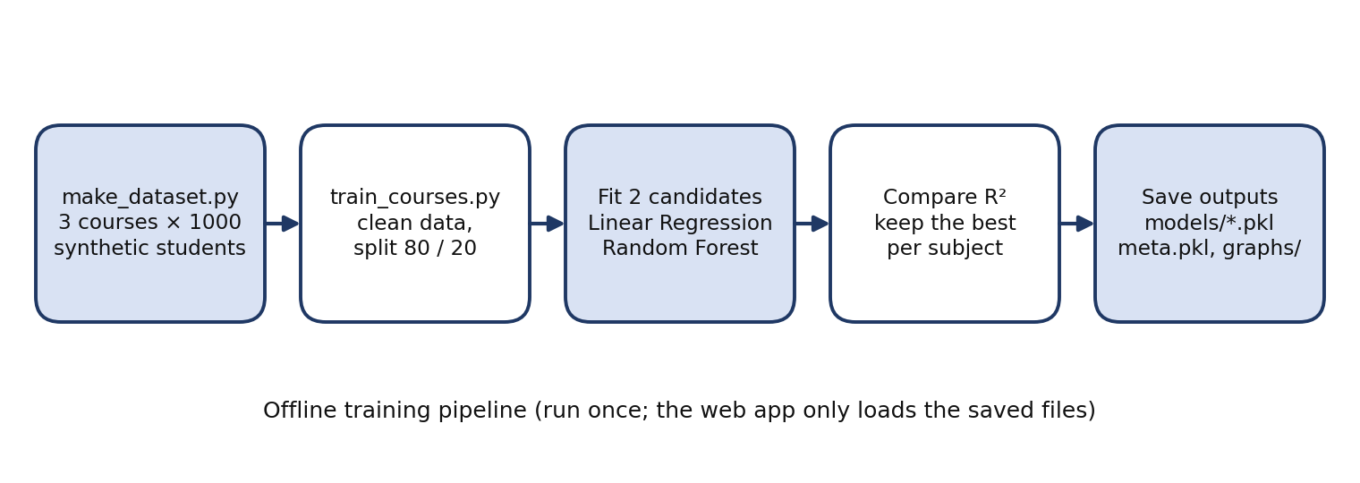
Fig. 4.1 :- Offline Training Pipeline
scripts/train_courses.py processes every CSV file in data/. For each course it removes duplicate rows, fills any missing value with the column mean, saves a correlation heatmap, and then trains one model per subject. The features of subject S are the other five subjects plus study_hours. The data are split 80% / 20% (random_state = 42). Two candidates are fitted – Linear Regression and a Random Forest with 100 trees – and the one with the higher R² on the 20% test split is saved with joblib. The chosen file path and feature list are written to meta.pkl, and all scores are saved to graphs/model_evaluation.csv.
Table 4.2 :- Model Evaluation on the Hold-out Set (20%) for All 18 Subject Models
Course | Subject | LR R² | LR MAE | RF R² | RF MAE | Model saved
BCA | Java | 0.6327 | 6.19 | 0.5519 | 6.7 | Linear Regression
BCA | Operating System | 0.6883 | 6.83 | 0.6512 | 7.13 | Linear Regression
BCA | Machine Learning | 0.5829 | 6.41 | 0.5013 | 7.1 | Linear Regression
BCA | Computer Networks | 0.7058 | 5.38 | 0.6535 | 5.78 | Linear Regression
BCA | HTML & CSS | 0.5459 | 8.41 | 0.5072 | 8.64 | Linear Regression
BCA | DBMS | 0.7296 | 6.19 | 0.6913 | 6.59 | Linear Regression
BTech CSE | DSA | 0.6876 | 6.93 | 0.6499 | 7.28 | Linear Regression
BTech CSE | Operating System | 0.6776 | 5.11 | 0.6462 | 5.61 | Linear Regression
BTech CSE | DBMS | 0.6022 | 8.55 | 0.5743 | 8.81 | Linear Regression
BTech CSE | Computer Networks | 0.6465 | 6.99 | 0.6132 | 7.59 | Linear Regression
BTech CSE | Python | 0.5149 | 7.49 | 0.4778 | 7.69 | Linear Regression
BTech CSE | Engineering Maths | 0.6636 | 5.39 | 0.6176 | 5.84 | Linear Regression
MCA | Advanced Java | 0.6944 | 6.33 | 0.6423 | 6.8 | Linear Regression
MCA | Cloud Computing | 0.5408 | 8.58 | 0.5221 | 8.78 | Linear Regression
MCA | Data Science | 0.6257 | 8.6 | 0.5712 | 9.22 | Linear Regression
MCA | Software Engineering | 0.5604 | 6.39 | 0.5069 | 6.73 | Linear Regression
MCA | Web Technologies | 0.5986 | 7.74 | 0.5546 | 8.04 | Linear Regression
MCA | Algorithms | 0.6082 | 5.91 | 0.5403 | 6.33 | Linear Regression
LR = Linear Regression, RF = Random Forest, MAE = mean absolute error in marks.
Table 4.3 :- Average Model Performance by Course
Course | LR mean R² | LR mean MAE | RF mean R² | RF mean MAE
BCA | 0.648 | 6.57 | 0.593 | 6.99
BTech CSE | 0.632 | 6.74 | 0.596 | 7.14
MCA | 0.605 | 7.26 | 0.556 | 7.65
All 18 models | 0.628 | 6.86 | 0.582 | 7.26

Result: Linear Regression obtained the higher R² in all 18 comparisons, so all 18 saved models are Linear Regression models. This is expected: the cohorts were generated with a linear relationship between the marks, and with 800 training rows and only six inputs the simpler model generalises better than 100 trees. On average a prediction is about 6.9 marks away from the true mark. The tiny file size of each model (about 1 KB) reflects the same fact.
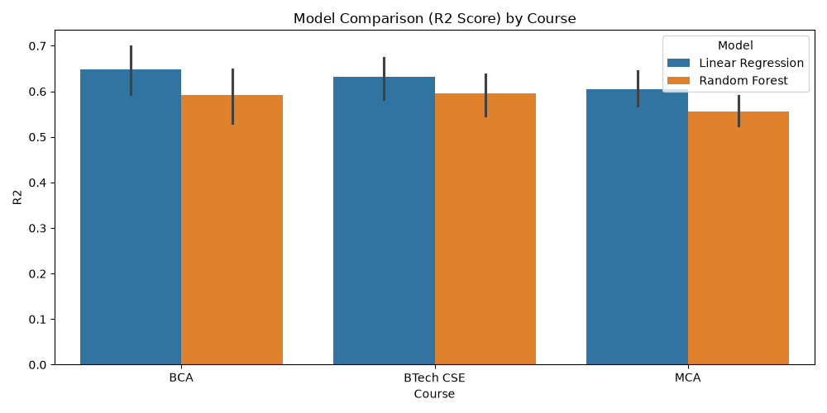
Fig. 4.2 :- Model Comparison (R²) by Course, Generated by the Training Script
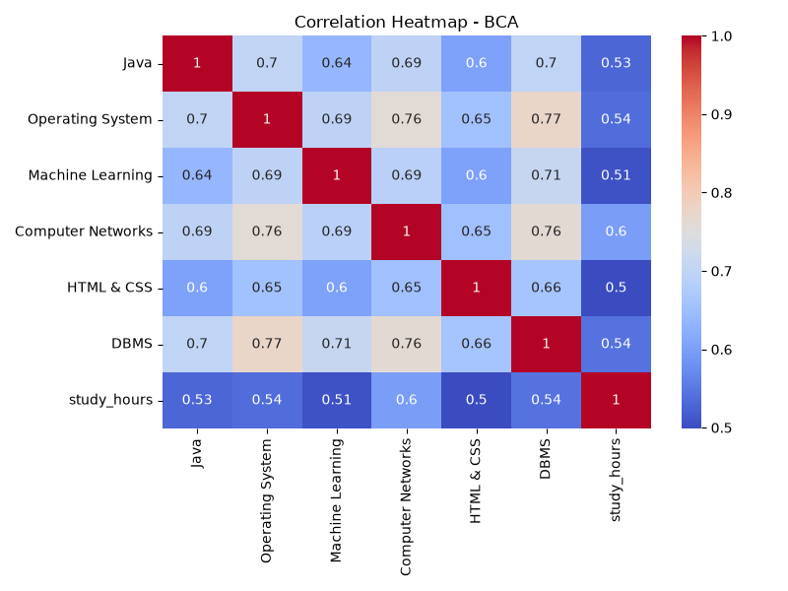
Fig. 4.3 :- Correlation Heatmap of the BCA Cohort

4.4 Backend Implementation (Flask)

Application entry point
app.py creates the Flask application, registers the api blueprint and serves the single page:
app = Flask(__name__)
app.register_blueprint(api)

@app.route("/")
def index():
return render_template("index.html")

Model loading (core/model_loader.py)
get_meta() loads meta.pkl once. get_models(course) loads the six models of a course once and keeps them in a dictionary cache. get_reference(course) reads the cohort CSV of the course (spaces in the course name are replaced by underscores, so "BTech CSE" becomes BTech_CSE.csv).

Analysis logic (core/analyzer.py)
analyze(course, marks, hours) is the heart of the system. For every subject it builds a one-row table of the model's features, predicts the expected mark, computes the percentile and the target, and finally computes the overall mark and its percentile:
for s in subjects:
feats = meta[course]["features"][s]
row = pd.DataFrame([[values[f] for f in feats]], columns=feats)
expected = float(models[s].predict(row)[0])
pct = float((ref[s] < marks[s]).mean() * 100)
target = min(100.0, max(marks[s] + 5, float(ref[s].quantile(0.70))))
info[s] = {"expected": round(expected,1), "percentile": round(pct,1),
"label": label_from_percentile(pct), "target": round(target,1),
"need": round(max(0.0, target - marks[s]), 1)}

label_from_percentile() returns "Needs Improvement" below 35, "Average" below 70 and "Good" otherwise. hours_split() applies the weights 3 / 2 / 1 to the daily hours. make_plan() sorts the subjects by percentile and uses the three weakest (a, b, c) to produce the plan; if a course has fewer subjects the weakest one is reused.
Table 4.4 :- The 7-Day Study Plan Template
Day | Activity
Day 1 | Weakest subject (a): revise basic concepts, with its allotted hours
Day 2 | Subject a: solve practice questions, with its allotted hours
Day 3 | Second-weakest subject (b): revise weak areas, with its allotted hours
Day 4 | Subjects a and b: mini test
Day 5 | Third-weakest subject (c): revise, plus practice questions in subject b
Day 6 | Solve previous-year question papers for all subjects
Day 7 | Full mock test and review of mistakes

REST endpoints (routes/api.py)
Table 4.5 :- REST API Endpoints
Method | Endpoint | Description
GET | / | Returns the HTML page.
GET | /api/courses | Returns a JSON object that maps each course to its list of subjects (read from meta.pkl).
POST | /api/analyze | Accepts the student's data as JSON and returns the complete analysis result.

Request body of POST /api/analyze:
{
"name": "Mohit Kumar Pandit",
"course": "BCA",
"marks": { "Java": 45, "Operating System": 58, "Machine Learning": 72,
"Computer Networks": 81, "HTML & CSS": 66, "DBMS": 38 },
"hours": 4
}

Table 4.6 :- Fields of the JSON Response
Field | Meaning
name, course | Echoed from the request.
overall, overall_pct, overall_label | Mean mark, its percentile in the cohort and the corresponding label.
subjects, marks | Subject list of the course and the submitted marks.
info | For each subject: expected, percentile, label, target, need.
split | Hours per day allotted to each subject.
plan | List of seven strings, one per day.
best, worst | Subject with the highest mark; subject with the lowest percentile.
low_subjects, avg_subjects, below_expected | Subjects labelled Needs Improvement; subjects labelled Average; subjects whose mark is more than 5 below the expected mark.
recommended_resources | List of subjects with score, label, target, need, priority badge and two resources each.

4.5 Recommendation and Resource Engine
core/resources.py contains a dictionary SUBJECT_RESOURCES for all 15 distinct subjects of the three courses. For every subject there are two resources for each of the three performance tiers, i.e. 90 curated entries (title, type, URL and a one-line description). The types include video courses, interactive guides, documentation, coding practice, notes and projects. A DEFAULT_RESOURCES entry (six more links) is used if a subject has no specific entry.
get_recommended_resources(info, marks) sorts the subjects from the lowest to the highest percentile and groups them into High Priority (Needs Improvement), Medium Priority (Average) and Mastery (Good). Weak subjects therefore receive foundation material such as beginner video courses, while strong subjects receive advanced references and project ideas.

4.6 Frontend Implementation
The page templates/index.html has a navbar, a header banner, a left panel with the input form and a right panel for the results. static/js/app.js (vanilla JavaScript, no framework) performs the following tasks:
Table 4.7 :- Main Functions of the Frontend
Function / event | Task
DOMContentLoaded | Calls GET /api/courses and fills the course dropdown.
renderMarkInputs(course) | Creates one number field (0–100) for each subject of the selected course.
Hours slider | Range 0.5–8 h in steps of 0.5 h (default 3 h) with a live badge.
Form submit handler | Checks the name and every mark, highlights errors with input-error, shows an alert, then sends the JSON with fetch() and shows a loading spinner.
renderResults(d) | Draws the score banner, subject rings (green / amber / red by label), study-plan card with hour bars, key insights and next steps.
togglePlan() | Shows or hides the full 7-day plan.
renderResources() | Builds the resource cards and the filter tabs (All, Focus First, Practice & Review, Advanced Mastery).

The visual design uses a dark-navy background with purple accents, glass-style cards, colour-coded badges and the Inter typeface. The marks grid and the result cards use CSS grid so that they stack on narrow screens.

4.7 Installation and Execution
- Open a terminal in the project folder: cd ai_studymates.
- Create and activate a virtual environment (recommended): python -m venv venv, then venv\Scripts\activate on Windows or source venv/bin/activate on macOS/Linux.
- Install the dependencies: pip install -r requirements.txt.
- Generate the cohorts (only if data/ is missing): python scripts/make_dataset.py.
- Train the models (only if models/ and meta.pkl are missing): python scripts/train_courses.py.
- Start the server: python app.py, then open http://localhost:5000 in a browser.
To use real marks, replace the CSV files in data/ with files of the same format and re-run scripts/train_courses.py; the models, meta.pkl and the graphs are regenerated automatically.

4.8 Prototype and Duplicate Files in the Package
The archive also contains files from earlier stages of development. They are not used by the Flask application and are listed here for completeness.
Table 4.8 :- Files Not Used by the Flask Application
File | Description
studymate_app.py, studymates_v2.py | Earlier Streamlit dashboards (the second one is course-aware).
train.py | First training script, for the three-score Students Performance dataset.
StudentsPerformance.csv, reference_marks.csv | Dataset and cohort used by the first prototype.
model_math_score.pkl, model_reading_score.pkl, model_writing_score.pkl, feature_map.pkl | Models and metadata of the first prototype.
make_dataset.py, train_courses.py (project root) | Identical copies of the files in scripts/.
graphs/1_distribution.png … 4_model_comparison.png | Graphs of the first prototype.
__pycache__/ | Python bytecode caches (generated automatically).
PROJECT_REPORT.md | Earlier draft of the project report.

5. OUTPUT SCREENSHOT
The screenshots below were captured from the running application (python app.py) with the sample student shown in Table 5.1.
Table 5.1 :- Sample Input Used for the Screenshots
Item | Value
Student | Mohit Kumar Pandit (ID BWU/BCA/24/071)
Course | BCA
Marks | Java 45, Operating System 58, Machine Learning 72, Computer Networks 81, HTML & CSS 66, DBMS 38
Daily study hours | 4.0 h
Result | Overall 60.0%, better than 30% of BCA students, label Needs Improvement; weakest subject Java (5th percentile); best subject Computer Networks (81)

5.1 :- Home Page & Student Information
On opening the page the course list is fetched from the API. The right panel shows the empty state with the four features: percentile rank, study plan, insights and learning resources.
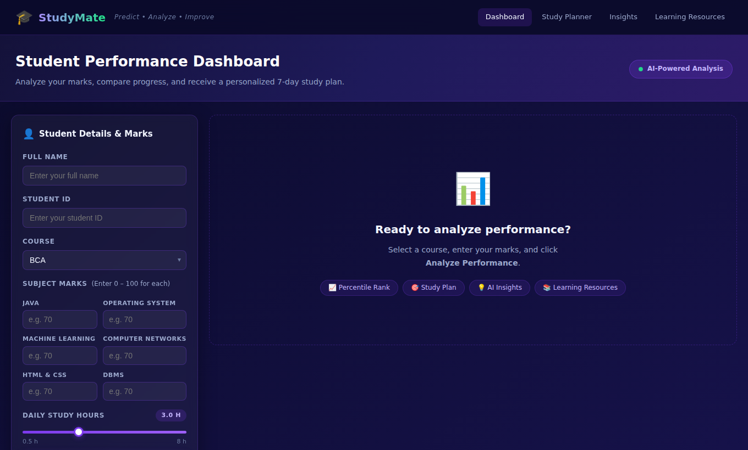
Screenshot 5.1 :- Home Page with the Student Details Form

5.2 :- Subject Marks & Study Hours Input
After a course is chosen, one input per subject appears. The slider sets the daily study hours between 0.5 and 8.
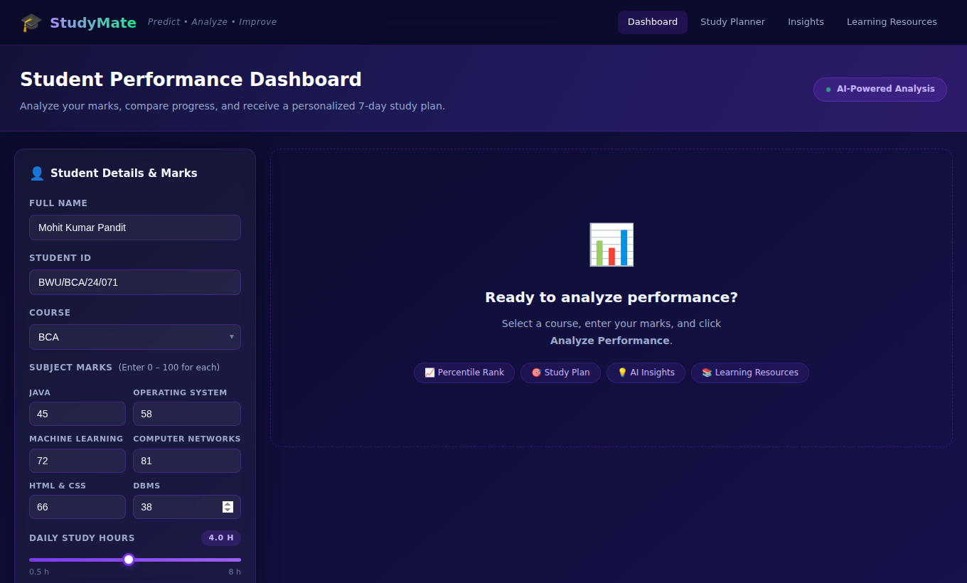
Screenshot 5.2 :- Marks Grid Generated for the BCA Course and Study-Hours Slider

5.3 :- Overall Performance Banner
The banner shows the overall label, the estimated score (mean mark) and the percentage of cohort students the student is ahead of.
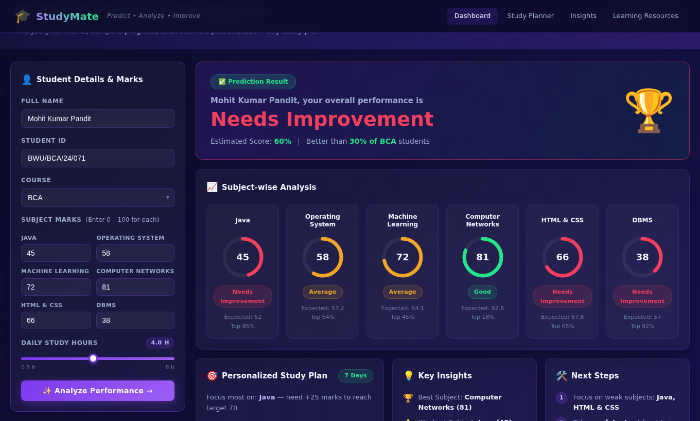
Screenshot 5.3 :- Overall Result Banner

5.4 :- Subject-wise Analysis, Study Plan, Insights and Next Steps
Each ring shows the mark and is coloured by the label. Beneath it are the expected mark and the "Top x%" position. The study plan card shows the focus subject and, as bars, the daily hours allotted to the first three subjects of the course.
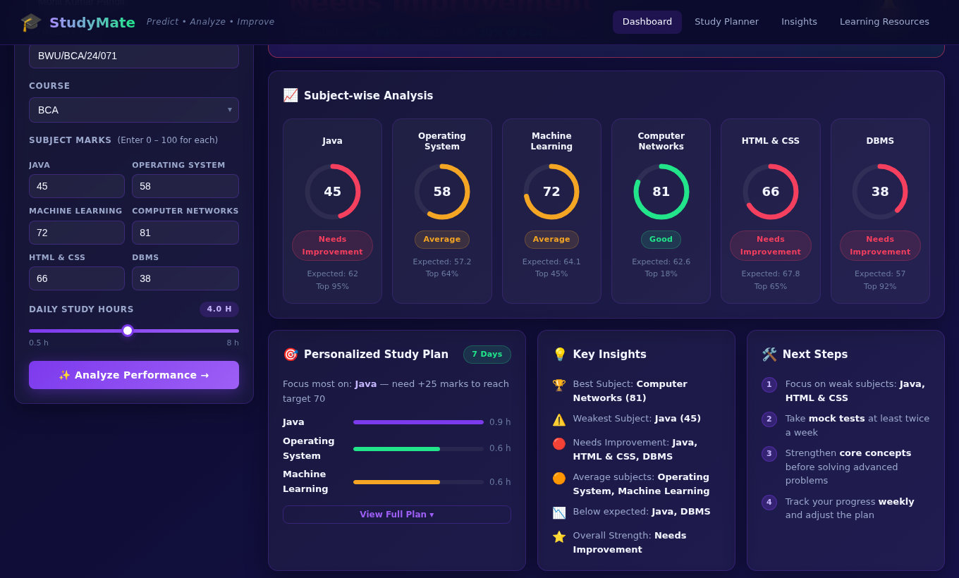
Screenshot 5.4 :- Subject Rings, Study Plan Summary, Key Insights and Next Steps

5.5 :- 7-Day Study Planner
Pressing "View Full Plan" lists the seven daily activities generated from the three weakest subjects.
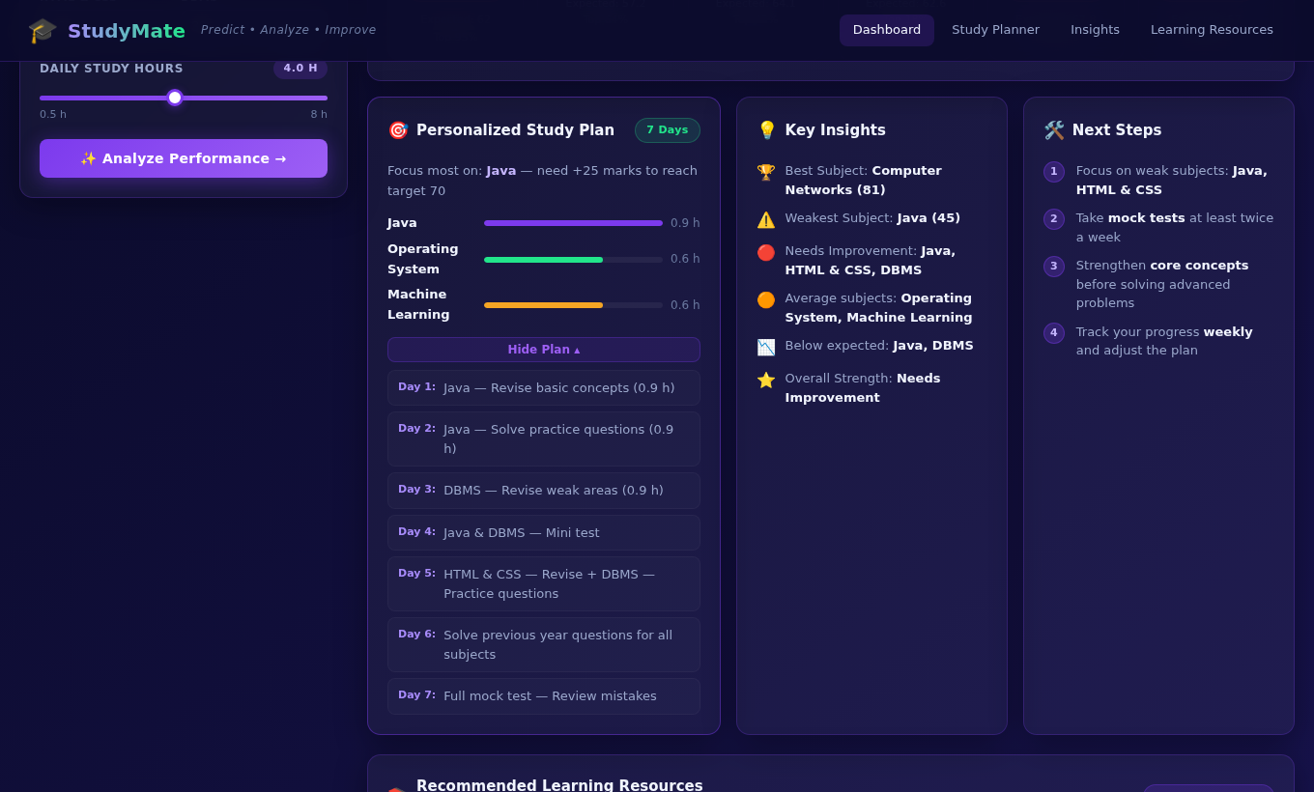
Screenshot 5.5 :- Expanded 7-Day Study Plan

5.6 :- Priority Recommendations and Resource Links
Resources are grouped by subject and ordered from the weakest to the strongest. The tabs filter the cards by priority.
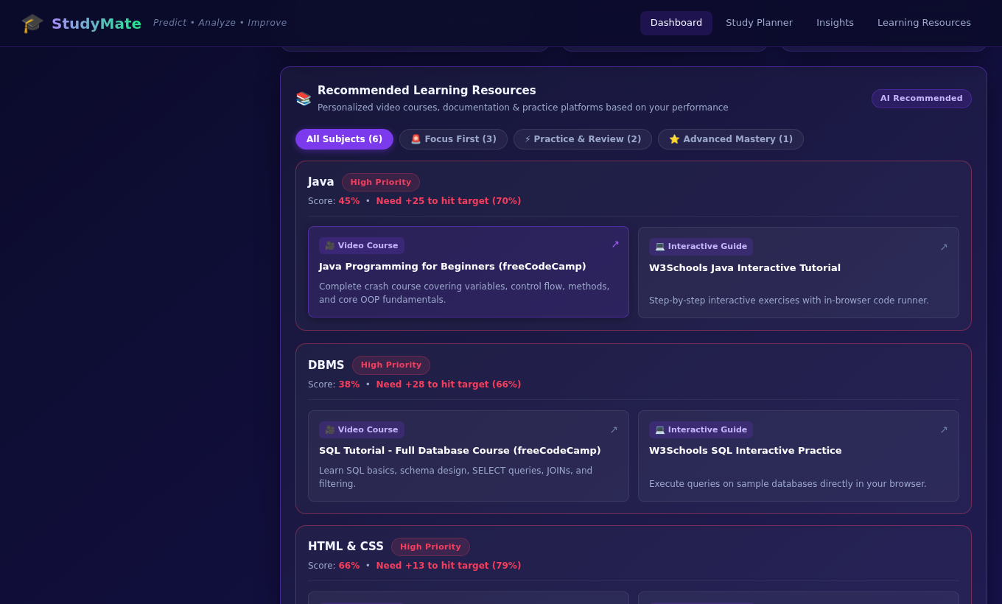
Screenshot 5.6 :- Recommended Learning Resources with Priority Badges and Filters

5.7 :- Responsive Layout
On a 390-pixel-wide screen the form fields stack into a single column.
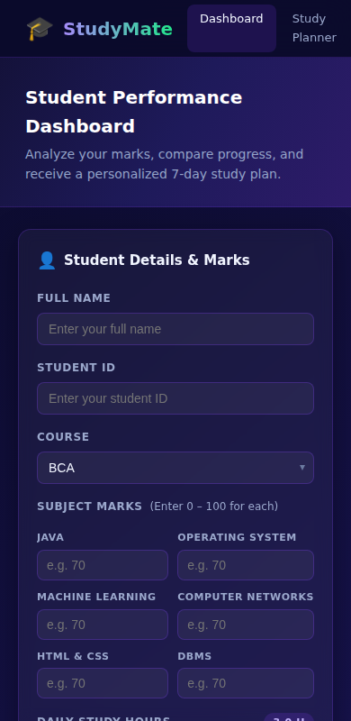
Screenshot 5.7 :- Input Form on a Narrow (Mobile-width) Screen

6. TESTING AND DEBUGGING

Introduction
Testing and debugging make sure that the scoring logic is correct, that user input is checked, that the browser and the server communicate properly and that the interface renders results correctly. Testing shows that the requirements are met, and debugging finds and removes the errors that testing reveals.
The tests in this chapter were executed against the running application (Flask server on port 5000, a headless Chrome browser driven by Playwright for the interface tests, and direct HTTP requests for the API tests). The results in the tables are the outputs that were actually observed.

Types of Testing

1. Unit Testing
Individual functions were tested in isolation. label_from_percentile() was tested at the boundary values 0, 34.9, 35, 69.9, 70 and 100, and hours_split() was checked for several daily-hour values.

2. Integration Testing
The cooperation between the browser and the server was tested: selecting a course must load the correct subjects from /api/courses, and submitting the form must call /api/analyze and update the banner, rings, plan and resource cards together.

3. System Testing
The complete application was exercised end to end for all three courses, with typical, very high (all marks 95) and very low (all marks 30) inputs.

4. Validation and Boundary Testing
Missing names, blank marks and marks outside the range 0–100 were entered to confirm that the interface blocks them before a request is sent. Requests with missing or unknown data were also sent directly to the API to observe the server's behaviour.

Test Cases
Table 6.1 :- Test Cases and Observed Results
Test Id | Description | Input | Expected Result | Actual Output | Status
TC-1 | Load course list | GET /api/courses | HTTP 200; BCA, BTech CSE, MCA with 6 subjects each | As expected | Pass
TC-2 | Course selection renders fields | Choose BCA in the dropdown | Six numeric inputs with the BCA subject names | As expected | Pass
TC-3 | Empty name | Press Analyze with no name | Alert "Please enter your full name." | As expected | Pass
TC-4 | Blank mark | Name filled, marks blank | First field outlined red; alert names "Java" | As expected | Pass
TC-5 | Mark above 100 | Java = 105 | Submission blocked with alert | As expected | Pass
TC-6 | Negative mark | Java = -5 | Submission blocked with alert | As expected | Pass
TC-7 | Label boundaries | Percentile 0, 34.9, 35, 69.9, 70, 100 | Needs Imp., Needs Imp., Average, Average, Good, Good | As expected | Pass
TC-8 | Valid BCA analysis | Sample input of Table 5.1 | HTTP 200; overall 60.0, 30.4th percentile, Needs Improvement; worst Java, best Computer Networks | As expected | Pass
TC-9 | Other courses | Valid BTech CSE and MCA marks | HTTP 200 with six subject results each | As expected (overall 63.3, Average) | Pass
TC-10 | Hour split at 4 h | Sample input, 4 h/day | Weights 3,3,3,2,2,1; weak subjects 0.9 h, average 0.6 h, strong 0.3 h | As expected | Pass
TC-11 | All marks 95 | Six marks of 95 | Label Good; targets capped at 100; plan still produced | Good, 99.7th percentile, targets 100 | Pass
TC-12 | All marks 30 | Six marks of 30 | Needs Improvement; equal hours for all subjects | Needs Improvement, 0.1th percentile, 0.5 h each | Pass
TC-13 | Dashboard rendering | Valid submission | Banner, rings, 7-item plan, resource tabs shown; empty state hidden | As expected | Pass
TC-14 | Plan toggle and slider | Click View Full Plan; slider to 8 | Seven plan items shown; badge shows 8.0 H | As expected | Pass
TC-15 | Course switch | Change course to MCA | Fields replaced by the six MCA subjects | As expected | Pass

Debugging Observations
Testing also revealed behaviours that are not defects of the core calculations but that should be known and are good candidates for improvement. They are recorded here as the result of the debugging phase.
Table 6.2 :- Observations and Known Limitations
Observation | Details | Suggested fix
No server-side validation | Requests sent directly to /api/analyze with a missing course, an unknown course (for example BBA), a missing subject or a non-numeric mark return HTTP 500 (KeyError / ValueError). The browser validation prevents this for normal use. | Validate the JSON in routes/api.py and return HTTP 400 with a clear message.
Rounded hour split | Each share is rounded to one decimal, so the shares can add up to slightly more or less than the chosen hours (for example 4.2 h for a 4 h day). | Round the last share so the total matches.
Minimum of 1 hour | hours_split() treats any value below 1.0 as 1.0, so the 0.5 h slider setting is calculated as 1 h. | Remove the minimum or raise the slider minimum to 1 h.
Student ID not used | The Student ID field is on the form, but only the name, course, marks and hours are sent to the server. | Send the ID and use it for history.
Cohort file read per request | get_reference() reads the CSV on every analysis, while the models are cached. | Cache the DataFrame per course.
Navbar on narrow screens | At 390 px width the navbar links extend beyond the screen, causing a small horizontal scroll, although the form itself stacks correctly. | Collapse the links into a menu on small screens.
Hour bars show three subjects | The study-plan card draws hour bars only for the first three subjects of the course (in course order), which are not necessarily the three weakest or the three with the most hours. The full split is returned by the API (split). | Show the three subjects with the largest share, or all six.
External font and links | The Inter font is loaded from Google Fonts and the resource links point to external sites, so a connection is needed for the exact look and for opening resources. | Bundle the font; periodically check the links.

Overall Conclusion
The tests show that the core calculations – prediction, percentile, labelling, hour split and plan – behave as designed, that normal user mistakes are caught in the browser, and that the interface renders the results correctly. The observations above describe small improvements that would make the system more robust for wider use.

7. CONCLUSION AND FUTURE ENHANCEMENT
AI StudyMate turns a list of marks into guidance. In a single page and a single request, a student learns how each subject compares with a cohort of 1,000 peers, how the mark compares with the level that the student's other marks and study time would predict, which subjects need the most time, and which resources to use. The project combines data generation, model training and selection, a modular Flask back end, a REST API and an interactive front end into one complete, working system.
The model comparison showed that for the cohorts used, Linear Regression predicts better than Random Forest in all 18 subject models (mean R² of 0.63 and mean absolute error of 6.9 marks). The separation of core/, routes/, scripts/ and the front-end files keeps the code readable and makes it easy to add courses, subjects and resources. The tests confirmed the correct behaviour of the main features and identified a few robustness improvements.

Future Enhancement
Although the current version provides the essential features of diagnosis, planning and recommendation, the following improvements would make it more accurate and more suitable for real deployment.

Real Data and Better Models
Replace the synthetic cohorts with anonymised marks of real students and extend the features (attendance, internal assessments, semester). With real data, tuned models and cross-validation can be used and the Random Forest may become competitive.

Server-side Validation and Error Handling
Validate every request on the server, return HTTP 400 with readable messages and add automated unit and API tests.

User Accounts and Progress History
Add login, use the Student ID and a database (for example SQLite or PostgreSQL) to store past analyses and show improvement from one session to the next.

Smarter Study Plans
Use the full daily study time in the plan, add topic-level recommendations, and allow the student to adjust the plan.

PDF Export and Reminders
Let students download the 7-day plan as a PDF and receive reminders by e-mail or SMS.

Interface Improvements
Add a collapsible mobile navigation menu, charts that compare the student with the cohort, and a light theme.
With these improvements, AI StudyMate can grow into a comprehensive academic advisory platform for students and faculty.

8. REFERENCES
Python – Official Documentation
https://docs.python.org/3/
(For core language syntax, standard libraries and file handling)
Flask – Web Development Framework
https://flask.palletsprojects.com/
(For application structure, blueprints, routing and JSON responses)
scikit-learn – Machine Learning in Python (Pedregosa et al., JMLR 12, 2825–2830, 2011)
https://scikit-learn.org/
(For Linear Regression, Random Forest, train/test split and R² / MAE metrics)
Breiman, L. – Random Forests, Machine Learning 45(1), 5–32, 2001
https://doi.org/10.1023/A:1010933404324
(For the Random Forest algorithm)
pandas – Data Analysis Library
https://pandas.pydata.org/docs/
(For reading cohort files and percentile / quantile calculations)
NumPy – Scientific Computing Library
https://numpy.org/doc/
(For random data generation and numerical operations)
joblib – Model Persistence
https://joblib.readthedocs.io/
(For saving and loading the trained models)
matplotlib and seaborn
https://matplotlib.org/ • https://seaborn.pydata.org/
(For the correlation heatmaps and the model-comparison chart)
MDN Web Docs
https://developer.mozilla.org/
(For JavaScript, the Fetch API, DOM manipulation, SVG and CSS grid)
Romero, C. and Ventura, S. – Educational Data Mining and Learning Analytics: An Updated Survey, WIREs Data Mining and Knowledge Discovery, 2020
https://wires.onlinelibrary.wiley.com/
(For research background on educational data mining)
Students Performance in Exams (public dataset)
https://www.kaggle.com/datasets/spscientist/students-performance-in-exams
(Used in the first prototype)
Class notes and study materials provided by Brainware University

