Ride Sharing Analytics & Driver Performance pipeline
A
Project Report

Submitted By
Name: Khushi Singh
Student ID: CT_CSI_DE_86

Course: B.Tech (Computer Science & Engineering)

College: Maharishi Markandeshwar Deemed to be University, Mullana

Submission Date: 11/07/2026

1.Project Overview
The Ride Sharing Data Engineering Pipeline is a PySpark-based project that processes ride-sharing data using the Medallion Architecture (Bronze, Silver, and Gold). It uses three datasets: Drivers, Trips, and Trip Logs. The Bronze layer ingests raw CSV data and stores it in Parquet format. The Silver layer cleans the data, removes duplicates, joins the datasets, and creates new columns such as Trip Duration, Completion Status, and Driver Performance. The Gold layer generates business insights, including Total Revenue, Top Drivers, Revenue by City, Cancellation Analysis, and Popular Pickup Locations. This project demonstrates how raw data can be transformed into clean and meaningful information for business analysis using PySpark.
2. Technologies Used
- Python
- PySpark
- Google Colab
- Google Drive
- Git & GitHub
3. Project Workflow
i.Bronze Layer
- Reads raw CSV files using PySpark.
- Converts raw data into Parquet format.
- Stores data in the Bronze layer.
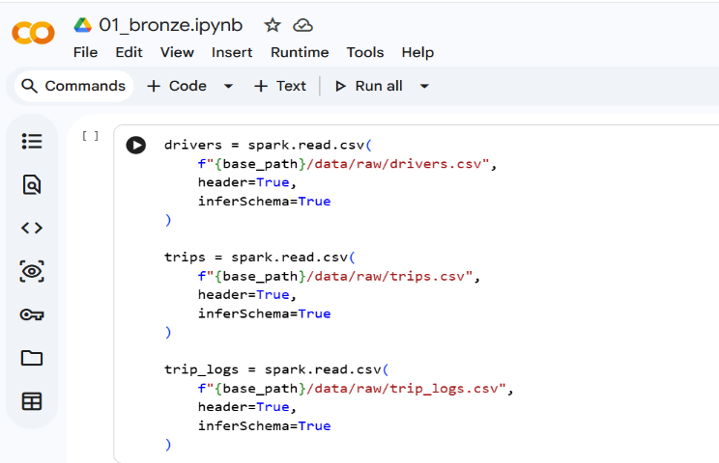
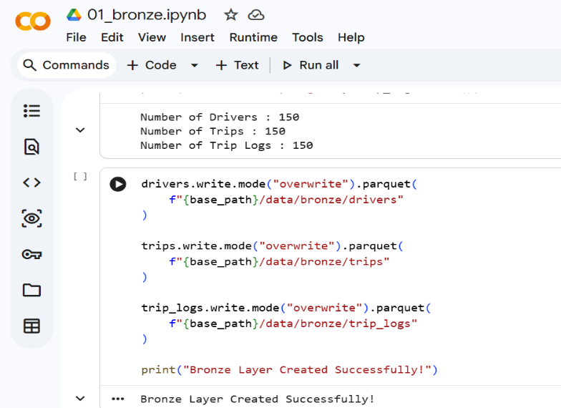

ii.Silver Layer
- Reads Bronze data.
- Removes duplicates and handles missing values.
- Joins the datasets.
- Calculates Trip Duration.
- Creates Completion Status and Driver Performance columns.
- Stores cleaned data in the Silver layer.
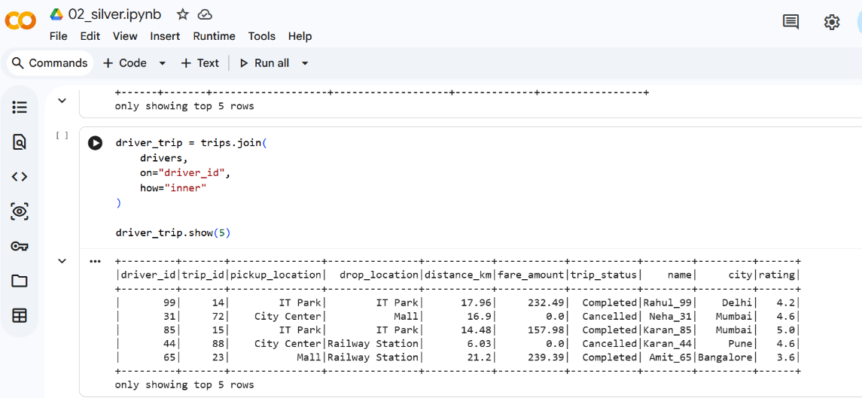

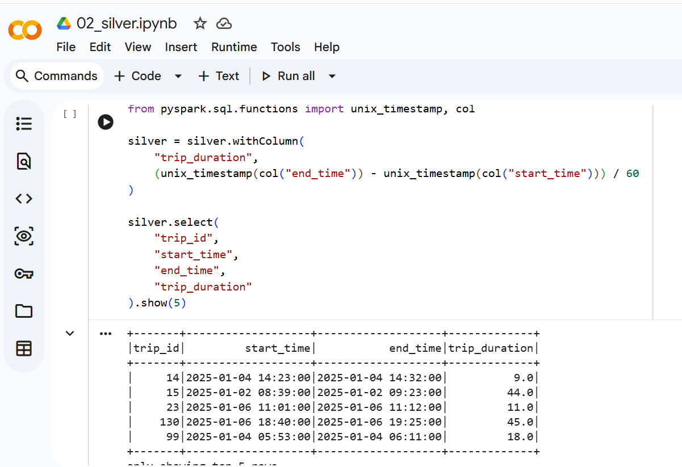

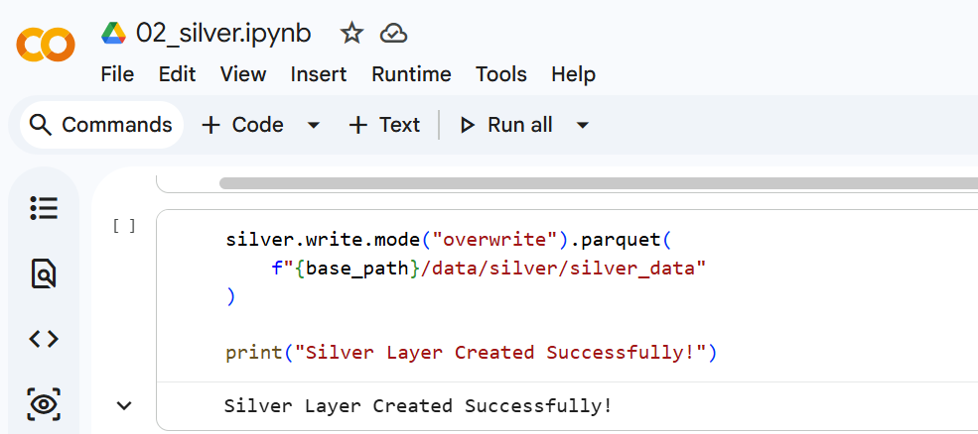

iii.Gold Layer
- Reads Silver data.
- Performs business analysis.
- Calculates Total Revenue, Top Drivers, Revenue by City, Cancellation Analysis, and Popular Pickup Locations.
- Stores the final business-ready data in the Gold layer.
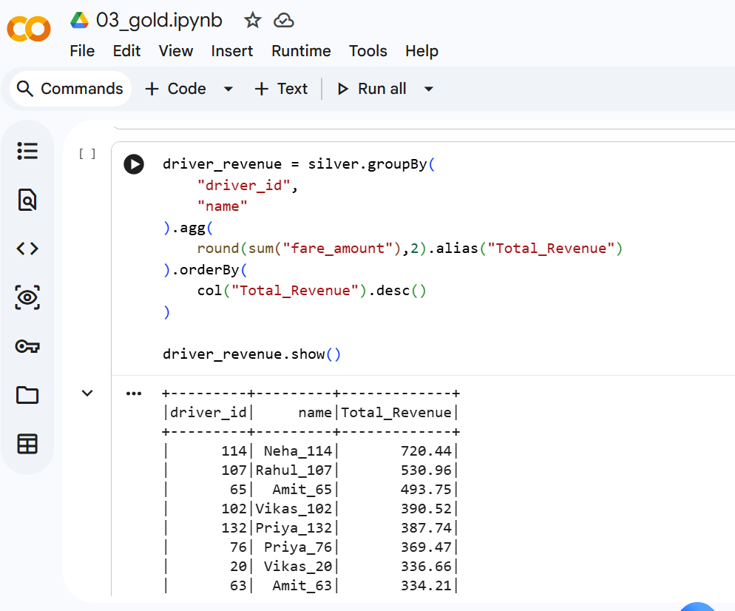
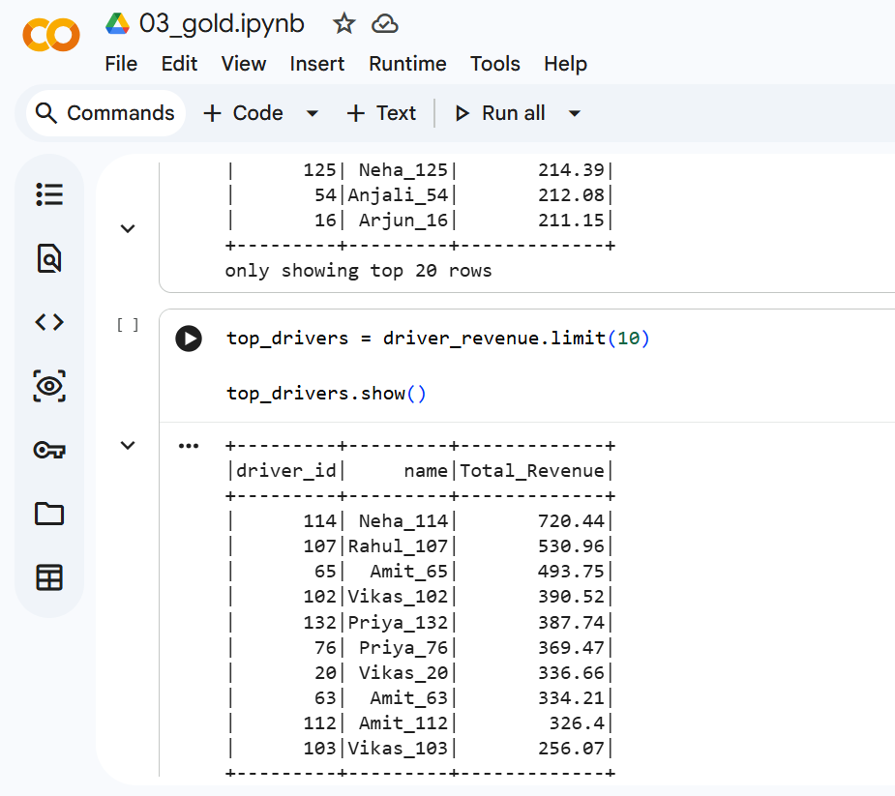
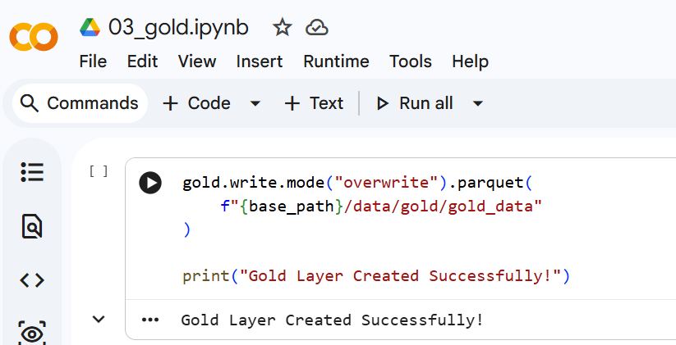

4.Project Structure
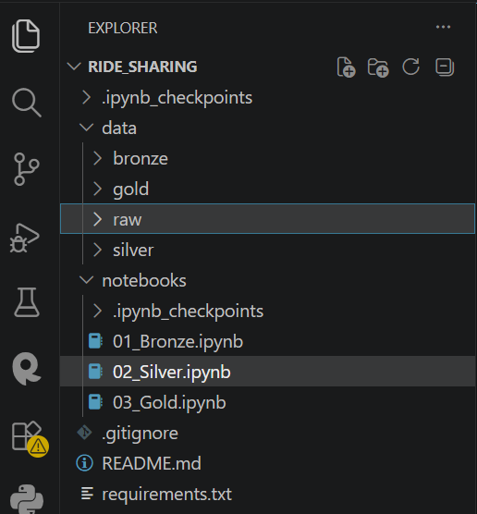

5. Conclusion
This project successfully implements the Medallion Architecture using PySpark. The raw data is transformed into clean and structured datasets, and the Gold layer provides meaningful business insights that can support decision-making in a ride-sharing system.

