Q2-

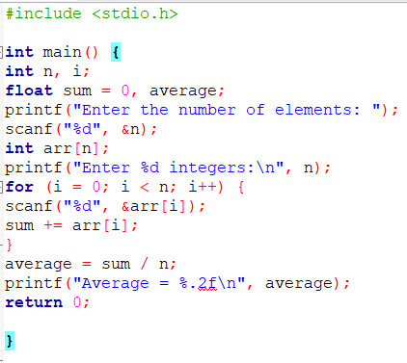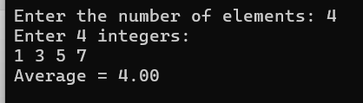

Q3-

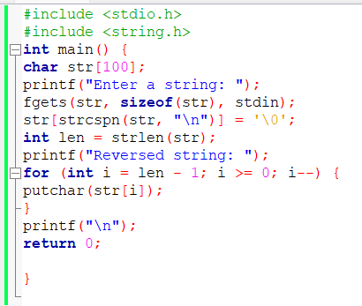 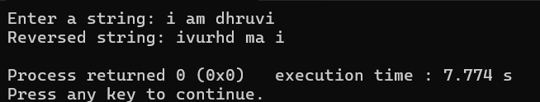

Q4- git clone

https://github.com/DaveGamble/cJSON.git

cd cJSON