
BRAND BLUEPRINT
& Visual Identity Guide

FOR INTERNAL USE & DESIGN PARTNERS
University of Michigan | College of Engineering | Electric Vehicle Center
Version 3.0 | 2026

About This Document
This Brand Blueprint is the authoritative guide for all Electric Vehicle Center visual communications – from the website and social media to presentations, print, and signage. It is designed to be both a strategic reference and a practical working tool.

The EVC brand is built on the University of Michigan and Michigan Engineering brand foundations, while expressing a distinct identity shaped by our mission in electric mobility: technical precision, forward momentum, collaborative energy, and trusted expertise.

Questions about brand application should be directed to the EVC Communication Office.

01 – BRAND FOUNDATION

Introduction & Purpose
A brand is more than a logo, color palette, or tagline. At its core, a brand is a reputation – the sum of what people think, feel, believe, and do when they encounter an organization.
For the Electric Vehicle Center (EVC), our brand is shaped through every interaction we have with our stakeholders: faculty, students, industry partners, government leaders, media, donors, and the public. Every presentation, website visit, event, email, conversation, social media post, and collaboration either strengthens or weakens that reputation.
This Brand Blueprint exists to help ensure that the EVC presents itself consistently, professionally, and strategically across all platforms and experiences. Consistency builds familiarity. Familiarity builds trust. Trust strengthens our ability to fulfill our mission and vision.

What We Want Our Audiences to Do
Branding is not simply about informing audiences – it is about engaging them. We aim to shape not only what stakeholders know about the EVC, but also what they feel, believe, and ultimately do.
- Know who we are and what we do
- Believe in our expertise, credibility, and leadership
- Feel trust, excitement, and confidence in our work
- Do things like collaborate with us, support us, join us, learn from us, and help advance electric mobility

Brand Essence
The EVC brand is rooted in leadership, expertise, collaboration, and trust. We position ourselves as:
- Thought leaders in electric mobility
- Trusted academic and industry partners
- Neutral, evidence-based, and unbiased
- Collaborative and action-oriented
- Confident without arrogance
- Innovative while remaining grounded and practical

Our aspiration is not simply to participate in the future of electric mobility – it is to help shape it.

Mission, Vision & Strategic Messaging

Mission
We educate, innovate, and engage to accelerate the future of electric mobility.

Vision
To make Michigan the E-Motor Capital and position Detroit as the E-Motor City.

Strategic Pillars
- Technology & Innovation
- Education
- Workforce Development
- Facilities Expansion
- Trusted Analysis (Studies & Insights)

Core Values – STEPP
- Social Responsibility
- Teamwork
- Empowerment
- Passion
- Professionalism

Key Evergreen Messages
These messages should be used consistently across all channels. Repetition and alignment build recognition.
- Educate, Innovate, Engage
- Driving EV Tech & Talent
- Trusted, Unbiased Leadership in Electric Mobility
- Collaboration Across Industry, Academia, and Government
- Building the Future of Electric Mobility in Michigan

02 – LOGO SYSTEM

Logo System
The EVC logo family is built on the University of Michigan brand system and follows Michigan Engineering sub-brand standards. The Block M is the anchor of every version – paired with unit text in approved lockups.
Always use official logo files. Never recreate, redraw, or approximate the logo. Contact EVC Communication for the appropriate file format.

Logo Versions at a Glance

Logo Version | Best Used For | Available Formats
Formal Horizontal | External audiences, press, partnerships, official documents | PNG, EPS (color, white)
Formal Stacked | Vertical spaces: posters, banners, signage, pull-up displays | PNG, EPS (color, white)
Informal Horizontal | Internal use, staff presentations, familiar audiences | PNG, EPS (color, white)
Marketing Horizontal | Web, social media headers, event materials | PNG, EPS (color, white)
Stacked (Short) | Social media profiles, app icons, thumbnails | PNG, EPS (color, blue bg)
Block M Only | Extremely tight spaces, watermarks, embossing | PNG, EPS

Formal Horizontal Lockup
The primary logo for external communications. Includes Michigan Engineering identifier above the EVC name and University of Michigan below. Use this when the audience may not already know us well.



Formal Stacked Lockup
Use when vertical layout is preferred. Same hierarchy as the horizontal formal – Michigan Engineering, Electric Vehicle Center, University of Michigan.

 | Best for: posters, pull-up banners, event displays, vertical social posts

Informal Horizontal Lockup
A streamlined version for internal use and contexts where the EVC is already well known. Drops the “Michigan Engineering” identifier. Not for first introductions or formal external materials.



Marketing Horizontal Lockup
Includes University of Michigan below EVC name, without the Michigan Engineering line. A good balance between visibility and brevity for marketing contexts.

Social / Square Lockup
Used for social media profile images, app icons, favicons, and anywhere a compact branded mark is needed. Block M with “Electric Vehicle Center” stacked on Michigan Blue background.



Tagline Placement
EVC taglines (“Driving EV Tech & Talent,” campaign lines, etc.) are kept separate from the logo. The logo mark has a protected clear space and taglines are never placed inside it.
In presentations, taglines typically appear in an opposing corner from the logo – for example, logo top-left, tagline bottom-right. This gives both elements room to breathe and creates visual balance.

Logo Do’s and Don’ts

Do
- Use the appropriate version for the audience and context
- Maintain clear space equal to the height of the Block M on all sides
- Use approved color versions: full color on white/light, white version on dark/color backgrounds
- Download files directly from EVC Communication or the CoE brand portal

Don’t
- Stretch, compress, rotate, or skew the logo
- Recreate the logo in Word, PowerPoint, or any other application
- Place the logo on busy photographic backgrounds without a clear space buffer
- Use the athletic Block M (embroidered/varsity style) in place of the official digital mark
- Add drop shadows, outlines, or other effects
- Change the font of the unit name text

03 – COLOR PALETTE

Color Palette
The EVC color system is built on the University of Michigan primary palette – Michigan Maize and Michigan Blue – with a curated set of secondary accent colors drawn from the official U-M supporting palette.
The EVC palette is intentionally broader than most U-M units. We lean into purples, oranges, blues, and greens to convey energy, innovation, and technical depth – all while remaining unmistakably Michigan.

Design principle: Primary colors anchor the brand. Secondary accent colors differentiate content, create visual hierarchy, and give the EVC identity its distinctive energy. Accent colors should complement, never compete with, Maize and Blue.

Primary Colors

Color | Name & Values | Web Accessible Pairs | EVC Usage
#FFCB05 | Michigan Maize  PMS: 7406 | Web: #FFCB05  CMYK: C0, M18, Y100, K0 | Pair with: Michigan Blue (#00274C)  Do not use as body text on white | Primary brand anchor. Headers, accents, call-to-action highlights, logo backgrounds.
#00274C | Michigan Blue  PMS: 282 | Web: #00274C  CMYK: C100, M60, Y0, K60 | Pair with: Maize (#FFCB05)  Pair with: White (#FFFFFF) | Primary brand anchor. Backgrounds, headers, nav bars, section headers, primary text on light.

Secondary Accent Colors
These colors are EVC-approved from the U-M supporting palette. They are used as accents, highlights, data visualization categories, section differentiation, and decorative elements – never as replacements for the primary palette.

Color | Name & Values | Web Accessible Pairs | EVC Usage
#D86018 | Ross Orange  PMS: 1595 | Web: #D86018  CMYK: C0, M71, Y100, K3 | Pair with: Black (#000000) | Energy, urgency, calls to action, event promotion, highlights.
#A5A508 | Wave Field Green  PMS: 398 | Web: #A5A508  CMYK: C14, M6, Y100, K24 | Pair with: Black (#000000)  Pair with: Michigan Blue (#00274C) | Technology, innovation, battery/energy themes. Use sparingly as accent.
#2F65A7 | Arboretum Blue  PMS: 660 | Web: #2F65A7  CMYK: C88, M50, Y0, K0 | Pair with: White (#FFFFFF) | Links, interactive elements, secondary buttons, data visualization, infographics.
#702082 | A2 Amethyst  PMS: 2603 | Web: #702082  CMYK: C72, M99, Y0, K3 | Pair with: Maize (#FFCB05)  Pair with: White (#FFFFFF) | Education pillar, workforce themes, section differentiation in multi-topic content.
#575294 | Matthaei Violet  PMS: 668 | Web: #575294  CMYK: C70, M77, Y7, K23 | Pair with: Maize (#FFCB05)  Pair with: White (#FFFFFF) | Companion to A2 Amethyst. Use together for depth in purple range or independently.

Neutral Colors
Used for backgrounds, borders, dividers, secondary text, and UI structure. Essential for web and digital design.

Color | Name & Values | Web Accessible Pairs | EVC Usage
#989C97 | Angeli Hall Ash  PMS: PANTONE Warm Gray 6 | Web: #989C97  CMYK: C14, M19, Y21, K39 | Pair with: Black (#000000)  Pair with: Michigan Blue (#00274C) | Secondary text, captions, dividers, form borders, UI inactive states.
#655A52 | Law Quad Stone  PMS: PANTONE Warm Gray 11 | Web: #655A52  CMYK: C26, M36, Y38, K68 | Pair with: White (#FFFFFF) | Dark neutral. Footer backgrounds, dark mode accents, earthy grounding element.

Colors We Do Not Use
The following U-M palette colors are intentionally excluded from EVC brand applications. Each omission is deliberate:

Color | Hex | Reason for Exclusion
Tappan Red | #9A3324 | Too close to MSU Spartan red. Creates brand confusion.
Rackham Green | #75988D | Soft, muted tone conflicts with our electric/angular identity.
Taubman Teal | #00B2A9 | Evokes water – a hazard association for battery technology.
UMMA Tan | #CFC096 | Lacks sufficient contrast and energy for EVC contexts.
Burton Tower Beige | #9B9A6D | Too subdued; does not support the EVC’s bold visual direction.
Peony Pink | #E01F7C | Too bright.

Web Accessibility Requirements
All color combinations used on the EVC website must meet WCAG 2.0 Level AA accessibility standards, as required by the University of Michigan. This means:
- Minimum contrast ratio of 4.5:1 for normal body text
- Minimum contrast ratio of 3:1 for large text (24px+ or 19px+ bold)
The color pairings listed in the palette table above have been verified for WCAG AA compliance. Do not introduce new color combinations without checking contrast. Free tools: SiteImprove, WebAIM Contrast Checker, Colour Contrast Analyser.

04 – TYPOGRAPHY

Typography
Typography is one of the most consistent ways to communicate brand character. The EVC type system uses two primary typeface families: Roboto for headings and display, and Arial/Open Sans for body text and UI elements.

Primary Typefaces

Roboto – Headlines & Display
Roboto is the primary heading typeface for digital and web applications. A humanist sans-serif with clean geometry and excellent legibility on screens, Roboto aligns with Michigan Engineering’s official web typography standard.
- Use for: H1, H2, H3 headings, section labels, navigation, bold calls to action
- Available free via Google Fonts (fonts.google.com/specimen/Roboto)
- Weights in use: Regular (400), Medium (500), Bold (700)

Arial – Body Text & Office Documents
Arial serves as the body typeface and the standard font for Office documents (Word, PowerPoint, Excel). Universally available on all platforms, it ensures consistent rendering across all EVC communications without font substitution risk.
- Use for: body copy, captions, footnotes, email, all Office document content
- Fallback for: Roboto in environments where Google Fonts are unavailable
- Weights in use: Regular, Bold

Open Sans – Web Body Text (Optional)
Open Sans is the CoE-standard body typeface for web applications. It pairs naturally with Roboto and may be used in place of Arial on web properties where Google Fonts are available.
- Use for: web body text, captions, UI labels on the EVC website
- Available free via Google Fonts (fonts.google.com/specimen/Open+Sans)

Type Scale – Web & Digital
Consistent typographic hierarchy guides the reader and reinforces professionalism. Use this scale as the baseline for the EVC website and digital content:

Element | Font | Size | Weight | Usage
H1 – Page Title | Roboto | 48–56px | Bold (700) | Hero sections, primary page titles
H2 – Section Head | Roboto | 32–42px | Bold (700) | Major section headers
H3 – Subsection | Roboto | 24–32px | Medium (500) | Subsections, card titles
H4 – Sub-head | Roboto | 18–24px | Medium (500) | Minor headings, sidebar labels
Body | Arial / Open Sans | 16–18px | Regular (400) | All body copy
Small / Caption | Arial / Open Sans | 13–14px | Regular (400) | Captions, footnotes, metadata
Label / Button | Roboto | 14–16px | Bold (700) | CTAs, nav items, button text

Type Scale – Print & Presentations

Element | Font | Size | Weight | Usage
Title Slide | Roboto | 36–44pt | Bold (700) | Presentation main title
Section Header | Roboto | 24–28pt | Bold (700) | Slide section openers
Slide Title | Roboto | 20–24pt | Medium (500) | Individual slide titles
Body Copy | Arial | 18–20pt | Regular | Slide body text
Caption / Note | Arial | 12–14pt | Regular | Footnotes, captions, source credits
Document Body | Arial | 11–12pt | Regular | Word docs, reports, letters

Typography Rules
- Set Roboto headings in Michigan Blue (#00274C) as the default; Maize or white on dark backgrounds
- Body text should be near-black (#1A1A1A or #222222) – not pure black – for easier reading on screens
- Line height: 1.5× for body text; 1.2× for headings
- Maximum line length: 65–75 characters for body text to maintain readability
- Sentence case for body text and most headings; ALL CAPS only for section labels and navigation
- Left-align body text; center-align sparingly (never center long paragraphs)
- Minimum font size on web: 14px for any visible text; 16px for body copy

05 – VISUAL IDENTITY & DESIGN PHILOSOPHY

Visual Identity & Design Philosophy
The EVC visual identity does not emerge from a style guide alone – it emerges from the nature of our work. Electric vehicle technology is precise, energetic, structured, and forward-moving. Our visual language reflects that.

The EVC Visual Character
Every design decision at the EVC carries an intentional rationale. The following principles guide how we present ourselves visually:

Angular, Not Circular
The EVC favors squares, rectangles, and angular shapes over circles and organic forms. This is not arbitrary – engineering is precise, structured, and purposeful. Circles suggest softness and ambiguity; angles suggest clarity and direction. This preference extends to photography crops, UI elements, image frames, and graphic treatments.
- Photo crops: rectangular, never circular
- UI elements: squared corners or minimal radius (2–4px max)
- Graphic overlays: diagonal lines, angular blocks, not bubbles or soft blobs
- Icon style: geometric and linear, not rounded/playful

No Teal – A Principled Exclusion
Taubman Teal is deliberately excluded from the EVC palette. The reason is specific and memorable: teal evokes water. Water and batteries do not mix. For an organization whose identity is built around battery technology, this association creates exactly the wrong impression. It’s a subtle distinction – but brand integrity lives in subtle distinctions.

Electric Energy Cues
Motion, electricity, and forward momentum should be woven into design where appropriate – not as decorations, but as expressions of what we do. Examples include:
- The lightning bolt as a supporting graphic element
- Diagonal movement in layout and imagery
- High-contrast, high-energy color combinations
- Photography that emphasizes motion, spark, and discovery

Clean, Structured Layouts
EVC design favors strong grid structure, generous white space, and clear visual hierarchy. Never sacrifice clarity for stylistic complexity. A clean, well-organized layout communicates professionalism and expertise more effectively than a cluttered one.

Strong Contrast
High contrast is both an accessibility requirement and a brand characteristic. We use bold combinations – Blue on Maize, White on Blue, Maize on Dark – that are immediately legible and visually commanding. Avoid low-contrast, washed-out, or overly subtle palettes.

Photography Direction
Photography is a primary carrier of EVC brand personality. Images should communicate our values visually, not just illustrate our activities.

What to Show
- Technology in action: labs, equipment, charging infrastructure, vehicles
- People in collaboration: researchers, students, partners working together
- Faces in authentic moments: not staged stock, not artificial smiles
- Energy and momentum: motion blur, dramatic lighting, close-up technical detail
- Real-world impact: facilities, test tracks, deployment contexts

How to Frame It
- Rectangular crops (landscape or portrait) – never circular, never oval
- Strong directional light when possible – avoid flat, even, corporate-catalog lighting
- Michigan settings and faces when available – grounds us in place and mission
- Tight crops on compelling subjects are preferable to wide, cluttered scenes

What to Avoid
- Generic stock photography of anonymous people in suits
- Circular or rounded photo crops
- Low-resolution or heavily compressed images
- Overly stylized filters or heavy vignettes

Iconography & Graphic Elements
- Icons should be geometric and linear – consistent with the angular visual philosophy
- Line weight should be consistent within a document or design system
- The lightning bolt is an approved EVC graphic accent (used in marketing materials and as a supporting element)
- The Michigan Engineering SLASH element may be used per CoE brand guidelines in appropriate contexts
- Do not mix multiple icon styles (flat, illustrated, 3D) within the same material

06 – WEB & DIGITAL STANDARDS

Web & Digital Standards
This section is written specifically for the EVC website redesign and ongoing digital communications. It translates brand principles into actionable web design specifications.

Web Typography Implementation
Load Roboto and Open Sans via Google Fonts. Do not use system font substitutes for headings.

Element | Font Family | Size / Weight | CSS Reference
Body | Open Sans | 16px / 400 | font-family: 'Open Sans', Arial, sans-serif
H1 | Roboto | 48px / 700 | font-family: 'Roboto', Arial, sans-serif
H2 | Roboto | 36px / 700 | font-family: 'Roboto', Arial, sans-serif
H3 | Roboto | 28px / 500 | font-family: 'Roboto', Arial, sans-serif
H4 | Roboto | 22px / 500 | font-family: 'Roboto', Arial, sans-serif
Nav | Roboto | 16px / 700 | font-family: 'Roboto', Arial, sans-serif
Caption | Open Sans | 13px / 400 | font-family: 'Open Sans', Arial, sans-serif
Button | Roboto | 15px / 700 | UPPERCASE; letter-spacing: 0.05em

Web Color Application
Use this as a reference for applying EVC colors in web contexts:

Context / Element | Color | Notes
Primary nav background | #00274C | Michigan Blue; white text
Primary nav text | #FFFFFF | White on Michigan Blue
Page background | #FFFFFF | Always white for main content
Section background (alt) | #F4F4F4 | Light gray for alternating sections
Body text | #1A1A1A | Near-black for readability
H1, H2 headings | #00274C | Michigan Blue
H3, H4 headings | #00274C | Michigan Blue (or Arboretum Blue #2F65A7 for variety)
Hyperlinks | #2F65A7 | Arboretum Blue; underline on hover
Hyperlinks visited | #575294 | Matthaei Violet
Primary button (bg) | #00274C | Wave Field Green; Michigan Blue text
Primary button (text) | #FFCB05 | Michigan Maize
Secondary button (bg) | #FFCB05 | Michigan Maize; Blue text
Secondary button (text) | #00274C | Michigan Blue
Footer background | #00274C | Michigan Blue; white text
Footer text | #FFFFFF | White
Accent rule / divider | #FFCB05 | Michigan Maize; use sparingly
Alert / highlight band | #FFCB05 | Maize background with Blue text
Card border | #CCCCCC | Mid-gray; keeps UI clean

Web Design Principles

Layout & Grid
- Use a 12-column grid system with consistent gutters (recommend 24px gutters)
- Maximum content width: 1200–1440px; center on wider viewports
- Generous white space – do not fill every available pixel
- Maintain consistent section padding (recommend 80–120px top/bottom on desktop)

Photography on the Web
- All photos: rectangular crops only (no circles or ovals)
- Hero images: full-width or wide-format, high resolution (2x for retina)
- Team/people photos: consistent aspect ratios within any given page section
- Compress images for web (use WebP format where supported)

Accessibility
- All images must have descriptive alt text
- Color must never be the only way information is conveyed
- All interactive elements must be keyboard navigable
- Minimum touch target size: 44x44px for mobile
- Test with WAVE or axe browser tools before launch

Mobile Responsiveness
- Design mobile-first; verify all layouts at 375px, 768px, 1024px, and 1440px
- Navigation: hamburger/drawer on mobile, full horizontal nav on desktop
- Font sizes should increase slightly on mobile for readability
- Ensure buttons and links are large enough for touch interaction

07 – VOICE, TONE & MESSAGING

Voice & Tone
The EVC communicates in a voice that is journalistic, intelligent, and direct. We are not a PR machine generating hype – we are an academic institution that holds ourselves to standards of accuracy, credibility, and clarity.

Our Communication Character
- Journalistic: factual, evidence-based, attribution-conscious
- Intelligent: we respect our audiences’ expertise without condescending or oversimplifying
- Accessible: no unnecessary jargon; we explain acronyms and technical terms when appropriate
- Professional: polished and consistent without being stiff or institutional
- Engaging: we write for human beings, not search engines
- Strategic: every message reinforces who we are and what we stand for

Style Notes
- We generally follow AP Style
- Acronyms: spell out on first use, then abbreviate (Electric Vehicle Center (EVC))
- We write for skimmers: strong headlines, clear subheads, front-loaded paragraphs
- We prefer short dashes (–) over em dashes (–) and use them sparingly
- We do not use excessive exclamation points or superlatives
- Avoid “groundbreaking,” “revolutionary,” “cutting-edge” – show the evidence instead

What We Avoid
- Overclaiming: let the work speak; we back every assertion with evidence
- Political positioning: we are a trusted neutral academic partner – we do not take sides
- Jargon walls: technical terms should serve clarity, not signal insider status
- Corporate-speak: avoid hollow phrases like “leveraging synergies” or “holistic solutions”

08 – BRAND APPLICATION & TOUCHPOINTS

Brand Application
The EVC brand is applied consistently across all touchpoints – every interaction is an opportunity to reinforce who we are.

Primary Touchpoints
- Website (primary external face of the brand)
- E-newsletters and email communication
- Presentations and slide decks (PowerPoint)
- Social media (LinkedIn primary; Instagram, X secondary)
- Events, symposia, and conferences
- Print: brochures, fact sheets, reports, signage
- Displays: tents, banners, table throws, pull-up displays
- EVC team gear: shirts, polos, hats, jackets
- Promotional items (tchotchkes): chargers, flashlights, sunglasses, tech accessories

Presentations
- Use the EVC PowerPoint template – do not create off-template slides for external audiences
- The Michigan Engineering “slash” template from CoE Communication & Marketing is the preferred starting point; the EVC template builds on it
- Logo placement: upper left is standard for most slides
- Tagline placement: lower right corner, away from the logo (opposing-corner rule)
- Maintain clear space between the logo and any other elements
- Avoid busy, template-heavy slide designs; clean and spacious is preferred

Email Communications
- EVC email signature: name, title, EVC / Michigan Engineering / U-M, phone, website
- E-newsletters follow EVC template colors: Blue header, white body, Maize accents
- Subject lines: concise, specific, front-loaded with the most important word

Social Media
- Profile images: use the square on-blue lockup
- Header/banner images: use formal horizontal lockup or EVC-branded photography
- Post visual style: consistent with EVC color palette; avoid off-brand filters
- LinkedIn is the primary professional channel; maintain consistent voice and quality

Print & Physical Materials
Printed materials should follow the same color, typography, and logo standards as digital. Where applicable, build from the Michigan Engineering “slash” template provided by CoE Communication & Marketing.
- Brochures, fact sheets, one-pagers, and reports
- Signage and environmental branding for building, lab, and event spaces
- Always use high-resolution, print-ready logo files (EPS or high-res PNG)
- For print, request the printer “match the PMS color” for accurate Maize and Blue

Displays
Display materials must read clearly from a distance. Favor high contrast, bold logo placement, and minimal text.
- Tents, retractable/pull-up banners, table throws, and popup displays
- Use the formal stacked lockup for vertical displays; horizontal lockup for wide formats
- Maintain generous clear space – displays are seen quickly and at a glance
- White-version logo on Blue or dark backgrounds for maximum visibility

EVC Team Gear
Team gear builds internal culture and extends brand visibility. Staff wearing EVC apparel at conferences and events carries the brand organically.
- Shirts, polos, quarter-zips, hats, and jackets
- Use approved embroidered or printed logo versions – never an improvised recreation
- Maize-and-Blue color combinations preferred; tasteful neutrals also acceptable

Promotional Items (Tchotchkes)
Branded giveaways should reinforce the EVC mission conceptually, not just carry a logo. Preferred items connect to the EV and energy theme:
- Chargers, charging cables, and portable power banks
- Flashlights
- Sunglasses (a nod to Michigan summers and outdoor research)
- Tech accessories: cables, adapters, flash drives

09 – GENERATIVE AI & BRAND CONSISTENCY

Embracing Generative AI
The EVC embraces generative AI as a strategic tool for communication, design, creativity, and efficiency. This is consistent with our broader commitment to innovative methods and reflects our identity as a technology-forward organization.

What AI Helps With
- Maintaining brand voice and tone consistency across communication
- Drafting, editing, and refining written content
- Ideating visual concepts before committing to production
- Generating messaging variations for different audiences
- Accelerating workflow for newsletters, social posts, and presentations
- Supporting the strategic planning process through synthesis and analysis

Our Perspective
We view AI as a connector of information – a powerful tool for synthesis, pattern recognition, and ideation. The communicator’s role is to serve as the synthesizer of meaning: providing judgment, context, and strategic intent that AI alone cannot supply.
AI enhances human creativity and strategy. It does not replace thoughtful leadership, professional expertise, or editorial judgment.

AI is the connector of information. The communicator is the synthesizer of meaning.

Choosing the Right Tool for Images
Different AI tools serve different purposes. The EVC matches the tool to the job:

Midjourney – Truly Creative & Conceptual Work
Midjourney excels at evocative, stylized, artistic imagery. We reach for it when we want visuals that capture mood, energy, and concept – not literal documentation. Ideal for hero imagery, campaign concepts, and abstract representations of electric mobility.

Example: Midjourney – an abstract, painterly interpretation of an electric drive through a Michigan landscape. Clearly artistic, never mistaken for a photograph.

ChatGPT – Everyday Artistic Images
ChatGPT’s image generation handles everyday illustration and concept visuals: quick artistic images for social posts, blog headers, and presentations where a polished illustration is more useful than a custom Midjourney render.
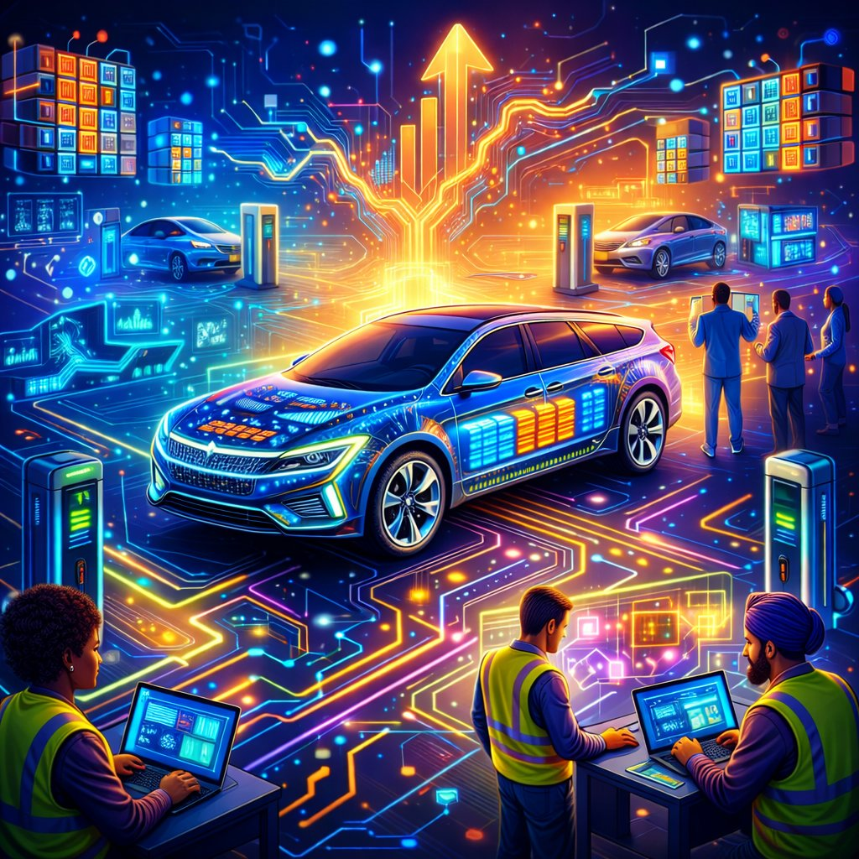
Example: ChatGPT – a stylized illustration of EV technology, workforce, and infrastructure. Useful, illustrative, and visibly an illustration.

Claude – Diagrams, Flowcharts & Structured Graphics
Claude is our tool for diagrams, flowcharts, process visuals, and structured graphics – the kind of clear, information-driven visuals that explain how things connect. Well suited to the EVC’s clean, angular, systems-oriented aesthetic.
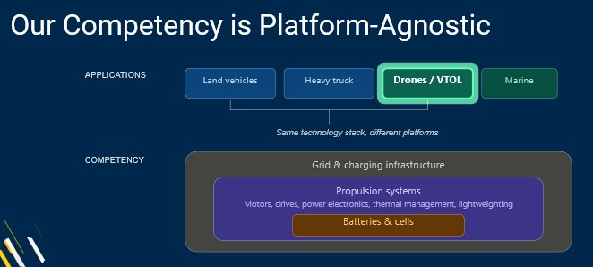
Example: Claude – a platform-agnostic competency diagram. Structured, legible, and aligned with EVC’s technical visual style.

A Note on Authenticity
We do not use AI to deceive. EVC AI-generated imagery is always clearly artistic, illustrative, or conceptual – we never create photorealistic images intended to pass as genuine photographs of real people, places, or events.
As a trusted, unbiased academic center, our credibility depends on authenticity. AI imagery should enhance communication without ever misleading our audiences. When there is any risk of confusion, keep the image visibly stylized or label it as AI-generated.

10 – REPUTATION & BRAND GROWTH

Reputation Management
Protecting and strengthening the EVC brand is everyone’s responsibility. A strong reputation is built slowly and can be damaged quickly. Every interaction – formal or informal, digital or in person – contributes to it.

How We Build Trust
- Ethical conduct in all research, partnerships, and communication
- Consistent professionalism across all team members and channels
- Transparency in what we know, acknowledge what we don’t, and communicate openly
- Delivering on our commitments – reliability is a brand attribute
- Listening to stakeholders and adapting based on feedback

Brand Growth & Adaptation
This Brand Blueprint is a living document. It will be reviewed and updated as the EVC grows, as the electric mobility landscape evolves, and as new platforms, audiences, and opportunities emerge.
Innovation and consistency are not opposites. Thoughtful evolution – that reinforces trust, recognition, and relevance over time – is the goal. Change for its own sake weakens a brand; purposeful evolution strengthens it.

Last updated: May 2026 – EVC Communication Office. For questions, updates, or logo files, contact the EVC Communication Director.

