Module-1 Assignment
- Explain in your own words what a program is and how it functions.

What is a program?

A program is instructions for a computer to execute specific tasks. It contains code written in a programming language which may be interpreted, compiled or assembled into machine readable form and then executed. Programs range from basic calculations and sorting to complex tasks such as online banking transactions, data analytics and artificial intelligence.

A program is a precisely written, step-by-step set of instructions that tells a computer how to perform a specific task or function. You can think of it as a recipe or a script for the computer to follow exactly.
How a Program Functions
The functioning of a program involves a series of stages:
- Creation: The program is written by a programmer in a specific programming language (like Python, Java, or C++), which is a structured language that humans can read and write.
- Compilation/Interpretation:
  - Compiled programs are translated entirely into machine code (the binary 1s and 0s that a computer processor understands directly) before they are run.
  - Interpreted programs are translated line-by-line as the program is running.
- Execution: The computer's central processing unit (CPU) reads and carries out the machine code instructions sequentially.
- Input/Output: A program typically takes some form of input (from a keyboard, mouse, file, or network), processes that data according to its logic, and produces an output (displaying text on a screen, saving a file, playing a sound, etc.).
In essence, the program provides the logic and the sequence, and the computer's hardware follows those instructions to achieve a desired result.
Q.What are the key steps involved in the programming process?

Types of Programming Languages

The stages of programming, often called the Program Development Life Cycle (PDLC), involve defining the problem, analyzing needs, designing the solution (algorithm/logic), coding (writing the program), testing & debugging, and finally deployment & maintenance, ensuring a structured approach from idea to working software and beyond, focusing on understanding requirements, planning, building, verifying, and supporting the program over time

Programming languages are classified based on their level of abstraction:
- High-Level Languages: Human-readable and are portable across computers. Examples: Python, Java, JavaScript. They need a compiler or interpreter to run.
- Low-Level Languages: Close to machine code, giving more control over hardware but harder to write. Examples: Machine code.
- Assembly Languages: A mix between high- and low-level, using simple symbolic instructions for a computer. An assembler converts it into machine code.

Q.What are the main differences between high-level and low-level programming
languages?
World Wide Web & How Internet Works

Parameters | High-Level Language | Low-Level Language
Abstraction Level | High abstraction, closer to human language | Low abstraction, closer to machine code
Ease of Use | Easier to learn and use | More complex and harder to learn
Portability | Highly portable across different systems | Less portable, often system-specific
Development Speed | Faster development time | Slower development time
Examples | Python, Java, C++, JavaScript | Assembly language, Machine code
Memory Management | Automatic memory management | Manual memory management
Error Handling | Built-in error handling features | Limited error handling, requires manual checks
Performance | Generally slower execution | Generally faster execution
Use Cases | Application development, scripting, web development | System programming, embedded systems, device drivers

The Internet is the massive, global network of connected hardware (cables, routers) that acts as the highway for data, while the World Wide Web (WWW) is a service running on the Internet, consisting of linked documents (webpages) accessed via browsers using HTTP/HTTPS, URLs, and hyperlinks, allowing users to view text, images, and videos. In short, the Internet is the infrastructure, and the Web is the information system built upon it, like books in a library (Internet).
How the Internet Works (The Infrastructure)
- Network of Networks: Millions of computers, servers, and devices connect globally through physical cables (fiber optics, copper) and wireless signals.
- Data Packets: Information is broken into small pieces (packets).
- Routers & Switches: Routers direct these packets across different networks, while switches manage traffic within a network, ensuring they reach the correct destination IP address (device).
- Protocols (TCP/IP): The Transmission Control Protocol (TCP) and Internet Protocol (IP) manage how these packets are addressed, sent, and reassembled.
- Research and create a diagram of how data is transmitted from a client to a server
over the internet.

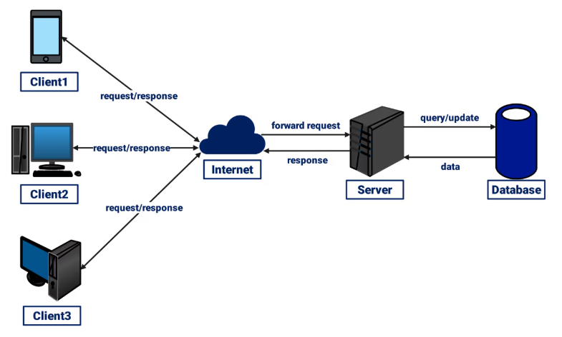

Q. Describe the roles of the client and server in web communication.

In web communication, the client (your browser/device) requests resources (pages, images, data) from a server, which stores, processes, and delivers those resources back to the client in a request-response cycle, enabling you to view websites and use web services. The client focuses on user interaction and presentation, while the server manages data, logic, and service delivery.
Client Role (e.g., Web Browser)
- Initiates Communication: Sends HTTP requests to servers when you type a URL, click a link, or submit a form.
- Requests Resources: Asks for specific files (HTML, CSS, JavaScript, images) or data.
- Renders Content: Receives files and uses interpreters (DOM, CSS, JS engines) to build and display the webpage for the user.
- Handles User Interaction: Manages user input and displays dynamic content.
Server Role (e.g., Web Server)
- Listens for Requests: Waits for incoming requests from clients.
- Processes Requests: Interprets the request (e.g., GET, POST) and fetches or generates the necessary data.
- Stores & Manages Data: Holds website files, databases, and application logic.
- Sends Responses: Delivers the requested data (HTML, JSON, files) back to the client with status codes (like 200 OK).

Network Layers on Client and Server

In a client-server network, both client (like your laptop) and server (like a web server) use all network layers, from the physical (cables/Wi-Fi) up to the application layer (browsers/apps), but in different roles: the client requests services (browsing, email) and the server provides them, with data flowing down the layers on the client (Application to Physical) and up the layers on the server (Physical to Application) for sending, and vice versa for receiving, all coordinated by protocols like TCP/IP.
Client-Side Process (Sending a Request)
- Application Layer (L7): You type a URL in your browser (e.g., Chrome), creating an HTTP request.
- Presentation Layer (L6): Data is formatted, compressed, or encrypted (e.g., HTTPS/TLS).
- Session Layer (L5): Manages the connection to the server.
- Transport Layer (L4): Breaks data into TCP segments, adding port numbers (e.g., 443 for HTTPS).
- Network Layer (L3): Adds IP addresses (source/destination) to form packets for routing.
- Data Link Layer (L2): Adds MAC addresses (for the next hop) to create frames.
- Physical Layer (L1): Converts frames into electrical/optical signals for transmission over cables or Wi-Fi.
Server-Side Process (Receiving & Responding)
- Physical Layer (L1): Receives signals and converts them back to bits.
- Data Link Layer (L2): Checks for errors and strips MAC info to pass packets up.
- Network Layer (L3): Reads IP addresses, routes the packet, and passes data up.
- Transport Layer (L4): Reassembles segments, checks for reliability (TCP).
- Session Layer (L5): Manages the server's side of the session.
- Presentation Layer (L6): Decrypts and decompresses data.
- Application Layer (L7): The web server (e.g., Apache) processes the HTTP request and generates a response.

Q . Explain the function of the TCP/IP model and its layers.

The TCP/IP model has four layers: Application (user services like HTTP, FTP), Transport (end-to-end reliability via TCP or speed via UDP), Internet (IP addressing and routing packets across networks), and Network Access (physical transmission, combining OSI's Data Link & Physical layers, handling Ethernet/Wi-Fi). These layers work together, moving data from user applications down to the physical network and back, ensuring reliable and efficient communication

TCP/IP Model Layers (Bottom-Up)
- Network Access Layer (Link Layer):
  - Function: Handles physical transmission of data over the network medium (cables, Wi-Fi). It manages MAC addresses, Ethernet frames, and converts packets into signals for the wire.
  - Protocols: Ethernet, Wi-Fi.
- Internet Layer (Network Layer):
  - Function: Responsible for logical addressing (IP addresses) and routing packets across different networks to find the best path to the destination.
  - Protocols: IP (Internet Protocol), ICMP, ARP.
- Transport Layer:
  - Function: Manages end-to-end communication, breaking data into segments, ensuring reliability (TCP), or fast delivery (UDP). Uses ports to direct data to specific applications.
  - Protocols: TCP (Transmission Control Protocol), UDP (User Datagram Protocol).
- Application Layer:
  - Function: The user-facing layer, providing network services directly to applications (browsers, email clients). Formats, presents, and encrypts data.
  - Protocols: HTTP, FTP, SMTP, DNS, HTTPS.

Q . Explain Client Server Communication Types of Internet Connections

Client-Server communication is a network model where a Client (like your browser) requests data/services from a powerful Server (like a website's computer), which processes the request and sends back a response, using protocols (HTTP, etc.) for rules. Key internet connection types provide this link: Broadband (Cable, DSL, Fiber), Mobile (3G/4G/5G), Satellite, and older Dial-up, all offering different speeds and reliability for accessing these servers.
Client-Server Communication Explained
- Core Idea: A request-response system where clients ask, servers answer.
- Client: Your device (PC, phone) or software (browser, app) that initiates a request (e.g., opening a webpage, sending an email).
- Server: A dedicated, powerful computer or program that stores data/resources and fulfills client requests (e.g., hosting websites, managing email).
- Protocols: Rules (like HTTP/HTTPS for web) that define how clients and servers "talk".
- Example (Web Browsing): You type a URL (Client Request) -> Browser sends HTTP request to website's server -> Server sends back HTML, images (Server Response) -> Browser displays the page.
Types of Internet Connections (How Clients Connect)
- Broadband (High-Speed):
  - Cable Internet: Uses coaxial cables (like TV lines) for fast, shared bandwidth.
  - DSL (Digital Subscriber Line): Uses existing phone lines, faster than dial-up, varies with distance from provider.
  - Fiber Optic (Fiber-to-the-Home): Uses light signals through glass strands; offers the fastest, most reliable speeds.
- Mobile Internet:
  - 3G/4G/5G: Cellular networks providing internet on smartphones and mobile devices; 5G offers significantly faster speeds.
- Satellite Internet:
  - Data travels to and from a satellite; good for rural areas but can have higher latency (delay).
- Dial-up:
  - Old, very slow method using phone lines; rarely used now.
- Wi-Fi/Ethernet: These are local connection methods (Wi-Fi router to device, Ethernet cable) that then connect to the internet (via Cable, DSL, Fiber, etc.).

Q . How does broadband differ from fiber-optic internet?

Broadband is a general term for high-speed internet, while fiber-optic is a specific, superior type of broadband using light through glass fibers for unmatched speed, lower latency, and reliability, unlike older broadband (DSL, cable) using copper (electricity) or radio waves, making fiber the fastest and most future-proof option. The core difference lies in the physical medium: copper/coax vs. pure light signals, with fiber offering symmetric (equal upload/download) speeds and resilience to interference, say sources from ACT Fibernet.
Broadband (General)
- Definition: A broad term for any high-speed internet connection.
- Technologies: Includes DSL (copper phone lines), Cable (coaxial cables), Satellite, Wireless, and Fiber.
- Medium: Varies (copper, coax, radio waves).
- Performance: Generally slower, less consistent (especially cable during peak times), and often asymmetric (slower uploads).
Fiber-Optic Internet (Specific Type of Broadband)
- Definition: A form of broadband using optical fibers.
- Technology: Transmits data as pulses of light through thin glass strands.
- Medium: Pure glass or plastic fibers.
- Performance:
  - Faster: Significantly higher speeds (often gigabit).
  - Symmetric: Equal download and upload speeds.
  - Lower Latency: Less delay.
  - More Reliable: Less susceptible to electromagnetic interference.

Q . What are the differences between HTTP and HTTPS protocols?

 | HTTP | HTTPS
Stands for | Hypertext Transfer Protocol | Hypertext Transfer Protocol Secure
Underlying Protocols | HTTP/1 and HTTP/2 use TCP/IP. HTTP/3 uses QUIC protocol. | Uses HTTP/2 with SSL/TLS to further encrypt the HTTP requests and responses
Port | Default Port 80 | Default Port 443
Used for | Older text-based websites | All modern websites
Security | No additional security features | Uses SSL certificates for public-key encryption
Benefits | Made communication over the internet possible | Improves website authority, trust, and search engine rankings

Q . What is the role of encryption in securing applications? Software Applications and Its Types

Encryption secures applications by scrambling data into unreadable code (ciphertext) using keys, protecting sensitive info from breaches, ensuring confidentiality, integrity, and authenticity for data at rest (stored) and in transit (moving), and helping meet compliance, making it vital for trust in online transactions and data management. It makes intercepted data useless to hackers, vital for everything from apps with logins (HTTPS) to banking and messaging, preventing theft and misuse.
Role of Encryption in Application Security
- Confidentiality: Transforms readable data (plaintext) into an unreadable format (ciphertext) so only authorized users with the decryption key can understand it.
- Data Protection (At Rest & In Transit): Secures data stored in databases/devices (at rest) and data moving between servers/users (in transit, like HTTPS websites).
- Integrity & Authentication: Ensures data hasn't been altered and proves its origin, preventing tampering.
- Prevents Breaches: Renders stolen data useless to attackers, acting as a critical defense against cyberattacks and data theft.
- Compliance: Helps applications meet regulatory standards (like PCI DSS) that mandate data protection.
- Secures User Interactions: Encrypts logins, messages, and online transactions (e.g., banking, shopping).
Software Applications and Its Types (Brief Overview for Context)
- Web Apps: (e.g., E-commerce, Social Media) – Use HTTPS (SSL/TLS) for secure browsing, encrypting communication.
- Mobile Apps: Secure user data on the device and during cloud sync.
- Desktop Apps: Encrypt local files, user credentials.
- Enterprise/Business Apps: Protect internal data, IP, and cloud data.

Q . What is the difference between system software and application software?
Software Architecture

System Software | Application Software
System Software maintains the system resources and gives the path for application software to run. | Application software is built for specific tasks.
Low-level languages are used to write the system software. | While high-level languages are used to write the application software.
It is general-purpose software. | While it's a specific purpose software.
Without system software, the system stops and can't run. | While Without application software system always runs.
System software runs when the system is turned on and stops when the system is turned off. | While application software runs as per the user's request.
Example: System software is an operating system, etc. | Example: Application software is Photoshop, VLC player, etc.
System Software programming is more complex than application software. | Application software programming is simpler in comparison to system software.
The Software that is designed to control, integrate and manage the individual hardware components and application software is known as system software. | A set of computer programs installed in the user's system and designed to perform a specific task is known as application software.
A system software operates the system in the background until the shutdown of the computer. | Application software runs in the front end according to the user's request.
The system software has no interaction with users. It serves as an interface between hardware and the end user. | Application software connects an intermediary between the user and the computer.
System software runs independently. | Application software is dependent on system software because they need a set platform for its functioning.

Q . Design a basic three-tier software architecture diagram for a web application.

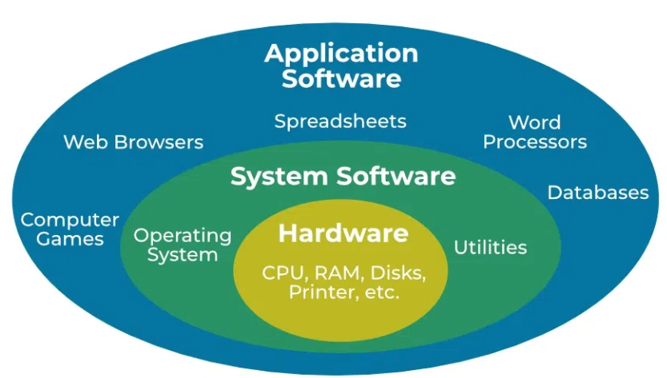

Q . What is the significance of modularity in software architecture? Layers in Software Architecture

Modularity in software architecture is crucial for managing complexity, enabling independent development, promoting reusability, and simplifying maintenance by breaking systems into loosely coupled, interchangeable modules with well-defined interfaces, while layered architectures provide a structured way to organize these modules, separating concerns (like UI, business logic, data access) into distinct levels for better maintainability, scalability, and clearer dependency flow.
Significance of Modularity
- Reduces Complexity: Divides large systems into smaller, manageable, understandable units (modules).
- Improves Maintainability: Changes in one module have less impact on others (reduced ripple effect).
- Enhances Reusability: Well-defined modules can be reused across different parts of the system or in other projects.
- Facilitates Scalability: Allows individual modules to be scaled or replaced independently.
- Simplifies Testing: Smaller, isolated modules are easier to test (unit testing).
- Enables Parallel Development: Teams can work on different modules concurrently with fewer dependencies.
Layers in Software Architecture
Layers provide a structural approach to modularity, organizing modules by responsibility.
- Definition: A vertical division of the application, where each layer offers specific services and depends on layers below it.
- Common Layers (Example):
  - Presentation Layer (UI): Handles user interaction.
  - Business Logic Layer: Contains core application rules and processes.
  - Data Access Layer: Manages database interactions.
- Key Principle: Dependencies flow downwards; a higher layer calls services from a lower layer, not vice versa (e.g., UI calls Business Logic, Business Logic calls Data Access).
- Benefits: Enforces separation of concerns, making changes within a layer (like switching databases in the Data Layer) easier without affecting others.

Q . Why are layers important in software architecture? Software Environments

Layers are crucial in software architecture for organizing code into distinct, reusable parts (like Presentation, Business, Data), promoting separation of concerns, which boosts maintainability, scalability, and testability, and allowing teams to work in parallel, ultimately speeding up development and making systems easier to understand and change without breaking everything.
Key Benefits of Layers:
- Modularity & Separation of Concerns: Each layer handles a specific job (e.g., UI, logic, data), making the system easier to understand and modify.
- Maintainability: Changes in one layer (like updating a database) usually don't affect others (like the user interface), simplifying debugging and updates.
- Scalability: Layers can be scaled independently (e.g., adding more web servers for the presentation layer) to handle increased load.
- Reusability: Well-defined layers can often be reused in other applications or projects, saving development time.
- Testability: Individual layers can be tested in isolation, making it easier to find and fix errors.
- Parallel Development: Different teams can work on different layers simultaneously, shortening overall project timelines.
- Portability: Lower layers can be swapped out (e.g., changing database types) while higher layers remain untouched, improving adaptability.
- Security: Sensitive logic can be isolated in deeper layers, restricting access from less trusted layers.

Q . Explain the importance of a development environment in software production.

A development environment (dev environment) is a crucial part of the software production lifecycle because it provides a dedicated, controlled, and isolated space for developers to write, test, debug, and build software without affecting live production systems or other developers' work [1, 2].
Its importance can be understood through several key functions:
1. Isolation and Safety
The primary purpose is isolation. Developers can make significant changes, experiment with new features, and deliberately "break" things in the dev environment without any risk to the live application that users rely on [2]. This safety net is essential for encouraging innovation and preventing service outages.
2. Consistency and Collaboration
A standardized development environment ensures that all members of a team are working with the same operating system configuration, dependencies, libraries, and database versions [2]. This consistency helps avoid the common problem of "it works on my machine" and ensures that the application behaves the same way for everyone on the team [1].
3. Debugging and Testing Efficiency
Development environments are set up with specific tools and configurations that aid in the development process [1]. These often include:
- Debugging tools: Allowing developers to pause execution, inspect variables, and step through code line by line [2].
- Logging and monitoring: Providing verbose output that would be too noisy for a production system but is invaluable for tracking down bugs.
4. Replicating the Production Environment
The development environment is typically designed to mirror the production (live) environment as closely as possible in terms of software stack and configuration, though often not in scale or performance [2]. This replication helps catch environment-specific bugs before the code is deployed to production, reducing deployment risks [1].
In summary, the development environment is the workshop where software is built. It is an indispensable space that allows for safe experimentation, effective collaboration, and efficient problem-solving, all of which are vital for delivering high-quality, stable software [1, 2].
Q . What is the difference between source code and machine code?

Feature | Source Code | Machine Code
Readability | Human-readable (e.g., using Python, Java, C++) | Machine-readable (binary, ones and zeros)
Creation | Written by programmers | Generated by a compiler or interpreter
Portability | Generally portable across different systems | Specific to a particular CPU architecture/OS
Execution | Requires translation before execution (compilation/interpretation) | Executed directly by the computer's CPU
Example | print("Hello, world!") | 01010000 10001111 ...

Q . Why is version control important in software development?

Version control is crucial in software development because it tracks every code change, enabling safe collaboration, easy rollbacks to previous versions, and efficient merging of different workstreams through branching, acting as a safety net that prevents lost work and helps teams maintain code quality, stability, and project organization. It serves as a single source of truth, allowing developers to work in parallel without conflicts, experiment freely, and quickly identify and fix bugs.
Key benefits of version control:
- Collaboration: Allows multiple developers to work on the same project simultaneously without overwriting each other's work, by isolating changes in separate branches.
- History & Tracking: Keeps a detailed log of who changed what, when, and why, providing full transparency and accountability.
- Reversibility (Rollbacks): Enables developers to revert the codebase to any previous stable state if a new change introduces issues, preventing catastrophic failures.
- Branching & Merging: Facilitates experimentation (new features, bug fixes) in isolated "branches" and safely integrates them back into the main project (mainline) once complete.
- Error Detection & Debugging: Helps pinpoint the exact commit that introduced a bug, making debugging faster and more efficient.
- Code Quality: Supports code reviews and testing before merging, improving overall software quality.
- Reproducibility: Ensures that any specific version of the software can be recreated reliably, essential for continuous integration/delivery (CI/CD).

Q . What are the benefits of using Github for students?

GitHub offers students immense benefits through the Student Developer Pack, providing free access to professional tools (Pro, cloud credits, IDEs), hands-on experience with industry-standard version control, a platform to build and showcase powerful project portfolios, and essential learning resources (courses, domains), all crucial for developing real-world skills, collaborating effectively, and boosting employability in tech without high costs.
Core GitHub Benefits (Free Pro & More)
- GitHub Pro: Unlimited private repositories (great for class projects), advanced code review, and more Actions minutes.
- Version Control Mastery: Learn Git, the industry standard for tracking code changes and collaboration, directly on the platform.
- Portfolio Building: Create a public, impressive portfolio of projects (personal, class, open-source) to show potential employers.
- Collaboration: Easily work with peers on group projects using branches, pull requests, and issue tracking.
Student Developer Pack Perks (Free Access to Premium Tools)
- Cloud & Hosting: Credits for DigitalOcean, Microsoft Azure, and free domain registration from Name.com to deploy apps.
- Learning Platforms: Free access to courses from Educative.io, Frontend Masters, DataCamp.
- Software & IDEs: Licenses for JetBrains IDEs and design tools like Bootstrap Studio.
- AI Assistance: Access to GitHub Copilot for code suggestions.
Career & Skill Development
- Industry Readiness: Gain experience with tools and workflows used in professional software development.
- Open Source Exposure: Learn to contribute to large-scale open-source projects.
- Employability: A strong GitHub profile with documented projects stands out to recruiters for internships and jobs.

Q . What are the differences between open-source and proprietary software?

S.No. | OPEN-SOURCE SOFTWARE | PROPRIETARY SOFTWARE
01. | Open-source software is computer software whose source code is available openly on the internet and programmers can modify it to add new features and capabilities without any cost. | Proprietary software is computer software where the source codes are publicly not available only the company which has created can modify it.
02. | Here the software is developed and tested through open collaboration. | Here the software is developed and tested by the individual or organization by which it is owned not by the public.
03. | In open-source software the source code is public. | In proprietary software, the source code is protected.
04. | Open-source software can be installed on any computer. | Proprietary software can not be installed into any computer without a valid license.
05. | Users do not need to have any authenticated license to use this software. | Users need to have a valid and authenticated license to use this software.
06. | Open-source software is managed by an open-source community of developers. | Proprietary software is managed by a closed team of individuals or groups that developed it.
07. | It is more flexible and provides more freedom which encourages innovation. | It is not much flexible so there is a very limited innovation scope with the restrictions.
08. | Users can get open software free of charge. | Users must have to pay to get the proprietary software.
09. | In open-source software faster fixes of bugs and better security are availed due to the community. | In proprietary software, the vendor is completely responsible for fixing malfunctions.
10. | Limited Intellectual Property Protections | Full Intellectual Property Protections
11. | Usually Developed and Maintained by non-profit organizations. | Usually Developed and Maintained by for-profit entities.
12. | Examples are Android, Linux, Firefox, Open Office, GIMP, VLC Media player, etc. | Examples are Windows, macOS, Internet Explorer, Google Earth, Microsoft Office, Adobe Flash Player, Skype, etc.

Q . How does GIT improve collaboration in a software development team?

Git improves collaboration by enabling parallel development through features like lightweight branching, facilitating seamless code integration with pull requests and merging, and ensuring transparency and accountability through detailed change tracking.
Key ways Git enhances team collaboration:
- Concurrent and Isolated Work Git's distributed nature allows every developer to have a complete copy (clone) of the project repository on their local machine. Developers can work independently on separate "feature branches" without affecting the main codebase, which prevents them from overwriting each other's work and minimizes conflicts.
- Streamlined Code Integration When a developer finishes a feature or bug fix on their branch, they can merge their changes back into the main branch. Git provides mechanisms to highlight and manually resolve any conflicts that may arise when multiple people work on the same lines of code, ensuring all changes are integrated correctly.
- Code Review and Quality Control Platforms like GitHub, GitLab, and Bitbucket use Git's functionality to offer pull requests (or merge requests). These requests allow team members to review, discuss, and approve code changes before they are merged into the main project, which is vital for maintaining high code quality and sharing knowledge.
- Comprehensive Version History Git records a detailed history of every change, including who made it, when, and why (via commit messages). This traceability is invaluable for debugging, understanding project evolution, and the ability to revert to previous stable versions if issues arise.
- Asynchronous and Remote Collaboration The distributed model is ideal for remote and globally distributed teams. Team members can commit changes to their local repositories and synchronize with the shared remote repository at their convenience, regardless of time zones or internet connectivity issues.
- Flexible Workflows and Automation Git is flexible and supports various collaborative workflows (like GitFlow or GitHub Flow) that teams can adapt to their specific needs. It also integrates seamlessly with Continuous Integration/Continuous Deployment (CI/CD) pipelines, which can automate testing and deployment processes whenever new code is pushed or a pull request is made.

Q . What is the role of application software in businesses?

Application software in businesses streamlines operations, boosts productivity, and drives growth by automating tasks, managing data, and improving communication across core functions like finance, HR, sales, and marketing, essentially acting as digital tools to achieve specific organizational goals. It enables better decision-making through data analysis, enhances customer service via CRM, and provides platforms for collaboration, from accounting (QuickBooks) to project management (Asana).
Key Roles in Business:
- Productivity & Automation: Automates repetitive tasks, reducing manual labor and freeing staff for strategic work (e.g., HR software for payroll, ERPs for processes).
- Data Management & Analysis: Organizes, analyzes, and visualizes data for insights (e.g., Excel, Tableau).
- Customer Relationship Management (CRM): Centralizes customer info to improve sales, marketing, and service (e.g., Salesforce).
- Financial Management: Handles accounting, invoicing, and financial reporting (e.g., QuickBooks, Xero).
- Project & Resource Management: Plans, tracks, and allocates resources for projects (e.g., Asana, ClickUp).
- Communication & Collaboration: Facilitates teamwork through platforms like Slack and Zoom, with features for real-time sharing.
- Supply Chain & Inventory: Manages logistics, stock, and order tracking.
Benefits for Businesses:
- Increased Efficiency: Streamlines workflows and reduces errors.
- Informed Decisions: Provides data-driven insights for better strategies.
- Scalability: Grows with the business, supporting expansion.
- Competitive Edge: Allows businesses to adapt and innovate faster.

Q . Create a flowchart representing the Software Development Life Cycle (SDLC).

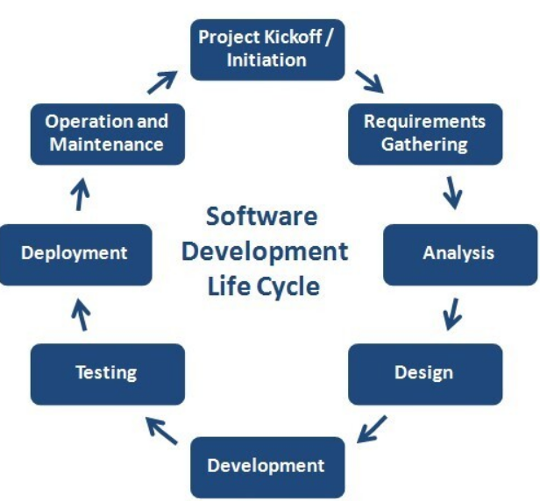

Q . What are the main stages of the software development process?

The main stages of the Software Development Life Cycle (SDLC) are Planning, Requirements Analysis, Design, Development (Coding), Testing, Deployment, and Maintenance, forming a roadmap from idea to ongoing support, ensuring quality and alignment with business goals by defining scope, building, verifying, releasing, and improving software systematically.

- Planning & Analysis: Defining project goals, feasibility, scope, and gathering detailed requirements from stakeholders.
- Design: Creating the architecture, user interface (UI), user experience (UX), and overall system blueprint.
- Development (Coding): Developers write the actual code based on the design specifications.
- Testing:Rigorous checks to find and fix bugs, ensuring the software meets requirements and performs as expected.
- Deployment: Releasing the finished software to the production environment for end-users.
- Maintenance & Updates: Ongoing support, bug fixes, performance enhancements, and new feature additions.

Q . Why is the requirement analysis phase critical in software development?

The requirements analysis phase is critical in software development because it defines what needs to be built, ensuring the final product meets user needs, aligns with business goals, and avoids costly rework, scope creep, and misunderstandings by establishing a shared vision, identifying risks early, and serving as the foundation for design, development, and testing. It bridges the gap between stakeholders and developers, ensuring everyone agrees on the project's scope and objectives from the outset.
Key reasons for its importance:
- Foundation for Success: A clear requirements document (SRS) acts as the blueprint, guiding the entire development process and preventing confusion later.
- Reduces Rework & Cost: Identifying and clarifying needs early minimizes expensive changes, redesigns, and bug fixes during later stages.
- Manages Scope Creep: Prevents uncontrolled additions to the project by defining clear boundaries for what's included.
- Enhances Communication: Fosters a common understanding and agreement among clients, developers, and managers, reducing conflicts.
- Mitigates Risks: Helps uncover potential technical, business, or user-related risks early, allowing for proactive mitigation.
- Ensures Client Satisfaction: By focusing on user needs and expectations, it increases the likelihood of delivering a valuable, successful product.
- Informs Planning: Provides realistic data for project planning, scheduling, and budgeting.

Q . What is the role of software analysis in the development process?

Software analysis defines what a system must do by gathering, documenting, and validating stakeholder needs into clear requirements, acting as a bridge between planning and coding to prevent costly rework, ensure efficiency, and guide design, coding, and testing by creating a detailed blueprint for developers, reducing risks, and ensuring the final product meets business goals.
Core Functions of Software Analysis
- Requirements Elicitation: Collecting needs from stakeholders via interviews, documentation review, etc., to understand the market, user expectations, and existing solutions.
- Analysis & Decomposition: Breaking down complex requirements into smaller, manageable components, identifying technical feasibility, and modeling system logic (e.g., using data flow diagrams or pseudocode).
- Documentation: Creating detailed specifications, use cases, and prototypes to serve as a shared understanding for the entire team.
- Validation & Verification: Confirming requirements are clear, complete, consistent, and actually meet user needs, often through stakeholder review and prototypes, to catch issues early.
- Prioritization: Ranking requirements to focus development efforts on the most critical features.
Why It's Crucial
- Reduces Risk: Uncovers potential problems, technical limitations, and conflicts early, saving significant time and money later.
- Ensures Alignment: Guarantees the software built aligns with business objectives and user expectations, reducing misinterpretation.
- Provides a Roadmap: Delivers clear technical specifications and a system model that developers use as a blueprint for design and coding.
- Improves Efficiency: Prevents duplicated efforts by understanding existing solutions and ensures resources are focused correctly.

Q . Design a basic system architecture for a food delivery app.
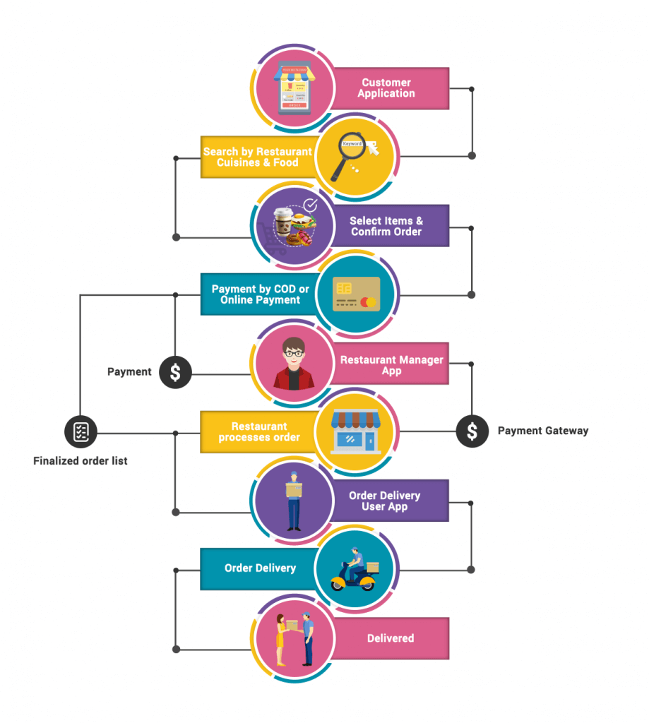
Q . What are the key elements of system design?

Key elements of system design involve balancing core non-functional requirements like scalability, performance, reliability, and security, with architectural components such as data flow, storage, APIs, and communication protocols, all while making informed trade-offs for cost and usability, guided by principles like modularity and separation of concerns. It's about creating a blueprint for a robust system that meets functional needs and handles real-world challenges.
Core Pillars (Non-Functional Requirements)
- Scalability: Ability to handle increasing load (users, data).
- Performance: Low latency, high throughput, efficiency.
- Reliability/Availability: Minimal downtime, fault tolerance.
- Security: Protection against unauthorized access, data breaches.
- Maintainability: Ease of updates, documentation, organized code.
- Usability: User-friendly interface and intuitive workflows.
Key Architectural Components & Concepts
- Data Flow & Storage: How data moves (load balancers, messaging queues) and where it's stored (databases, caching).
- APIs: Well-defined interfaces (REST, GraphQL) for component interaction.
- Networking: DNS, CDNs for efficient content delivery.
- Distributed Systems: Handling services across multiple machines (microservices).
Fundamental Principles & Considerations
- Modularity & Abstraction: Breaking systems into reusable, manageable parts.
- Coupling & Cohesion: Minimizing interdependencies (loose coupling) and maximizing internal focus (high cohesion).
- Trade-offs: Balancing competing factors like speed vs. consistency, cost vs. complexity.
- Simplicity: Solving current problems without over-engineering for hypothetical future issues.
- Failover & Redundancy: Planning for failures with backup systems.

Q . Why is software testing important?

Software testing is crucial because it ensures quality, reliability, and security by finding bugs early, saving significant costs, and enhancing user satisfaction and trust, ultimately preventing costly failures, protecting brand reputation, and verifying the software meets all functional and performance requirements before release. It acts as a safety net, catching defects when they are cheapest to fix, and validates that the application delivers a smooth, secure, and efficient experience for users.
Key reasons software testing is important:
- Cost Savings: Finding and fixing bugs in the development phase is far cheaper than fixing them after release, preventing costly issues, data breaches, and lost revenue.
- Quality & Reliability: Ensures the software functions correctly, meets specifications, and performs well under various conditions, making it dependable.
- Security: Identifies vulnerabilities in code, protecting against exploits and data breaches, which is vital for sensitive applications.
- User Experience & Satisfaction: Delivers a smooth, bug-free, and efficient experience, building customer trust and loyalty.
- Risk Mitigation: Reduces risks associated with software failure, protecting business reputation and preventing severe consequences in critical industries like healthcare or aviation.
- Performance: Verifies the software can handle increasing user loads and data volumes (scalability) efficiently.
- Supports Development: Enables smoother updates and new feature releases (Continuous Integration/Delivery) by ensuring stability.
- Compliance: Ensures adherence to industry standards and regulations.

Q . Document a real-world case where a software application required critical maintenance.

Case Study: British Airways System Outage (2017)
Background
On May 27, 2017, British Airways (BA) experienced a catastrophic IT system outage across its primary hubs: Heathrow, Gatwick, and London City airports. The failure grounded hundreds of flights, stranded approximately 75,000 customers, and resulted in an estimated compensation bill exceeding $200 million.
The Critical Maintenance Need
The root cause of the incident was traced back to a power supply issue at a data center, which was exacerbated by the inadequate maintenance and management of its IT systems. The software application required critical maintenance in several areas:
- Hardware and Infrastructure Maintenance: The initial cause was a power surge that was not handled correctly, suggesting a lack of robust power backup and management systems that are part of overall IT infrastructure maintenance.
- System Redundancy and Failover: The incident exposed a lack of effective redundancy; when the primary systems failed, the backup or failover systems did not function as intended or were affected by the same initial problem, leading to a total operational shutdown.
- Corrective Maintenance: The failure required immediate, corrective maintenance to restore core functions like check-in, baggage handling, and flight planning systems, which were all rendered inoperable.
- Preventive Maintenance: The entire situation underscored a failure in preventive maintenance, as potential vulnerabilities in the power and system infrastructure were not addressed proactively.
Consequences of Neglect
The failure to perform necessary maintenance resulted in severe consequences:
- Operational Disruption: Thousands of flights were canceled over three days, and airport staff were forced to use whiteboards and manual processes, causing chaos and significant delays.
- Financial Loss: The direct cost in compensation and lost revenue was substantial, estimated at over $200 million, and the company's share price dropped significantly.
- Reputational Damage: The incident severely damaged customer trust and the airline's reputation for reliability.
Resolution
The systems were eventually restored after several hours and days of intensive work, but the incident serves as a stark reminder of the essential nature of ongoing, critical software and infrastructure maintenance for large, dependent operations.
Q . What types of software maintenance are there?

Software maintenance primarily falls into four types: Corrective (fixing bugs), Adaptive (adjusting to new environments like OS updates), Perfective (enhancing features, performance, usability), and Preventive (proactively improving robustness to avoid future issues). These categories ensure software remains functional, relevant, and efficient throughout its lifecycle, addressing problems, evolving needs, and future risks.
The Four Main Types
Corrective Maintenance:
- What it is: Fixing defects, errors, or bugs discovered after the software is released.
- Example: Patching a security vulnerability or resolving a crash.

Adaptive Maintenance:
- What it is: Modifying the software to adapt to changes in its external environment.
- Example: Updating the software to run on a new operating system (like Windows 11) or new hardware.

Perfective Maintenance:
- What it is: Improving the software's performance, usability, maintainability, or adding new features based on user feedback.
- Example: Optimizing code for faster loading or redesigning a user interface for better experience.

Preventive Maintenance:
- What it is: Proactively making changes to increase reliability and prevent future problems, often through refactoring or documentation.
- Example: Refactoring complex code, updating libraries, or improving system documentation.

Q . What are the key differences between web and desktop applications?

Web apps run in a browser, need internet, offer easy access and updates (e.g., Gmail), while desktop apps install locally, work offline, offer high performance, but need device-specific installation (e.g., Photoshop). The main difference lies in access (browser vs. install), connectivity (internet-dependent vs. offline), and performance (browser/network vs. direct hardware access), impacting updates, cost, and feature depth.
Web Applications (Web Apps)
- Access: Via web browser (Chrome, Edge) from any device.
- Installation: None; runs on remote servers.
- Connectivity: Requires internet for most functions.
- Updates: Automatic and central.
- Performance: Can be slower due to network, but excellent for general tasks.
- Examples: Google Docs, Trello, Facebook.
Desktop Applications (Desktop Apps)
- Access: Installed on a specific device.
- Installation: Must be downloaded and installed on each computer.
- Connectivity: Works offline.
- Updates: Manual or system-level.
- Performance: Faster, uses full system power, ideal for intensive tasks (video editing).
- Examples: Adobe Photoshop, MS Word (local install), VLC Media Player.

Q . What are the advantages of using web applications over desktop applications?

Web applications offer major advantages over desktop apps through universal accessibility (any device, anywhere), automatic updates, easier collaboration, lower maintenance (no installs), platform independence (Windows, Mac, Linux work the same), and better scalability, all while reducing local storage needs and enabling real-time data sync.
Key Advantages of Web Apps:
- Accessibility & Mobility: Access from any device (PC, tablet, phone) with a browser and internet, perfect for remote work.
- Automatic Updates: Updates happen on the server, so users always have the latest version without manual downloads.
- Cross-Platform Compatibility: Works across different operating systems (Windows, macOS, Linux) without OS-specific versions.
- Centralized Maintenance: Updates and backups are managed centrally, reducing IT overhead.
- Real-Time Collaboration: Multiple users can access and edit the same data simultaneously (e.g., Google Docs).
- Lower Costs (Often): Subscription models (SaaS) can be cheaper upfront, and development can be more efficient.
- Scalability: Cloud-based architecture easily scales to handle more users and traffic.
- Data Security (Server-Side): Data is stored in the cloud, often with robust, centralized security measures.
- Easier Integration: Easier to connect with other web services and APIs.
When Desktop Apps Might Still Be Better:
- Offline Access: Desktop apps often work without an internet connection.
- Performance: Can offer faster, hardware-dependent performance for intensive tasks.
- Advanced Features: May have deeper, more complex features or better hardware integration.
Q . What role does UI/UX design play in application development?

UI/UX design is crucial in app development, shaping user satisfaction, engagement, and business success by making apps visually appealing (UI) and easy, intuitive, and efficient to use (UX). It ensures an application not only looks good but also solves real user problems, builds trust, reduces development costs long-term, and drives conversions by focusing on user research, logical flow, accessibility, and iterative improvements.
Key Roles of UI/UX Design:
- Attracts & Retains Users: A great first impression and enjoyable experience keep users engaged and coming back, fostering loyalty.
- Enhances Usability: Creates logical navigation, clear instructions, and a smooth journey, reducing the learning curve.
- Improves Satisfaction & Trust: Intuitive, visually pleasing, and consistent design makes users feel confident and satisfied with the product.
- Boosts Business Goals: Drives higher engagement, better conversion rates, and stronger brand presence by meeting user needs effectively.
- Ensures Accessibility: Designs for all users, including those with disabilities, by considering features like screen reader compatibility and color contrast.
- Reduces Costs: Investing in UI/UX early catches issues sooner, saving time and money compared to fixing them later in the development cycle.
- Guides Development: User research, wireframing, and prototyping provide clear direction, ensuring the final product aligns with user needs.

Q . What are the differences between native and hybrid mobile apps?

Native apps are built for a single platform (iOS/Android) using specific languages (Swift/Kotlin), offering top performance, full device access, and great UX, while hybrid apps use web tech (HTML/CSS/JS) in a native shell for single codebase, cross-platform ease, lower cost, but potentially slower speed and less integrated feel. Native excels in complex apps needing speed/hardware; hybrid suits simpler apps needing broad reach quickly.
Native Apps
- Development: Platform-specific (Swift/Kotlin for iOS, Java/Kotlin for Android).
- Performance: Fastest, most reliable, best UX.
- Device Access: Full access to camera, GPS, notifications, etc..
- Offline: Strong offline functionality.
- Cost/Time: Higher cost, longer development.
- Best For: Gaming, high-performance tools, complex apps.

Hybrid Apps
- Development: Single codebase (HTML, CSS, JavaScript) wrapped in a native container (Cordova, Ionic).
- Performance: Generally slower than native, but improving.
- Device Access: Access via plugins, can be less seamless.
- Offline: Works offline but data syncs when back online.
- Cost/Time: Faster, cheaper, easier cross-platform updates.
- Best For: Startups, MVPs, content-focused apps needing quick reach

Q . Create a DFD for a hospital management system

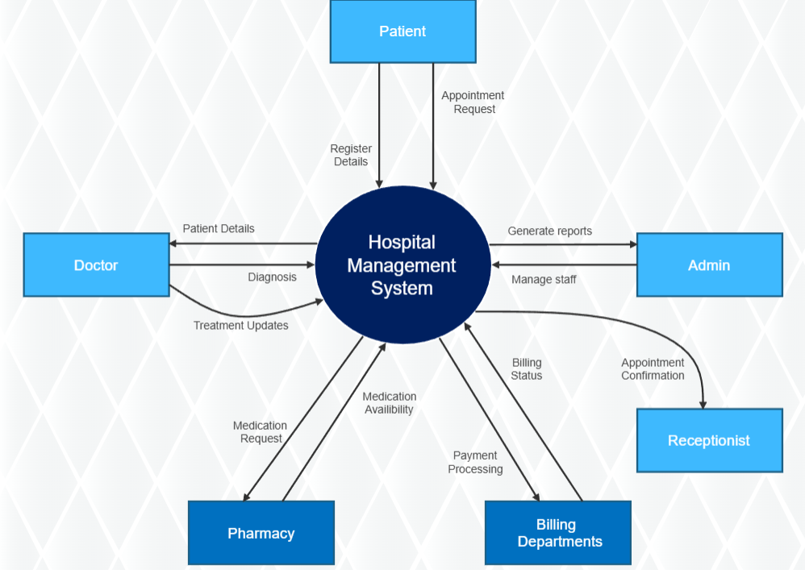

Q . What is the significance of DFDs in system analysis?

DFDs (Data Flow Diagrams) are crucial in system analysis for visually mapping how data moves through a system, identifying processes, data stores, and external entities, which improves communication, clarifies system scope, highlights inefficiencies/risks (like bottlenecks or security gaps), and supports better design decisions for both technical and non-technical users. They simplify complex workflows, helping analysts model current systems (as-is) and design future ones (to-be) for better process understanding and development.
Key Significance of DFDs in System Analysis:
- Clarifies Data Movement: Shows how data enters, flows, is transformed, and stored within a system, making complex processes transparent.
- Improves Communication: Provides a universal visual language understood by stakeholders (developers, users, managers), bridging gaps between technical and non-technical teams.
- Defines System Boundaries: Helps establish the system's scope by distinguishing internal processes from external entities (users, other systems).
- Identifies Inefficiencies & Risks: Reveals bottlenecks, redundant data, complex processes, and potential security vulnerabilities, allowing for proactive improvements.
- Supports Design & Documentation: Serves as a blueprint for new system design, aids in process planning, and becomes a key part of system documentation.
- Facilitates Analysis Levels: Can be decomposed into multiple levels (Context, Level 0, Level 1, etc.), offering high-level overviews to detailed breakdowns.
- Aids Decision-Making: Offers insights into data flows, helping stakeholders make informed decisions about system changes and optimizations.

Q . What are the pros and cons of desktop applications compared to web applications?

Desktop apps offer superior performance, offline access, and hardware integration for intensive tasks, but require installation and manual updates, limiting cross-device use; web apps provide instant access from any browser, automatic updates, and easier scalability, but depend heavily on internet connectivity, potentially offering lower performance and limited offline functionality, notes Exoft and UniRidge.
Desktop Applications
Pros:
- Performance: Faster, using local hardware for intensive tasks like video editing.
- Offline Access: Work without an internet connection.
- Hardware Access: Better integration with device features (camera, files).
- Security (Local): Data stays on the device, offering control (but needs user updates).
Cons:
- Installation: Requires manual setup on each device.
- Updates: Users must download and install updates.
- Platform-Dependent: Often built for specific OS (Windows, macOS).
- Limited Accessibility: Tied to the device where installed.
Web Applications
Pros:
- Accessibility: Access from any device with a browser and internet.
- No Installation: Runs in the browser.
- Automatic Updates: Developers push updates instantly.
- Scalability & Maintenance: Easier to scale and maintain centrally.
- Cross-Platform: Single codebase works everywhere.
Cons:
- Internet Dependent: Requires a stable connection for full functionality.
- Performance: Can be slower due to network latency.
- Limited Offline: Generally requires connectivity.
- Security: Relies on browser/server security, broader attack surface.

Q . Draw a flowchart representing the logic of a basic online registration system.

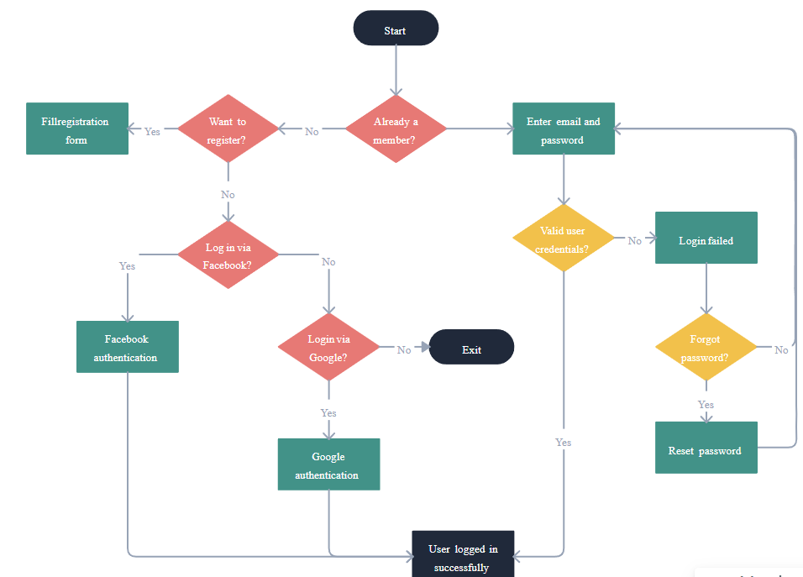

Q . How do flowcharts help in programming and system design?

Flowcharts are crucial in programming and system design as visual blueprints, simplifying complex logic, enhancing communication, streamlining development (planning, coding, debugging), ensuring modularity, and improving documentation for better analysis, maintenance, and teamwork by mapping out processes, decisions, and data flow. They serve as a universal language, making it easier to understand how programs work, identify errors, and manage system architecture.
In Programming
- Logic Visualization: They graphically depict the sequence of steps, conditions (diamonds for decisions), and loops, making complex algorithms easy to grasp.
- Efficient Coding: Flowcharts act as a plan, guiding developers to write cleaner, more efficient code, reducing time spent on fixing basic errors.
- Debugging: They help quickly spot flaws, bottlenecks, or illogical paths in the program's flow, streamlining troubleshooting.
- Modular Design: Breaking down programs into smaller, manageable parts (functions/modules) is facilitated, promoting reusability and easier updates.

