**­­­­­Project 1.B**

1. Project Description

Figure 1 shows an ER diagram for University database. This is the same in Project 1.A.

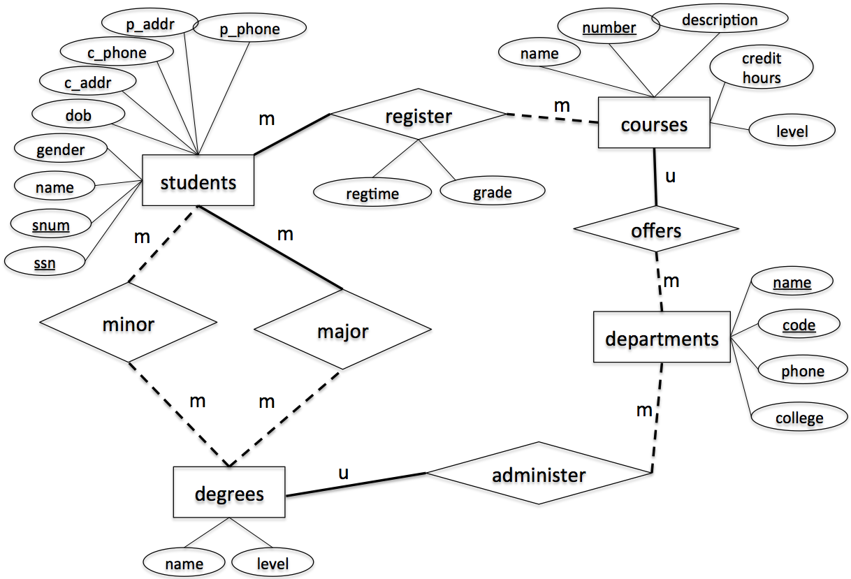

Figure 1. ER-diagram

This project is to implement the above design using a relational data model. Specifically, you are asked to write the following Java programs using JDBC connection to connect MySQL database to Java programs.

1. **CreateTables.java [Points: 15]**

After execution, your program must create the following tables. Each table must be created with the table name, attribute names and corresponding types and length as specified. Also, make sure to specify primary key, candidate key and foreign key (if any), accordingly.

* students
  1. Attribute, type and length: *snum: integer, ssn: integer, name: varchar(10), gender: varchar(1), dob: datetime, c_addr: varchar(20), c_phone: varchar(10), p_addr: varchar(20), p_phone: varchar(10)*
  2. Primary key: *ssn*
  3. Candidate key: *snum*
  4. Foreign key: *N/A*
* departments
  1. Attribute, type and length: *code: integer, name: varchar(50), phone: varchar(10), college: varchar(20)*
  2. Primary key: *code*
  3. Candidate key: *name*
  4. Foreign key: *N/A*
* degrees
  1. Attribute, type and length: *name: varchar(50), level: varchar(5),* department_code: integer
  2. Primary key: *name, level*
  3. Candidate key: *N/A*
  4. Foreign key: *department_code refers to code in table departments*
* courses

1. Attribute, type and length: *number: integer, name: varchar(50), description: varchar(50), credithours: integer, level: varchar(20), department_code: integer*
2. Primary key: *number*
3. Candidate key: *name*
4. Foreign key: *department_code refers to code in table departments*

* register

1. Attribute, type and length: *snum: integer, course_number: integer, regtime: varchar(20), grade: integer*
2. Primary key: *snum, course_number*
3. Candidate key: *N/A*
4. Foreign key: *snum refers to snum in table students, course_number refers to number in table courses*

* major

1. Attribute, type and length: *snum: integer, name: varchar(50), level: varchar(5)*
2. Primary key: *snum, name, level*
3. Candidate key: *N/A*
4. Foreign key: *snum refers to snum in table students, name & level refer to name & level in table degrees*

* minor

1. Attribute, type and length: *snum: integer, name: varchar(50), level: varchar(5)*
2. Primary key: *snum, name, level*
3. Candidate key: *N/A*
4. Foreign key: *snum refers to snum in table students, name & level refer to name & level in table degrees*

1. **InsertRecords.java [Points: 15]**

After execution, your program must insert the following records to the appropriate tables created by CreateTables.java.

* **students**

|  |  |  |  |  |  |  |  |  |
| --- | --- | --- | --- | --- | --- | --- | --- | --- |
| snum | ssn | name | gender | dob | c_addr | c_phone | p_addr | p_phone |
| 1001 | 654651234 | Randy | M | 2000/12/01 | 301 E Hall | 5152700988 | 121 Main | 7083066321 |
| 1002 | 123097834 | Victor | M | 2000/05/06 | 270 W Hall | 5151234578 | 702 Walnut | 7080366333 |
| 1003 | 978012431 | John | M | 1999/07/08 | 201 W Hall | 5154132805 | 888 University | 5152012011 |
| 1004 | 746897816 | Seth | M | 1998/12/30 | 199 N Hall | 5158891504 | 21 Green | 5154132907 |
| 1005 | 186032894 | Nicole | F | 2001/04/01 | 178 S Hall | 5158891155 | 13 Gray | 5157162071 |
| 1006 | 534218752 | Becky | F | 2001/05/16 | 12 N Hall | 5157083698 | 189 Clark | 2034367632 |
| 1007 | 432609519 | Kevin | M | 2000/08/12 | 75 E Hall | 5157082497 | 89 National | 7182340772 |

* **departments**

|  |  |  |  |
| --- | --- | --- | --- |
| **code** | **name** | **phone** | **college** |
| 401 | Computer Science | 5152982801 | LAS |
| 402 | Mathematics | 5152982802 | LAS |
| 403 | Chemical Engineering | 5152982803 | Engineering |
| 404 | Landscape Architect | 5152982804 | Design |

* **degrees**

|  |  |  |
| --- | --- | --- |
| **name** | **level** | **department_code** |
| Computer Science | BS | 401 |
| Software Engineering | BS | 401 |
| Computer Science | MS | 401 |
| Computer Science | PhD | 401 |
| Applied Mathematics | MS | 402 |
| Chemical Engineering | BS | 403 |
| Landscape Architect | BS | 404 |

* **major**

|  |  |  |
| --- | --- | --- |
| **snum** | **name** | **level** |
| 1001 | Computer Science | BS |
| 1002 | Software Engineering | BS |
| 1003 | Chemical Engineering | BS |
| 1004 | Landscape Architect | BS |
| 1005 | Computer Science | MS |
| 1006 | Applied Mathematics | MS |
| 1007 | Computer Science | PhD |

* **minor**

|  |  |  |
| --- | --- | --- |
| **snum** | **name** | **level** |
| 1007 | Applied Mathematics | MS |
| 1005 | Applied Mathematics | MS |
| 1001 | Software Engineering | BS |

* **courses**

|  |  |  |  |  |  |
| --- | --- | --- | --- | --- | --- |
| **number** | **name** | **description** | **credithours** | **level** | **department_code** |
| 113 | Spreadsheet | Microsoft Excel and Access | 3 | Undergraduate | 401 |
| 311 | Algorithm | Design and Analysis | 3 | Undergraduate | 401 |
| 531 | Theory of Computation | Theorem and Probability | 3 | Graduate | 401 |
| 363 | Database | Design Principle | 3 | Undergraduate | 401 |
| 412 | Water Management | Water Management | 3 | Undergraduate | 404 |
| 228 | Special Topics | Interesting Topics about CE | 3 | Undergraduate | 403 |
| 101 | Calculus | Limit and Derivative | 4 | Undergraduate | 402 |

* **register**

|  |  |  |  |
| --- | --- | --- | --- |
| **snum** | **course_number** | **when** | **grade** |
| 1001 | 363 | Fall2020 | 3 |
| 1002 | 311 | Fall2020 | 4 |
| 1003 | 228 | Fall2020 | 4 |
| 1004 | 363 | Spring2021 | 3 |
| 1005 | 531 | Spring2021 | 4 |
| 1006 | 363 | Fall2020 | 3 |
| 1007 | 531 | Spring2021 | 4 |

1. **Query.java [Points: 55]**

After execution, your program must print out the following information

* 1. The student number and ssn of the student whose name is "Becky"
  2. The major name and major level of the student whose ssn is 123097834
  3. The names of all courses offered by the department of Computer Science
  4. All degree names and levels offered by the department Computer Science
  5. The names of all students who have a minor

1. **ModifyRecords.java [10]**

After execution, your program must modify the following information

1. Change the name of the student with ssn = 746897816 to Scott
2. Change the major of the student with ssn = 746897816 to Computer Science, Master.
3. Delete all registration records that were in “Spring2021”,
4. **DropTables.java [5]**

After execution, your program must delete all tables.

**Submission Instruction**

*Submit all your java programs (*.java) to Canvas. Be sure to*

1. *Name your files as required, i.e., CreateTables.java, InsertRecords.java, Query.java, ModifyRecords.java, DropTables.java;*
2. *Make each of these java files independent executable, i.e., each having its main() method;*
3. *Set user name to be “coms363” and password to be “password” in database authentication.*
4. Set up working environment using Eclipse (This instruction is based on Windows)
   1. Make sure that you have Java JDK installed in your computer, if not, you can get Java JDK at <http://www.oracle.com/technetwork/java/javase/downloads/index.html>
   2. Download and install Eclipse IDE at <https://eclipse.org/downloads/> (choose “Eclipse IDE for Java Enterprise Java Developers”)
   3. Download and install Connector J at <https://dev.mysql.com/downloads/connector/j/>If you use Windows, search for MySQL installer – community app on your computer. If you see the following window, you have Connector J installed. You can also find the install path. If you don’t see Connector/J on the list, then click “Add” on the right, choose “MySQL connectors”, find Connector/J and install it.  
      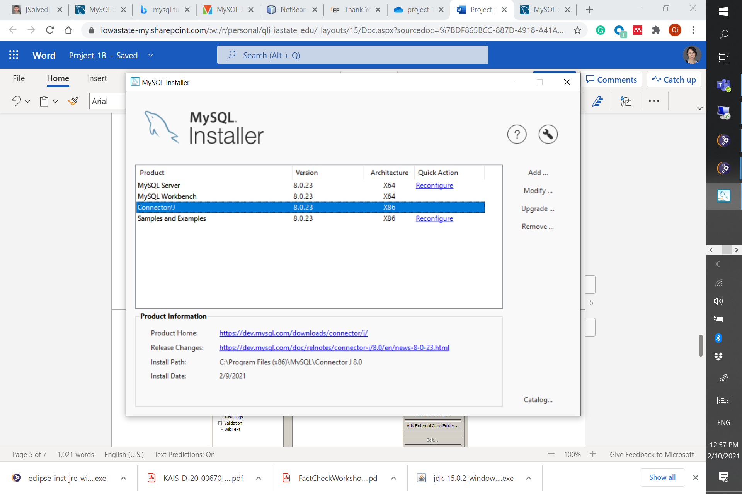
   4. Open Eclipse
   5. Create new Java project by go to “File > New > Other…” then select “Java Project”
   6. Give your Java project a name, then click “next”.   
      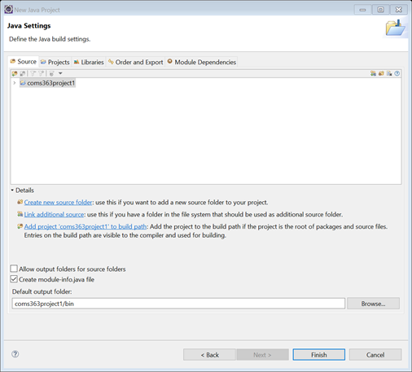
   7. Next, add Connector J JAR file to your project build path. Click on “libraries->classpath” and choose “Add External JARs…”
   8. Go to directory that you installed Connector J and select Connector J JAR file (this can be vary based on directory you have installed. For Windows, you can find the path in installers). Then click Finish.  
      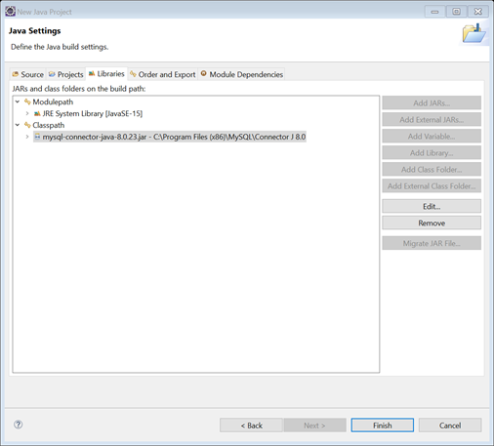
5. Examples of Java codes

This link <https://docs.oracle.com/javase/tutorial/jdbc/basics/processingsqlstatements.html> gives you a tutorial on coding JDBC. For your convenience, we give you some sample code below.

* 1. Establishing a connection

import java.sql.*;

private static Connection connect = null;

try

{

Class.forName("com.mysql.jdbc.Driver");

//Set up connection parameters

String userName = "*[username]*";

String password = "*[password]*";

String dbServer = "jdbc:mysql://mysql.cs.iastate.edu/*[schema]*";

//Set up connection

connect = DriverManager.getConnection(dbServer,userName,password);

}

Catch(Exception e)

{

}

* 1. Executing DML & DDL

Statement stmt = null;

stmt = connect.createStatement();

String sql = "INSERT INTO Registration " + "VALUES (100, 'Zara', 'Ali', 18)";

stmt.executeUpdate(sql);

* 1. Executing SQL query

ResultSet resultSet = null;

String sqlQuery = "";

String outputString = "";

sqlQuery = "SELECT * FROM student";

stmt = connect.createStatement();

resultSet = statement.executeQuery(sqlQuery);

while(resultSet.next())

{

outputString += resultSet.getInt("sid") + "....";

outputString += resultSet.getString("student_name") + "....";

outputString += resultSet.getString("student_email") + "\n";

}

Note:

For testing your code, we will use username= ‘coms363’ and password= ‘password’. To set up this user account, run the following code as root user.

CREATE USER 'coms363'@'localhost' IDENTIFIED BY 'password';

GRANT ALL PRIVILEGES ON *.* TO 'coms363'@'localhost';

Once you run your Java code, you should see updates on MySQL (remember to refresh SCHEMAS)