Samantha Neri, Khushveen Kaur Umra

CprE 489, Section 2

1st February 2023

**Lab 2 Report**

**Contribution:** Samantha Neri (50%), Khushveen Kaur Umra (50%)

**1) Summarize what you learned in a few paragraphs.**

With this lab, we’ve learned how to do some basic TCP socket programming, and establish a connection between a client and server. We also learned how to receive and send data through a TCP socket, and implemented the ruptime UNIX command.

Overall, TCP socket programming was relatively new for the both of us, and we had a bit of a struggle trying to understand the structure of the code. In the end, we were able to understand the basic process for Server and Client. Server includes creating and verifying a socket, initializes values, binds to the socket, listens for the client, then accepts the client connection. Client includes

**2) Include your two approaches for capturing uptime output from the pre-lab.**

1. We can get uptime by typing in the terminal “uptime [option]”; using an option such as p, s, h, or v will change the display format
2. We can type in the terminal the, “top” command to display Linux system uptime

**3) Include your well-commented code and demo your code to the TA.**

**a) Correct implementation of the TCP socket.**

**CLIENT:**

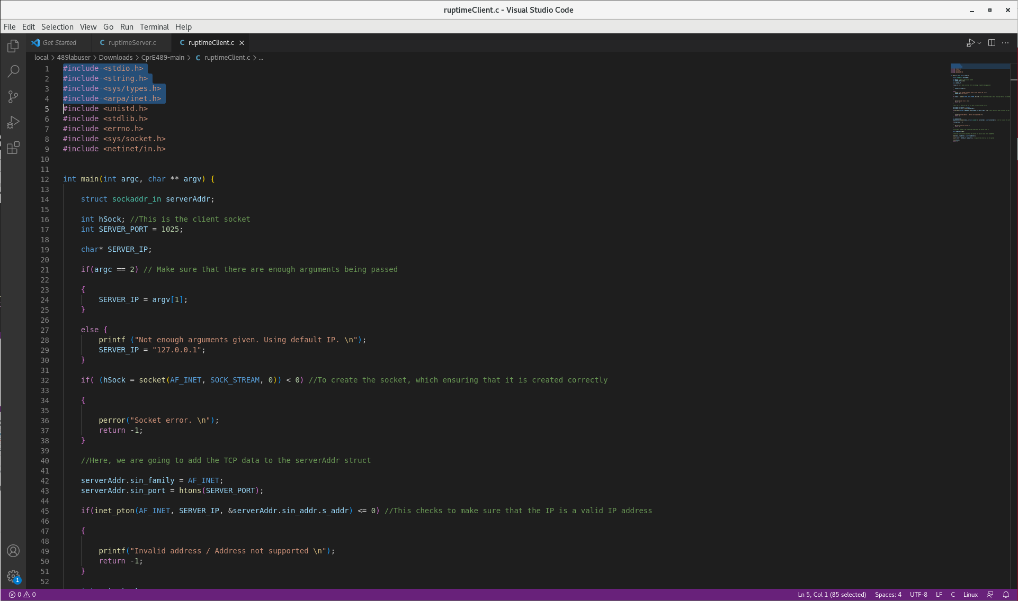

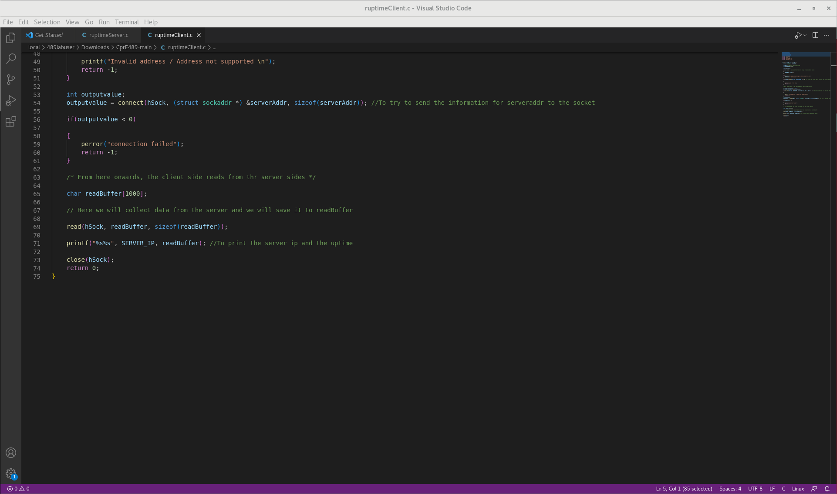

**SERVER:**

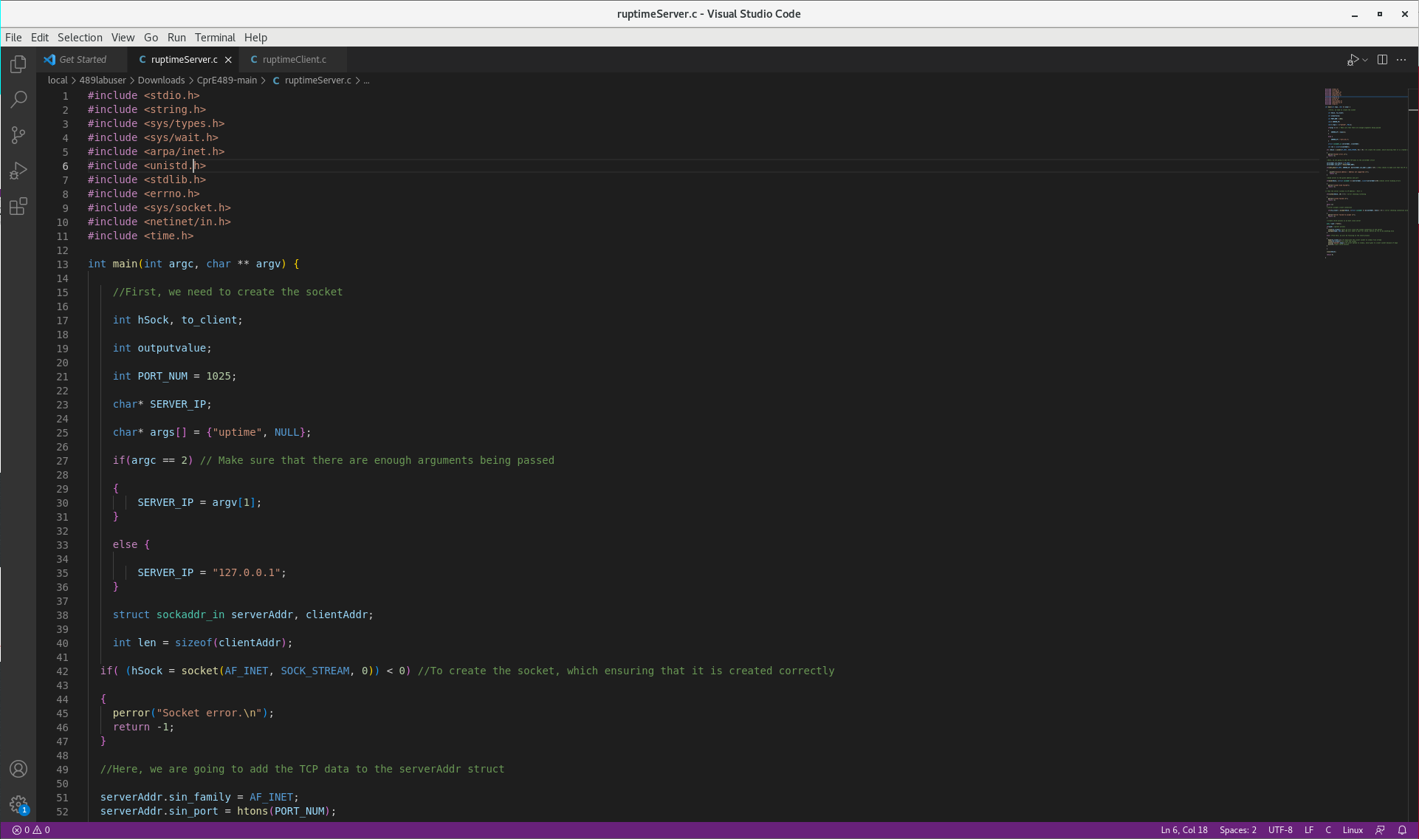

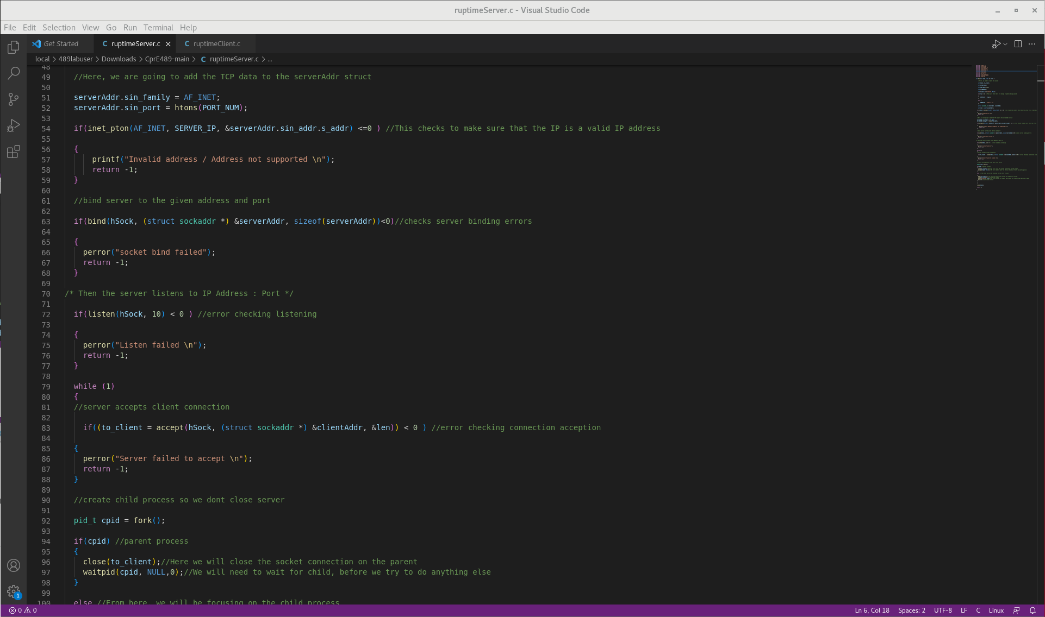

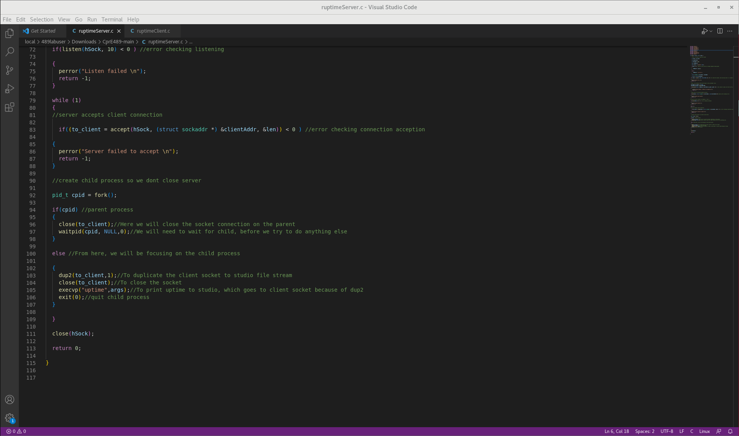

**b) Correctly parse the output of the uptime command.**

**SERVER**

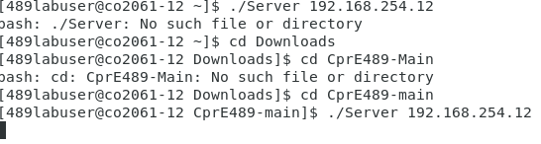

**CLIENT**

