18071
Q. Demonstrate FTP server in packet Tracer. Aim:-To demonstrate FTP server in packet tracer.
Setup:
(1). 2 Pc , 1 switch, 1 server.
(2).Connect Pcs to switch and switch to server.
Topology:
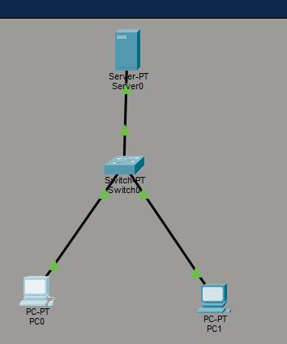
Config:
PC0
assign IP address 192.168.1.10
Subnet Mask 255.255.255.0
PC1
assign IP address 192.168.1.11
Khushi Vishwakarma | S.I.W.S College | Major Practical-3

18071
Subnet Mask 255.255.255.0
Server:
(1). Enable FTP option.
(2).Create username and password(123).
(3). Click all the 5 tick bores write , read ,Delete ,Rename list. (4). Add it.
PC0:
C:\ipconfig
C:\>ping 192.168.1.2
C:\>ftp 192.168.1.2
ftp>dir
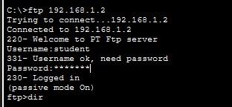
Khushi Vishwakarma | S.I.W.S College | Major Practical-3

18071
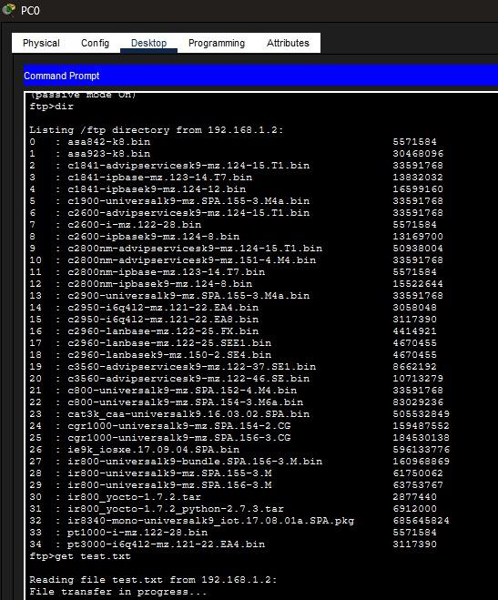
Conclusion:The above Topology has been executed successfully.
Khushi Vishwakarma | S.I.W.S College | Major Practical-3

