18071
Q. Demonstrate the RIP Routing in Packet Tracer.
Aim : To write a code to demonstrate RIP routing in packet tracer.
Steps:
1.In packet tracer take 2 PCs and 2 Routers.
2.Connect Router0 with PC0 via fastethernet0/0 using cross-copper cord and Router1 with PC1 via fasethernet0/0 using cross-copper cord.
3.Connect both router via fastethernet0/1 using cross-copper cord.
4.Set the IP address and default gateway of both the PCs in ip configuration of both the PCs respectively.
Topology:
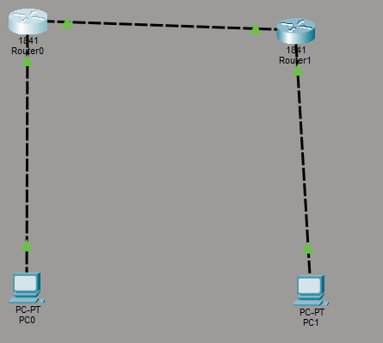
Router0:
Router> enable
Router# configure terminal
Router(config)# interface fastethernet0/0
Router(config-if)# ip address 192.168.1.1 255.255.255.0
Khushi Vishwakarma | S.I.W.S College | Major Practical 2

18071
Router(config-if)# no shutdown
Router(config-if)# exit
Router(config)# interface gigabitEthernet0/1
Router(config-if)# ip address 10.0.0.1 255.255.255.0 Router(config-if)# no shutdown
Router(config-if)# exit
Router(config)# router rip
Router(config-router)# version 2
Router(config-router)# network 192.168.1.0
Router(config-router)# network 10.0.0.0
Router(config-router)# no auto-summary
Router(config-router)# exit
Router(config)# end
Router1:
Router> enable
Router# configure terminal
Router(config)# interface gigabitEthernet0/0
Router(config-if)# ip address 10.0.0.2 255.255.255.0 Router(config-if)# no shutdown
Router(config-if)# exit
Router(config)# interface gigabitEthernet0/1
Router(config-if)# ip address 192.168.2.1 255.255.255.0 Router(config-if)# no shutdown
Router(config-if)# exit
Router(config)# router rip
Router(config-router)# version 2
Router(config-router)# network 10.0.0.0
Khushi Vishwakarma | S.I.W.S College | Major Practical 2

18071
Router(config-router)# network 192.168.2.0
Router(config-router)# no auto-summary
Router(config-router)# exit
Router(config)# end
Router#show ip route
Router#show ip protocol
Output:
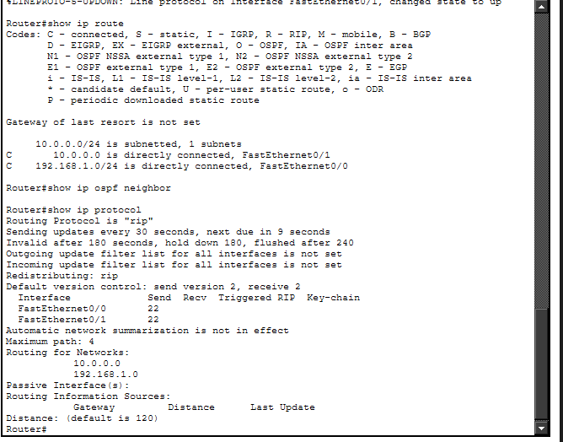
Verification:In PC0 command prompt.
C:>ipconfig
C:\>ping 192.168.2.2
Output:
Khushi Vishwakarma | S.I.W.S College | Major Practical 2

18071
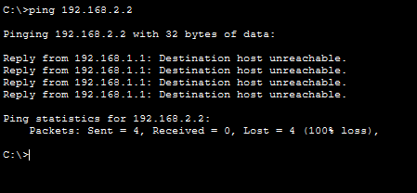
Conclusion:The abovr topology has been executed successfully.
Khushi Vishwakarma | S.I.W.S College | Major Practical 2

