18071
Q. Demonstrate HTTP server in Packet tracer.
Aim:- To demonstrate HTTP server in packet Tracer.
Setup:
(1). 1 Pc ,1 switch ,2 Server.
(2). Connect Pc with switch and switch with the servers.
(3).Connect Router0 with PC0 via fastethernet0/0 using copper stright wire and Router1 with PC1 via fasethernet0/0 using cross-copper cord.
(4).Connect both router via fastethernet0/1 using cross-copper cord.
(5).Set the IP address and default gateway of both the PCs in ip configuration of both the PCs respectively.
Topology:
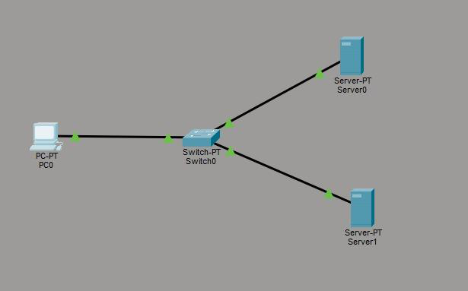
Config:
Server 0 (DNS Server)
Khushi Vishwakarma | S.I.W.S College | Major Practical-3

18071
Assign ip address 192.168.1.1
DNS Server 192.168.1.1
Server 1 (web server)
Assign ip address 192.168.1.2
DNS Server 192.168.1.1
DNS Server will be the same
PC0
Assign ip address 192.168.1.3
DNS Server 192.168.1.1
(1). In DNS server 0 select and on DNS .
(2). Then go to web server http and edit the index.
(3). Name the website in DNS column and add the web server address and make on entity i the below list by clicking add.
(4). In PC0 open the desktop and then web browser write the name of the website if the edited html files contet displays ,then the topology has been succcessfully established.
PC0:
C:\ipconfig
C:\>ping 192.168.1.3
Khushi Vishwakarma | S.I.W.S College | Major Practical-3

18071
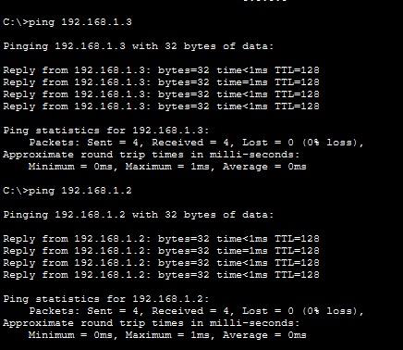
Khushi Vishwakarma | S.I.W.S College | Major Practical-3

18071
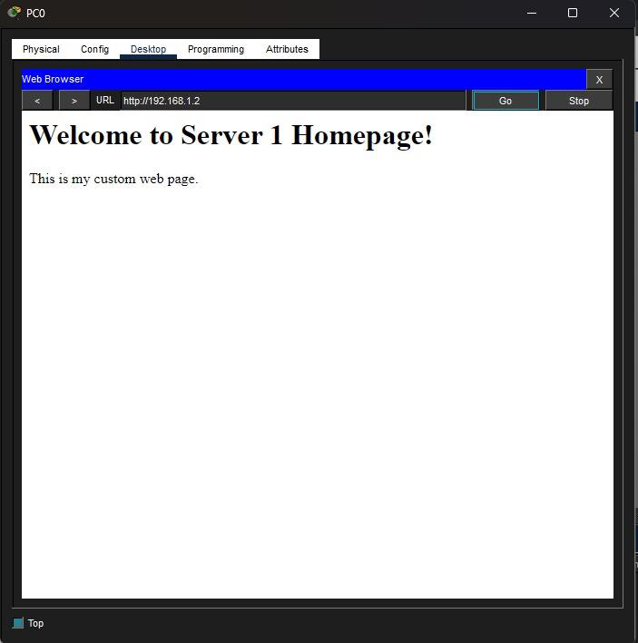
Conclusion:The above Topology has been executed successfully.
Khushi Vishwakarma | S.I.W.S College | Major Practical-3

