18071
Q. Demonstrate the Static Routing in Packet Tracer.
Aim : To write a code to demonstrate static routing in packet tracer.
Steps:
1.In packet tracer take 2 PCs and 2 Routers.
2.Connect Router0 with PC0 via fastethernet0/0 using cross-copper cord and Router1 with PC1 via fasethernet0/0 using cross-copper cord.
3.Connect both router via fastethernet0/1 using cross-copper cord.
4.Set the IP address and default gateway of both the PCs in ip configuration of both the PCs respectively.
Topology:
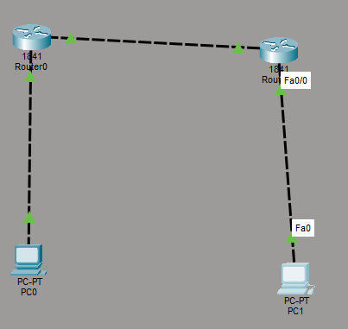
Code:
Router0:
Router> enable
Router# configure terminal
Khushi vishwakarma | S.I.W.S College | Magor Practical 2

18071
Router(config)# interface fastethernet0/0
Router(config-if)# ip address 10.0.0.1 255.0.0.0 Router(config-if)# no shutdown
Router(config-if)# exit
Router(config)# interface fastethernet0/1
Router(config-if)# ip address 20.0.0.1 255.0.0.0 Router(config-if)# no shutdown
Router(config-if)# exit
Router(config)#ip route 40.0.0.0 255.0.0.0 20.0.0.2 Router(config)#exit
Router1:
Router> enable
Router# configure terminal
Router(config)# interface fastethernet0/0
Router(config-if)# ip address 20.0.0.2 255.0.0.0 Router(config-if)# no shutdown
Router(config-if)# exit
Router(config)# interface fastethernet0/1
Router(config-if)# ip address 40.0.0.1 255.0.0.0 Router(config-if)# no shutdown
Router(config-if)# exit
Router(config)#ip route 10.0.0.0 255.0.0.0 20.0.0.1 Router(config)#exit
Verification: In Both PCs Command Prompt.
Khushi vishwakarma | S.I.W.S College | Magor Practical 2

18071
PC0:
C:\ipconfig
C:\ping 10.0.0.1
C:\ping 10.0.0.2
C:\ping 20.0.0.1
C:\ping 20.0.0.2
C:\ping 40.0.0.1
C\:ping 40.0.0.2
PC1:
C:\ipconfig
C:ping 40.0.0.1
C:ping 20.0.0.2
C:ping 20.0.0.1
C:ping 10.0.0.1
C:ping 10.0.0.2
Output:
PC0:
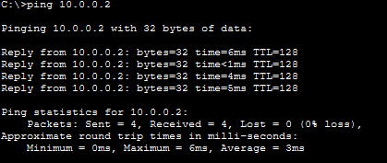
Khushi vishwakarma | S.I.W.S College | Magor Practical 2

18071
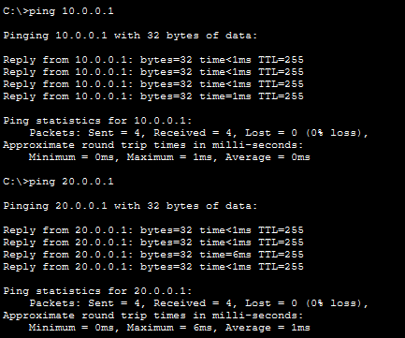
PC1:
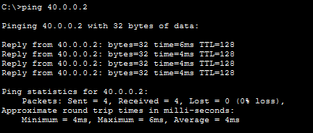
Conclusion:The above Topology has been executed successfully.
Khushi vishwakarma | S.I.W.S College | Magor Practical 2

18071
Khushi vishwakarma | S.I.W.S College | Magor Practical 2

