18071
Study of MDS Algorithm
Q. Demontrate MDS algorithm in python.
Aim : To write a program to demonstrate MDS Algorithm in python.
Program:
import hashlib
str1="syit class"
md5hashvalue=hashlib.md5()
print(md5hashvalue)
md5hashvalue.update(str1.encode('utf-8'))
md5hashvalue
messagedigest=md5hashvalue.hexdigest()
messagedigest
print(messagedigest)
Result:
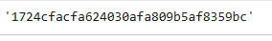
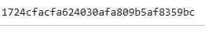
Conclusion: The above program has been executed successfully.
Khushi Vishwakarma | S.I.W.S College | Major Practical -7

