18071
Q. Demonstrate DNS server in packet Tracer.
Aim:- To demonstrate DNS server in packet Tracer.
Setup:
(1). One Pcs,One Switch & One server.
(2). Connect Pcs to switch and switch to server.
(3).Then in server on the DNS services.
(4). Then origin ip address and DNS server .
(5). For Pc also origin ip address and DNS server ip of the server.
Topology:
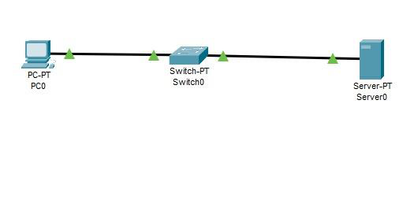
Config:
(1).Go to HTTP in server.
(2). There in file name index make some changes.
(3). Save it and then in DNS service add the name for the website and the DNS server and add that detail.
(4). Now go to Pc in there desktop click web browser and put the name of the file in URL and click go.
(5). If the topology work successfully then the website will be displayed.
Khushi Vishwakarma | S.I.W.S College | Major Practical-3

18071
Verification: In PCs Command Prompt.
PC0:
C:\ipconfig
C:\ping www.mywebsite.com
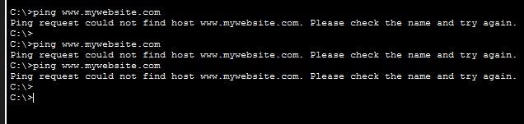
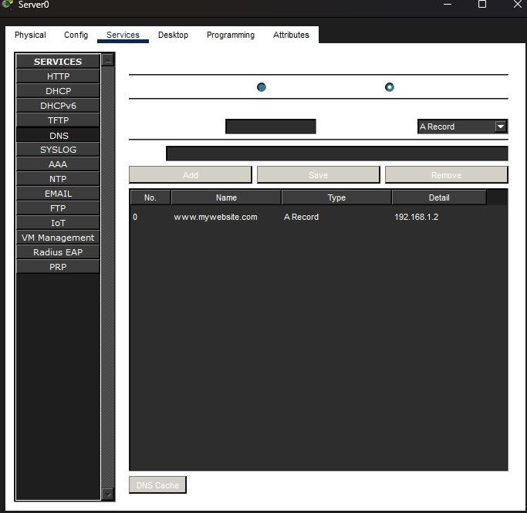
Khushi Vishwakarma | S.I.W.S College | Major Practical-3

18071
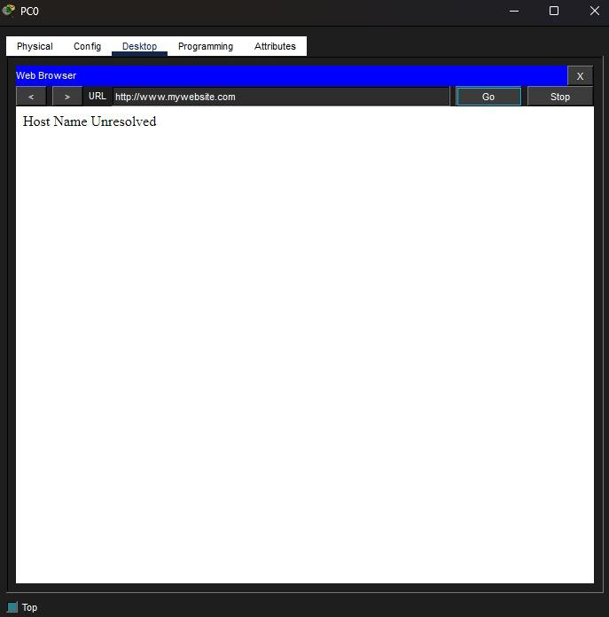
Conclusion:The above Topology has been executed successfully.
Khushi Vishwakarma | S.I.W.S College | Major Practical-3

