18071
Q. Demonstrate Routing OSPF in packet tracer.
Aim: To write a code to demonstrate routing OSPF in packet tracer.
Steps:
1. In packet tracer take 2 PCs and 2 Routers.
2. Connect Router0 with PC0 via fastethernet0/0 using cross-copper cord and Router1 with PC1 via fasethernet0/0 using cross-copper cord.
3. Connect both router via fastethernet0/1 using cross-copper cord.
4. Set the IP address and default gateway of both the PCs in ip configuration of both the PCs respectively.
Topology:
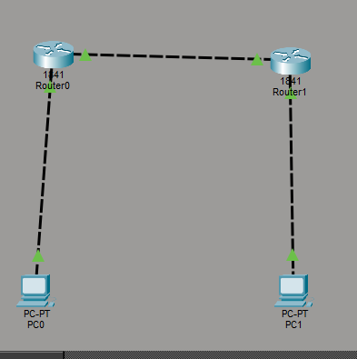
Code:
Router0:
Router> enable
Router# configure terminal
Router(config)# interface fastethernet0/0
Khushi Vishwakarma | S.I.W.S College | Major Practical 2

18071
Router(config-if)# ip address 192.168.1.1 255.255.255.0 Router(config-if)# no shutdown
Router(config-if)# exit
Router(config)# interface fastethernet0/1
Router(config-if)# ip address 10.0.0.1 255.255.255.0
Router(config-if)# no shutdown
Router(config-if)# exit
Router(config)#router ospf 1
Router(config-router)#network 192.168.1.0 0.0.0.255 area 0 Router(config-router)#exit
Router1:
Router> enable
Router# configure terminal
Router(config)# interface fastethernet0/0
Router(config-if)# ip address 10.0.0.2 255.255.255.0
Router(config-if)# no shutdown
Router(config-if)# exit
Router(config)# interface fastethernet0/1
Router(config-if)# ip address 192.168.2.1 255.255.255.0 Router(config-if)# no shutdown
Router(config-if)# exit
Router(config)#router ospf 2
Router(config-router)#network 10.0.0.0 0.0.0.255 area 0 Router(config-router)#network 192.168.2.0 0.0.0.255 area 0 Router(config-router)#exit
Verification :In PC in command Prompt.
Khushi Vishwakarma | S.I.W.S College | Major Practical 2

18071
PC0:
C:\ipconfig
C:\ping 192.168.2.10
Output:
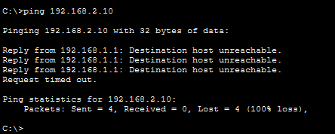
Verification: On any one Router
Router#show ip ospf neighbor
Router#show ip protocol
Router#show ip protocol
Output:
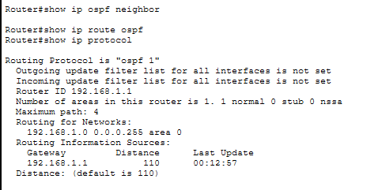
Conclusion : The above Topology has been executed successfully.
Khushi Vishwakarma | S.I.W.S College | Major Practical 2

18071
Khushi Vishwakarma | S.I.W.S College | Major Practical 2

