18071
Q. To create , Export and validate a Digital Certificate.
Aim: To write a code to create , Export and validate a Digital Certificate.
Steps :
1.Download and open ssl.
2.Add its bin path in envirnment variable.
3.Open command prompt.
Program:
C:\user\desktop>open reg-509 –day 365 –newkey rsa:204:keyout private-key pem-out certificate.pem
Enter PEM Pass : 123456
Country Name (2 letter code): IN
State or ProvinceName (Full Name):Mharashtra
Locality Name[]: Mumbai
Organization Name : SIWS
Organization Unit Name : iT
Comman name :TMD
Email Address cs:
C:\user\desktop>openssl pkcs12 –export –in certificate pem –inkey private-key.pem -out TMD.pfx
Enter Export Password:123456
Verifying – Enter Export Password:123456
>openssl pkcs12 –inTMD.pfx -clcerts –nokey – out public-key.pem
Enter Import password:123456
Import the certificate.
Result:
Khushi Vishwakarma | S.I.W.S College | Major Practical 9

18071
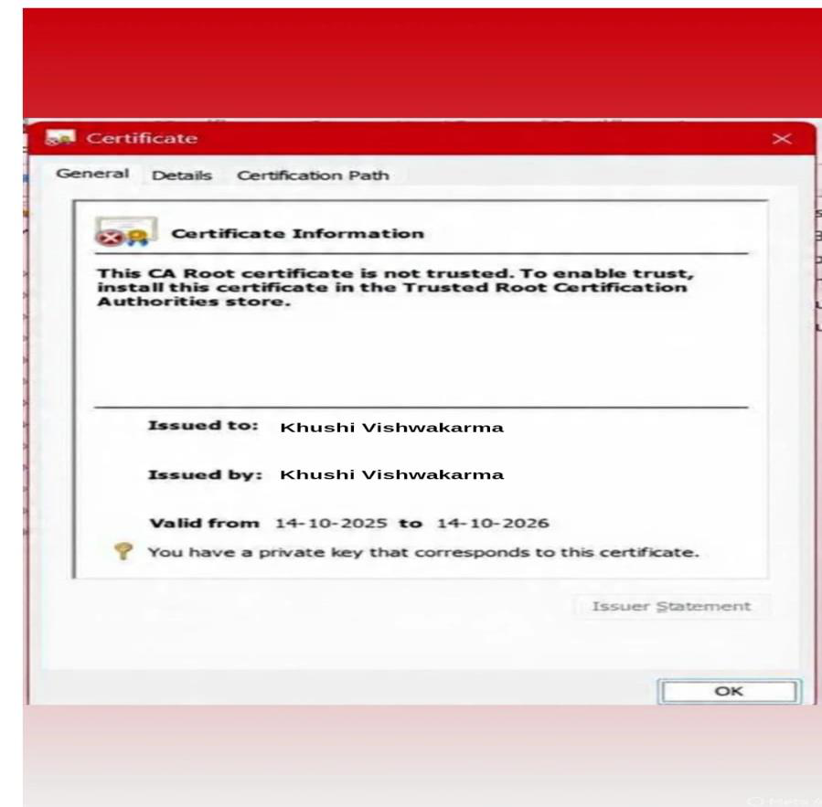
Conclusion: The above certificate is done successfully.
Khushi Vishwakarma | S.I.W.S College | Major Practical 9

