18071
Q. Demonstrate DHCP router in packet Tracer.
Aim:- To demonstrate DHCP server in packet Tracer.
Setup:
(1). Router ,switch & 2 Pcs.
(2).Connect the Pcs to switch and connect switch t the router.
(3).Give router a ip address then in Pc0 & Pc1 click the radio button of DHCP in the ip configureration panel the values will be assingned directly.
Topology:
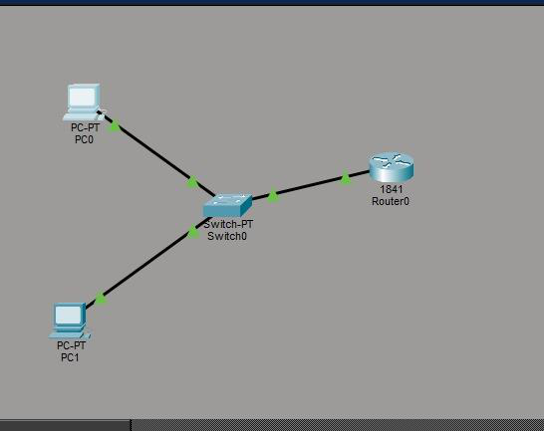
Code:
Router> enable
Router# configure terminal
Khushi Vishwakarma | S.I.W.S College | Major Practical-3

18071
Router(config)#
Router(config)# interface fastEthernet0/0
Router(config-if)# ip address 192.168.10.1 255.255.255.0 Router(config-if)# no shutdown
Router(config-if)# exit
Router(config)# ip dhcp pool MYPOOL
Router(dhcp-config)# network 192.168.10.0 255.255.255.0 Router(dhcp-config)# default-router 192.168.10.1
Router(dhcp-config)# dns-server 8.8.8.8
Router(dhcp-config)# exit
Verification: In Both PCs Command Prompt.
PC0:
C:\ipconfig
C:\>ping 192.168.10.1
Output:-
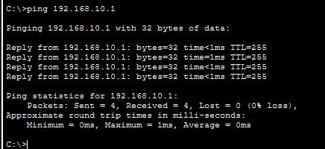
Conclusion:The above Topology has been executed successfully.
Khushi Vishwakarma | S.I.W.S College | Major Practical-3

18071
Khushi Vishwakarma | S.I.W.S College | Major Practical-3

