18071
Q. Demonstrate telnet in packet Tracer.
Aim:-To demonstrate Telnet in packet Tracer.
Setup:
(1). 1 PC , 1 Router , 1 switch.
(2). PC --->Switch--> Router connect using copper straight wire through cables. (3). Do Router ,Switch interface Up.
Topology:
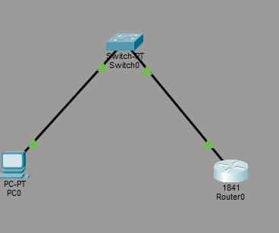
Config:
Switch :
Switch>enable
Switch#configure terminal
Switch(config-if)# ip address) 192.168.1.2 255.255.255.0 Switch(config-if)# no shutdown
Switch(config-if)#exit
Switch(config-if)# line vtg 04
Khushi Vishwakarma | S.I.W.S College | Major Practical-3

18071
Switch(config-if)# password cisco
Switch(config-line)#login
Switch(config-line)#end
Switch# write memory
Router:
Router>enable
Router#configure terminal
Router(config-if)# ip address 192.168.1.1
Router(config-if)#no shutdown
Router(config-if)#exit
Router(config)# line vty 04
Router(config-line)# password cisco
Router(config-line)#login
Router(config-line)#end
Router# write memory
Verify:
PC0:
C:\ipconfig
C:\>ping 192.168.1.1
Telnet 192.168.1.1
Telnet 192.168.1.2
Khushi Vishwakarma | S.I.W.S College | Major Practical-3

18071
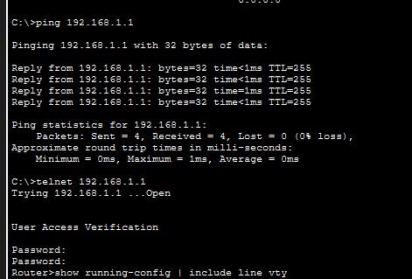
Conclusion:The above Topology has been executed successfully.
Khushi Vishwakarma | S.I.W.S College | Major Practical-3

