18071
7. Transportation Problem
Q. Write a program in python to demonstrate Transportation Problem using Northwest Corner Method.
Aim: To write a program in python to demonstrate Transportation Problem using Northwest Corner Method.
Program:
costs = [
[8, 6, 10], # from O1 to D1, D2, D3
[10, 4, 9] # from O2 to D1, D2, D3
]
supply = [2000, 2500] # supply for O1, O2
demand = [1500, 2000, 1000] # demand for D1, D2, D3
alloc = [[0]*3 for _ in range(2)] # allocation matrix
i = j = 0
while i < 2 and j < 3:
qty = min(supply[i], demand[j])
alloc[i][j] = qty
supply[i] -= qty
demand[j] -= qty
if supply[i] == 0 and demand[j] == 0:
i += 1
j += 1
elif supply[i] == 0:
Khushi Vishwakarma | S.I.W.S College | Minor Practical 7

18071
i += 1
elif demand[j] == 0:
j += 1
# Print results
print("Allocation Matrix (O1,O2 vs D1,D2,D3):") for row in alloc:
print(row)
total = 0
print("\nAllocations & Costs:")
for i in range(2):
for j in range(3):
if alloc[i][j] > 0:
cost = alloc[i][j] * costs[i][j]
total += cost
print(f"O{i+1}->D{j+1}: {alloc[i][j]} units × {costs[i][j]} = {cost}")
print("\nTotal Transportation Cost =", total)
Result:
Khushi Vishwakarma | S.I.W.S College | Minor Practical 7

18071
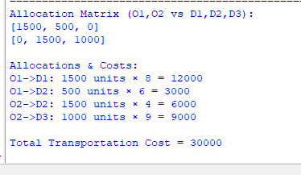
Conclusion: The above program has been executed successfully.
Khushi Vishwakarma | S.I.W.S College | Minor Practical 7

