18071
2 .Interpolation
Q. Write a program in python to demonstrate Forward difference table.
Aim: To write a program in python to demonstrate Forward difference table.
Program:
def forward_difference_table(x, y): n = len(y) diff_table = [y.copy()] # first row is y values
# generate forward differences
for i in range(1, n):
row = []
for j in range(n - i):
value = diff_table[i - 1][j + 1] - diff_table[i - 1][j] row.append(value)
diff_table.append(row)
return diff_table
def display_table(x, diff_table): n = len(x) print("\nForward Difference Table:") print("x\t" + "\t".join([f"Δ^{i}y" for i in range(n)]))
for i in range(n):
print(f"{x[i]:.2f}", end="\t")
for j in range(n - i):
print(f"{diff_table[j][i]:.2f}", end="\t") print()
def main(): n = int(input("Enter the number of data points: "))
print("Enter x values (equally spaced):")
x = [float(input(f"x[{i}]: ")) for i in range(n)]
print("Enter corresponding y values:")
y = [float(input(f"y[{i}]: ")) for i in range(n)]
# check if x values are equally spaced
h = x[1] - x[0]
if not all(abs(x[i + 1] - x[i] - h) < 1e-5 for i in range(n - 1)): print("Error: x values are not equally spaced.")
Khushi Vishwakarma | S.I.W.S College | Minor Practical 2

18071
return
diff_table = forward_difference_table(x, y)
display_table(x, diff_table)
if name == "main": main()
Result:
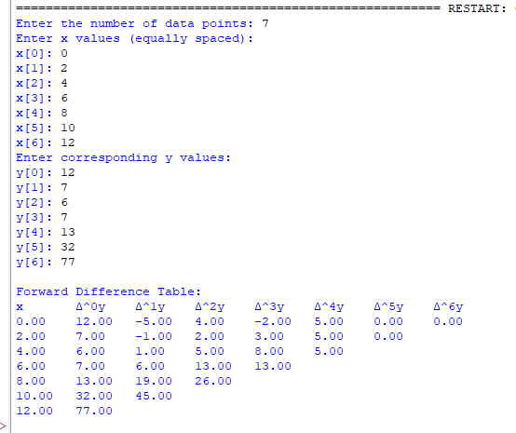
Conclusion: The above program has been executed successfully.
Khushi Vishwakarma | S.I.W.S College | Minor Practical 2

