18053
1. Transcendental Equation
Q. Write a program in python to demonstrate bisection method.
Aim: To write a program in python to demonstrate bisection method.
Formula: Xr = a+b/2
Xr = ((a+b)/2)
Program:
import math
# Function evaluator
def f(x, func_str):
return eval(func_str, {"x": x, "math": math})
# Bisection Method
def bisection(func_str, a, b, tol):
if f(a, func_str) * f(b, func_str) > 0:
print("Invalid interval! f(a) and f(b) must have opposite signs.") return
print("\nIter\t a\t b\t Xr\t f(Xr)")
iter = 1
while (b - a) / 2 > tol:
Xr = (a + b) / 2
fx = f(Xr, func_str)
print(f"{iter}\t {a:.3f}\t {b:.3f}\t {Xr:.3f}\t {fx:.3f}")
if abs(fx) < tol:
break
if f(a, func_str) * fx < 0:
b = Xr
else:
a = Xr
Ajeet Kumar Saroj | S.I.W.S College | Minor Practical 1

18053
iter += 1
print(f"\nApproximate root = {Xr:.3f} (correct to 3 decimal places)")
# === Main Program ===
print("=== Bisection Method ===")
func_str = input("Enter the function f(x): ") # Example: x**3 - 4*x + 1 a = float(input("Enter starting value a: ")) # Example: 0
b = float(input("Enter ending value b: ")) # Example: 1
tol = 0.0001 # Accuracy
bisection(func_str, a, b, tol)
Result:
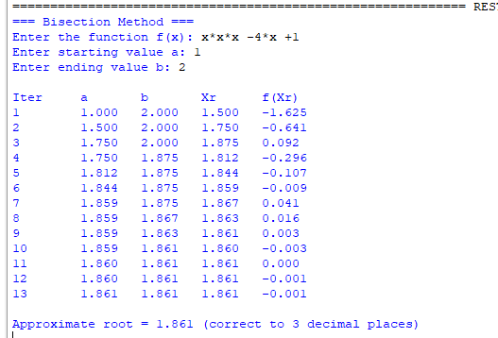
Conclusion: The above program has been executed successfully.
Ajeet Kumar Saroj | S.I.W.S College | Minor Practical 1

