18071
6.Numerical Integration
Trapezoidal Rule
Q. Write a program in python to demonstrate Trapezoidal RuleMethod.
Aim: To write a program in python to demonstrate Trapezoidal Rule Method.
Program:
def f(x):
return 1 / (1 + x**2)
a = 0
b = 1
n = 2 # number of subintervals
h = (b - a) / n
x = [a + i * h for i in range(n + 1)]
f_values = [f(xi) for xi in x]
print("===============================================================") print(" i x(i) f(x(i)) = 1/(1+x^2)")
print("---------------------------------------------------------------")
for i in range(n + 1):
print(f" {i+1:<2d} {x[i]:<10.4f} {f_values[i]:<10.4f}")
print("---------------------------------------------------------------")
I = (h / 2) * (f_values[0] + 2 * sum(f_values[1:-1]) + f_values[-1])
print(f"h = (b - a) / n = ({b} - {a}) / {n} = {h}")
print("\nUsing Trapezoidal Rule:")
print("I = (h/2) * [f(x0) + 2f(x1) + f(x2)]")
Khushi Vishwakarma | S.I.W.S College | Minor Practical 6

18071
print(f"I = ({h}/2) * [{f_values[0]:.4f} + 2{f_values[1]:.4f} + {f_values[2]:.4f}]")
print("---------------------------------------------------------------")
print(f"Approximate value of the integral I = {I:.4f}")
print("===============================================================") Result:
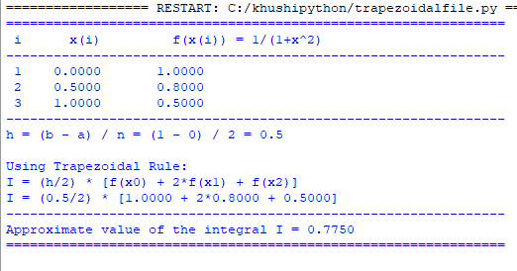
Conclusion: The above program has been executed successfully.
Khushi Vishwakarma | S.I.W.S College | Minor Practical 6

