18071
1 Bisection method.
Q. Write a program in python to demonstrate bisection method.
Aim: To write a program in python to demonstrate bisection method.
Formula: Xr = a+b/2
Xr = ((a+b)/2)
Program:
import math
# Function evaluator
def f(x, func_str):
return eval(func_str, {"x": x, "math": math})
# Bisection Method def bisection(func_str, a, b, tol): if f(a, func_str) * f(b, func_str) > 0: print("Invalid interval! f(a) and f(b) must have opposite signs.") return
print("\nIter\t a\t b\t Xr\t f(Xr)")
iter = 1
while (b - a) / 2 > tol:
Xr = (a + b) / 2 fx =
f(Xr, func_str)
print(f"{iter}\t {a:.3f}\t {b:.3f}\t {Xr:.3f}\t {fx:.3f}")
if abs(fx) < tol:
break
if f(a, func_str) * fx < 0:
b = Xr
else:
a= Xr
Khushi Vishwakarma | S.I.W.S College | Minor Practical

18071
iter += 1
print(f"\nApproximate root = {Xr:.3f} (correct to 3 decimal places)") # === Main Program ===
print("=== Bisection Method ===")
func_str = input("Enter the function f(x): ") # Example: x**3 - 4*x + 1 a = float(input("Enter starting value a: ")) # Example: 0
b= float(input("Enter ending value b: ")) # Example: 1
tol = 0.0001 # Accuracy
bisection(func_str, a, b, tol)
Result:
Result:
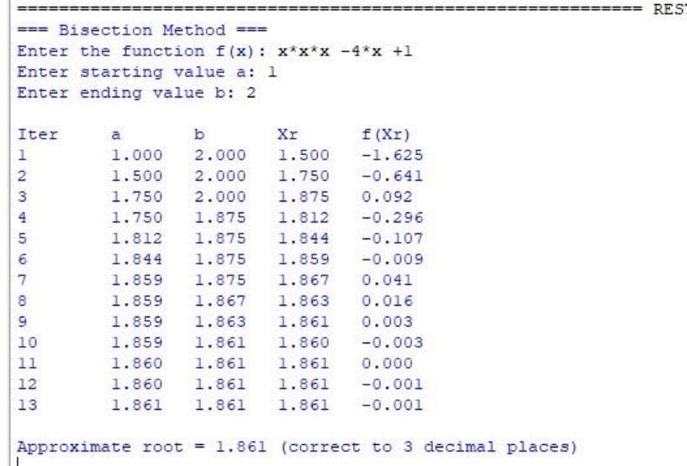
Conclusion: The above program has been executed successfully.
Khushi Vishwakarma | S.I.W.S College | Minor Practical

18071
Regula Falsi method.
Q. Write a program in python to demonstrate Regula Falsi method.
Aim: To write a program in python to demonstrate regula falsi method.
Formula:
Xr = af(b) - bf(a) / f(a) - f(b)
Xr = (((a*f(b)) - (b*f(a))) / (f(a) - f(b)))
Program:
def f(x, func_str): return eval(func_str, {"x": x, "math": math})
def regula_falsi(func_str, a, b, tol): if f(a, func_str) * f(b, func_str) > 0: print("Invalid interval! f(a) and f(b) must have opposite signs.") return
print("\nIter\t a\t b\t Xr\t f(Xr)") iter = 1
Xr_old = a
while True:
# Formula for Regula Falsi
Xr = (a * f(b, func_str) - b * f(a, func_str)) / (f(b, func_str) - f(a, func_str))
fx = f(Xr, func_str)
print(f"{iter}\t {a:.3f}\t {b:.3f}\t {Xr:.3f}\t {fx:.3f}")
if abs(fx) < tol or abs(Xr - Xr_old) < tol: break
if f(a, func_str) * fx < 0:
b = Xr
else:
a = Xr
Khushi Vishwakarma | S.I.W.S College | Minor Practical

18071
Xr_old = Xr
iter += 1
print(f"\nApproximate root = {Xr:.3f} (correct to 3 decimal places)")
print("=== Regula Falsi Method ===")
func_str = input("Enter the function f(x): ")
# Example: x*3 - 2x - 5 a = float(input("Enter starting value a: ")) # Example: 2 b = float(input("Enter ending value b: ")) # Example: 3 tol = 0.0001 # Accuracy
regula_falsi(func_str, a, b, tol)
Result:
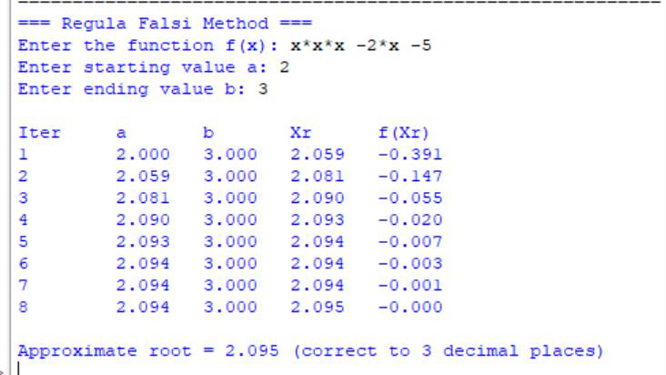
Conclusion: The above program has been executed successfully.
Newton Raphson
Q. Write a program in python to demonstrate Newton Raphson method. Aim: To write a program in python to demonstrate Newton Raphson method.
Formula:
Xn + 1 = xr - f(x) / f’(x)
Xn+1 = (xr - (f(x) / f’(x))
Program:
Khushi Vishwakarma | S.I.W.S College | Minor Practical

18071
def f(x, func_str):
return eval(func_str, {"x": x, "math":math})
def derivative(x, func_str):
h = 1e-5 return (f(x + h, func_str) - f(x - h, func_str)) / (2 * h)
def newton_raphson(func_str, x0, tol):
print("\nIter\t x\t\t f(x)\t\t f'(x)\t\t Next x") iter = 1
while True:
fx = f(x0, func_str)
dfx = derivative(x0, func_str)
if dfx == 0:
print("Error: Derivative is zero. Method fails.") return
x1 = x0 - fx / dfx
print(f"{iter}\t {x0:.5f}\t {fx:.5f}\t {dfx:.5f}\t {x1:.5f}")
if abs(x1 - x0) < tol:
break
x0 = x1
iter += 1
print(f"\nApproximate root = {x1:.3f} (correct to 3 decimal places)")
print("=== Newton–Raphson Method ===") func_str = input("Enter the function f(x): ") # Example: x*3 - 2x - 5 x0 = float(input("Enter the initial guess: ")) # Example: 2 tol = 0.0001 # Accuracy
newton_raphson(func_str, x0, tol)
Result:
Khushi Vishwakarma | S.I.W.S College | Minor Practical

18071
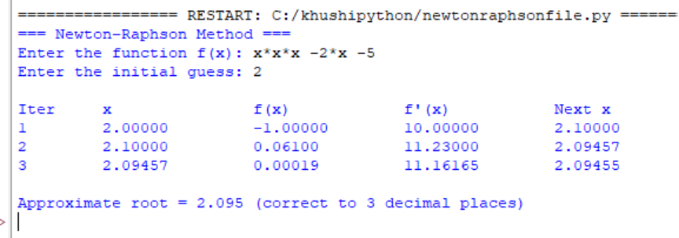
Conclusion: The above program has been executed successfully.
2 .Interpolation
Q. Write a program in python to demonstrate Forward difference table. Aim: To write a program in python to demonstrate Forward difference table.
Program:
def forward_difference_table(x, y):
n = len(y)
diff_table = [y.copy()] # first row is y values
# generate forward differences
for i in range(1, n):
row = []
for j in range(n - i):
value = diff_table[i - 1][j + 1] - diff_table[i - 1][j] row.append(value)
diff_table.append(row)
return diff_table
def display_table(x, diff_table): n = len(x) print("\nForward Difference Table:") print("x\t" + "\t".join([f"Δ^{i}y" for i in range(n)]))
for i in range(n):
print(f"{x[i]:.2f}", end="\t")
for j in range(n - i):
Khushi Vishwakarma | S.I.W.S College | Minor Practical

18071
print(f"{diff_table[j][i]:.2f}", end="\t") print()
def main(): n = int(input("Enter the number of data points: "))
print("Enter x values (equally spaced):")
x = [float(input(f"x[{i}]: ")) for i in range(n)]
print("Enter corresponding y values:")
y = [float(input(f"y[{i}]: ")) for i in range(n)]
# check if x values are equally spaced
h = x[1] - x[0]
if not all(abs(x[i + 1] - x[i] - h) < 1e-5 for i in range(n - 1)): print("Error: x values are not equally spaced.")
return
diff_table = forward_difference_table(x, y) display_table(x, diff_table)
if name == "main": main()
Result:
Khushi Vishwakarma | S.I.W.S College | Minor Practical

18071
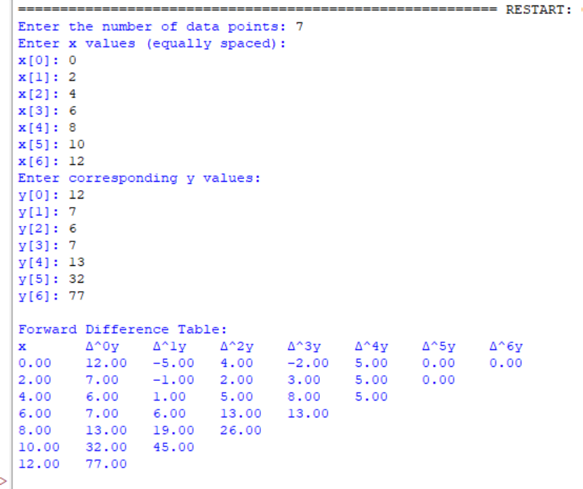
Conclusion: The above program has been executed successfully.
Null value in Forward difference table.
Q. Write a program in python to find Null value in Forward difference table. Aim: To write a program in python to find Null value in Forward difference table.
Program:
def solve_missing_term(y): # Coefficients for 5-point formula: y4 - 4y3 + 6y2 - 4y1 + y0 = 0 coeffs = [1, -4, 6, -4, 1]
if y.count(None) != 1:
print("Error: Exactly one value must be 'null'.") return None
Khushi Vishwakarma | S.I.W.S College | Minor Practical

18071
m = y.index(None)
total = 0
for i in range(5):
if i != m:
total += coeffs[i] * y[i]
y_missing = -total / coeffs[m]
return m, y_missing
def check_equal_spacing(x): h = x[1] - x[0] for i in range(len(x) - 1): if abs((x[i + 1] - x[i]) - h) > 1e-6: return False return True
def main(): print("=================================================") print("Enter x values (must be equally spaced):") x = [float(input(f"x[{i}]: ")) for i in range(5)]
if not check_equal_spacing(x):
print("Error: x values are not equally spaced.") return
print("Enter y values (use 'null' for the missing one):")
y = []
for i in range(5):
val = input(f"y[{i}]: ").strip().lower()
if val == "null":
y.append(None)
else:
y.append(float(val))
result = solve_missing_term(y)
if result:
idx, y_miss = result
print(f"\nEstimated missing y[{idx}] (at x = {x[idx]:.1f}) = {y_miss:.4f}")
print("=================================================")
if name == "main": main()
Result:
Khushi Vishwakarma | S.I.W.S College | Minor Practical

18071
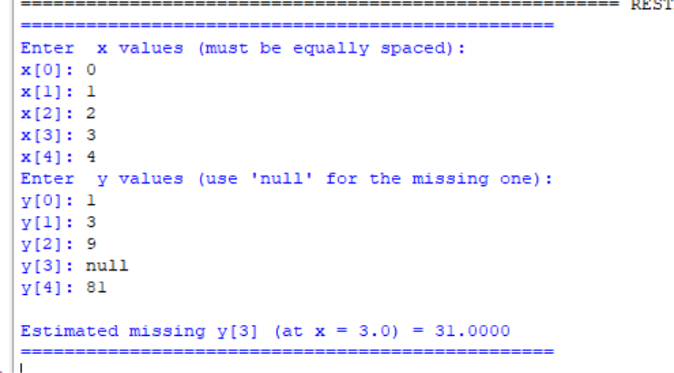
Conclusion: The above program has been executed successfully.
3.Curve Fitting
Q. Write a program in python to demonstrate curve fitting. Aim: To write a program in python to demonstrate curve fitting.
Formula:
Sum(y) = na0 + a1sum(x)
Sum(xy) = a0 sum(x) + a1sum(x^2)
Program:
def fit_line(x, y): n = len(x) sum_x = sum(x) sum_y = sum(y) sum_x2 = sum(i*i for i in x) sum_xy = sum(x[i]*y[i] for i in range(n))
a1 = (n*sum_xy - sum_x*sum_y) / (n*sum_x2 - sum_x**2) a0 = (sum_y - a1*sum_x) / n
return a0, a1
Khushi Vishwakarma | S.I.W.S College | Minor Practical

18071
def main(): n = int(input("How many data points? ")) x, y = [], [] for i in range(n): xi, yi = map(float, input(f"Enter x and y for point {i+1}: ").split()) x.append(xi) y.append(yi)
a0, a1 = fit_line(x, y)
print(f"\nEquation of line: y = {a0:.4f} + {a1:.4f}x")
xv = float(input("Enter x value to predict y: ")) yv = a0 + a1 * xv
print(f"Predicted y = {yv:.4f}")
Example
x = [10, 2, 5, 7]
y = [25, 12, 20, 30]
main()
Result:
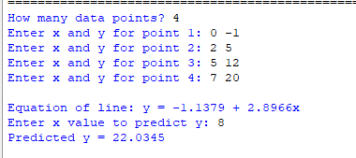
Conclusion: The above program has been executed successfully.
2 degree curve fitting
Q. Write a program in python to demonstrate 2 degree curve fitting. Aim: To write a program in python to demonstrate 2 degree curve fitting.
Formula:
Sum(y) = na0 + a1sum(x) + a2sum(x^2)
Khushi Vishwakarma | S.I.W.S College | Minor Practical

18071
Sum(xy) = a0 sum(x) + a1sum(x^2) + a2sum(x^3)
Sum(x^2y) = a0sum(x^2) + a1sum(x^3) +a2sum(x^4)
Program:
def fit_quadratic(x, y): n = len(x)
# Required summations
sum_x = sum(x)
sum_x2 = sum(i**2 for i in x)
sum_x3 = sum(i**3 for i in x)
sum_x4 = sum(i**4 for i in x)
sum_y = sum(y)
sum_xy = sum(x[i] * y[i] for i in range(n))
sum_x2y = sum((x[i]**2) * y[i] for i in range(n))
# Solving normal equations for a0, a1, a2 # Using Cramer's rule / determinant method
# Main determinant
D = (n*(sum_x2*sum_x4 - sum_x3*sum_x3)
- sum_x*(sum_x*sum_x4 - sum_x2*sum_x3) + sum_x2*(sum_x*sum_x3 - sum_x2*sum_x2))
# Determinant for a0
D0 = (sum_y*(sum_x2*sum_x4 - sum_x3*sum_x3)
- sum_x*(sum_xy*sum_x4 - sum_x3*sum_x2y) + sum_x2*(sum_xy*sum_x3 - sum_x2*sum_x2y))
# Determinant for a1
D1 = (n*(sum_xy*sum_x4 - sum_x3*sum_x2y)
- sum_y*(sum_x*sum_x4 - sum_x2*sum_x3)
+ sum_x2*(sum_x*sum_x2y - sum_xy*sum_x2))
# Determinant for a2
D2 = (n*(sum_x2*sum_x2y - sum_xy*sum_x3)
- sum_x*(sum_x*sum_x2y - sum_xy*sum_x2)
Khushi Vishwakarma | S.I.W.S College | Minor Practical

18071
+ sum_y*(sum_x*sum_x3 - sum_x2*sum_x2))
a0 = D0 / D
a1 = D1 / D
a2 = D2 / D
return a0, a1, a2
def main(): n = int(input("How many data points? ")) x, y = [], [] for i in range(n): xi, yi = map(float, input(f"Enter x and y for point {i+1}: ").split()) x.append(xi) y.append(yi)
a0, a1, a2 = fit_quadratic(x, y)
print(f"\nQuadratic Equation: y = {a0:.4f} + {a1:.4f}x + {a2:.4f}x^2")
xv = float(input("Enter x value to predict y: ")) yv = a0 + a1*xv + a2*(xv**2)
print(f"Predicted y = {yv:.4f}")
Run program
main()
Result:
Khushi Vishwakarma | S.I.W.S College | Minor Practical

18071
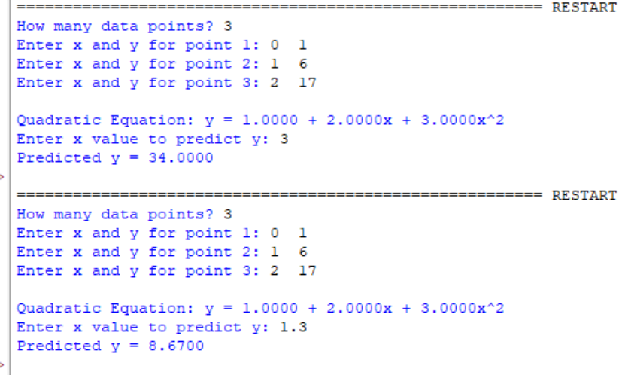
Conclusion: The above program has been executed successfully.
4. Solution of simultaneous Algebric equation
Gaussian elimination method.
Q. Write a program in python to demonstrateGaussian elimination Method. Aim: To write a program in python to demonstrate Gaussian elimination Method.
Program:
print("="*70) print("Initial augmented matrix [A | b]:")
Input augmented matrix [A|b]
a = [ [1.0, 10.0, -1.0, 3.0], [2.0, 3.0, 20.0, 7.0], [10.0, -1.0, 2.0, 4.0] ] n = len(a)
Function to print matrix neatly
def print_matrix(a): for row in a:
print(" [", end=" ")
for val in row
Khushi Vishwakarma | S.I.W.S College | Minor Practical

18071
: print(f"{val:10.6f}", end=" ")
print("]")
print()
print_matrix(a)
Forward Elimination
for i in range(n):
# Pivoting max_row = i
for k in range(i+1, n):
if abs(a[k][i]) > abs(a[max_row][i]):
max_row = k
if max_row != i:
a[i], a[max_row] = a[max_row], a[i]
print(f"R{max_row+1} <-> R{i+1}")
print_matrix(a)
# Make elements below pivot zero
for k in range(i+1, n):
factor = a[k][i] / a[i][i]
for j in range(i, n+1):
a[k][j] -= factor * a[i][j]
print(f"R{k+1} = R{k+1} - ({factor:.6f})*R{i+1}") print_matrix(a)
print("Upper-triangular matrix after forward elimination:") print_matrix(a)
Back Substitution
Khushi Vishwakarma | S.I.W.S College | Minor Practical

18071
x = [0 for _ in range(n)]
for i in range(n-1, -1, -1):
x[i] = a[i][n] for j in range(i+1, n):
x[i] -= a[i][j] * x[j] x[i] /= a[i][i]
print("Solution vector:")
for i in range(n):
print(f"x{i+1} = {x[i]:.8f}")
Result:
Khushi Vishwakarma | S.I.W.S College | Minor Practical

18071
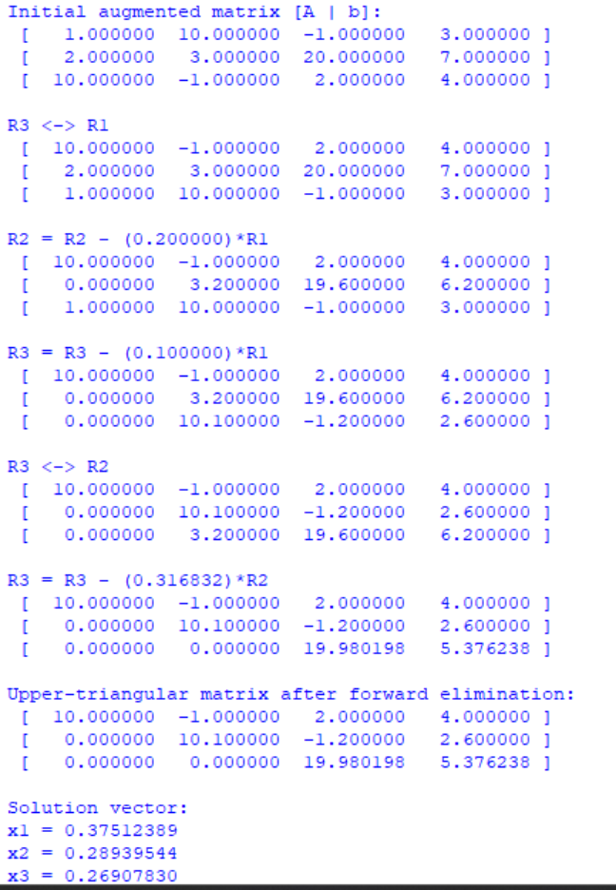
Conclusion: The above program has been executed successfully.
5. Numerical Solutions of first and second order differential equations.
Taylor Series
Q. Write a program in python to demonstrate Taylor Series.
Khushi Vishwakarma | S.I.W.S College | Minor Practical

18071
Aim: To write a program in python to demonstrate Taylor Series.
Program:
def f(x, y): return x**2 - y
def derivatives_at(x0, y0)
: # y' = x^2 – y
y1 = f(x0, y0)
# y'' = d/dx(x^2 - y) = 2x - y' (since dy/dx = y')
y2 = 2*x0 – y1
# y''' = d/dx(y'') = 2 - y'' (since derivative of -y' is -y'') y3 = 2 - y2
# y^(4) = d/dx(y''') = - y''' (because derivative of -y'' is -y''') y4 = -y3
# y^(5) = d/dx(y^(4)) = - y^(4) y5 = -y4
return [y0, y1, y2, y3, y4, y5]
def taylor_step(x0, y0, h, order=5):
derivs = derivatives_at(x0, y0)
# Taylor series up to given order (0..5)
y_next = derivs[0]
factorial = 1
for k in range(1, order+1):
factorial *= k
y_next += (h**k / factorial) * derivs[k]
Khushi Vishwakarma | S.I.W.S College | Minor Practical

18071
return y_next, derivs
if name == "main":
x0 = 0.0
y0 = 1.0
h = 0.1
order = 5
print("="*70)
y1, derivs = taylor_step(x0, y0, h, order)
print(f"Derivatives at x0 = {x0}, y0 = {y0}:") print(f" y(0) = {derivs[0]:.6f}")
print(f" y'(0) = {derivs[1]:.6f}")
print(f" y''(0) = {derivs[2]:.6f}")
print(f" y'''(0) = {derivs[3]:.6f}")
print(f" y^(4)(0) = {derivs[4]:.6f}")
print(f" y^(5)(0) = {derivs[5]:.6f}")
print()
print(f"Taylor approximation up to order {order}:") print(f" y({x0+h}) ≈ {y1:.10f}")
print(f"Rounded to 4 decimal places: {y1:.4f}")
Result:
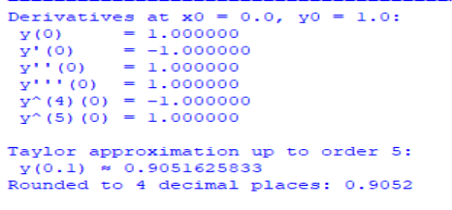
Conclusion: The above program has been executed successfully.
Khushi Vishwakarma | S.I.W.S College | Minor Practical

18071
Euler’s Method.
Q. Write a program in python to demonstrate Euler’s Method. Aim: To write a program in python to demonstrate Euler’s Method.
Program:
def f(x, y):
return x + y #
Example differential equation: dy/dx = x + y
main program
if name == "main":
x0 = 0.0 # initial x
y0 = 1.0 # initial y
h = 0.1 # step size
n = 5 # number of steps
print("="*70)
print(f"{'Euler\'s Method Approximation':^70}") print("="*70)
print(f"{'x':>8} {'y':>15}")
for i in range(n):
Khushi Vishwakarma | S.I.W.S College | Minor Practical

18071
y1 = y0 + h * f(x0, y0)
print(f"{x0:8.4f} {y0:15.6f}")
x0 += h
y0 = y1
print(f"\nApproximate value of y({x0:.1f}) = {y0:.6f}") Result:
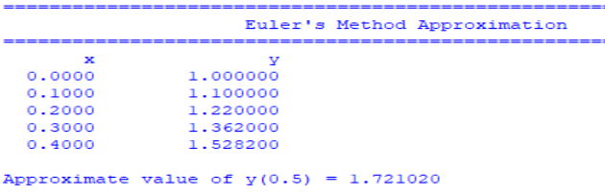
Conclusion: The above program has been executed successfully.
Modified Euler’s Series.
Q. Write a program in python to demonstrate Modified Euler’s Method. Aim: To write a program in python to demonstrate Modified Euler’s Method.
Program:
def f(x, y):
return x + y # Example: dy/dx = x + y
main program
if name == "main":
x0 = 0.0 # initial x y0 = 1.0 # initial y
h = 0.1 # step size
n = 5 # number of steps
print("="*70)
print(f"{'Modified Euler’s Method Approximation':^70}") print("="*70)
print(f"{'x':>8} {'y':>15}")
Khushi Vishwakarma | S.I.W.S College | Minor Practical

18071
for i in range(n):
k1 = f(x0, y0)
y_predict = y0 + h * k1 # Euler prediction k2 = f(x0 + h, y_predict) # Corrector slope y1 = y0 + (h / 2) * (k1 + k2) # Improved estimate
print(f"{x0:8.4f} {y0:15.6f}")
x0 += h
y0 = y1
print(f"\nApproximate value of y({x0:.1f}) = {y0:.6f}")
Output:
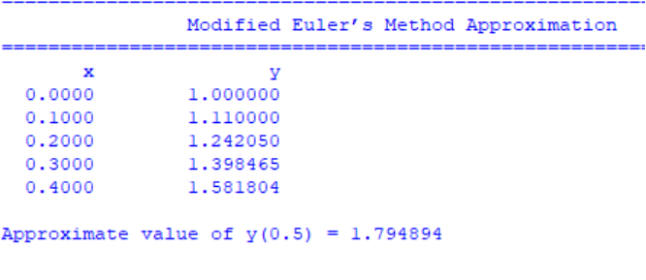
Conclusion: The above program has been executed successfully.
Runge-Kutta 4th Order Method.
Q. Write a program in python to demonstrate Runge-Kutta 4th Order Method Aim: To write a program in python to demonstrate Runge-Kutta 4th Order Method.
Program:
def f(x, y):
return x + y
Exact solution for checking (for dy/dx = x + y, y(0)=1 → y = 2e^x - x - 1)
Khushi Vishwakarma | S.I.W.S College | Minor Practical

18071
def exact_solution(x):
return 2 * math.exp(x) - x - 1
#Initial conditions
x = 0.0
y = 1.0
h = 0.1
steps = int(0.2 / h) # compute up to x = 0.2
print("==================================================================== ")
print(" Runge-Kutta 4th order (RK4) step-by-step")
print("==================================================================== ") print("Equation: y' = x + y ,
y(0)=1\n")
print(f"{'Step':>3} | {'x_n':>6} | {'y_n (before)':>16} | {'k1':>7} | {'k2':>7} | {'k3':>7} | {'k4':>7} | {'y_(n+1)':>10}") print("-"*75)
for i in range(1, steps + 1):
k1 = f(x, y)
k2 = f(x + h/2, y + (h/2)*k1)
k3 = f(x + h/2, y + (h/2)k2)
k4 = f(x + h, y + hk3)
increment = (h/6)*(k1 + 2*k2 + 2*k3 + k4)
y_next = y + increment
print(f"{i:3d} | {x:6.3f} | {y:16.9f} | {k1:7.6f} | {k2:7.6f} | {k3:7.6f} | {k4:7.6f} | {y_next:10.9f}")
# update for next iteration
Khushi Vishwakarma | S.I.W.S College | Minor Practical

18071
x += h
y = y_next
print("-"*75)
print(f"Final RK4 approximation: y({x:.3f}) = {y:.9f}")
print(f"Exact value : y({x:.3f}) = {exact_solution(x):.9f}") print(f"Absolute error : {abs(y - exact_solution(x)):.12e}") Result:
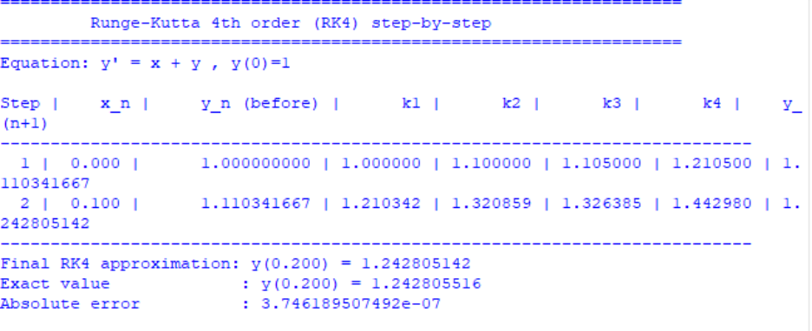
Conclusion: The above program has been executed successfully.
6.Numerical Integration
Trapezoidal Rule
Q. Write a program in python to demonstrate Trapezoidal RuleMethod. Aim: To write a program in python to demonstrate Trapezoidal Rule Method.
Program:
def f(x):
return 1 / (1 + x**2)
a = 0
Khushi Vishwakarma | S.I.W.S College | Minor Practical

18071
b = 1
n = 2 # number of subintervals
h = (b - a) / n
x = [a + i * h for i in range(n + 1)]
f_values = [f(xi) for xi in x]
print("===============================================================") print(" i x(i) f(x(i)) = 1/(1+x^2)")
print("---------------------------------------------------------------")
for i in range(n + 1):
print(f" {i+1:<2d} {x[i]:<10.4f} {f_values[i]:<10.4f}")
print("---------------------------------------------------------------")
I = (h / 2) * (f_values[0] + 2 * sum(f_values[1:-1]) + f_values[-1])
print(f"h = (b - a) / n = ({b} - {a}) / {n} = {h}")
print("\nUsing Trapezoidal Rule:")
print("I = (h/2) * [f(x0) + 2f(x1) + f(x2)]")
print(f"I = ({h}/2) * [{f_values[0]:.4f} + 2{f_values[1]:.4f} + {f_values[2]:.4f}]")
print("---------------------------------------------------------------")
print(f"Approximate value of the integral I = {I:.4f}")
print("===============================================================") Result:
Khushi Vishwakarma | S.I.W.S College | Minor Practical

18071
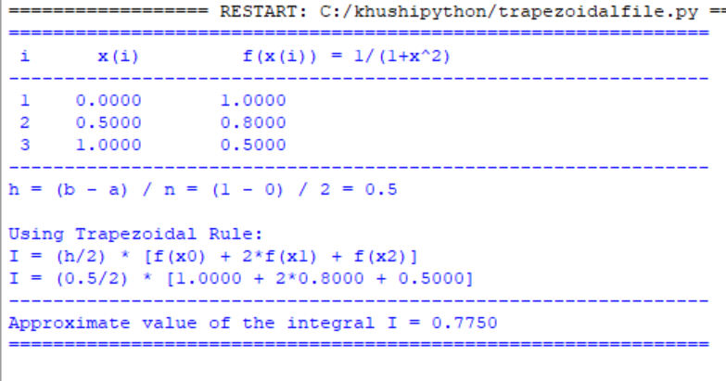
Conclusion: The above program has been executed successfully.
Simpson’s 1/3rd Rule
Q. Write a program in python to demonstrate Simpson’s 1/3rd Rule. Aim: To write a program in python to demonstrate Simpson’s 1/3rd Rule.
Program:
import math
def f(x):
Return math.exp(-x**2)
a = 0
b = 1
n = 4 # number of subintervals (must be even)
h = (b - a) / n
x = [a + i * h for i in range(n + 1)]
f_values = [f(xi) for xi in x]
print("="*70)
print("Simpson’s 1/3 Rule for I = ∫(0 to 1) e^(-x^2) dx")
Khushi Vishwakarma | S.I.W.S College | Minor Practical

18071
print("------------------------------------------------------")
print("i\t x(i)\t\t f(x(i)) = e^(-x^2)")
print("------------------------------------------------------")
for i in range(n + 1):
print(f"{i}\t {x[i]:.4f}\t\t {f_values[i]:.6f}")
print("------------------------------------------------------")
I = (h/3) * (f_values[0] + f_values[-1] + 4 * sum(f_values[i] for i in range(1, n, 2)) + 2 * sum(f_values[i] for i in range(2, n-1, 2)))
print(f"h = (b - a) / n = ({b} - {a}) / {n} = {h}")
print("\nUsing Simpson’s 1/3 Rule:")
print("I = (h/3) * [f(x0) + 4*(f(x1)+f(x3)+...) + 2*(f(x2)+f(x4)+...) + f(xn)]")
print(f"I = ({h}/3) * [{f_values[0]:.4f} + 4*{f_values[1]:.4f} + 2*{f_values[2]:.4f} + " f"4*{f_values[3]:.4f} + {f_values[4]:.4f}]")
print("------------------------------------------------------")
print(f"Approximate value of the integral I = {I:.6f}")
print("="*70)
Result:
Khushi Vishwakarma | S.I.W.S College | Minor Practical

18071
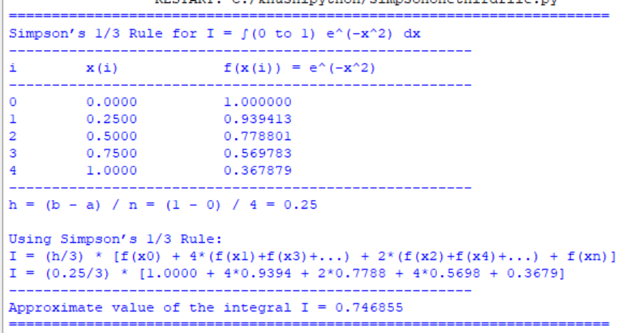
Conclusion: The above program has been executed successfully.
Simpson’s 3/8th Rule
Q. Write a program in python to demonstrate Simpson’s 3/8th Rule. Aim: To write a program in python to demonstrate Simpson’s 3/8th Rule.
Program:
import math
def f(x): return math.exp(-x**2)
a = 0
b = 1
n = 6 # number of subintervals (must be a multiple of 3) h = (b - a) / n
x = [a + i * h for i in range(n + 1)]
f_values = [f(xi) for xi in x]
print("="*70)
Khushi Vishwakarma | S.I.W.S College | Minor Practical

18071
print("Simpson’s 3/8 Rule for I = ∫(0 to 1) e^(-x^2) dx")
print("------------------------------------------------------")
print("i\t x(i)\t\t f(x(i)) = e^(-x^2)")
print("------------------------------------------------------")
for i in range(n + 1):
print(f"{i}\t {x[i]:.4f}\t\t {f_values[i]:.6f}")
print("------------------------------------------------------")
sum_3 = sum(f_values[i] for i in range(1, n) if i % 3 != 0) sum_2 = sum(f_values[i] for i in range(3, n, 3))
I = (3h/8) * (f_values[0] + 3sum_3 + 2*sum_2 + f_values[-1])
print(f"h = (b - a) / n = ({b} - {a}) / {n} = {h}")
print("\nUsing Simpson’s 3/8 Rule:")
print("I = (3h/8) * [f(x0) + 3*(f(x1)+f(x2)+f(x4)+f(x5)+...) + 2*(f(x3)+f(x6)+...) + f(xn)]") print(f"I = (3*{h}/8) * [{f_values[0]:.4f} + 3*({sum_3:.4f}) + 2*({sum_2:.4f}) + {f_values[-1]:.4f}]")
print("------------------------------------------------------")
print(f"Approximate value of the integral I = {I:.6f}")
print("="*70)
Result:
Khushi Vishwakarma | S.I.W.S College | Minor Practical

18071
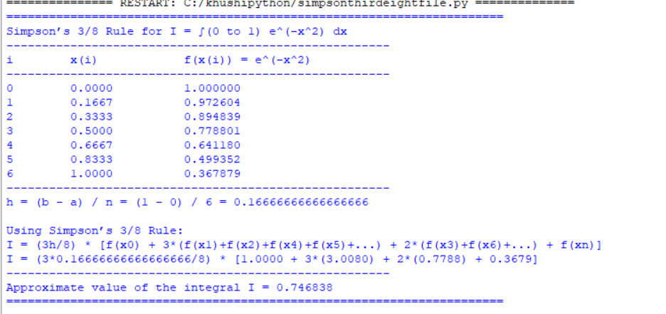
Conclusion: The above program has been executed successfully.
7. Transportation Problem
Q. Write a program in python to demonstrate Transportation Problem using Northwest Corner Method.
Aim: To write a program in python to demonstrate Transportation Problem using Northwest Corner Method.
Program:
costs = [
[8, 6, 10], # from O1 to D1, D2, D3
[10, 4, 9] # from O2 to D1, D2, D3
]
supply = [2000, 2500] # supply for O1, O2
demand = [1500, 2000, 1000] # demand for D1, D2, D3
alloc = [[0]*3 for _ in range(2)] # allocation matrix
Khushi Vishwakarma | S.I.W.S College | Minor Practical

18071
i = j = 0
while i < 2 and j < 3:
qty = min(supply[i], demand[j])
alloc[i][j] = qty
supply[i] -= qty
demand[j] -= qty
if supply[i] == 0 and demand[j] == 0:
i += 1
j += 1
elif supply[i] == 0:
i += 1
elif demand[j] == 0:
j += 1
# Print results
print("Allocation Matrix (O1,O2 vs D1,D2,D3):") for row in alloc:
print(row)
total = 0
print("\nAllocations & Costs:")
for i in range(2):
for j in range(3):
if alloc[i][j] > 0:
cost = alloc[i][j] * costs[i][j]
total += cost
Khushi Vishwakarma | S.I.W.S College | Minor Practical

18071 print(f"O{i+1}->D{j+1}: {alloc[i][j]} units × {costs[i][j]} = {cost}")
print("\nTotal Transportation Cost =", total)
Result:
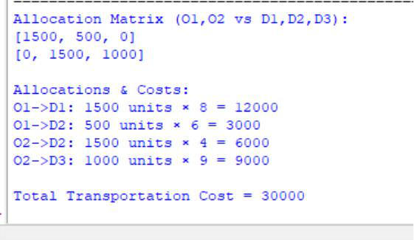
Conclusion: The above program has been executed successfully.
Khushi Vishwakarma | S.I.W.S College | Minor Practical

