18071
3.Curve Fitting
Q. Write a program in python to demonstrate curve fitting.
Aim: To write a program in python to demonstrate curve fitting.
Formula:
Sum(y) = na0 + a1sum(x)
Sum(xy) = a0 sum(x) + a1sum(x^2)
Program:
def fit_line(x, y): n = len(x) sum_x = sum(x) sum_y = sum(y) sum_x2 = sum(i*i for i in x) sum_xy = sum(x[i]*y[i] for i in range(n))
a1 = (n*sum_xy - sum_x*sum_y) / (n*sum_x2 - sum_x**2) a0 = (sum_y - a1*sum_x) / n
return a0, a1
def main(): n = int(input("How many data points? ")) x, y = [], [] for i in range(n): xi, yi = map(float, input(f"Enter x and y for point {i+1}: ").split()) x.append(xi) y.append(yi)
a0, a1 = fit_line(x, y)
print(f"\nEquation of line: y = {a0:.4f} + {a1:.4f}x")
xv = float(input("Enter x value to predict y: ")) yv = a0 + a1 * xv
print(f"Predicted y = {yv:.4f}")
Example
x = [10, 2, 5, 7]
y = [25, 12, 20, 30]
main()
Result:
Khushi Vishwakarma | S.I.W.S College | Minor Practical 3

18071
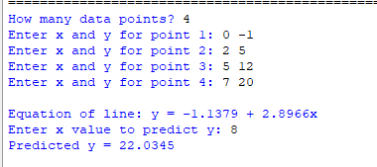
Conclusion: The above program has been executed successfully.
Khushi Vishwakarma | S.I.W.S College | Minor Practical 3

